1 On a standardized test, Cathy had a score of 74, which was exactly 1 standard deviation below the mean. If the standard deviation for the test is 6, what is the mean score for the test?
1) | 68 | 3) | 77
2) | 71 | 4) | 80

2 On a standardized test, a score of 82 falls exactly 1 standard deviation below the mean. If the standard deviation for the test is 4, what is the mean score for the test?
1) | 78 | 3) | 84
2) | 80 | 4) | 86

3 On a standardized test, Phyllis scored 84, exactly one standard deviation above the mean. If the standard deviation for the test is 6, what is the mean score for the test?
1) | 72 | 3) | 84
2) | 78 | 4) | 90

4 On a standardized test, a score of 86 falls exactly 1.5 standard deviations below the mean. If the standard deviation for the test is 2, what is the mean score for this test?
1) | 84 | 3) | 87.5
2) | 84.5 | 4) | 89

5 On a standardized examination, Laura received a score of 85, which was exactly 2 standard deviations above the mean. If the standard deviation for the examination is 4, what is the mean for this examination?
1) | 93 | 3) | 83
2) | 87 | 4) | 77

6 In the accompanying diagram, the shaded area represents approximately 95% of the scores on a standardized test. If these scores ranged from 78 to 92, which could be the standard deviation?

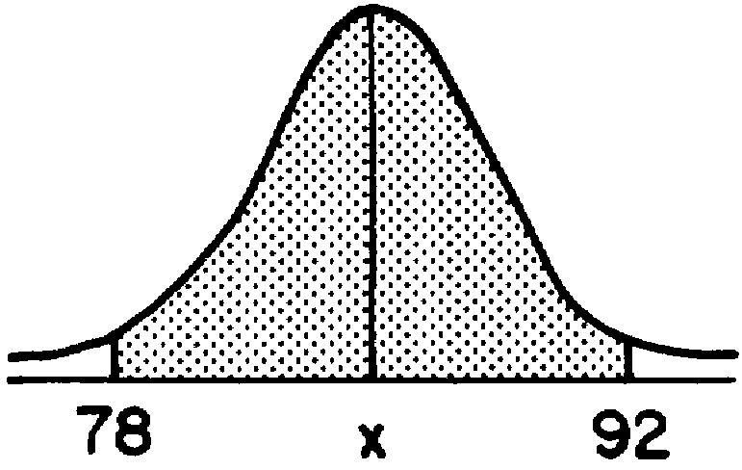
1) | 3.5 | 3) | 14.0
2) | 7.0 | 4) | 20.0

7 In the accompanying diagram, about 68% of the scores fall within the shaded area, which is symmetric about the mean, . The distribution is normal and the scores in the shaded area range from 50 to 80.
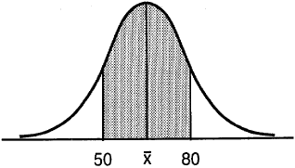

What is the standard deviation of the scores in this distribution?
1) |  | 3) | 30
2) | 15 | 4) | 65

8 The heights of the members of a high school class are normally distributed. If the mean height is 65 inches and a height of 72 inches represents the 84th percentile, what is the standard deviation for this distribution?
1) | 7 | 3) | 12
2) | 11 | 4) | 137

9 The heights of a group of girls are normally distributed with a mean of 66 inches. If 95% of the heights of these girls are between 63 and 69 inches, what is the standard deviation for this group?
1) | 1 | 3) | 3
2) | 1.5 | 4) | 6

10 In a normal distribution, and when represents the mean and represents the standard deviation. The standard deviation is
1) | 10 | 3) | 30
2) | 20 | 4) | 60

11 In a normal distribution, 68% of the scores fall between 72 and 86 and the mean is 79. What is the standard deviation?

12 In a certain school district, the ages of all new teachers hired during the last 5 years are normally distributed. Within this curve, 95.4% of the ages, centered about the mean, are between 24.6 and 37.4 years. Find the mean age and the standard deviation of the data.

13 On a test that has a normal distribution of scores, a score of 57 falls one standard deviation below the mean, and a score of 81 is two standard deviations above the mean. Determine the mean score of this test.
1 ANS: 4 REF: 068624siii

2 ANS: 4 REF: 089317siii

3 ANS: 2 REF: 069517siii

4 ANS: 4
If the standard deviation is 2, then 1.5 deviations equals 3 points. Since 86 is below the mean, add 3 to 86 to equal 89.

REF: 010604b

5 ANS: 4 REF: 089925siii

6 ANS: 1 REF: 069030siii

7 ANS: 2 REF: 069726siii

8 ANS: 1 REF: 080020siii

9 ANS: 2 REF: 010331siii

10 ANS: 1 REF: 018930siii

11 ANS:
7

REF: 019712siii

12 ANS:
31, 3.2. Since the group of teachers between 24.6 and 37.4 years old represents 95.4% of the population, this group is within 2 standard deviations of the mean. To find the mean, average 24.6 and 37.4, which equals 31. To find the standard deviation, find the range of the scores 37.4 - 24.6 = 12.8, and divide 12.8 by 4 (the # of standard deviations) which equals 3.2. 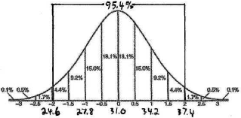

REF: 060324b

13 ANS:
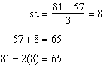

REF: 011534a2

