1 The expression is equivalent to
1) 1 2) 3) i 4)

2 What is the multiplicative inverse of 3i?
1) 2) 3) 4)

3 What is the multiplicative inverse of ?
1) 2) 3) 4)

4 The expression is equivalent to
1) 2) 3) 4)

5 Expressed in form, is equivalent to
1) 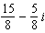 2) 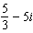 3) 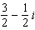 4)

6 The expression is equivalent to
1) 2) 3) 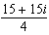 4)

7 The expression 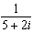 is equivalent to
1) 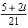 2) 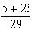 3) 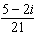 4) 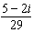

8 The expression 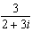 is equivalent to
1) 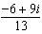 2) 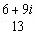 3) 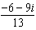 4) 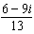

9 The expression 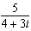 is equivalent to
1) 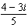 2) 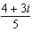 3) 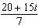 4) 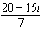

10 The expression is equivalent to
1) 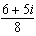 2) 3) 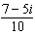 4)

11 Impedance measures the opposition of an electrical circuit to the flow of electricity. The total impedance in a particular circuit is given by the formula 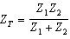. What is the total impedance of a circuit, , if and ?
1) 1 2) 0 3) 4)

12 Express in simplest form.
1 ANS: 3
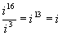

REF: 010518b

2 ANS: 4
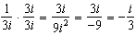

REF: 060614b

3 ANS: 4 REF: 068521siii

4 ANS: 3
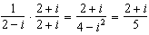

REF: 061014b

5 ANS: 3 REF: 069722siii

6 ANS: 1
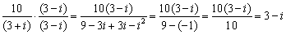

REF: 010811b

7 ANS: 4 REF: 019522siii

8 ANS: 4 REF: 019414siii

9 ANS: 1 REF: 010128siii

10 ANS: 4
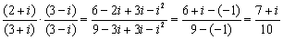

REF: 060513b

11 ANS: 3
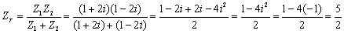

REF: 060509b

12 ANS:

REF: 089612siii

