1 In the diagram below of right triangle ACB, altitude is drawn to hypotenuse .
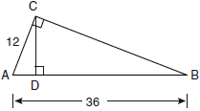
If and , what is the length of ?
1) | 32
2) | 6
3) | 3
4) | 4

2 In the diagram below of right triangle ABC, is the altitude to hypotenuse , , and .
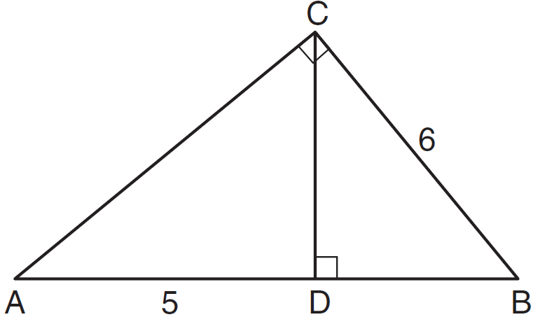
What is the length of ?
1) | 5
2) | 9
3) | 3
4) | 4

3 In the diagram below, is an altitude of right triangle PQR, , and .
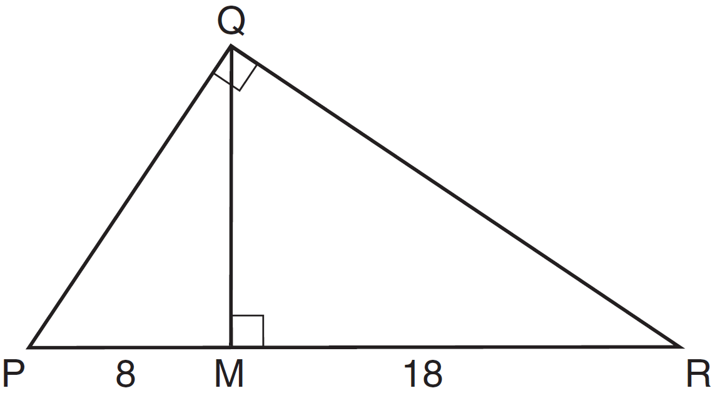

What is the length of ?
1) | 20
2) | 16
3) | 12
4) | 10

4 In the diagram below, the length of the legs and of right triangle ABC are 6 cm and 8 cm, respectively. Altitude is drawn to the hypotenuse of .
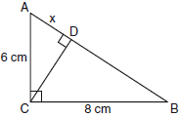
What is the length of to the nearest tenth of a centimeter?
1) | 3.6
2) | 6.0
3) | 6.4
4) | 4.0

5 In the diagram below of right triangle ABC, altitude is drawn to hypotenuse , , and .
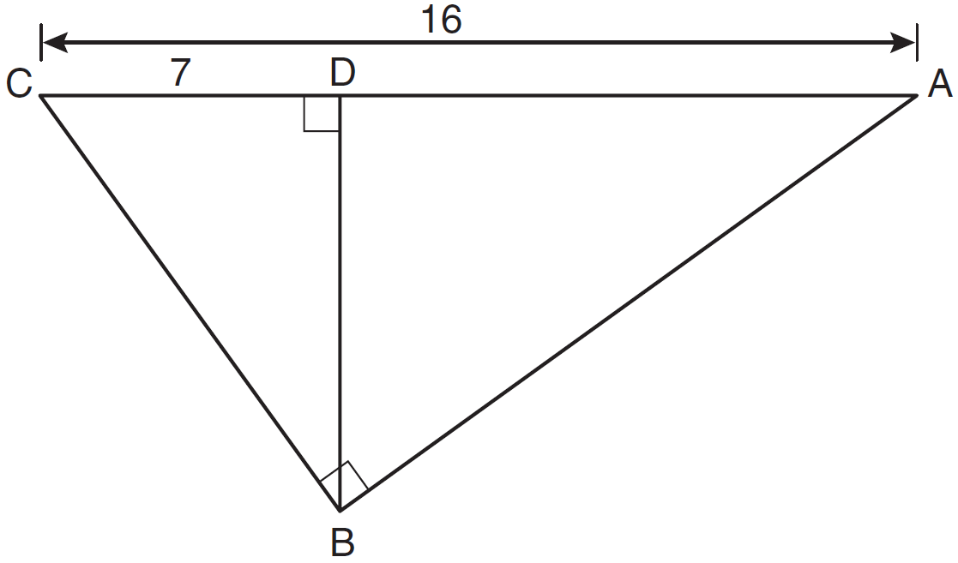
What is the length of ?
1)
2)
3)
4) | 12

6 In the diagram below of right triangle ABC, altitude is drawn to hypotenuse .
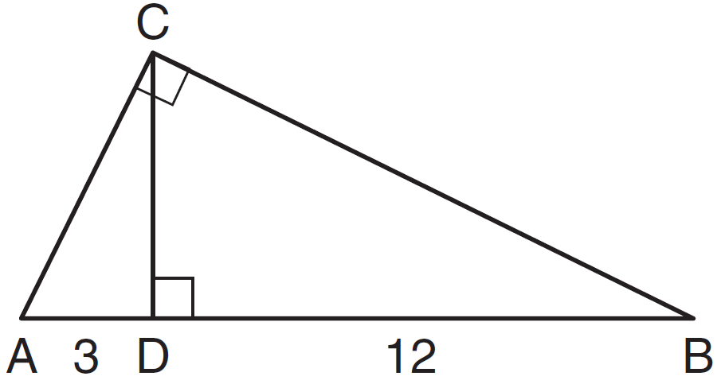
If and , what is the length of altitude ?
1) | 6
2)
3) | 3
4)

7 In right triangle ABC shown in the diagram below, altitude is drawn to hypotenuse , , and .
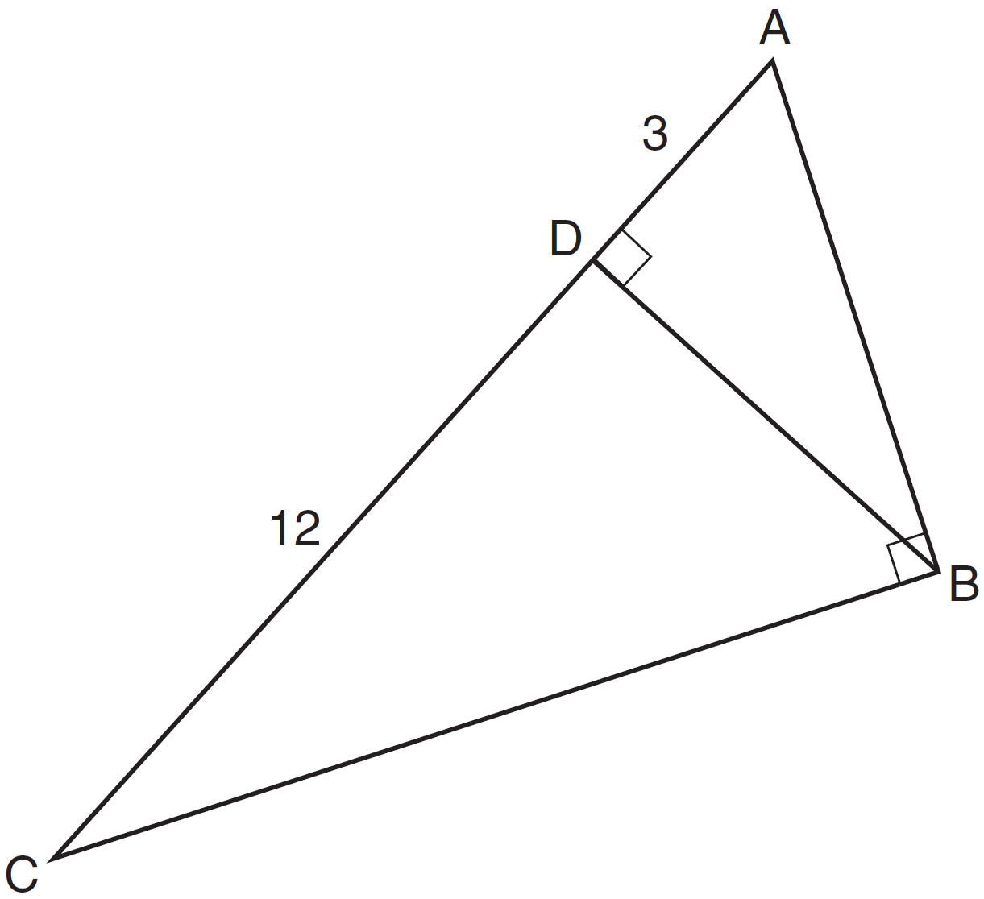
What is the length of ?
1)
2) | 6
3)
4) | 9

8 Triangle ABC shown below is a right triangle with altitude drawn to the hypotenuse .
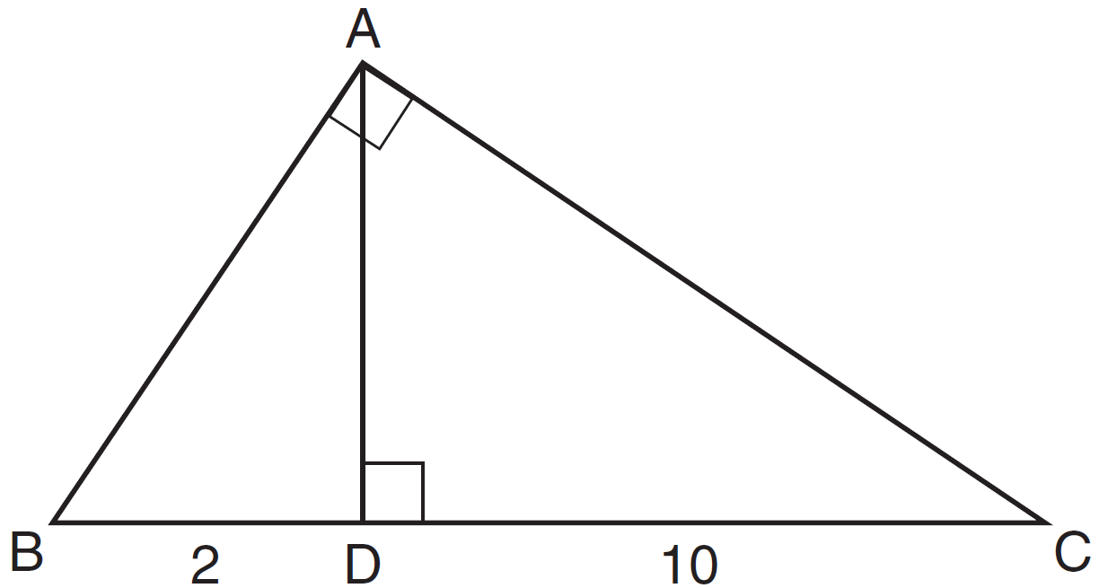
If and , what is the length of ?
1)
2)
3)
4)

9 In the diagram below of right triangle ABC, is the altitude to hypotenuse , , and .
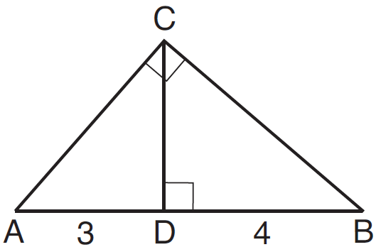
What is the length of ?
1)
2)
3)
4)

10 In , is a right angle and is drawn perpendicular to hypotenuse . If , , and , what is the length of ?
1) | 9
2) | 12
3) | 3
4) | 15

11 The accompanying diagram shows a 24-foot ladder leaning against a building. A steel brace extends from the ladder to the point where the building meets the ground. The brace forms a right angle with the ladder.
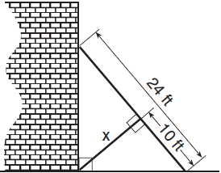
If the steel brace is connected to the ladder at a point that is 10 feet from the foot of the ladder, which equation can be used to find the length, x, of the steel brace?
1) | 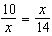
2) | 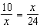
3)
4)

12 The accompanying diagram shows part of the architectural plans for a structural support of a building. PLAN is a rectangle and .
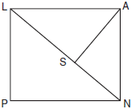
Which equation can be used to find the length of ?
1) | 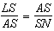
2) | 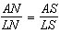
3) | 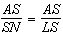
4) | 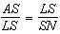

13 In the diagram below of right triangle ABC, an altitude is drawn to the hypotenuse .

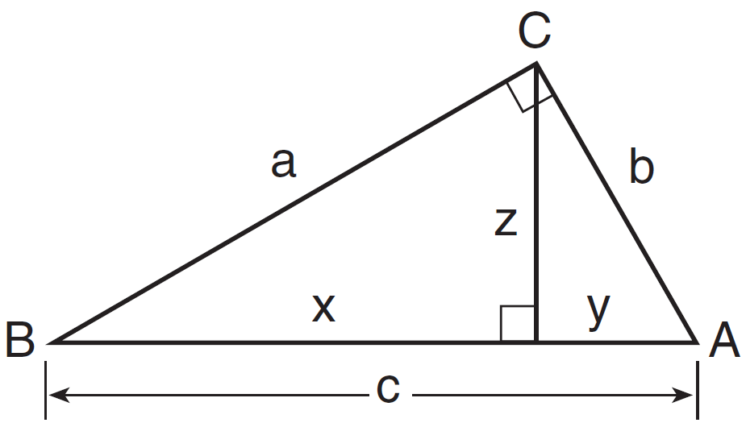

Which proportion would always represent a correct relationship of the segments?
1) | 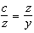
2) | 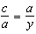
3) | 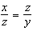
4) | 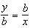

14 In right triangle ABC shown below, altitude is drawn to hypotenuse .

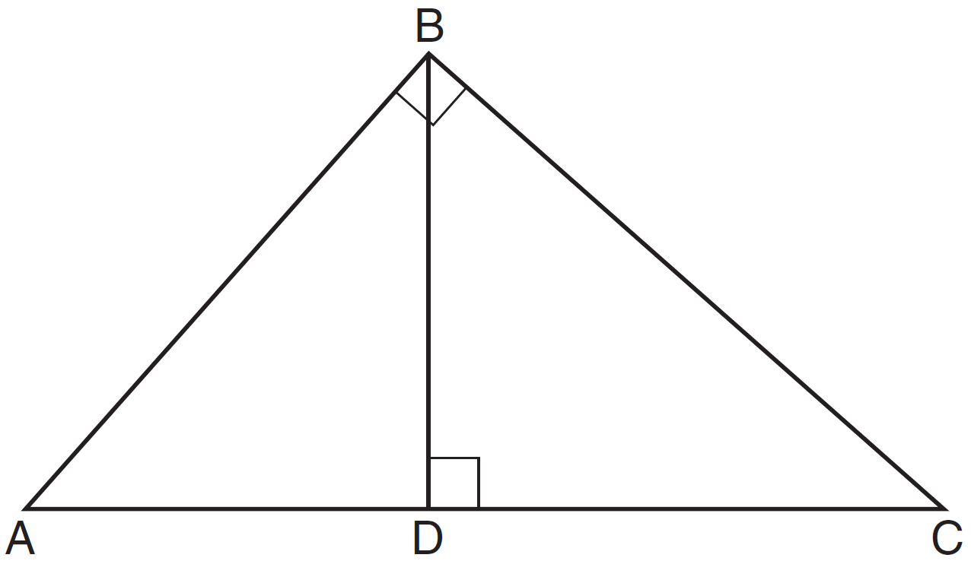

If and , determine and state the length of .

15 In the diagram below, is a right triangle. The altitude, h, to the hypotenuse has been drawn. Determine the length of h.

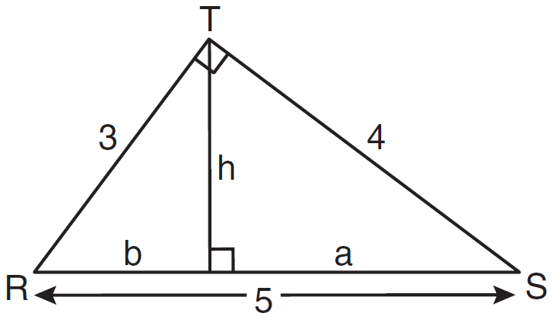

16 Four streets in a town are illustrated in the accompanying diagram. If the distance on Poplar Street from F to P is 12 miles and the distance on Maple Street from E to M is 10 miles, find the distance on Maple Street, in miles, from M to P.

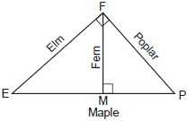

17 The drawing for a right triangular roof truss, represented by , is shown in the accompanying diagram. If is a right angle, altitude meters, and is 6 meters longer than , find the length of base in meters.

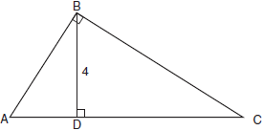

18 In the diagram below of right triangle ACB, altitude intersects at D. If and , find the length of in simplest radical form.

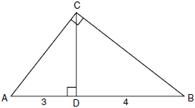

19 In right triangle ABC below, is the altitude to hypotenuse . If and the ratio of AD to AB is 1:5, determine and state the length of . [Only an algebraic solution can receive full credit.]

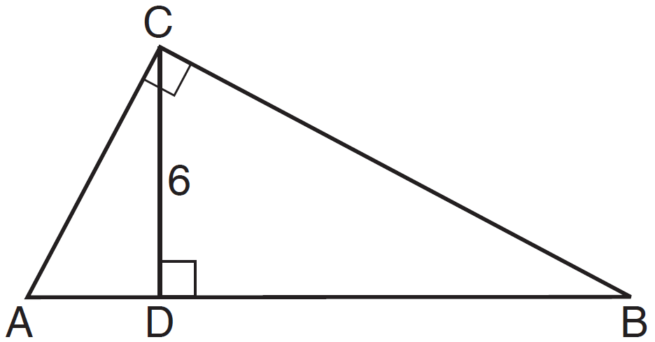

20 In right triangle FGH shown below, , altitude is drawn to , , and .

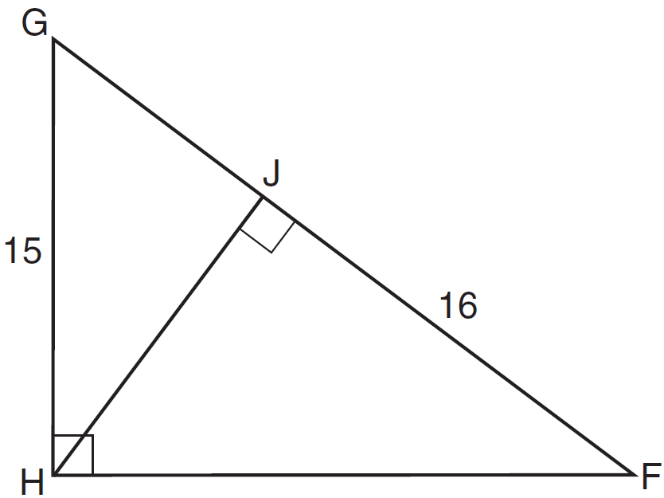

Determine and state the length of . Determine and state the length of . [Only algebraic solutions can receive full credit.]

21 In the diagram below, right triangle RSU is inscribed in circle O, and is the altitude drawn to hypotenuse . The length of is 16 more than the length of and . Find the length of . Find, in simplest radical form, the length of .

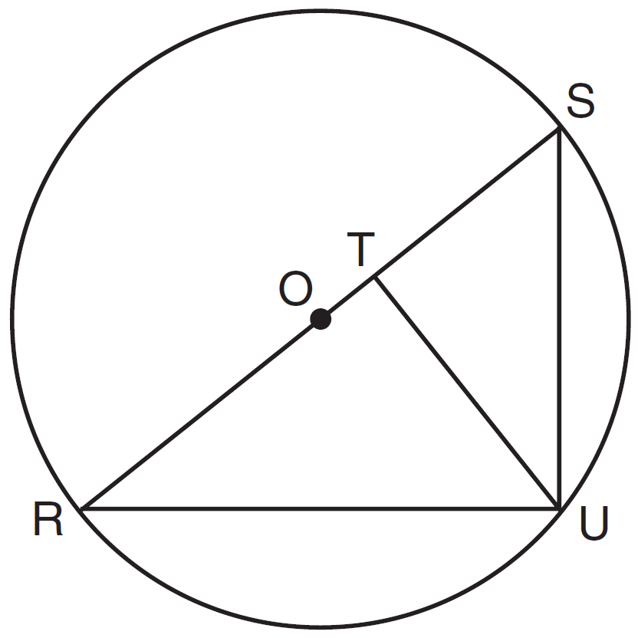

1 ANS: 4
Let . 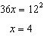

REF: 080922ge

2 ANS: 4
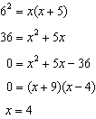

REF: 011123ge

3 ANS: 3
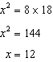

REF: 061506ge

4 ANS: 1
since is a 6-8-10 triangle. 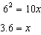

REF: 060915ge

5 ANS: 1
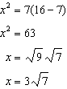

REF: 061128ge

6 ANS: 1
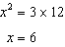

REF: 011308ge

7 ANS: 3
.

REF: 061327ge

8 ANS: 3
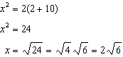

REF: 081326ge

9 ANS: 3
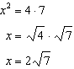

REF: 081528ge

10 ANS: 4
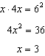.

REF: 011227ge

11 ANS: 1 REF: 010619b

12 ANS: 1 REF: 010920b

13 ANS: 3 REF: 081410ge

14 ANS:
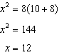

REF: 061431ge

15 ANS:
2.4. 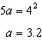 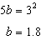 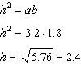

REF: 081037ge

16 ANS:
8. 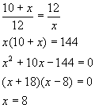

REF: 060828b

17 ANS:
10. Let 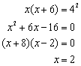. Since .

REF: 080932b

18 ANS:
. 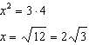

REF: fall0829ge

19 ANS:
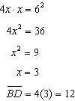

REF: 011437ge

20 ANS:
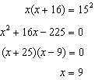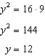

REF: 011638ge

21 ANS:
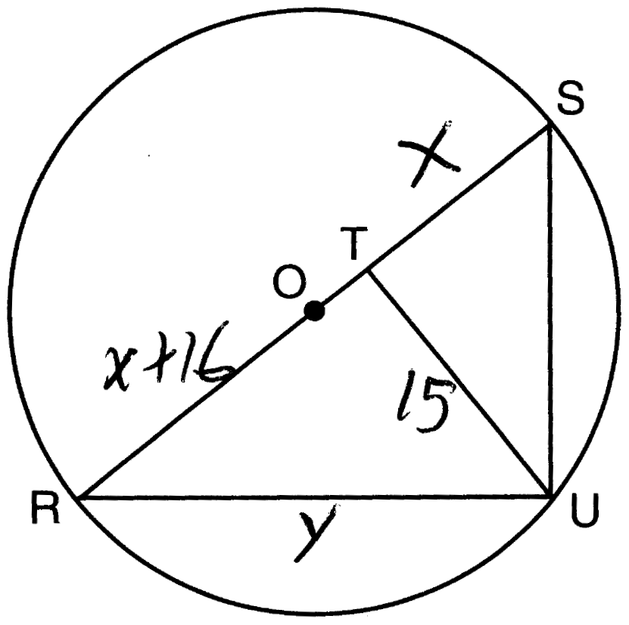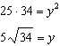

REF: 011538ge

