1 In the diagram below of , .
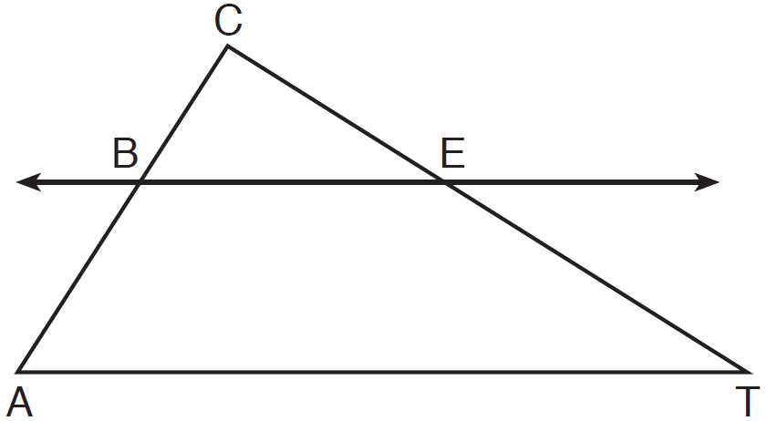
If , , and , what is the length of ?
1) | 5
2) | 14
3) | 20
4) | 26

2 In the diagram below of , , , , and .
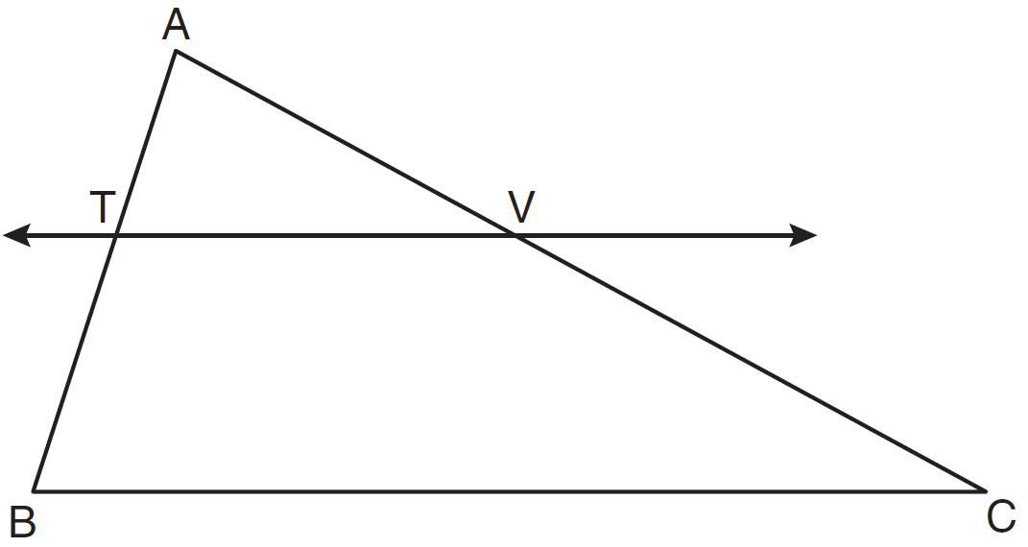
What is the length of ?
1)
2)
3) | 14
4) | 24

3 In the diagram of shown below, .
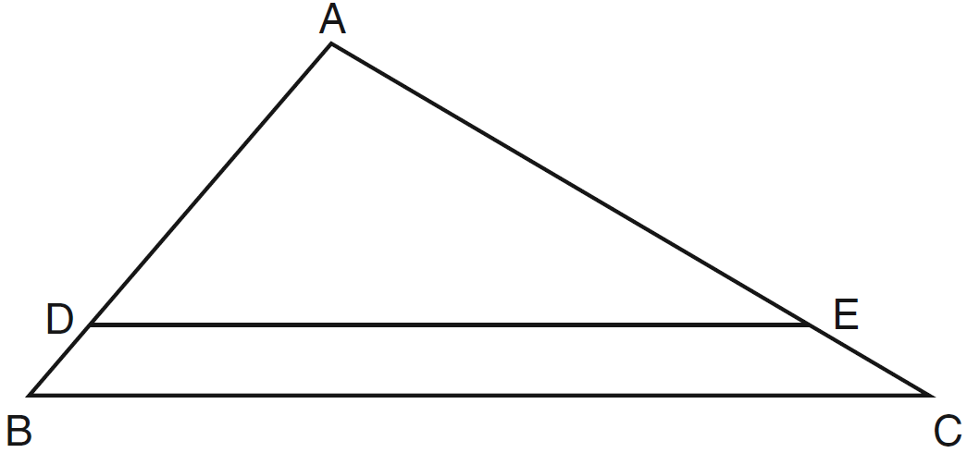
If , , and , what is the length of ?
1) | 6
2) | 2
3) | 3
4) | 15

4 Triangle PQT with is shown below.

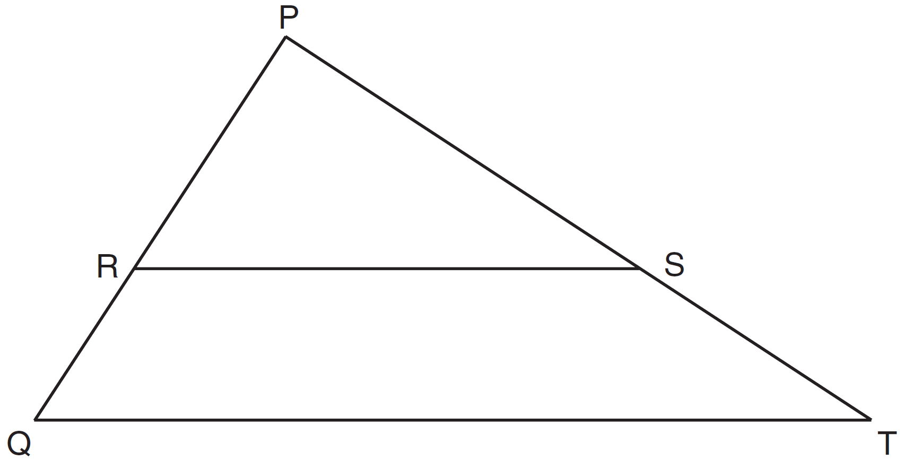

If , , and , what is the length of ?
1) | 14
2) | 17
3) | 35
4) | 38

5 In the diagram of below, , , , and .

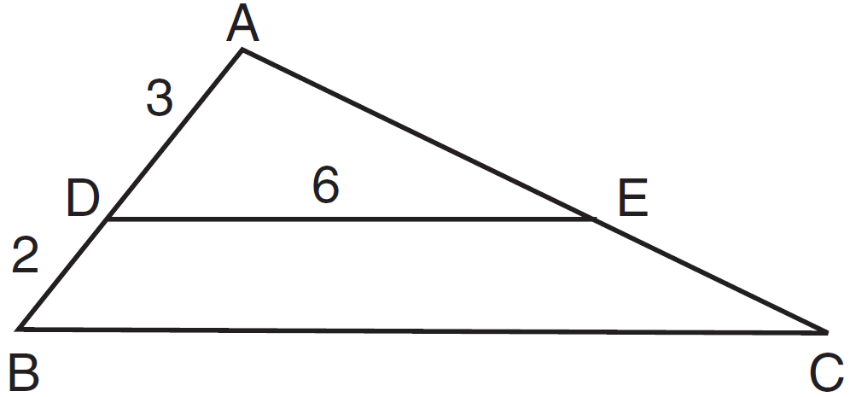

What is the length of ?
1) | 12
2) | 10
3) | 8
4) | 4

6 In the diagram of below, .

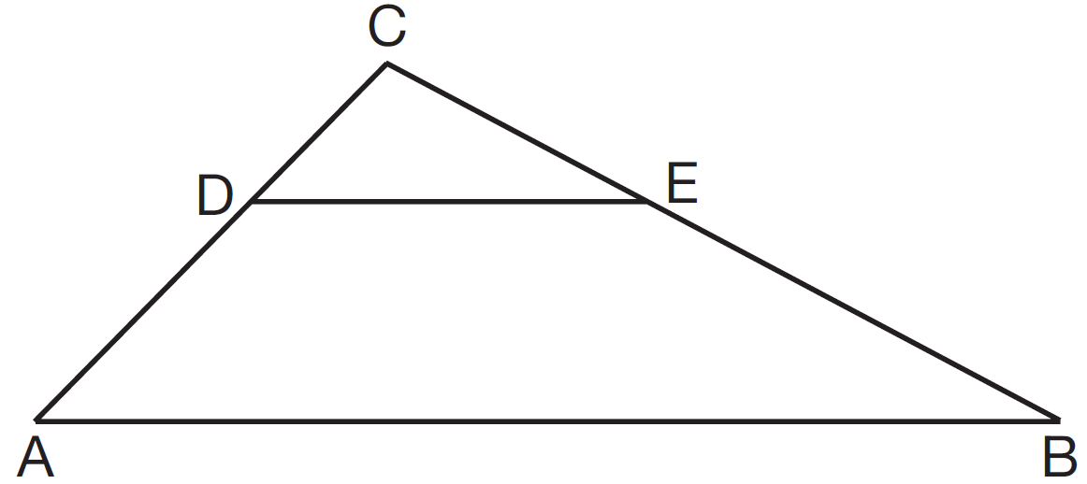

If , , , and , what is the length of ?
1) | 10
2) | 8
3) | 6
4) | 4

7 In the diagram below of , , , , , , , and .

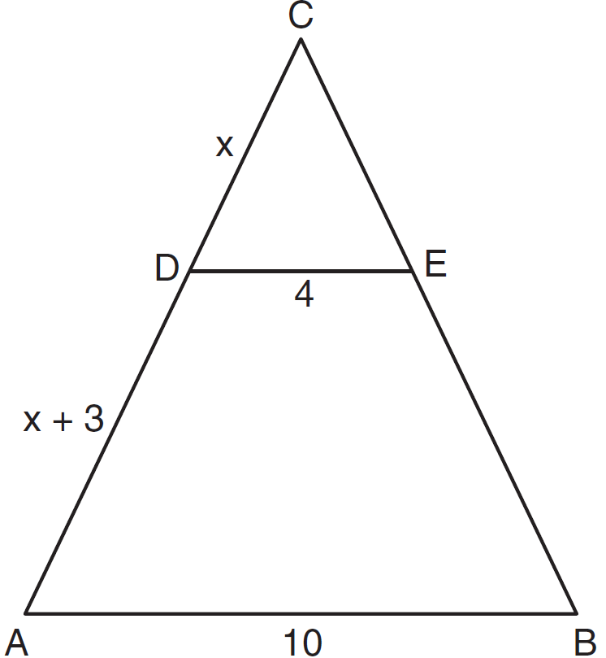

What is the value of x?
1) | 0.5
2) | 2
3) | 5.5
4) | 6

8 In the accompanying diagram of equilateral triangle ABC, and .

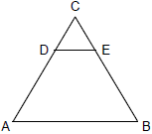

If AB is three times as long as DE, what is the perimeter of quadrilateral ABED?
1) | 20
2) | 30
3) | 35
4) | 40

9 In , point D is on , and point E is on such that . If , , and , what is the length of ?
1) | 8
2) | 9
3) | 10.5
4) | 13.5

10 In the diagram below of , with and , .

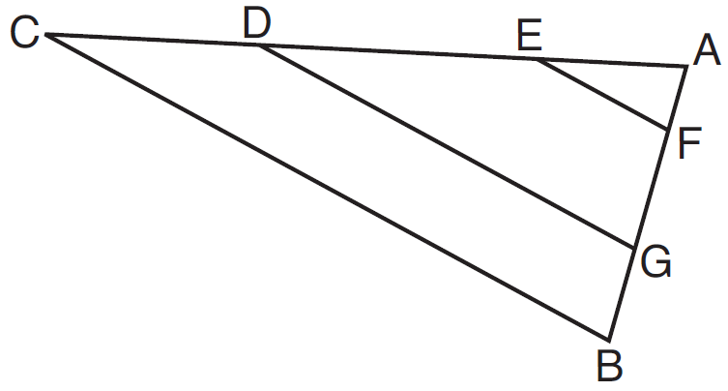

Which statement is false?
1) | 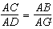
2) | 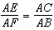
3) | 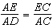
4) | 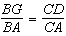

11 In the diagram below of , E is a point on and B is a point on , such that . If , , and , find the length of .

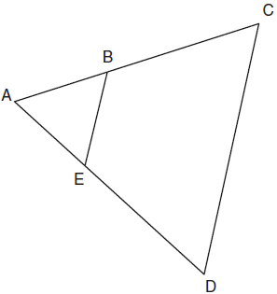

12 In the diagram below of , B is a point on and C is a point on such that , , , , and . Find the length of .

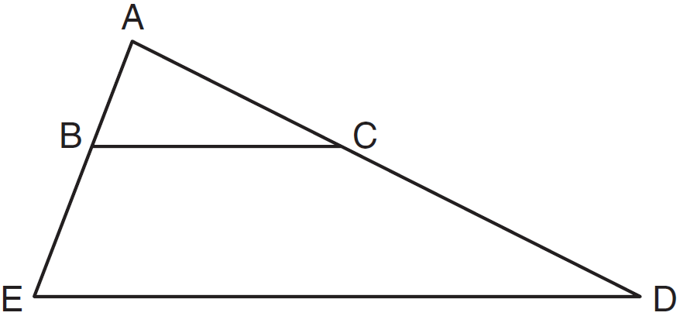

13 In the diagram below of , D is a point on , E is a point on , , inches, inches, and inches. Find, to the nearest tenth of an inch, the length of .

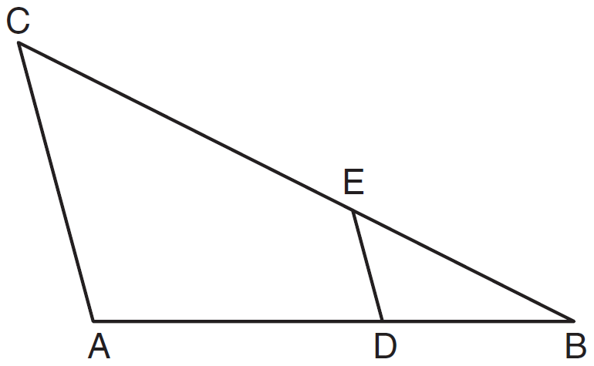

1 ANS: 2
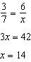

REF: 081027ge

2 ANS: 3
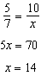

REF: 081103ge

3 ANS: 3
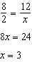. 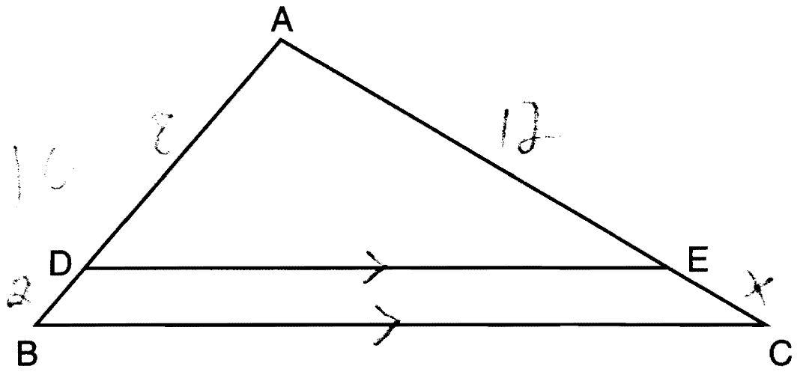

REF: 061216ge

4 ANS: 3
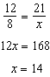

REF: 061426ge

5 ANS: 2
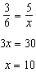

REF: 081423ge

6 ANS: 3
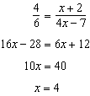

REF: 011521ge

7 ANS: 4
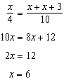

REF: 011626ge

8 ANS: 4
Because 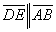, ΔCDE is an equilateral triangle as well. If DE = 5, then CD = 5 and CE = 5, and AD = 10 and BE = 10. Since AB is three times as long as DE, AB = 15.

REF: 089915a

9 ANS: 4
. 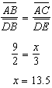

REF: 060927ge

10 ANS: 3 REF: 081507ge

11 ANS:
5. 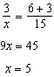

REF: 011033ge

12 ANS:
32. 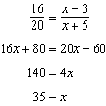.

REF: 011137ge

13 ANS:
16.7. 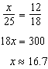

REF: 061133ge

