1 A wooden cube has an edge length of 6 centimeters and a mass of 137.8 grams. Determine the density of the cube, to the nearest thousandth. State which type of wood the cube is made of, using the density table below.

Type of Wood | Density  (g/cm³)
Pine | 0.373
Hemlock | 0.431
Elm | 0.554
Birch | 0.601
Ash | 0.638
Maple | 0.676
Oak | 0.711

2 During an experiment, the same type of bacteria is grown in two petri dishes. Petri dish A has a diameter of 51 mm and has approximately 40,000 bacteria after 1 hour. Petri dish B has a diameter of 75 mm and has approximately 72,000 bacteria after 1 hour.

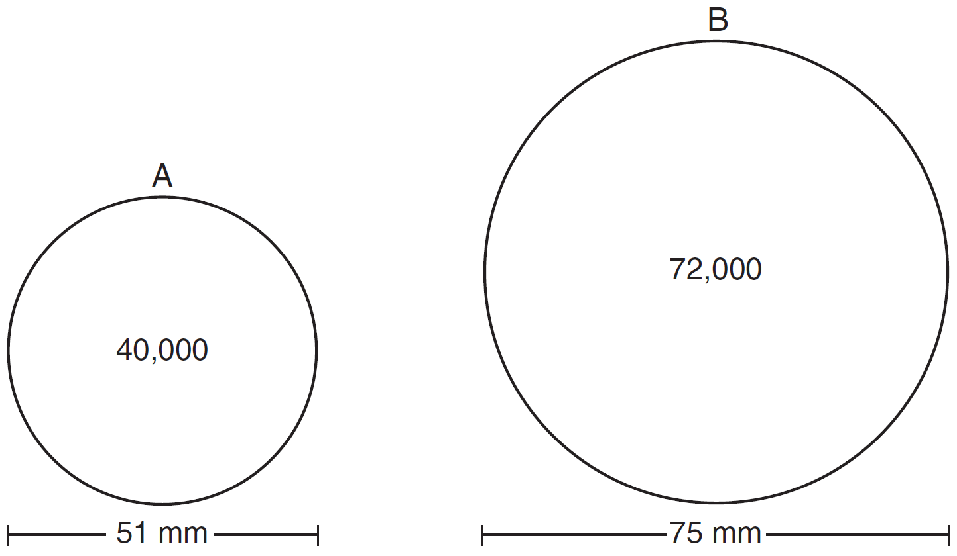

Determine and state which petri dish has the greater population density of bacteria at the end of the first hour.

3 A machinist creates a solid steel part for a wind turbine engine. The part has a volume of 1015 cubic centimeters. Steel can be purchased for $0.29 per kilogram, and has a density of 7.95 g/cm³. If the machinist makes 500 of these parts, what is the cost of the steel, to the nearest dollar?

4 A rectangular tabletop will be made of maple wood that weighs 43 pounds per cubic foot. The tabletop will have a length of eight feet, a width of three feet, and a thickness of one inch. Determine and state the weight of the tabletop, in pounds.

5 A contractor needs to purchase 500 bricks. The dimensions of each brick are 5.1 cm by 10.2 cm by 20.3 cm, and the density of each brick is . The maximum capacity of the contractor’s trailer is 900 kg. Can the trailer hold the weight of 500 bricks? Justify your answer.

6 Trees that are cut down and stripped of their branches for timber are approximately cylindrical. A timber company specializes in a certain type of tree that has a typical diameter of 50 cm and a typical height of about 10 meters. The density of the wood is 380 kilograms per cubic meter, and the wood can be sold by mass at a rate of $4.75 per kilogram. Determine and state the minimum number of whole trees that must be sold to raise at least $50,000.

7 A pyramid with a square base is made of solid glass. The pyramid has a base with a side length of 5.7 cm and a height of 7 cm. The density of the glass is 2.4 grams per cubic centimeter. Determine and state, to the nearest gram, the mass of the pyramid.

8 A candle in the shape of a right pyramid is modeled below. Each side of the square base measures 12 centimeters. The slant height of the pyramid measures 16 centimeters.

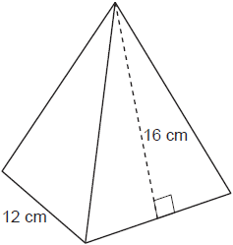

Determine and state the volume of the candle, to the nearest cubic centimeter. The wax used to make the candle weighs 0.032 ounce per cubic centimeter. Determine and state the weight of the candle, to the nearest ounce.

9 A packing box for baseballs is the shape of a rectangular prism with dimensions of . Each baseball has a diameter of 2.94 inches.

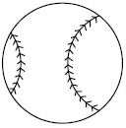

Determine and state the maximum number of baseballs that can be packed in the box if they are stacked in layers and each layer contains an equal number of baseballs. The weight of a baseball is approximately 0.025 pound per cubic inch. Determine and state, to the nearest pound, the total weight of all the baseballs in the fully packed box.

10 Pure silver has a density of 10.5 g/cm³. Samantha has a pure silver charm on her necklace in the shape of a sphere. The radius of the charm is 0.5 cm. Determine and state the mass of the charm, to the nearest tenth of a gram.

11 Ali made six solid spherical decorations out of modeling clay. Each decoration has a radius of 2.5 inches. The weight of clay is 68 pounds per cubic foot. Determine and state, to the nearest pound, the total weight of the six decorations.

12 A bakery sells hollow chocolate spheres. The larger diameter of each sphere is 4 cm. The thickness of the chocolate of each sphere is 0.5 cm. Determine and state, to the nearest tenth of a cubic centimeter, the amount of chocolate in each hollow sphere. The bakery packages 8 of them into a box. If the density of the chocolate is 1.308 g/cm³, determine and state, to the nearest gram, the total mass of the chocolate in the box.

13 Shae has recently begun kickboxing and purchased training equipment as modeled in the diagram below. The total weight of the bag, pole, and unfilled base is 270 pounds. The cylindrical base is 18 inches tall with a diameter of 20 inches. The dry sand used to fill the base weighs 95.46 lbs per cubic foot.

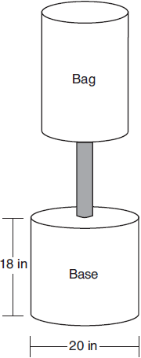

To the nearest pound, determine and state the total weight of the training equipment if the base is filled to 85% of its capacity.

14 New streetlights will be installed along a section of the highway. The posts for the streetlights will be 7.5 m tall and made of aluminum. The city can choose to buy the posts shaped like cylinders or the posts shaped like rectangular prisms. The cylindrical posts have a hollow core, with aluminum 2.5 cm thick, and an outer diameter of 53.4 cm. The rectangular-prism posts have a hollow core, with aluminum 2.5 cm thick, and a square base that measures 40 cm on each side. The density of aluminum is 2.7 g/cm3, and the cost of aluminum is $0.38 per kilogram. If all posts must be the same shape, which post design will cost the town less? How much money will be saved per streetlight post with the less expensive design?

15 Walter wants to make 100 candles in the shape of a cone for his new candle business. The mold shown below will be used to make the candles. Each mold will have a height of 8 inches and a diameter of 3 inches. To the nearest cubic inch, what will be the total volume of 100 candles?

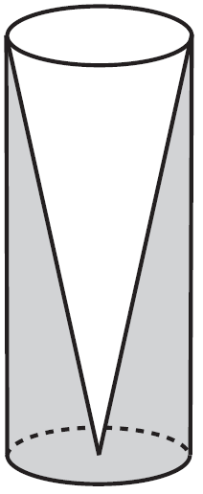

Walter goes to a hobby store to buy the wax for his candles. The wax costs $0.10 per ounce. If the weight of the wax is 0.52 ounce per cubic inch, how much will it cost Walter to buy the wax for 100 candles? If Walter spent a total of $37.83 for the molds and charges $1.95 for each candle, what is Walter's profit after selling 100 candles?

16 A snow cone consists of a paper cone completely filled with shaved ice and topped with a hemisphere of shaved ice, as shown in the diagram below. The inside diameter of both the cone and the hemisphere is 8.3 centimeters. The height of the cone is 10.2 centimeters.

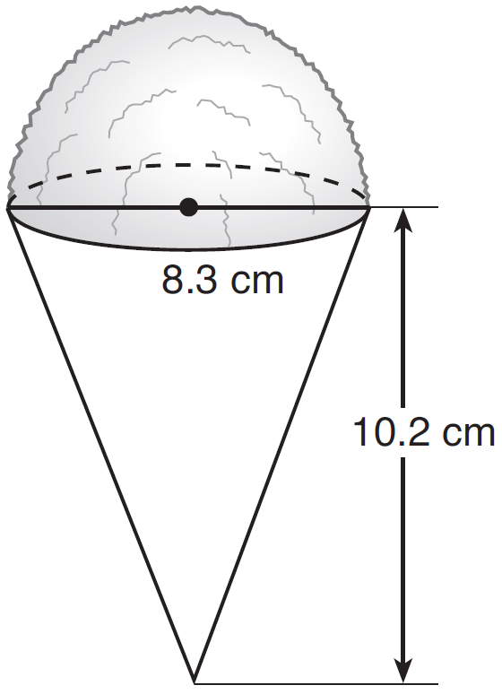

The desired density of the shaved ice is , and the cost, per kilogram, of ice is $3.83. Determine and state the cost of the ice needed to make 50 snow cones.

17 The water tower in the picture below is modeled by the two-dimensional figure beside it. The water tower is composed of a hemisphere, a cylinder, and a cone. Let C be the center of the hemisphere and let D be the center of the base of the cone.

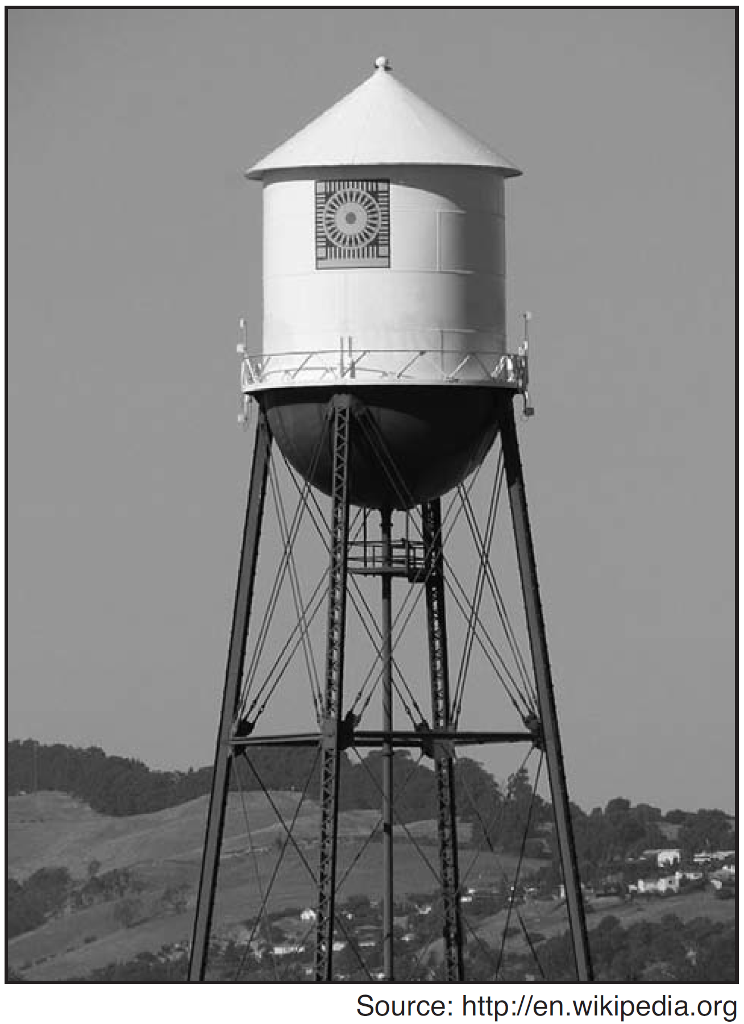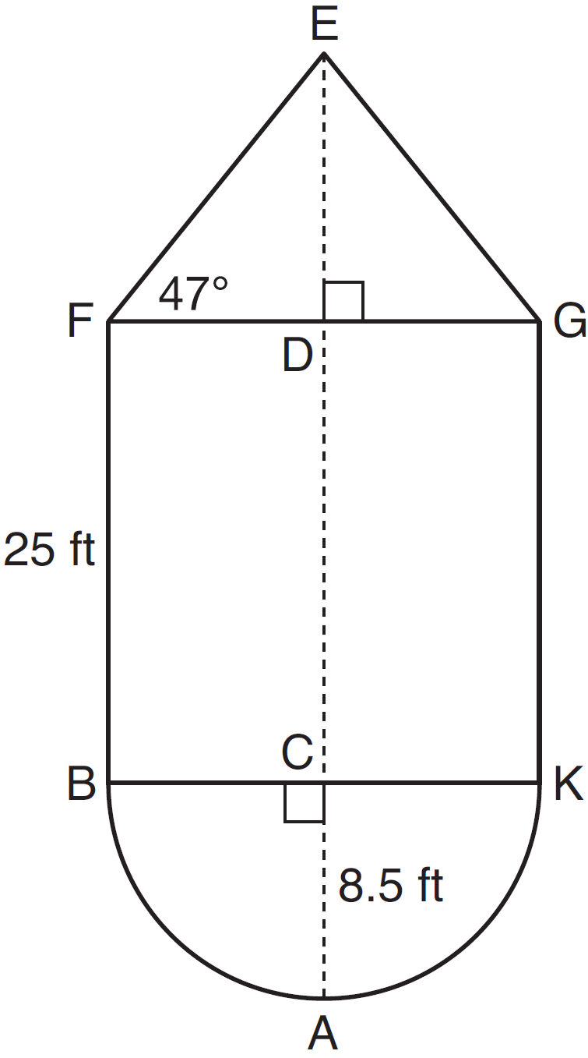

If feet, feet, and , determine and state, to the nearest cubic foot, the volume of the water tower. The water tower was constructed to hold a maximum of 400,000 pounds of water. If water weighs 62.4 pounds per cubic foot, can the water tower be filled to 85% of its volume and not exceed the weight limit? Justify your answer.
1 ANS:
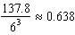 Ash

DIF: 2 REF: 081525geo

2 ANS:
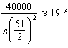 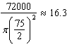 Dish A

DIF: 2 REF: 011630geo

3 ANS:
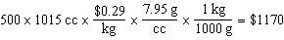

DIF: 2 REF: 011829geo

4 ANS:
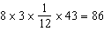

DIF: 2 REF: 012027geo

5 ANS:
No, the weight of the bricks is greater than 900 kg. . 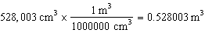. 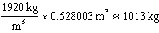.

DIF: 2 REF: fall1406geo

6 ANS:
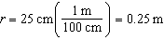 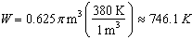 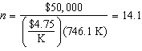 15 trees

DIF: 4 REF: spr1412geo

7 ANS:
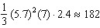

DIF: 2 REF: 082431geo

8 ANS:
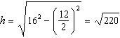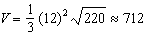

DIF: 4 REF: 012433geo

9 ANS:
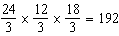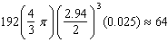

DIF: 4 REF: 082234geo

10 ANS:
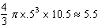

DIF: 2 REF: 012528geo

11 ANS:
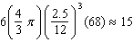

DIF: 4 REF: 082434geo

12 ANS:
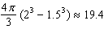

DIF: 4 REF: 081834geo

13 ANS:
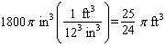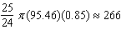

DIF: 4 REF: 061834geo

14 ANS:
C: 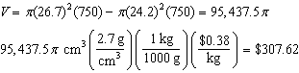
P: 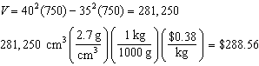
DIF: 6 REF: 011736geo

15 ANS:
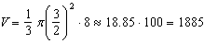
DIF: 6 REF: 081536geo

16 ANS:
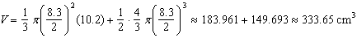
DIF: 6 REF: 081636geo

17 ANS:
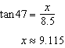 Cone: 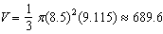 Cylinder: Hemisphere: 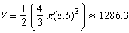 No, because , which is greater than 400,000.
DIF: 6 REF: 061535geo

