1 The table below shows the population and land area, in square miles, of four counties in New York State at the turn of the century.

County | 2000  Census Population | 2000  Land Area
Broome | 200,536 | 706.82
Dutchess | 280,150 | 801.59
Niagara | 219,846 | 522.95
Saratoga | 200,635 | 811.84

Which county had the greatest population density?
1) | Broome | 3) | Niagara
2) | Dutchess | 4) | Saratoga

2 The 2010 U.S. Census populations and population densities are shown in the table below.

State | Population Density 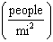 | Population in  2010
Florida | 350.6 | 18,801,310
Illinois | 231.1 | 12,830,632
New York | 411.2 | 19,378,102
Pennsylvania | 283.9 | 12,702,379

Based on the table above, which list has the states' areas, in square miles, in order from largest to smallest?
1) | Illinois, Florida, New York, Pennsylvania | 3) | New York, Florida, Pennsylvania, Illinois
2) | New York, Florida, Illinois, Pennsylvania | 4) | Pennsylvania, New York, Florida, Illinois

3 Seawater contains approximately 1.2 ounces of salt per liter on average. How many gallons of seawater, to the nearest tenth of a gallon, would contain 1 pound of salt?
1) | 3.3 | 3) | 4.7
2) | 3.5 | 4) | 13.3

4 A jewelry company makes copper heart pendants. Each heart uses 0.75 in³ of copper and there is 0.323 pound of copper per cubic inch. If copper costs $3.68 per pound, what is the total cost for 24 copper hearts?
1) | $5.81 | 3) | $66.24
2) | $21.40 | 4) | $205.08

5 A rectangular fish tank measures 24 inches long, 12 inches wide, and 16 inches high, as modeled in the diagram below.

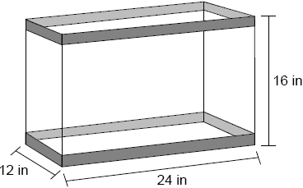

If the empty tank weighs 25 pounds and the fish tank is filled with water to a height of 14 inches, what is the approximate weight of the tank and water? [27.7 in.³=1 pound of water]
1) | 146 | 3) | 171
2) | 166 | 4) | 191

6 Lou has a solid clay brick in the shape of a rectangular prism with a length of 8 inches, a width of 3.5 inches, and a height of 2.25 inches. If the clay weighs 1.055 oz/in³, how much does Lou's brick weigh, to the nearest ounce?
1) | 66 | 3) | 63
2) | 64 | 4) | 60

7 A shipping container is in the shape of a right rectangular prism with a length of 12 feet, a width of 8.5 feet, and a height of 4 feet. The container is completely filled with contents that weigh, on average, 0.25 pound per cubic foot. What is the weight, in pounds, of the contents in the container?
1) | 1,632 | 3) | 102
2) | 408 | 4) | 92

8 The density of the American white oak tree is 752 kilograms per cubic meter. If the trunk of an American white oak tree has a circumference of 4.5 meters and the height of the trunk is 8 meters, what is the approximate number of kilograms of the trunk?
1) | 13 | 3) | 13,536
2) | 9694 | 4) | 30,456

9 The square pyramid below models a toy block made of maple wood.

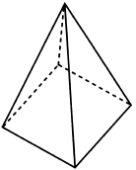

Each side of the base measures 4.5 cm and the height of the pyramid is 10 cm. If the density of maple is 0.676 g/cm³, what is the mass of the block, to the nearest tenth of a gram?
1) | 45.6 | 3) | 136.9
2) | 67.5 | 4) | 202.5

10 A regular pyramid with a square base is made of solid glass. It has a base area of 36 cm² and a height of 10 cm. If the density of glass is 2.7 grams per cubic centimeter, the mass of the pyramid, in grams, is
1) | 120 | 3) | 360
2) | 324 | 4) | 972

11 Molly wishes to make a lawn ornament in the form of a solid sphere. The clay being used to make the sphere weighs .075 pound per cubic inch. If the sphere's radius is 4 inches, what is the weight of the sphere, to the nearest pound?
1) | 34 | 3) | 15
2) | 20 | 4) | 4

12 A standard-size golf ball has a diameter of 1.680 inches. The material used to make the golf ball weighs 0.6523 ounce per cubic inch. What is the weight, to the nearest hundredth of an ounce, of one golf ball?
1) | 1.10 | 3) | 2.48
2) | 1.62 | 4) | 3.81

13 A hemispherical tank is filled with water and has a diameter of 10 feet. If water weighs 62.4 pounds per cubic foot, what is the total weight of the water in a full tank, to the nearest pound?
1) | 16,336 | 3) | 130,690
2) | 32,673 | 4) | 261,381

14 A hemispherical water tank has an inside diameter of 10 feet. If water has a density of 62.4 pounds per cubic foot, what is the weight of the water in a full tank, to the nearest pound?
1) | 16,336 | 3) | 130,690
2) | 32,673 | 4) | 261,381

1 ANS: 3
Broome: 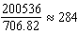 Dutchess: 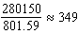 Niagara: 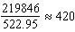 Saratoga: 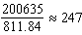

REF: 061902geo

2 ANS: 1
Illinois: 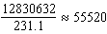 Florida: 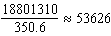 New York: 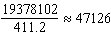 Pennsylvania: 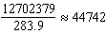

REF: 081720geo

3 ANS: 2
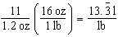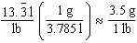

REF: 061618geo

4 ANS: 2
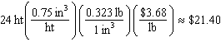

REF: 012306geo

5 ANS: 3
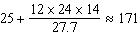

REF: 082423geo

6 ANS: 1

REF: 012014geo

7 ANS: 3
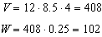

REF: 061507geo

8 ANS: 2
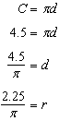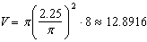

REF: 081617geo

9 ANS: 1
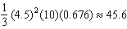

REF: 062212geo

10 ANS: 2
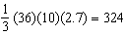

REF: 082312geo

11 ANS: 2
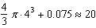

REF: 011619geo

12 ANS: 2
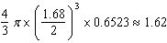

REF: 081914geo

13 ANS: 1
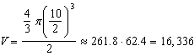

REF: 081516geo

14 ANS: 1
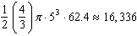

REF: 061620geo

