1 The value of x in the equation is
1) | 1
2) | 2
3) | 5
4)

2 Which value of k satisfies the equation ?
1)
2)
3)
4)

3 What is the value of b in the equation ?
1)
2)
3)
4)

4 The solution of is
1)
2)
3)
4)

5 Solve for x:
1)
2)
3)
4) | 0

6 What is the value of x in the equation ?
1) | 1
2)
3)
4)

7 What is the value of x in the equation ?
1)
2)
3)
4)

8 Solve algebraically for x:

9 Solve for x:

10 Solve for x:

11 If , what is the value of x?

12 Solve for x:

13 Solve for x:

14 Solve for x:

15 Solve for x:

16 Solve algebraically for x:

17 Solve algebraically for x:

18 Solve algebraically for x:

19 Solve for x:

20 Solve for x:

21 Solve for x:

22 Solve for x:

23 If , what is the value of x?

24 Solve algebraically for all values of x: 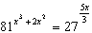
1 ANS: 2
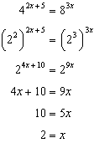.

REF: 061105a2

2 ANS: 4
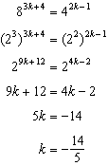.

REF: 011309a2

3 ANS: 3
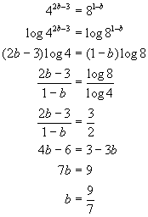. 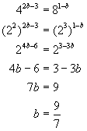. 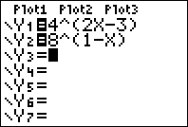. 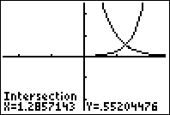. 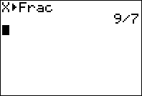

REF: 010709b

4 ANS: 1
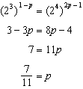

REF: 061611a2

5 ANS: 2
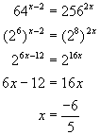. 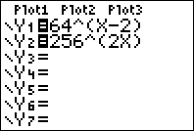. 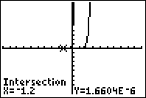. 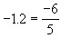

REF: fall9907b

6 ANS: 4
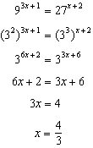.

REF: 081008a2

7 ANS: 4
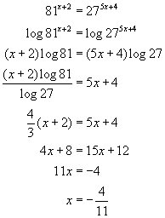. 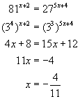. 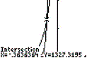. 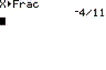

REF: 060303b

8 ANS:
2. 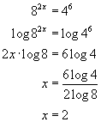. 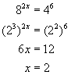. 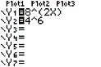. 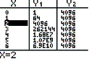

REF: 010626b

9 ANS:
1

REF: 088705siii

10 ANS:
3

REF: 069506siii

11 ANS:
3

REF: 069905siii

12 ANS:

REF: 080309siii

13 ANS:
2

REF: 089913siii

14 ANS:
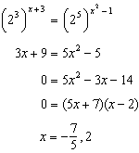

REF: 081636a2

15 ANS:
11

REF: 010409siii

16 ANS:
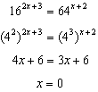

REF: 011128a2

17 ANS:
. 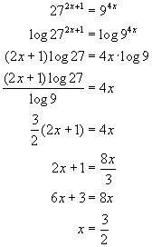. 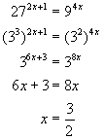. 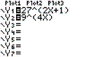. 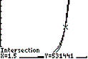

REF: 060422b

18 ANS:
4. 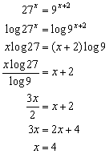. 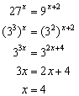. 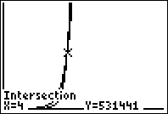. 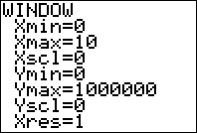

REF: 080922b

19 ANS:

REF: 068515siii

20 ANS:
2

REF: 069012siii

21 ANS:
8

REF: 019508siii

22 ANS:
3

REF: 060005siii

23 ANS:
2
REF: 080106siii

24 ANS:
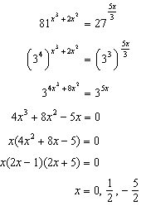
REF: 061239a2

