1 In the function , the minimum value occurs when x is
1)
2) | 2
3)
4) | 4

2 If Lylah completes the square for in order to find the minimum, she must write in the general form . What is the value of a for ?
1) | 6
2)
3) | 12
4)

3 Which equation is equivalent to ?
1)
2)
3)
4)

4 The function can be written in vertex form as
1)
2)
3)
4)

5 Which equation is equivalent to ?
1)
2)
3)
4)

6 Which equation and ordered pair represent the correct vertex form and vertex for ?
1)
2)
3)
4)

7 The graph of a quadratic function is shown below.

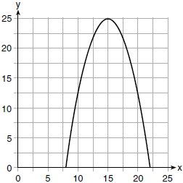

An equation that represents the function could be
1) | 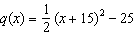
2) | 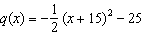
3) | 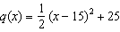
4) | 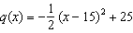

8 Determine and state the vertex of using the method of completing the square.

9 Use the method of completing the square to determine the vertex of . State the coordinates of the vertex.

10 a) Given the function , state whether the vertex represents a maximum or minimum point for the function. Explain your answer.
b) Rewrite in vertex form by completing the square.
1 ANS: 2 REF: 011601ai

2 ANS: 1
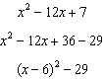

REF: 081520ai

3 ANS: 1
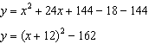

REF: 081911ai

4 ANS: 3
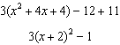

REF: 081621ai

5 ANS: 4
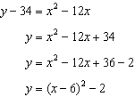

REF: 011607ai

6 ANS: 3
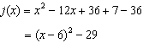

REF: 061616ai

7 ANS: 4
Vertex , point 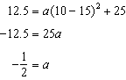

REF: 061716ai

8 ANS:

REF: 061932ai

9 ANS:

REF: 062130ai

10 ANS:
The vertex represents a maximum since . 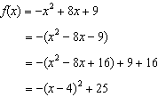

REF: 011536ai

