1 For which value of x is undefined?
1) |  | 3)
2) |  | 4)

2 The graph of lies in Quadrant(s)
1) | I and II | 3) | III and IV
2) | II and III | 4) | I and IV

3 The cells of a particular organism increase logarithmically. If g represents cell growth and h represents time, in hours, which graph best represents the growth pattern of the cells of this organism?
1) | 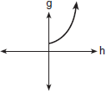 | 3) | 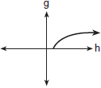
2) | 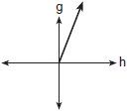 | 4) | 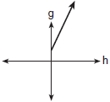

4 Which graph represents the function ?
1) | 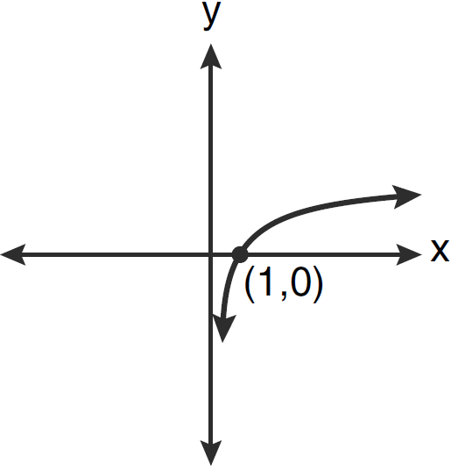 | 3) | 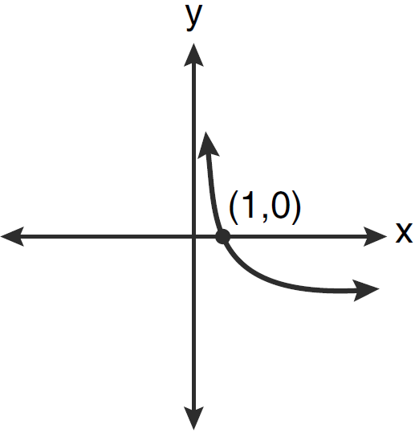
2) | 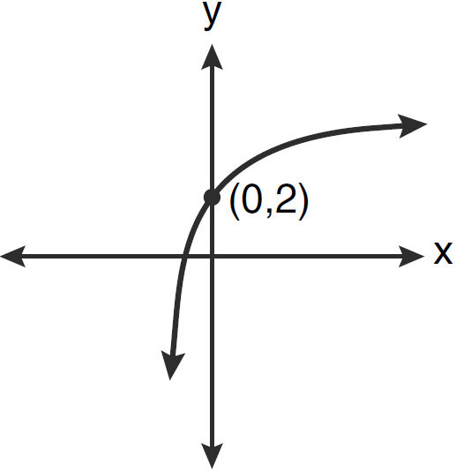 | 4) | 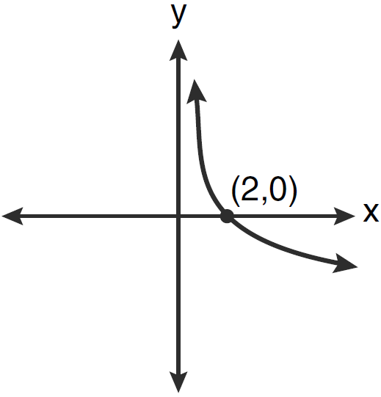

5 For what value of k will the graph of contain the point ?

6 Complete the table below for the values of y for the equation .

x |  |  | 1 | 2 | 4
y

7 A hotel finds that its total annual revenue and the number of rooms occupied daily by guests can best be modeled by the function , where R is the total annual revenue, in millions of dollars, and n is the number of rooms occupied daily by guests. The hotel needs an annual revenue of $12 million to be profitable. Graph the function on the accompanying grid over the interval . Calculate the minimum number of rooms that must be occupied daily to be profitable.



1 ANS: 1 REF: 060301b

2 ANS: 4 REF: 018535siii

3 ANS: 3 REF: 010420b

4 ANS: 1 REF: 061211a2

5 ANS:
0

REF: 088508siii

6 ANS:

x |  |  | 1 | 2 | 4
y | -2 | -1 | 0 | 1 | 2

REF: 019742siii

7 ANS:
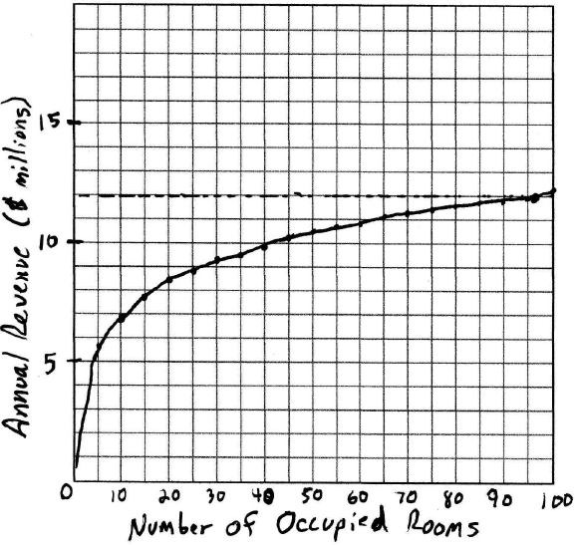 96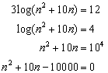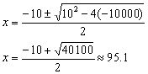. 96 rooms must be occupied. The other root is negative. 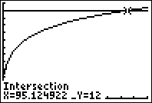

REF: 080530b

