1 The table below shows the number of hours of daylight on the first day of each month in Rochester, NY.

Month | Hours of Daylight
Jan. | 9.4
Feb. | 10.6
March | 11.9
April | 13.9
May | 14.7
June | 15.4
July | 15.1
Aug. | 13.9
Sept. | 12.5
Oct. | 11.1
Nov. | 9.7
Dec. | 9.0

Given the data, what is the average rate of change in hours of daylight per month from January 1st to April 1st? Interpret what this means in the context of the problem.

2 The function 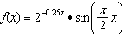 represents a damped sound wave function. What is the average rate of change for this function on the interval , to the nearest hundredth?
1) |  | 3)
2) |  | 4) | 3.36

3 The average monthly high temperature in Buffalo, in degrees Fahrenheit, can be modeled by the function , where t is the month number . State, to the nearest tenth, the average monthly rate of temperature change between August and November. Explain its meaning in the given context.

4 The monthly high temperature (ºF) in Buffalo, New York can be modeled by , where m is the number of the month and . Find the average rate of change in the monthly high temperature between June and October, to the nearest hundredth. Explain what this value represents in the given context.
1 ANS:
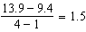 The average rate of change in the number of hours of daylight from January 1-April 1 is 1.5.

REF: 061925aii

2 ANS: 3
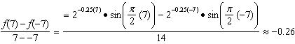

REF: 061721aii

3 ANS:
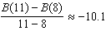 The average monthly high temperature decreases 10.1º each month from August to November.

REF: 011930aii

4 ANS:
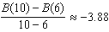. The average monthly high temperature decreases about 4º each month from June and October.

REF: 012336aii

