1 If where , then the inverse of the function is
1) |  | 3)
2) |  | 4)

2 The inverse of a function is a logarithmic function in the form . Which equation represents the original function?
1) |  | 3)
2) |  | 4)

3 What is the inverse of the function ?
1) |  | 3)
2) |  | 4)

4 What is the inverse of the function ?
1) |  | 3)
2) |  | 4)

5 The graph of is shown below. Which graph represents ?
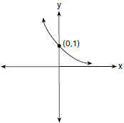
1) | 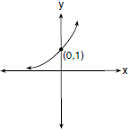 | 3) | 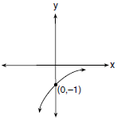
2) | 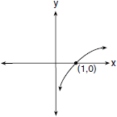 | 4) | 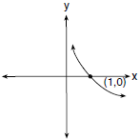

6 Which sketch shows the inverse of , where ?
1) | 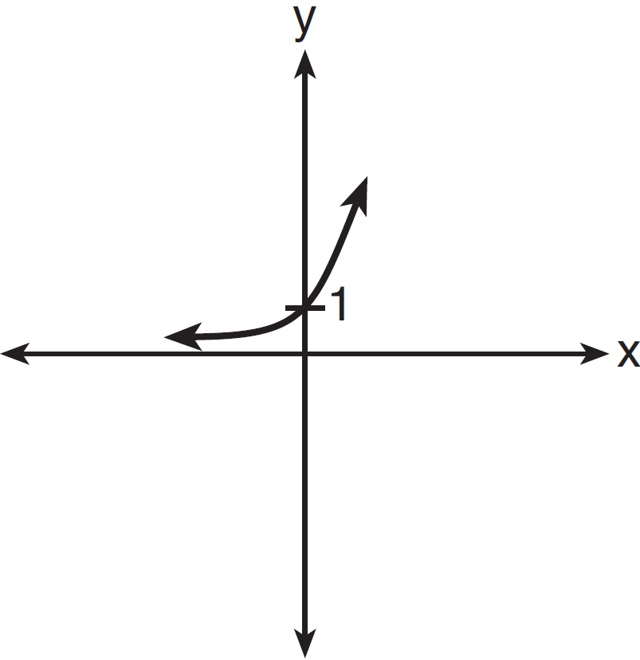 | 3) | 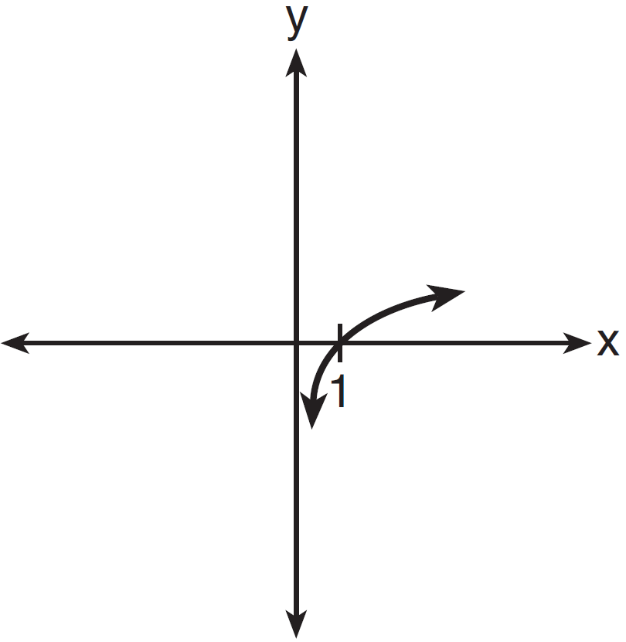
2) | 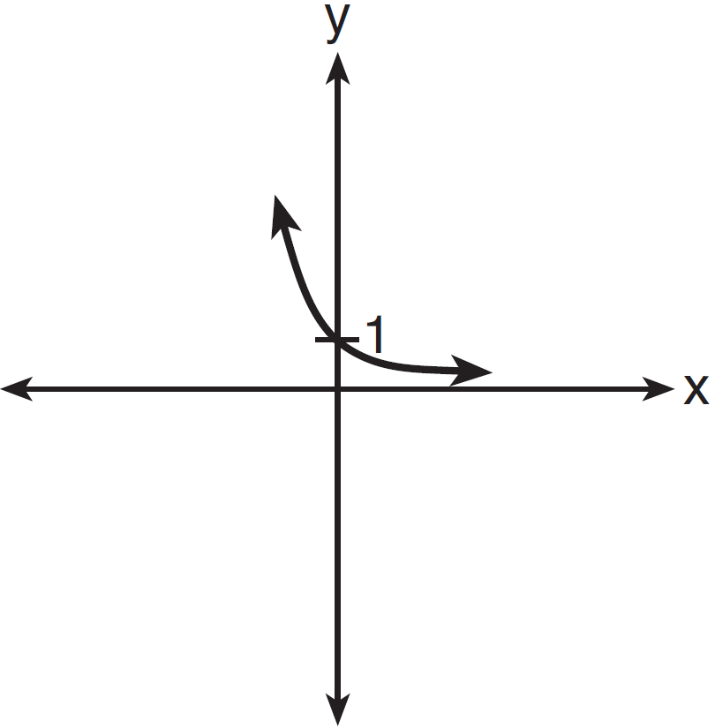 | 4) | 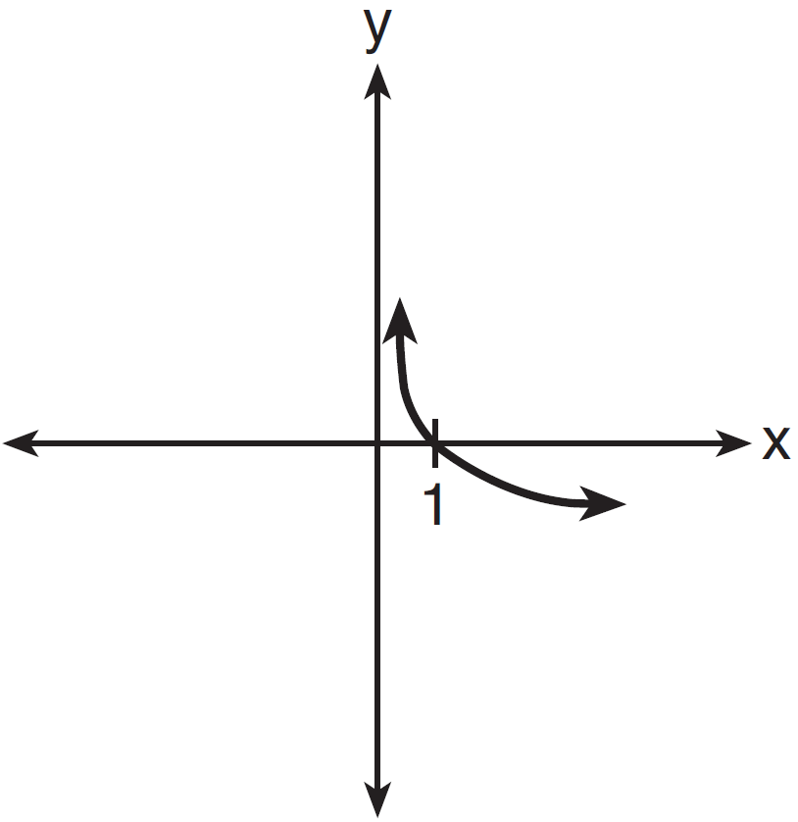

7 If a function is defined by the equation , which graph represents the inverse of this function?
1) | 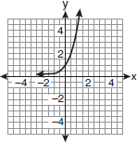 | 3) | 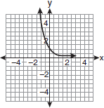
2) | 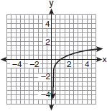 | 4) | 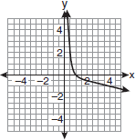

8 Which sketch best represents the graph of ?
1) | 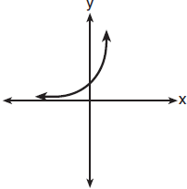 | 3) | 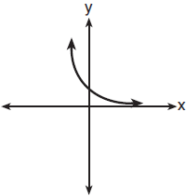
2) | 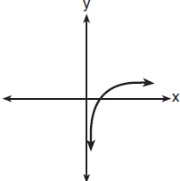 | 4) | 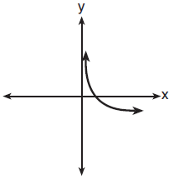

9 Which two functions are inverse functions of each other?
1) | and | 3) | and
2) | and | 4) | and 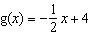

10 Which equation defines a function whose inverse is not a function?
1) |  | 3)
2) |  | 4)

11 Consider the function . Is an even function? Justify your answer. Write an equation for , the function that results after is shifted up 5 units. Write an equation for , the inverse of .

12 Sketch the graph of the functions and . Considering the graphs, describe the relationship between f(x) and g(x). Specify the domain and the range of g.

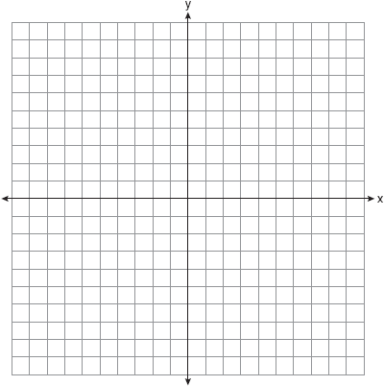

13 Sketch below the graph of . On the same set of axes, sketch the graph of .

14 Sketch and label the graph of the equation for all values of x in the interval . On the same set of axes, reflect the graph drawn in the line , and label it c. What is the equation of c?

15 Sketch and label the graph of .

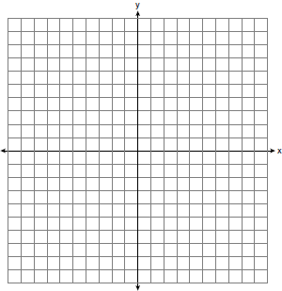

The graph of is subject to each of these transformations:
(1) reflection in the y-axis
(2) reflection in the line
(3) translation:
Next to the appropriate numeral below, write the letter of the equation, chosen from the list below, that best described the image of under each of the numbered transformations.
Equations
(a)
(b)
(c)
(d)

(1)
(2)
(3)

1 ANS: 3 REF: 011917aii

2 ANS: 1
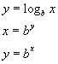

REF: 060115b

3 ANS: 3 REF: 011708aii

4 ANS: 2 REF: 061521a2

5 ANS: 4 REF: 011727a2

6 ANS: 3 REF: 011422a2

7 ANS: 2

REF: fall0916a2

8 ANS: 2 REF: 081816aii

9 ANS: 3 REF: 081027a2

10 ANS: 1 REF: 068932siii

11 ANS:
No, because 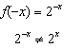 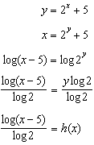

REF: 082435aii

12 ANS:
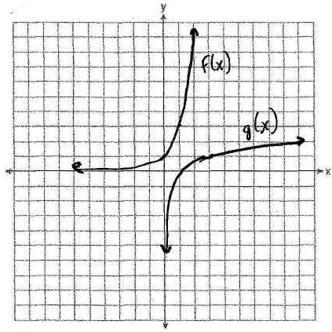 f(x) and g(x) are inverses of each other. The domain of g is the positive reals and the range of g is the reals.

REF: fall9927b

13 ANS:
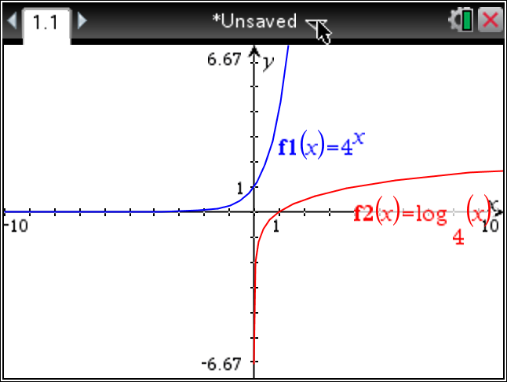

REF: 069039siii

14 ANS:
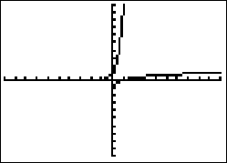,

REF: 019442siii

15 ANS:
c, a, d

REF: 088539siii

