1 Which recursively defined function has a first term equal to 10 and a common difference of 4?
1) | 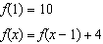
2) | 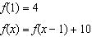
3) | 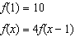
4) | 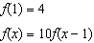

2 Which function defines the sequence , where ?
1)
2)
3)
4)

3 Given , which function can be used to generate the sequence ?
1)
2)
3)
4)

4 If the pattern below continues, which equation(s) is a recursive formula that represents the number of squares in this sequence?

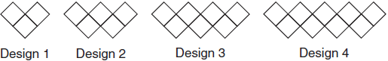
1)
2)
3) | 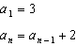
4) | 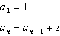

5 Given the pattern below, which recursive formula represents the number of triangles in this sequence?

1)
2)
3) | 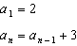
4)

6 A sunflower is 3 inches tall at week 0 and grows 2 inches each week. Which function(s) shown below can be used to determine the height, , of the sunflower in n weeks?
I.
II.
III.
1) | I and II
2) | II, only
3) | III, only
4) | I and III

1 ANS: 1 REF: 081514ai

2 ANS: 1 REF: 081610ai

3 ANS: 3 REF: 061720aii

4 ANS: 3 REF: 011818ai

5 ANS: 4 REF: 062121ai

6 ANS: 4 REF: 061421ai

