1 After examining the functions and over the interval , Lexi determined that the correct number of solutions to the equation is
1) | 1 | 3) | 3
2) | 2 | 4) | 0

2 For which approximate value(s) of x will ?
1) |  | 3)
2) |  | 4) | , only

3 For which values of x, rounded to the nearest hundredth, will ?
1) | 2.29 and 3.63 | 3) | 2.84 and 3.17
2) | 2.37 and 3.54 | 4) | 2.92 and 3.06

4 If and , then what is the solution for ?
1) | 1.65 | 3) | 5.62
2) | 3.14 | 4) | no solution

5 Given and , what is a solution of to the nearest tenth?
1) | 1.1 | 3) | 3.9
2) | 3.7 | 4) | 4.3

6 Website popularity ratings are often determined using models that incorporate the number of visits per week a website receives. One model for ranking websites is , where x is the number of visits per week in thousands and is the website's popularity rating. According to this model, if a website is visited 16,000 times in one week, what is its popularity rating, rounded to the nearest tenth? Graph on the axes below.

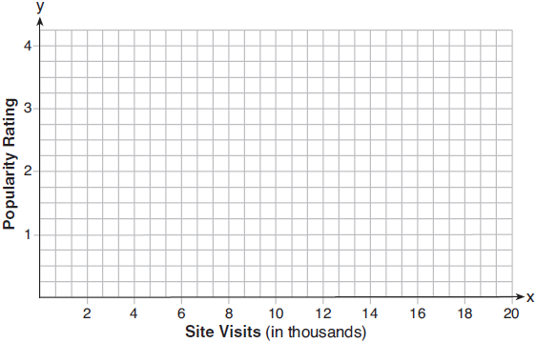

An alternative rating model is represented by 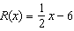, where x is the number of visits per week in thousands. Graph on the same set of axes. For what number of weekly visits will the two models provide the same rating?
1 ANS: 2
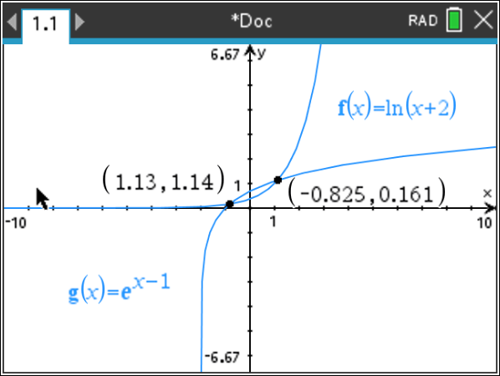

REF: 081920aii

2 ANS: 3
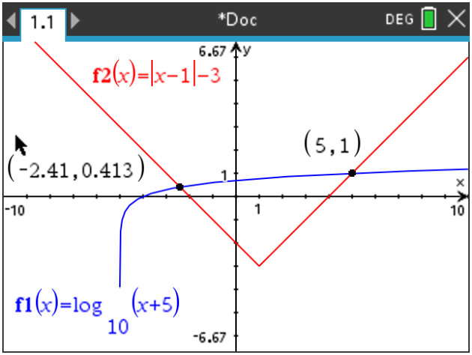

REF: 012317aii

3 ANS: 1 REF: 011814aii

4 ANS: 3 REF: 081819aii

5 ANS: 2
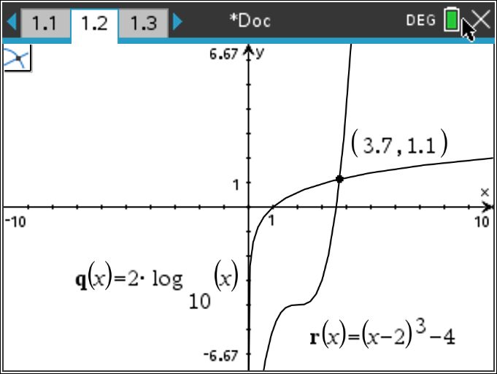

REF: 082417aii

6 ANS:
, 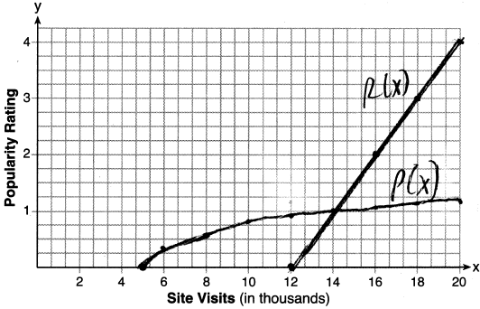, 14000

REF: 061837aii

