1
If , then x is equivalent to
1) | 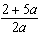
2) | 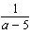
3) | 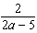
4)

2 When solved for x in terms of a, the solution to the equation is
1)
2) | 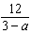
3)
4) | 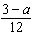

3 When the equation is solved for x in terms of a, and , the result is
1)
2)
3)
4)

4 If , what is x expressed in terms of a and b?
1)
2)
3) | 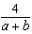
4) | 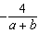

5 If , then x equals
1) | a
2)
3)
4)

6 If , then x is equivalent to
1)
2)
3)
4)

7 When the equation 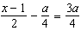 is solved for x in terms of a, the solution is
1) | 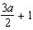
2)
3) | 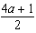
4)

8 Solve the equation below for x in terms of a.
1 ANS: 3
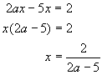

REF: 010421a

2 ANS: 2
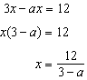

REF: 062422ai

3 ANS: 2
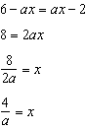

REF: 082420ai

4 ANS: 3
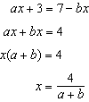

REF: 081426ia

5 ANS: 4
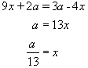

REF: 010011a

6 ANS: 4
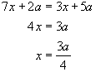

REF: 060513a

7 ANS: 4
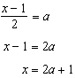

REF: 062223ai

8 ANS:
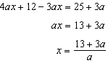

REF: 081632ai

