1 The expression 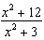 can be rewritten as
1) 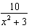 2) 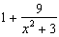 3) 4) 4

2 The expression 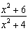 is equivalent to
1) 2) 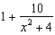 3) 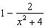 4) 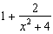

3 The expression 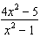 is equivalent to
1) 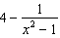 2) 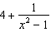 3) 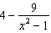 4) 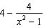

4 The expression 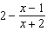 is equivalent to
1) 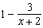 2) 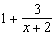 3) 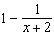 4) 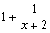

5 Algebraically prove that 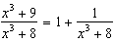, where .
1 ANS: 2
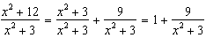

REF: 062218aii

2 ANS: 4
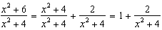

REF: 082321aii

3 ANS: 1
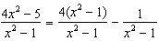

REF: 012510aii

4 ANS: 2
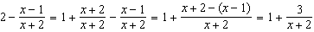

REF: 081907aii

5 ANS:
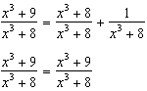

REF: 061631aii

