B – Graphs and Statistics, Lesson 2, Frequency Tables (r. 2018)

GRAPHS AND STATISTICS
Frequency Tables
Common Core Standard  S-ID.B.5 Summarize categorical data for two categories in two-way frequency tables. Interpret relative frequencies in the context of the data (including joint, marginal, and conditional relative frequencies). Recognize possible associations and trends in the data. | Next Generation Standard  AI-S.ID.5 Summarize categorical data for two categories in two-way frequency tables. Interpret relative frequencies in the context of the data (including joint, marginal, and conditional relative frequencies). Recognize possible associations and trends in the data.

Overview of Lesson
Teacher Centered Introduction  Overview of Lesson  - activate students’ prior knowledge  - vocabulary  - learning objective(s)  - big ideas: direct instruction  - modeling | Student Centered Activities  guided practice ⬅Teacher: anticipates, monitors, selects, sequences, and connects student work  - developing essential skills  - Regents exam questions  - formative assessment assignment (exit slip, explain the math, or journal entry)

LEARNING OBJECTIVES
Students will be able to:
- Complete a two-way frequency table.
- Calculate the percentage of data elements in a cell, row, or column of a two-way frequency table.

VOCABULARY

univariate
bivariate
frequency table
two-way frequency table
percentage
percent

BIG IDEAS

frequency table: A table that shows the observed number or frequency for a single number or range of numbers in a set of univariate data.  Example:  Interval Tally Frequency  1-5 I 6  6-10 II 7  11-15 II 2 | two-way frequency table: A table that shows the observed number or frequency for two variables in a set of bivariate data, the rows indicating one category and the columns indicating the other category.  Example:  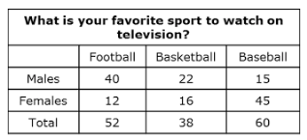

Calculating Percents
To calculate what percent A is of B, you simply divide A by B, then take that number and move the decimal place two spaces to the right.
Example: To find what percent 3 is of 4, simply divided 3 by 4, then take .75 and move the decimal two spaces to the right. The answer is 75%.
You can also use proportions. To find what percent 3 is of 4, set up the proportion

DEVELOPING ESSENTIAL SKILLS
- Organize Data
The senior spirit committee sold hot dogs, pizza, water, and soda at soccer games to raise money for the prom. 400 sales were made. They sold 200 sodas, 150 bottles of water, 158 hot dogs, and 182 pizzas. 50 students who bought hot dogs also bought sodas, and 58 students who bought pizzas also bought bottles of water. 30 students bought soda, but no food; and 46 students bought hot dogs, but no drink. Organize this data in a two-way frequency table.
Concession Stand Sales
 | Soda | Water | No Drink | Total
Hot Dog | 50 | 62 | 46 | 158
Pizza | 120 | 58 | 4 | 182
No Food | 30 | 30 | 0 | 60
Total | 200 | 150 | 50 | 400

- Calculate Percentages
Calculate the percent of sales in each cell of your two-way frequency table to the nearest tenth of a percent.
Concession Stand Sales
 | Soda | Water | No Drink | Total
Hot Dog | 12.5% | 15.5% | 11.5% | 39.5%
Pizza | 30% | 14.5% | 1% | 45.5%
No Food | 7.5% | 7.5% | 0% | 15%
Total | 50% | 37.5% | 12.5% | 100%

REGENTS EXAM QUESTIONS
S.ID.B.5: Frequency Tables

12) The school newspaper surveyed the student body for an article about club membership. The table below shows the number of students in each grade level who belong to one or more clubs.
 | 1 Club | 2 Clubs | 3 or More Clubs
9th | 90 | 33 | 12
10th | 125 | 12 | 15
11th | 87 | 22 | 18
12th | 75 | 27 | 23

If there are 180 students in ninth grade, what percentage of the ninth grade students belong to more than one club?

13) A survey of 100 students was taken. It was found that 60 students watched sports, and 34 of these students did not like pop music. Of the students who did not watch sports, 70% liked pop music. Complete the two-way frequency table.

 | Watch Sports | Don’t Watch Sports | Total
Like Pop
Don’t Like Pop
Total

14) A statistics class surveyed some students during one lunch period to obtain opinions about television programming preferences. The results of the survey are summarized in the table below.

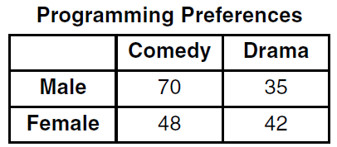

Based on the sample, predict how many of the school's 351 males would prefer comedy. Justify your answer.

15) A public opinion poll was taken to explore the relationship between age and support for a candidate in an election. The results of the poll are summarized in the table below.

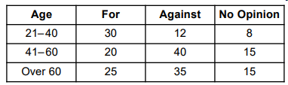

What percent of the 21-40 age group was for the candidate?
1) | 15 | 3) | 40
2) | 25 | 4) | 60

16) A radio station did a survey to determine what kind of music to play by taking a sample of middle school, high school, and college students. They were asked which of three different types of music they prefer on the radio: hip-hop, alternative, or classic rock. The results are summarized in the table below.

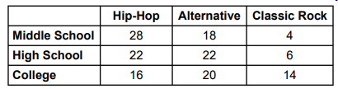

What percentage of college students prefer classic rock?
1) | 14% | 3) | 33%
2) | 28% | 4) | 58%

17) Students were asked to name their favorite sport from a list of basketball, soccer, or tennis. The results are shown in the table below.

 | Basketball | Soccer | Tennis
Girls | 42 | 58 | 20
Boys | 84 | 41 | 5

What percentage of the students chose soccer as their favorite sport?
1) | 39.6% | 3) | 50.4%
2) | 41.4% | 4) | 58.6%

SOLUTIONS

12) ANS:
25%
Strategy: Use data from the table and information from the problem to calculate a percentage.
STEP 1. Determine the total number of students in the ninth grade who are in 2 or more clubs (33+12).
STEP 2. Divide by the total number of students in the ninth grade (180).
STEP 3. Convert the decimal to a percentage
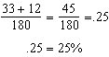

PTS: 2 NAT: S.ID.B.5 TOP: Frequency Histograms, Bar Graphs and Tables

13) ANS:
Step 1. Fill in the known information from the problem.
 | Watch Sports | Dont Watch Sports | Total
Like Pop
Don’t Like Pop | 34
Total | 60 |  | 100
Step 2. Complete additional cells using given information.
 | Watch Sports | Dont Watch Sports | Total
Like Pop | 26
Don’t Like Pop | 34
Total | 60 | 40 | 100
Step 3. Complete the “Don’t Watch Sports - Like Pop” cell using information from the problem that states “Of the students who did not watch sports, 70% liked pop music.” Compute .
 | Watch Sports | Dont Watch Sports | Total
Like Pop | 26 | 28
Don’t Like Pop | 34
Total | 60 | 40 | 100
Step 4. Complete the reamining cells.
 | Watch Sports | Dont Watch Sports | Total
Like Pop | 26 | 28 | 54
Don’t Like Pop | 34 | 12 | 46
Total | 60 | 40 | 100

PTS: 2 NAT: S.ID.B.5 TOP: Frequency Tables

14) ANS:
234 of the school’s 351 males prefer comedy based on the sample.
Step 1. Understand that the table is only a sample of the population, and the population of males is 351. Assume that the sample was not biased.
Step 2. Strategy. Determine the percent (or fraction) of the males in the sample that prefer comedy, then apply that percent to the total population.
Step 3. Execution of strategy.
males were surveyed.
Based on the sample, 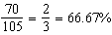 of the males preferred comedy.
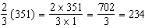.
Step 4. Does it make sense. Yes, if of the males in the sample prefer comedy, we can predict that of the males in the population will prefer comedy.

PTS: 2 NAT: S.ID.B.5 TOP: Frequency Tables

15) ANS: 4
Step 1. Understand that the problem is only interested in the percent for the candidate in the 21-40 age group. The bottom two rows of the table are not relevant to the problem.
Step 2. Strategy. Determine the total number of poll responses in the 21-40 age group and what percentage of these responses were for the candidate.
Step 3. Execute the strategy.
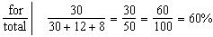
Step 4. Does it make sense? Yes. We know that 30 responses were for the candidate. Choices a), b), and c) are wrong because: a) 15% of 50 is ; b) 25% of 50 is ; and c) 40% of 50 is . Choice d) is the only correct answer because 60% of 50 is .

PTS: 2 NAT: S.ID.B.5 TOP: Frequency Tables

16) ANS: 2
Understand the Problem:
The questions asks what percentage of college students prefer classic rock. The information in the table about middle school and high school students is not important.

The total number of college students is 16 + 20 + 14 = 50.
14 out of 50 college students prefer classic rock.

Strategy: Write and solve a proportion to convert 14 out of 50 to a percentage.
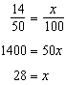

PTS: 2 NAT: S.ID.B.5 TOP: Frequency Tables

17) ANS: 1
Strategy:
STEP 1. Find the total numbers of students who like each sport.
Basketball: A total of 126 boys and girls chose basketball.
Soccer: A total of 99 boys and girls chose soccer.
Tennis: A total of 25 boys and girls chose tennis.
STEP 2. Find the total number of students in the entire table.
Total basketball plus total soccer plus total tennis = 250
STEP 3. Write a proportion to find the percentage of students who chose soccer.
STEP 4. Solve the proportion for x
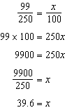

PTS: 2 NAT: S.ID.B.5 TOP: Frequency Tables

