**D – Rate, Lesson 1, Conversions (r. 2018)**

RATE

Conversions

|  |  |
| --- | --- |
| **Common Core Standard**  **N.Q.A.1** Use units as a way to understand problems and to guide the solution of multi-step problems; choose and interpret units consistently in formulas; choose and interpret the scale and the origin in graphs and data displays. | **Next Generation Standard**  **AI-N.Q.1** Select quantities and use units as a way to:  i) interpret and guide the solution of multi-step problems; ii) choose and interpret units consistently in formulas; and iii) choose and interpret the scale and the origin in graphs and data displays. |

**LEARNING OBJECTIVES**

Students will be able to:

1. Understand units as essential to understanding and interpreting graphs.
2. Understand units as essential to problem solving.
3. Use and convert units when problem solving.

**Overview of Lesson**

|  |  |
| --- | --- |
| **Teacher Centered Introduction**  **Overview of Lesson**  **- activate students’ prior knowledge**  **- vocabulary**  **- learning objective(s)**  **- big ideas: direct instruction**  **- modeling** | **Student Centered Activities**  **guided practice ⬅Teacher: anticipates, monitors, selects, sequences, and connects student work**  **- developing essential skills**  **- Regents exam questions**  **- formative assessment assignment (exit slip, explain the math, or journal entry)** |

**VOCABULARY**

cancellation

convert / conversion

cross-multiplication

denominator

numerator

per

proportion

rate

ratio

scale

**BIG IDEAS**

**Big Units - Small Units**

As a general rule, big units are used to measure big things and small units are used to measure small things.

For example,

* the distance from New York City to San Francisco is a big distance, so it would be measured in big units, like miles or kilometers.
* the distance from a student’s elbow to the tip of his or her finger is a small distance, so it would be measured in small units, like inches or centimeters.

Since both big and small units can be used to measure the same thing, it is sometimes desirable to change from one unit of measurement to another. When different size units are used to measure the same thing:

* Changing from a big unit to a small unit involves multiplication.
* Changing from a small unit to a big unit involves division.

For example, 1 foot = 12 inches. The following diagram shows the mathematical operations involved in converting feet to inches and inches to feet.



**Ratios, Rates, and Proportions**

A **ratio** is a simple comparison of two numbers, such as 12:1 or 1:12.

A **rate** is a ratio that includes units, such as , which is read as “Twelve inches *per* foot,” or , which is read as “One foot *per* twelve inches.” The vinculum (fraction bar) is read as the word “*per*.”

A **unit rate** is a rate with a denominator of 1 unit. is a unit rate. is *not* a unit rate.

NOTE: When working with problems that involve rates, it is common practice to omit the unit labels and manipulate ratios instead of rates. While this increases computational efficiency, it can lead to conceptual errors. While and express the same mathematical relationship between inches and feet, this is because they are rates – not ratios. When the units are omitted, these rates become the ratios, and , which are *not* the same mathematical relationship. After a long series of computations with ratios, it is easy to mislabel the units. Therefore, a good practice is to always make notes about the units.

A **proportion** is an equation with two ratios and an equal sign between them. For example, is a proportion.

* Every proportion has four parts: two numerators and two denominators.
* When three of the four parts in a proportion are given, it is possible to solve for the fourth part using **cross-multiplication**. An example of using cross-multiplication to solve a proportion in which one part is unknown follows:

|  |  |  |  |
| --- | --- | --- | --- |
| Notes | Left Expression | Sign | Right Expression |
| Given |  | = |  |
| Cross Multiply |  | = |  |
| Solution | x | = | 16 |

* When using proportions to solve unit conversion problems, it is important to label the units to avoid conceptual errors. This is done by simply adding units notation when setting up the proportion. In the following example, the rate of 4 quarts per 1 gallon is used to find the number of quarts in 4 gallons. All the numerators are gallon units and all the denominators are quarts units. Since the x is in a denominator, the answer will be in quarts units.

|  |  |  |  |
| --- | --- | --- | --- |
| Notes | Left Expression | Sign | Right Expression |
| Given |  | = |  |
| Cross Multiply |  | = |  |
| Solution | x | = | 16 *quarts* |

**Cancellation of Units (Factor-Unit Conversion)**{\displaystyle {\frac {10\ {\cancel {\text{mile}}}}{1\ {\cancel {\text{hour}}}}}\times {\frac {1609.344{\text{ meter}}}{1\ {\cancel {\text{mile}}}}}\times {\frac {1\ {\cancel {\text{hour}}}}{3600{\text{ second}}}}=4.4704\ {\frac {\text{meter}}{\text{second}}}.}

**Cancellation** can be used to simplify units within a single expression. The general approach is to consider the units as factors, which can be cancelled using the same rules that are used for cancellation of fractions.

In the following example, cancellation is to find the number of seconds in a year.



Another example of using cancellation is converting 10 miles per hour to meters per second.



**Units and Graphs**

A graph is one view of the relationship between two variables. The variables are measured in specific units, which are very important to understanding the meaning of the graph.

Example: The two graphs below are from different Regents problems. The units for the *x*-axis both measure time, but the units are different. The units for the y-axis are totally different kinds of measurements. The different units used require different interpretations of the two graphs.

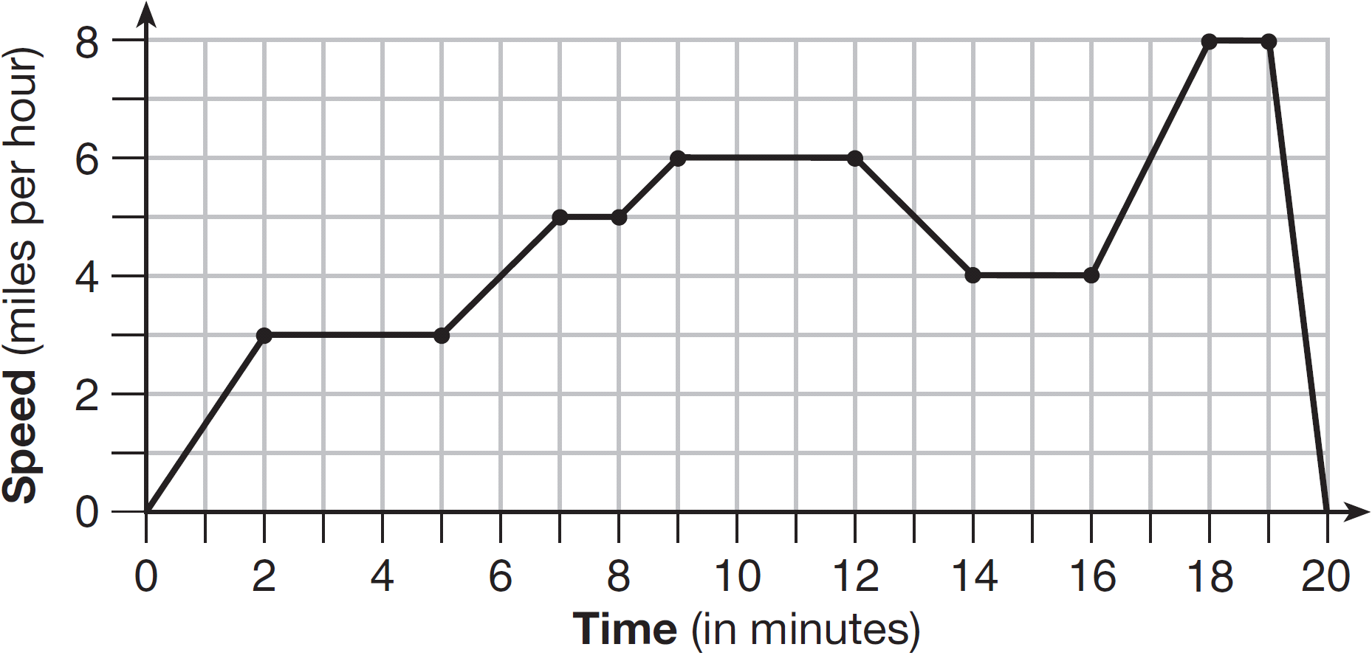

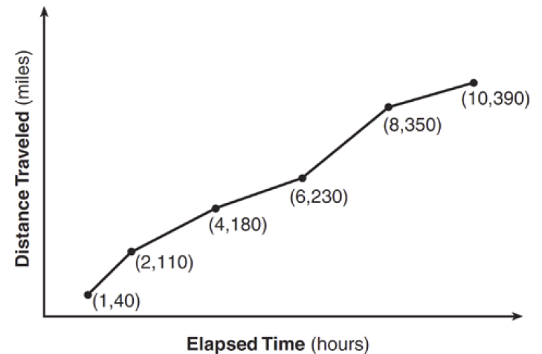

**Conversions Chart Used in Regents Algebra 1 (Common Core) Exams**

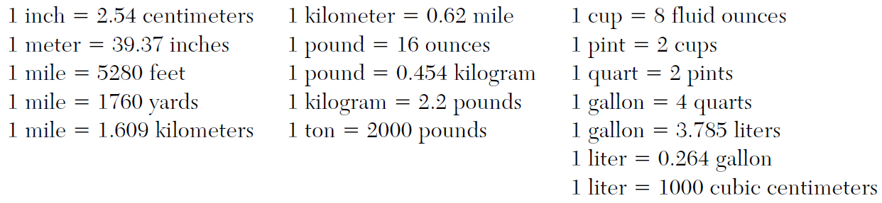

**DEVELOPING ESSENTIAL SKILLS**

|  |  |
| --- | --- |
| Convert the following: | Solutions |
| 20 kilometers to feet |  |
| 30 kilometers per hour to miles per hour |  |
| 1 cubic foot to cubic centimeters |  |

**REGENTS EXAM QUESTIONS (through June 2018)**

N.Q.A.l: Conversions

82) Peyton is a sprinter who can run the 40-yard dash in 4.5 seconds. He converts his speed into miles per hour, as shown below.



Which ratio is *incorrectly* written to convert his speed?

|  |  |  |  |
| --- | --- | --- | --- |
| 1) |  | 3) |  |
| 2) |  | 4) |  |

83) Dan took 12.5 seconds to run the 100-meter dash. He calculated the time to be approximately

|  |  |  |  |
| --- | --- | --- | --- |
| 1) | 0.2083 minute | 3) | 0.2083 hour |
| 2) | 750 minutes | 4) | 0.52083 hour |

84) Faith wants to use the formula  to convert degrees Fahrenheit, *f*, to degrees Celsius, . If Faith calculated , what would her result be?

|  |  |  |  |
| --- | --- | --- | --- |
| 1) | 20° Celsius | 3) | 154° Celsius |
| 2) | 20° Fahrenheit | 4) | 154° Fahrenheit |

85) A typical marathon is 26.2 miles. Allan averages 12 kilometers per hour when running in marathons. Determine how long it would take Allan to complete a marathon, to the *nearest tenth of an hour*. Justify your answer.

86) A construction worker needs to move 120 ft3 of dirt by using a wheelbarrow. One wheelbarrow load holds 8 ft3 of dirt and each load takes him 10 minutes to complete. One correct way to figure out the number of hours he would need to complete this job is

|  |  |  |  |
| --- | --- | --- | --- |
| 1) |  | 3) |  |
| 2) |  | 4) |  |

87) The Utica Boilermaker is a 15-kilometer road race. Sara is signed up to run this race and has done the following training runs:

I. 10 miles

II. 44,880 feet

III. 15,560 yards

Which run(s) are at least 15 kilometers?

|  |  |  |  |
| --- | --- | --- | --- |
| 1) | I, only | 3) | I and III |
| 2) | II, only | 4) | II and III |

**SOLUTIONS**

82) ANS: 2

Strategy: Work through each step of the problem and ask the DIMS question. Does It Make Sense.

STEP 1.  This makes sense. The yard units cancel and Peyton’s speed becomes measured in feet per second instead of yards per second. We take the ratio of  to the next step in our analysis.

STEP 2. . This does not make sense. The speed of a runner would not be measured in feet per second miles. The problem is that the numerator and denominator are switched. It should be . When the numerator and denominator are changed, the problem becomes . The feet units cancel and our measurement of Peyton’s speed has distance over time, which makes sense. Answer choice b is selected to show that this ratio is *incorrectly* written.

STEP 3. Though we have solved the problem, we can continue our step by step analysis by taking the ratio of  to the next step in our analysis. The problem now becomes

. This makes sense. The seconds units cancel and we again have distance over miles. We take the ratio  to the next step.

STEP 4.  miles per hour. This makes sense. Peyton is a fast sprinter.

PTS: 2 NAT: N.Q.A.1 TOP: Conversions

83) ANS: 1

Step 1. Read both the question and the answers. Understand that the problem is asking you to convert seconds into either minutes or hours. The 100 meters is constant, so it is not important to the problem of converting time into minutes or hours.

Step 2. Create two proportions using the conversion rates of 1) 60 seconds per minute; and 2) 3600 seconds per hour, to express 12.5 seconds in minutes and hours.

Step 3. Execute the strategy.

|  |  |
| --- | --- |
| 12.5 second equals how many minutes? | 12.5 second equals how many hours? |

The correct choice is a), 12.5 seconds equals 0.2083 minutes.

4. Does it make sense? Yes. It is obvious that 12.5 seconds does not equal 750 minutes (choice b) and it is also obvious that 12.5 seconds is not more than half an hour (choice d). The only choice that is less than a minute is choice a), and 12.5 seconds is definitely less than a minute.

PTS: 2 NAT: N.Q.A.1 TOP: Conversions KEY: dimensional analysis

84) ANS: 1

|  |  |  |  |
| --- | --- | --- | --- |
| Given  Find |  | = |  |
| Substitute 68 for *f* |  | = |  |
| Solve  inside parentheses |  | = |  |
| Simplify Fraction  Using Cancellation |  | = |  |
| Simplify Right  Expression |  | = | 20 |

PTS: 2 NAT: N.Q.A.1 TOP: Conversions KEY: formula

85) ANS:

3.5 hours

Note: 1 kilometer = 0.62 miles

Step 1. Convert 12 kilometers per hour to miles per hour.

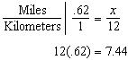 Allan averages 7.44 miles per hour.

Step 2. Use the speed formula to find time.

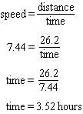

Step 3. Round to the nearest tenth of an hour.



PTS: 2 NAT: N.Q.A.1 TOP: Conversions KEY: dimensional analysis

86) ANS: 4

The units for the correct solution must be in hours.

: Wrong. After cancellations, the remaining units are 

: Wrong. After cancellations, the remaining units are 

: Wrong. After cancellations, the remaining units are 

: Correct. After cancellations, the remaining units are .

PTS: 2 NAT: N.Q.A.1 TOP: Conversions KEY: dimensional analysis

87) ANS: 1

Strategy: Convert the distance of each training run to kilometers.

I. 1 kilometer equals approximately 0.62 miles, so 1 mile equals approximately  kilometers. Ten miles equals approximately  kilometers. Therefore, ten miles is greater than 15 kilometers.

II. One mile contains 5,280 feet, so 44,880 feet equals  miles. 8.5 miles times 1.61 kilometers per mile equals approximately  kilometers. Therefore, 44,880 feet is less than 15 kilometers.

III. One yard contains three feet, so 15,560 yards equals  feet. 46,680 feet equals approximately  miles. 8.84 miles equals  kilometers. Therefore, 15,560 yards is less than 15 kilometers.

The only training run that is longer than 15 kilometers is the ten mile training run.

PTS: 2 NAT: N.Q.A.1 TOP: Conversions KEY: dimensional analysis