**M – Functions, Lesson 7, Comparing Functions (r. 2018)**

FUNCTIONS

Comparing Functions

|  |  |
| --- | --- |
| **CC Standard**  **F-IF.C.9** Compare properties of two functions each represented in a different way (algebraically, graphically, numerically in tables, or by verbal descriptions). *For example, given a graph of one quadratic function and an algebraic expression for another, say which has the larger maximum.*  PARCC: Tasks are limited to linear functions, quadratic functions, square root, cube root, piecewise defined (including step functions and absolute value functions), and exponential functions with domains in the integers. | **NG Standard**  **AI-F.IF.9** Compare properties of two functions each represented in a different way (algebraically, graphically, numerically in tables, or by verbal descriptions).  (Shared standard with Algebra II)  Note: Algebra I tasks are limited to the following functions: linear, quadratic, square root, piecewise defined (including step and absolute value), and **exponential functions of the form  where *a* > 0 and *b* > 0 (*b* ≠ 1).** |

**LEARNING OBJECTIVES**

Students will be able to:

1) Compare properties of two functions each represented in a different way.

**Overview of Lesson**

|  |  |
| --- | --- |
| **Teacher Centered Introduction**  **Overview of Lesson**  **- activate students’ prior knowledge**  **- vocabulary**  **- learning objective(s)**  **- big ideas: direct instruction**  **- modeling** | **Student Centered Activities**  **guided practice ⬅Teacher: anticipates, monitors, selects, sequences, and connects student work**  **- developing essential skills**  **- Regents exam questions**  **- formative assessment assignment (exit slip, explain the math, or journal entry)** |

**VOCABULARY**

context

equation

four views of a function

function rule

graph

maximum

minimum

table of values

vertex

x-intercept

y-intercept

**BIG IDEAS**

**Definition of a Function**: a function takes the input value of an independent variable and pairs it with one and only one output value of a dependent variable.

|  |  |
| --- | --- |
|  | **Function**: A function is a relation that assigns exactly one value of the dependent variable to each value of the independent variable. A function is always a relation.  Example: y=2x |

A function can be represented mathematically through four inter-related views. These are:

#1 a function rule (equation)

#2 a table of values

#3 a graph.

#4 context (words)

The TI-83+ graphing calculator allows you to input the function rule and access the graph and table of values, as shown below:

|  |  |  |
| --- | --- | --- |
| Function Rule View | View | View |

**Function Rules** show the relationship between dependent and independent variables in the form of an equation with two variables.

§ The **independent** variable is the **input** of the function and is typically denoted by the x-variable.

§ The **dependent** variable is the **output** of the function and is typically denoted by the y-variable.

When inputting function rules in a TI 83+ graphing calculator, the y-value (dependent variable) must be isolated as the left expression of the equation.

**Tables of Values** show the relationship between dependent and independent variables in the form of a table with columns and rows:

§ The **independent** variable is the **input** of the function and is typically shown in the left column of a vertical table or the top row of a horizontal table.

§ The **dependent** variable is the **output** of the function and is typically shown in the right column of a vertical table or the bottom row of a horizontal table.

**Graphs** show the relationship between dependent and independent variables in the form of line or curve on a coordinate plane:

§ The value of **independent** variable is the **input** of the function and is typically shown on the **x-axis** (horizontal axis) of the coordinate plane.

§ The value of the **dependent** variable is the **output** of the function and is typically shown on the **y-axis** (vertical axis) of the coordinate plane.

**DEVELOPING ESSENTIAL SKILLS**

1 The *x*-value of which function’s *x*-intercept is larger, *f* or *h*? Justify your answer.



|  |  |
| --- | --- |
| **x** | **h(x)** |
|  | 6 |
| 0 | 4 |
| 1 | 2 |
| 2 | 0 |
| 3 |  |

2 Consider the function  and the function *q* represented in the table below.

|  |  |
| --- | --- |
| ***x*** | ***q*(*x*)** |
|  |  |
|  | 0 |
| 0 | 0 |
| 1 |  |
| 2 | 0 |

Determine which function has the *smaller* minimum value for the domain . Justify your answer.

3 Which function shown below has a greater average rate of change on the interval ? Justify your answer.



|  |  |
| --- | --- |
| **x** | **f(x)** |
|  | 0.3125 |
|  | 0.625 |
|  | 1.25 |
|  | 2.5 |
| 0 | 5 |
| 1 | 10 |
| 2 | 20 |
| 3 | 40 |
| 4 | 80 |
| 5 | 160 |
| 6 | 320 |

1 ANS: *f(x)* The graph of *f(x)* crosses the x-axis when x = 5. The graph of *h(x)* crosses the x-axis when x = 2.

2 ANS: *q* has the smaller minimum value for the domain . *p*’s minimum is -5 *q*’s minimum is .

3 ANS:  has a greater rate of change

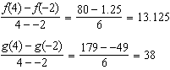

**REGENTS EXAM QUESTIONS (through June 2018)**

F.IF.C.9: Comparing Functions

464) Which function has the greatest *y*-intercept?

|  |  |  |  |
| --- | --- | --- | --- |
| 1) |  | 3) | the line that has a slope of 2 and passes through (1, -4). |
| 2) |  | 4) |  |

465) Given the following quadratic functions:



and

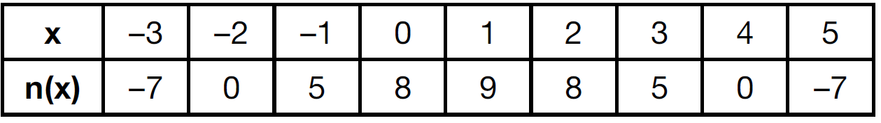

Which statement about these functions is true?

|  |  |  |  |
| --- | --- | --- | --- |
| 1) | Over the interval , the average rate of change for  is less than that for . | 3) | The function  has a greater maximum value than . |
| 2) | The *y*-intercept of  is greater than the *y*-intercept for . | 4) | The sum of the roots of  is greater than the sum of the roots of . |

466) Let *f* be the function represented by the graph below.

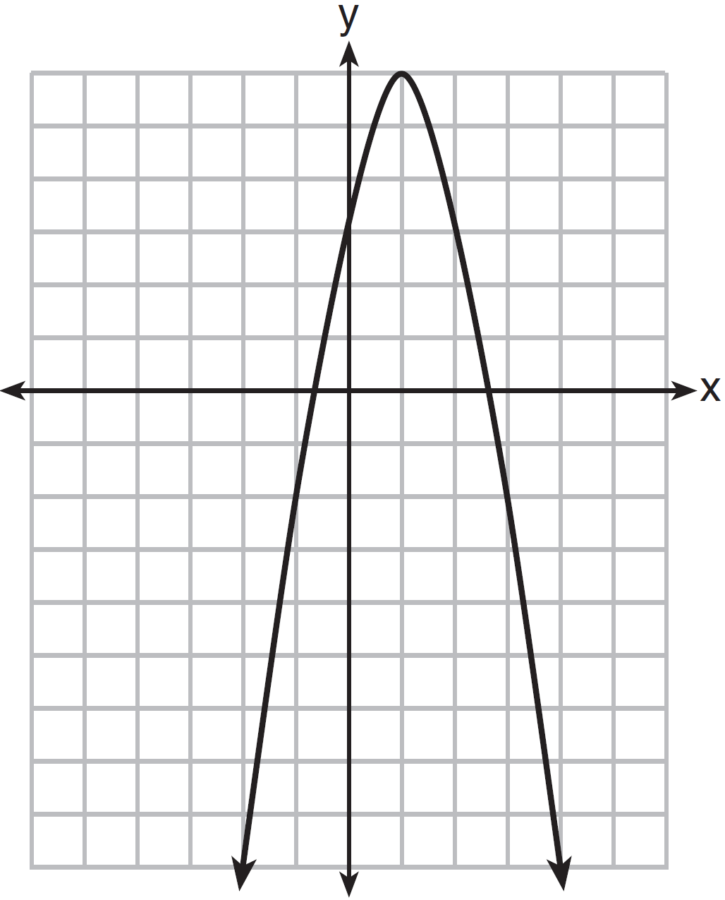

Let *g* be a function such that . Determine which function has the larger maximum value. Justify your answer.

467) Which quadratic function has the largest maximum?

|  |  |  |  |
| --- | --- | --- | --- |
| 1) |  | 3) |  |
| 2) |  | 4) |  |

468) Which statement is true about the quadratic functions , shown in the table below, and ?

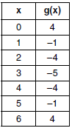

|  |  |  |  |
| --- | --- | --- | --- |
| 1) | They have the same vertex. | 3) | They have the same axis of symmetry. |
| 2) | They have the same zeros. | 4) | They intersect at two points. |

469) The graph representing a function is shown below.

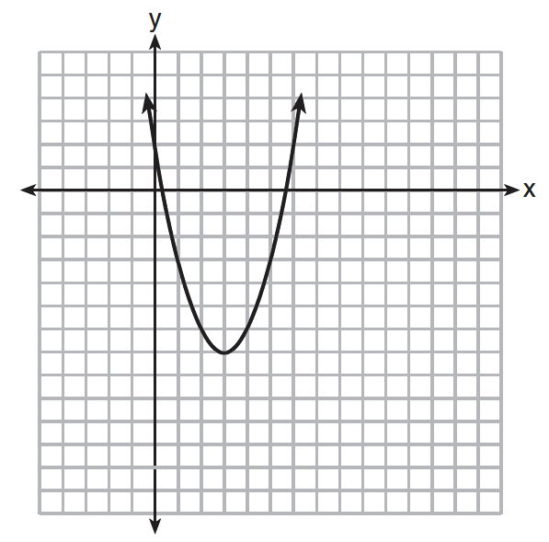

Which function has a minimum that is *less* than the one shown in the graph?

|  |  |  |  |
| --- | --- | --- | --- |
| 1) |  | 3) |  |
| 2) |  | 4) |  |

470) Nancy works for a company that offers two types of savings plans. Plan *A* is represented on the graph below.

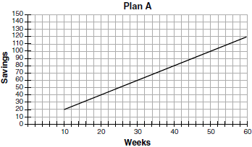

Plan *B* is represented by the function , where *x* is the number of weeks. Nancy wants to have the highest savings possible after a year. Nancy picks Plan *B*. Her decision is

|  |  |  |  |
| --- | --- | --- | --- |
| 1) | correct, because Plan *B* is an exponential function and will increase at a faster rate | 3) | incorrect, because Plan *A* will have a higher value after 1 year |
| 2) | correct, because Plan *B* is a quadratic function and will increase at a faster rate | 4) | incorrect, because Plan *B* is a quadratic function and will increase at a slower rate |

471) The function , which is graphed below, and the function  are given.

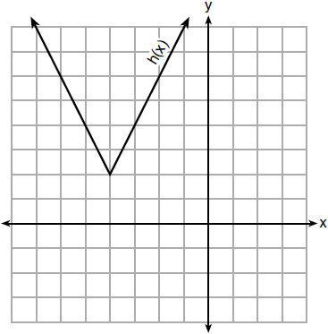

Which statements about these functions are true?

I.  has a lower minimum value than .

II. For all values of *x*, .

III. For any value of *x*, .

|  |  |  |  |
| --- | --- | --- | --- |
| 1) | I and II, only | 3) | II and III, only |
| 2) | I and III, only | 4) | I, II, and III |

472) Which quadratic function has the largest maximum over the set of real numbers?

|  |  |  |  |
| --- | --- | --- | --- |
| 1) |  | 3) |  |
| 2) |  | 4) |  |

473) Which of the quadratic functions below has the *smallest* minimum value?

|  |  |  |  |
| --- | --- | --- | --- |
| 1) |  | 3) |  |
| 2) |  | 4) |  |

**SOLUTIONS**

464) ANS: 4

Strategy: Find y-intercept for each answer choice, then eliminate wrong answers.

Eliminate  because .

Eliminate  because 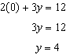

Eliminate the line that has slope of 2 and passes through (1, -4) because it has a positive slope and it’s y-intercept must be less than -4.

Choose the graph because the y-intecept is 5, which is greater than the y-intercepts of the other three choices.

PTS: 2 NAT: F.IF.C.9

465) ANS: 4

Strategy: Each answer choice must be evaluated using a different strategy.

a. Use the slope formula to find the rate of change for

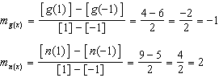

Statement a is false. The average rate of change for  is *more* than that for .

b. Compare the y-intercepts for both functions. The y-intercepts occur when *x* = 0.

The y-intercept for g(x) = 6. 

The y-intercept for n(x) = 8 from the table.

Statement b is false. The *y*-intercept of  is *less* than the *y*-intercept for .

c. Compare the maxima of both functions.

The maxima of  is 6. This can be found manually or with a

graphing calculator.

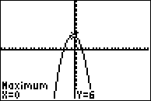

The maxima of n(x) = 9, which can be seen in the table.

Statement c is false. The function  has a *smaller* maximum value than .

d. Compare the sum of the roots for both functions.

The sum of the roots for g(x) =  from a graphing calculator.

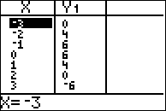

The sum of the roots for n(x) =  from the table.

Statement d is true. The sum of the roots of  is greater than the sum of the roots of .

PTS: 2 NAT: F.IF.C.9 TOP: Graphing Quadratic Functions

466) ANS:

Function g has the larger maximum value. The maximum of function *g* is 11. The maximum of function *f* is 6.

Strategy: Determine the maximum for *f* from the graph. Determine the maximum for g by inputting the function rule in a graphing calculator and inspecting the graph.

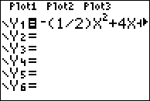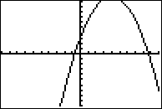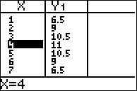

The table of values shows the maximum for *g* is 11.

Another way of finding the maximum for g is to use the axis of symmetry formula and the function rule, as follows: 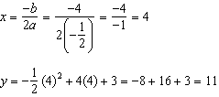

PTS: 2 NAT: F.IF.C.9 TOP: Graphing Quadratic Functions

467) ANS: 3

Strategy: Each answer choice needs to be evaluated for the largest maximum using a different strategy..

a) Input  in a graphing calculator and find the maximum.

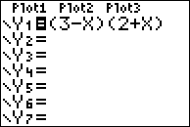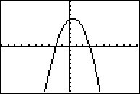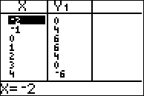

The maximum for answer choice *a* is a little more than 6.

b) The table shows that the maximum is a little more than 9.

c) Input  in a graphing calculator and find the maximum.

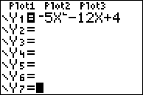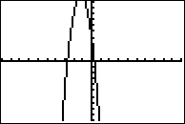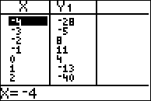

The table of values shows that the maximum is 11 or more.

d) The graph shows that the maximum is a little more than 4.

Answer choice *c* is the best choice.

PTS: 2 NAT: F.IF.C.9 TOP: Graphing Quadratic Functions

468) ANS: 3

The first function  is in vertex form  and has its vertex at (3,2).

The second function is in table form and has its vertex at (3, -5).

Therefore, the axis of symmetry for both functions is x=3..

PTS: 2 NAT: F.IF.C.9 TOP: Comparing Functions

KEY: AI

469) ANS: 3

Strategy: The graph shows a parabola with a vertex at (3, -7), so the minima is at -7. Identify the lowest y-value of each function rule. Then, select the function rule that has a lowest y value that is less than -7.

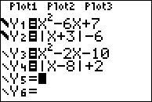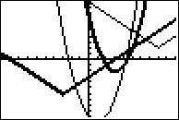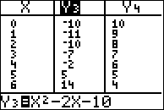

The graph view of the four functions shows that the function  has a y-value less than -7.

PTS: 2 NAT: F.IF.C.9 TOP: Comparing Functions

470) ANS: 2

Observe: The function  is a second degree equation, so it must be a quadratic function. One year equals 52 weeks.

Strategy:

Step 1.: Solve the Plan *B* function for 

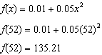

Step 2. Compare the Plan A (52, 105) and Plan B (52, 135.21) coordinates for 52 weeks and observe that B has higher savings.

Step 3. Eliminate wrong answers.

~~a)~~ correct, because Plan *B* is an ~~exponential~~ function and will increase at a faster rate b) correct, because Plan *B* is a quadratic function and will increase at a faster rate

~~c)~~ ~~incorrect~~, because Plan *A* will have a higher value after 1 year

~~d)~~ ~~incorrect~~, because Plan *B* is a quadratic function and will increase at a slower rate

PTS: 2 NAT: F.IF.C.9 TOP: Comparing Functions

471) ANS: 2

Strategy: Graph , then examine the truth value of the answer choices.

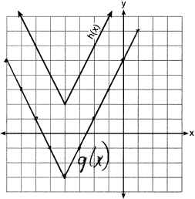

I.  has a lower minimum value than . True: 

II. For all values of *x*, . False.  is always > than .

III. For any value of *x*, . True.  is always 5 more than .

PTS: 2 NAT: F.IF.C.9 TOP: Comparing Functions

472) ANS: 2

Strategy: Find the maximum y-value for each function rule using a graphing calculator. Estimate the maximum y-value for each table.

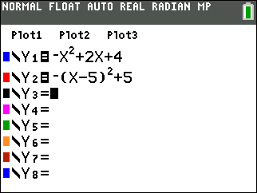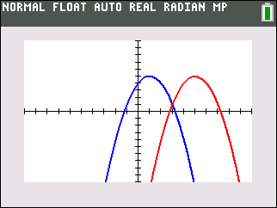

Both function rules have maximum values of 5.

The maximum value of  is estimated as greater that 5.

The maximum value of  is estimated as less than 5.

PTS: 2 NAT: F.IF.C.9 TOP: Comparing Functions

473) ANS: 2

Strategy: Determine the minimum y-value for each function, then choose the smallest y-value.

STEP 1. Evaluate each answer choice.

Answer Choice 1. The minimum can be found by transforming the function from standard form to vertex form.

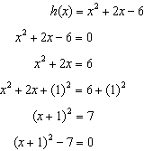

The vertex occurs at (-1, -7), so the minimum y-value is -7.

Answer Choice 2. The minimum can be found by inspection of the graph. The minimum y-value is -10.

Answer Choice 3. The minimum can be found using the graph or table views of the function in a graphing calculator. The minimum y-value is between -2 and -3.

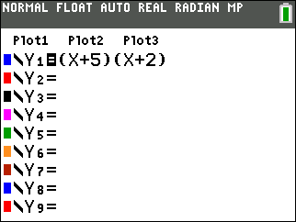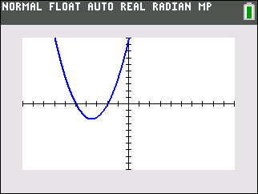

Answer Choice 4. The miinimum can be found by inspection of the table of values. The minim y-value is -6.

STEP 2. Pick the lowest y-value of all the answer choices.

PTS: 2 NAT: F.IF.C.9 TOP: Comparing Functions