**H – Quadratics, Lesson 5, Vertex Form of a Quadratic (r. 2018)**

QUADRATICS

Vertex Form of a Quadratic

|  |  |
| --- | --- |
| **Common Core Standards**  **F-IF.C.8** Write a function defined by an expression in different but equivalent forms to reveal and explain different properties of the function.  **F-IF.C.8a** Use the process of factoring and completing the square in a quadratic function to show zeros, extreme values, and symmetry of the graph, and interpret these in terms of a context. | **Next Generation Standards**  **AI-F.IF.8** Write a function in different but equivalent forms to reveal and explain different properties of the function.  (Shared standard with Algebra II)  **AI-F.IF.8a For a quadratic function, use an algebraic process** to find zeros, maxima, minima, and symmetry of the graph, and interpret these in terms of context.  **Note: Algebraic processes include but not limited to factoring, completing the square, use of the quadratic formula, and the use of the axis of symmetry.** |

**LEARNING OBJECTIVES**

Students will be able to:

1. Transform quadratics equations to and between standard, factored, and vertex forms of a quadratic.
2. Identify the zeros, maxima, minima, and axis-of symmetry of parabolas.

**Overview of Lesson**

|  |  |
| --- | --- |
| **Teacher Centered Introduction**  **Overview of Lesson**  **- activate students’ prior knowledge**  **- vocabulary**  **- learning objective(s)**  **- big ideas: direct instruction**  **- modeling** | **Student Centered Activities**  **guided practice ⬅Teacher: anticipates, monitors, selects, sequences, and connects student work**  **- developing essential skills**  **- Regents exam questions**  **- formative assessment assignment (exit slip, explain the math, or journal entry)** |

**VOCABULARY**

axis of symmetry

completing the square

maxima

minima

parabola

standard form of a parabola

turning point

vertex

vertex form of a quadratic

x-axis intercepts

zeros

**BIG IDEAS**

The graph of a quadratic is called a **parabola**, and a parabola has several characteristics, including:

1. **vertex**, also known as the turning point. The vertex is the highest or lowest point on a parabola and is usually expressed as a coordinate pair.
2. **maxima** is the y-value of the turning point when the graph opens downward.
3. **minima** is the y-value of the turning point when the graph opens upward.
4. **axis of symmetry** is a vertical line that passes through the vertex of a parabola and divides the parabola into two symmetrical halves. It is sometimes called the line of reflection.
5. **zeros**, also known as roots or solutions, are the x-values of the coordinates of the **x-axis intercepts**.

There are three general forms of a quadratic equation:

1. standard form, given by , where is the quadratic term, *bx* is the linear term, and *c* is the constant. A positive value of *a* indicates the parabola opens upwards and a negative value of *a* indicates the parabola opens downward. As the value of a approaches zero, the appearance of the parabola approaches the appearance of a horizontal line.
2. vertex form, given by , where (*h,k*) is the vertex of the parabola and *x* = *h* is the axis of symmetry.
3. factored form, given by , where r and s are solutions.

|  |  |
| --- | --- |
| **Image result for characteristics of a parabola** | **In standard form, the function rule for this parabola is:**    This form reveals that the parabola opens upward and has a y-intercept of 3.  **In vertex form, the function rule for this parabola is:**    The form reveals the vertex is at (1,-4) and the axis of symmetry is x=1.  **In factored form, the function rule for this parabola is**    This form reveals the solutions are |

The ability to transform quadratic equations between standard, vertex, and quadratic forms is useful for identifying the characteristics of their graphs.

**DEVELOPING ESSENTIAL SKILLS**

Complete the following table.

|  |  |  |  |  |
| --- | --- | --- | --- | --- |
| **Standard Form** | **Vertex Form** | **Factored Form** | **Vertex and Axis of Symmetry** | **Solutions** |
|  |  |  |  |  |
|  |  |  |  |  |
|  |  |  |  |  |
|  |  |  |  |  |
|  |  |  |  |  |

Answers

|  |  |  |  |  |
| --- | --- | --- | --- | --- |
| **Standard Form** | **Vertex Form** | **Factored Form** | **Vertex and Axis of Symmetry** | **Solutions** |
|  |  |  |  |  |
|  |  |  |  |  |
|  |  |  |  |  |
|  |  |  |  |  |
|  |  |  |  |  |

**REGENTS EXAM QUESTIONS (through June 2018)**

F.IF.C.8: Vertex Form of a Quadratic

218) a) Given the function , state whether the vertex represents a maximum or minimum point for the function. Explain your answer.

b) Rewrite *f(x)* in vertex form by completing the square.

219) If Lylah completes the square for  in order to find the minimum, she must write  in the general form . What is the value of *a* for ?

|  |  |  |  |
| --- | --- | --- | --- |
| 1) | 6 | 3) | 12 |
| 2) |  | 4) |  |

220) In the function , the minimum value occurs when *x* is

|  |  |  |  |
| --- | --- | --- | --- |
| 1) |  | 3) |  |
| 2) | 2 | 4) | 4 |

221) Which equation is equivalent to ?

|  |  |  |  |
| --- | --- | --- | --- |
| 1) |  | 3) |  |
| 2) |  | 4) |  |

222) Which equation and ordered pair represent the correct vertex form and vertex for ?

|  |  |  |  |
| --- | --- | --- | --- |
| 1) |  | 3) |  |
| 2) |  | 4) |  |

223) The function  can be written in vertex form as

|  |  |  |  |
| --- | --- | --- | --- |
| 1) |  | 3) |  |
| 2) |  | 4) |  |

**SOLUTIONS**

218) ANS:

a) The vertex represents a maximum since .

b) 

The vertex is at (4,25), but this information is not required by the problem.

PTS: 4 NAT: F.IF.C.8 TOP: Graphing Quadratic Functions

219) ANS: 1

Strategy: Transform  into the form of  and find the value of *a*.

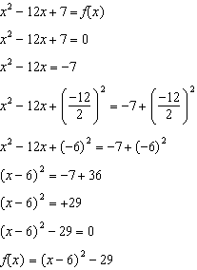

If , then .

PTS: 2 NAT: A.SSE.B.3 TOP: Solving Quadratics

KEY: completing the square

220) ANS: 2

Strategy #1. Recognize that the function  is expressed in vertex form, and that the vertex is located at . Accordingly, the minimum value of occurs when .

Strategy #2: Input the function rule in a graphing calculator, then examine the graph and table views to determine the vertex. The problem wants to know the x value of the when is at its minimum.

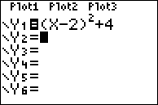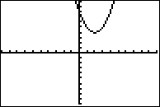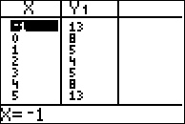

The minimum value of  when  is equal to 2.

Strategy #3: Substitute each value of x into the equation and determine the minimum value of .

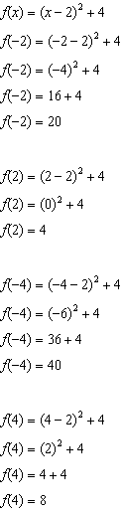

PTS: 2 NAT: A.SSE.B.3 TOP: Vertex Form of a Quadratic

NOT: NYSED classifies this as A.SSE.3

221) ANS: 4

Strategy: Simplify the equation .

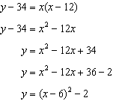

PTS: 2 NAT: A.REI.B.4 TOP: Solving Quadratics

KEY: completing the square

222) ANS: 3

Step 1. Understand from the answer choices that the problem wants us to choose the answer that is equivalent to .

Step 2. Strategy: Input  in a graphing calulator and inspect the table and graph views of the function, then eliminate wrong answers.

Step 3. Execute the strategy.

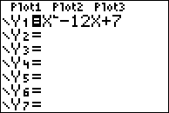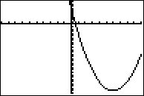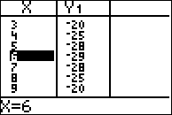

Choice c) is correct because it is the only answer choice that shows the vertex at (6, -29).

Step 4. Does it make sense? Yes. You can see that  and  are the same funtion by inputting both in a graphing calculator.

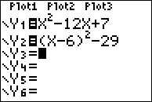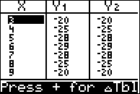

PTS: 2 NAT: F.IF.C.8 TOP: Vertex Form of a Quadratic

223) ANS: 3

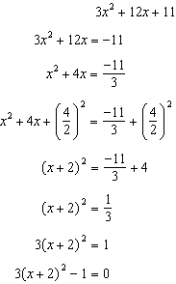

PTS: 2 NAT: A.SSE.B.3b TOP: Families of Functions