M – Functions, Lesson 3, Domain and Range (r. 2018)

FUNCTIONS
Domain and Range
CC Standard  F-IF.5 Relate the domain of a function to its graph and, where applicable, to the quantitative relationship it describes. For example, if the function h(n) gives the number of person-hours it takes to assemble n engines in a factory, then the positive integers would be an appropriate domain for the function. | NG Standard  AI-F.IF.5 Determine the domain of a function from its graph and, where applicable, identify the appropriate domain for a function in context.

LEARNING OBJECTIVES
Students will be able to:
- Determine the domain of a function from its graph.
- Identify appropriate sets of numbers for the domain and range of a function.

Overview of Lesson
Teacher Centered Introduction  Overview of Lesson  - activate students’ prior knowledge  - vocabulary  - learning objective(s)  - big ideas: direct instruction  - modeling | Student Centered Activities  guided practice ⬅Teacher: anticipates, monitors, selects, sequences, and connects student work  - developing essential skills  - Regents exam questions  - formative assessment assignment (exit slip, explain the math, or journal entry)

VOCABULARY

continuous
counting numbers
discrete
domain
integers
natural numbers
range
rational numbers
real numbers
whole numbers

BIG IDEAS

The domain of x and the range of y.

The coordinate plane consists of two perpendicular number lines, which are commonly referred to as the x-axis and the y-axis. Each number line represents the set of real numbers. The x-axis represents the independent variable (inputs) and the y-axis represents the dependent variable (outputs).
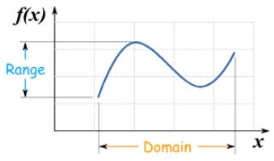

The domain of a function is that part (or parts) of the x-axis number line required for the funtion’s input values. This can be an interval of all real numbers, or limited to specific subsets of real numbers, such as positive or negative integers.

The range of a function is that part (or parts) of the y-axis number line required for the funtion’s output values. This can be an interval of all real numbers, or limited to specific subsets of real numbers, such as positive or negative integers.

A function maps an element of the domain onto one and only one element of the range.

Choosing Appropriate Domains and Ranges

Many functions make sense only when a subset of all the Real Numbers are used as inputs. This subset of the Real Numbers that makes sense is known as the domain of the function.

Example: If a store makes $2.00 profit on each sandwich sold, total profits might be modeled by the function , where represents total profits and s represents the number of sandwiches sold. The entire set of real numbers, including fractions and irrational numbers, make no sense for this function, because the store only sells whole sandwiches. In this example, the domain of the function should be restricted to the set of whole numbers. Likewise, the range of a function can also be limited to a well-defined subset of the Real Numbers on the y-axis.

Domains and ranges can be either continuous or discrete.

DEVELOPING ESSENTIAL SKILLS
1. The effect of pH on the action of a certain enzyme is shown on the accompanying graph.

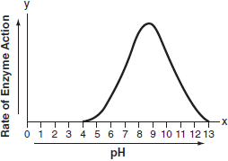

What is the domain of this function?
a. |  | c.
b. |  | d.

2. Data collected during an experiment are shown in the accompanying graph.

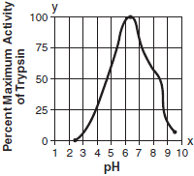

What is the range of this set of data?
a. |  | c.
b. |  | d.

3. What is the range of the relation if the domain is the set ?
a. |  | c.
b. |  | d.

4. The domain for is . The greatest value in the range of is
a. |  | c. | 8
b. | 2 | d. | 11

5. The domain of is . The largest value in the range of is
a. | 20 | c. | 3
b. | 16 | d. | 4

ANSWERS

1. ANS: A

2. ANS: C

3. ANS: B

4. ANS: C

5. ANS: B

REGENTS EXAM QUESTIONS (through June 2018)
F.IF.B.5: Domain and Range

418) The graph of the function is shown below.

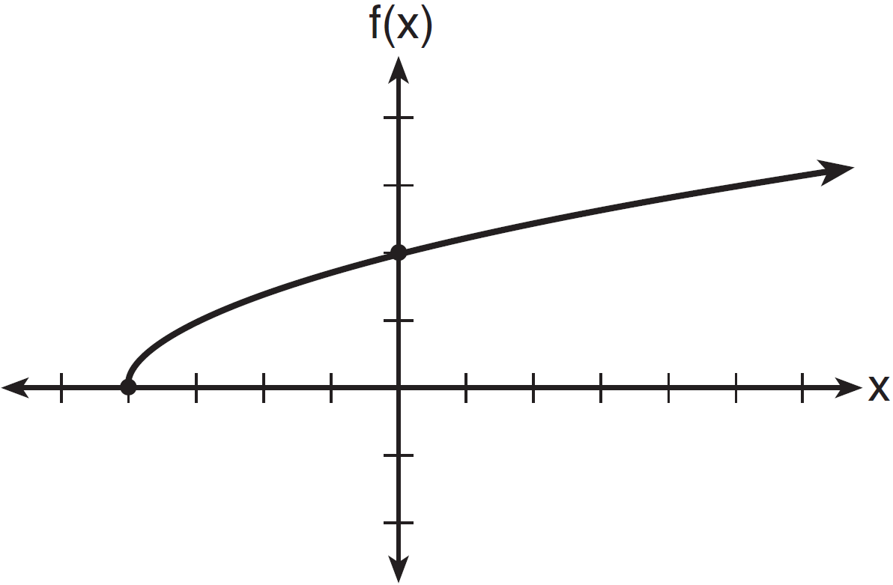

The domain of the function is
1) |  | 3)
2) |  | 4)

419) If 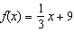, which statement is always true?
1) |  | 3) | If , then
2) |  | 4) | If , then

420) Let f be a function such that is defined on the domain . The range of this function is
1) |  | 3)
2) |  | 4)

421) The range of the function defined as is
1) |  | 3)
2) |  | 4)

422) The range of the function is all real numbers
1) | less than or equal to | 3) | less than or equal to
2) | greater than or equal to | 4) | greater than or equal to

423) What is the domain of the relation shown below?
1) |  | 3)
2) |  | 4)

424) If the domain of the function is , then the range is
1) |  | 3)
2) |  | 4)

425) Officials in a town use a function, C, to analyze traffic patterns. represents the rate of traffic through an intersection where n is the number of observed vehicles in a specified time interval. What would be the most appropriate domain for the function?
1) |  | 3) | 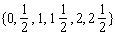
2) |  | 4)

426) The function represents the height, , in feet, of an object from the ground at t seconds after it is dropped. A realistic domain for this function is
1) |  | 3)
2) |  | 4) | all real numbers

427) Which domain would be the most appropriate set to use for a function that predicts the number of household online-devices in terms of the number of people in the household?
1) | integers | 3) | irrational numbers
2) | whole numbers | 4) | rational numbers

428) A store sells self-serve frozen yogurt sundaes. The function represents the cost, in dollars, of a sundae weighing w ounces. An appropriate domain for the function would be
1) | integers | 3) | nonnegative integers
2) | rational numbers | 4) | nonnegative rational numbers

429) A construction company uses the function , where p is the number of people working on a project, to model the amount of money it spends to complete a project. A reasonable domain for this function would be
1) | positive integers | 3) | both positive and negative integers
2) | positive real numbers | 4) | both positive and negative real numbers

430) An online company lets you download songs for $0.99 each after your have paid a $5 membership fee. Which domain would be most appropriate to calculate the cost to download songs?
1) | rational numbers greater than zero | 3) | integers less than or equal to zero
2) | whole numbers greater than or equal to one | 4) | whole numbers less than or equal to one

431) The daily cost of production in a factory is calculated using , where x is the number of complete products manufactured. Which set of numbers best defines the domain of ?
1) | integers | 3) | positive rational numbers
2) | positive real numbers | 4) | whole numbers

432) At an ice cream shop, the profit, , is modeled by the function , where c represents the number of ice cream cones sold. An appropriate domain for this function is
1) | an integer | 3) | a rational number
2) | an integer | 4) | a rational number

433) If , which interval describes the range of this function?
1) |  | 3)
2) |  | 4)

SOLUTIONS

418) ANS: 4
Strategy: Use the number line of the x-axis, the fact that the graph begins with a solid dot, indicating that -4 is included in the domain, and the fact that the graph includes an arrow indicating that the graph continues to positive infinity, to select answer choice d.

PTS: 2 NAT: F.IF.A.1 TOP: Domain and Range

419) ANS: 4
Strategy: Inspect the function rule in a graphing calculator, then eliminate wrong answers.
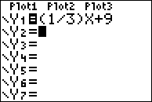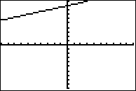
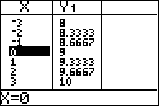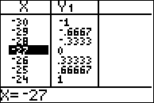

Answer choice a can be eliminated because the table clearly shows values greater than zero.
Answer choice b can be eliminated because the table clearly shows values less than zero.
Answer choice c can be eliminated because if x is greater than -27, then
Choose answer choice d because the graph and table clearly show that all values of are positive when values of x are positive.

PTS: 2 NAT: F.IF.A.2 TOP: Domain and Range

420) ANS: 1
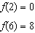
Strategy: Inspect the function rule in a graphing calculator over the domain , eliminate wrong answers.
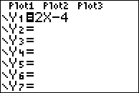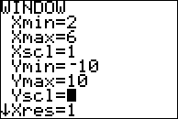
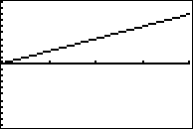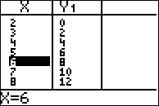
Choose answer choice a because the table of values and the graph clearly show that and , and all values of y between and are between 0 and 8.
Eliminate answer choice b because infinity is clearly bigger than 8.
Eliminate answer choice c because these are the domain of x, not the range of y.
Eliminate answer choice d because negative infinity is clearly less than 0.

PTS: 2 NAT: F.IF.A.2 TOP: Domain and Range

421) ANS: 2
Strategy: Input the function in a graphing calculator and inspect the graph and table views..
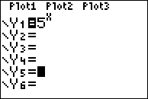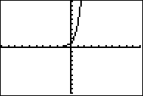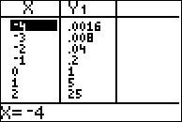
The value of y approaches zero, but never reachers zero, as the value of x decreases.
The the range of is .

PTS: 2 NAT: F.IF.A.2 TOP: Domain and Range
KEY: real domain, exponential

422) ANS: 2
Strategy: Input the function into a graphing calculator and inspect the range of y-values.
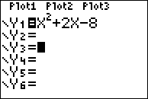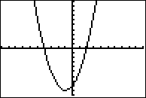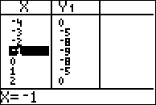
The graph and the table of values show that all values of f(x) are greater than or equal to -9. Choice b) is the correct answer.

PTS: 2 NAT: F.IF.A.2 TOP: Domain and Range
KEY: real domain, quadratic

423) ANS: 1
Domain refers to the x-axis while range refers to the y-axis. This question is asking what values on the x-axis are required by this relation.
Strategy: Underline all the x-values of the relation, then organize the unique values.
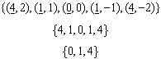
You could graph the entire relation if you have x-values of 0, 1, and 4.

PTS: 2 NAT: F.IF.A.2 TOP: Domain and Range
KEY: limited domain

424) ANS: 3
Substitute each value of the domain into the function and solve for the range for each value.
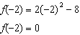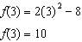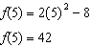

PTS: 2 NAT: F.IF.A.2 TOP: Domain and Range
KEY: limited domain

425) ANS: 4
Strategy: Examine each answer choice and eliminate wrong answers.

Eliminate answer choices a and b because negative numbers of cars observed do not make sense.
Eliminate answer choice c because fractional numbers of cars observed do not make sense.
Choose answer choice d because it is the only choice that makes sense. The number of cars observed must be either zero or some counting number.

PTS: 2 NAT: F.IF.B.5 TOP: Domain and Range

426) ANS: 2
Strategy: Input the function into a graphing calculator and examine it to determine a realistic range. First, transform to for input.
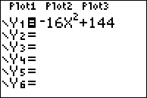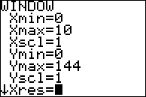
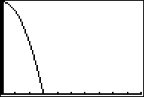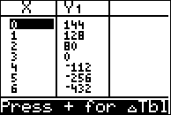
The graph and table of values show that it takes 3 seconds for the object to reach the ground. Therefore, a realistic domain for this function is .
represents the time when the object is dropped.
represents the time when the object hits the ground.
Answer choice b is correct.

PTS: 2 NAT: F.IF.B.5 TOP: Domain and Range

427) ANS: 2
Strategy: Eliminate wrong answers.

Eliminate answer choice a because the set of integers contains negative numbers, which do not make sense when counting the number of appliances in a household.
Choose answer choice b because the set of whole numbers is defined as {0, 1, 2, 3, ...}. This does make sense when counting the number of appliances in a household.
Eliminate answer choice c because the set of irrational numbers includes numbers like and , which do not make sense when counting the number of appliances in a household.
Eliminate answer choice d because the set of rational numbers includes fractions such as and , which do not make sense when counting the number of appliances in a household.

PTS: 2 NAT: F.IF.B.5 TOP: Domain and Range

428) ANS: 4
Step 1. Understand that the problem is asking for a set of numbers that would be appropriate x-values to measure the weight (in ounces) of frozen yogurt sundaes.
Step 2. Strategy. Eliminate wrong answers.
Step 3. Execution of Strategy.
a) Integers would not be an appropriate domain because there is no need for negative whole numbers. It makes no sense to have a yogurt sundae that weighs -4 ounces.
b) Rational numbers would not be an appropriate domain because, once again, there is no need for negative numbers. It makes no sense to have a yogurt sundae that weighs ounces.
c) Nonnegative Integers could work except for zero, which is a non-negative integer. It makes no sense to have a yogurt sundae that weighs zero ounces.
d) Nonnegative rational numbers are the best choice.
Step 4. Does it make sense? Yes. You could weigh yogurt sundaes by the ounce, half ounce, quarter ounce, or any other nonnegative fraction.

PTS: 2 NAT: F.IF.B.5 TOP: Domain and Range

429) ANS: 1
Strategy: Eliminate wrong answers. The number of people must be counting numbers, since it makes no sense to have a half a person or a quarter person.
The positive integers are 1, 2, 3, 4, ...., which makes sense.
Positive real numbers should be eliminated because positive real numbers include fractions, and fractions make no sense for the number of workers.
Both positive and negative integers should be eliminated because it makes no sense to have negative numbers of workers.
Both positive and negative real numbers should also be eliminated because it makes no sense to have negative numbers of workers.
The correct choice is positive integers.

PTS: 2 NAT: F.IF.B.5 TOP: Domain and Range

430) ANS: 2
Understand the Question: Cost is a function of the number of songs downloaded, so cost is the dependent variable and the number of songs is the independent variable. The domain of a function refers to the independent variable (x-axis), so the problem is asking which numbers are most appropriate for the number of songs downloaded.
Then, eliminate wrong answers:
Eliminate: Rational numbers greater than zero because there is no need for fractions.
Choose: Whole numbers greater than or equal to one because you only need positive whole numbers.
Eliminate: Integers less than or equal to zero because you would not download a negative number of songs.
Eliminate: Whole numbers less than or equal to one because you would not download a negative number of songs.

PTS: 2 NAT: F.IF.B.5

431) ANS: 4
Reason: If x represents the number of complete products manufactured, there is no need for fractions or negative numbers.
Strategy: Eliminate wrong answers:
a) integers There is no need for negative numbers.
b) positive real numbers There is no need for fractions and/or irrational numbers.
c) positive rational numbers There is no need for fractions.
d) whole numbers A complete product can be represented by a whole number.

PTS: 2 NAT: F.IF.B.5 TOP: Domain and Range

432) ANS: 2
Strategy: Eliminate wrong answers.
1. Eliminate an integer because all of the integers less than or equal to zero are negative numbers and you cannot sell a negative number of ice cream cones.
2. Select an integer because these are the whole numbers and you can only sell a whole ice cream cone.
3. Eliminate a rational number because you cannot sell a negative number of ice cream cones or negatives fractions of ice cream cones.
4. Eliminate a rational number because you cannot sell fractional parts of ice cream cones.

PTS: 2 NAT: F.IF.B.5 TOP: Domain and Range

433) ANS: 3
Strategy: Inspect the table and graph views of this function in a graphing calculator to find the range (not the domain).
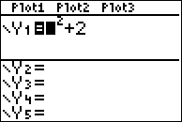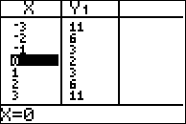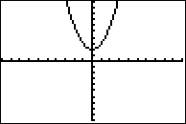
The table of values and the graph both show the smalles value of f(x) is 2, which occurs when . The maximum value of f(x) is infiniy. Therefore, the range of the function is .

NOTE: is the domain of the function. Don’t confuse domain and range.

PTS: 2 NAT: F.IF.A.2 TOP: Domain and Range
KEY: real domain, quadratic

