**N – Sequences and Series, Lesson 1, Sequences (r. 2018)**

SEQUENCES AND SERIES

Sequences

|  |  |
| --- | --- |
| **CC Standard**  **F-IF.A.3** Recognize that sequences are functions, ~~sometimes defined recursively~~, whose domain is a subset of the integers. *~~For example, the Fibonacci sequence is defined recursively by f(0) = f(1) = 1, f(n+1) = f(n) + f(n-1) for n ≥ 1.~~*  ~~PARCC: This standard is part of the Major work in Algebra I and will be assessed accordingly.~~  **F-LE.2** Construct linear and exponential functions, ~~including arithmetic and geometric sequences~~, given a graph, a description of a relationship, or two input-output pairs (include reading these from a table).  PARCC: Tasks are limited to constructing linear and exponential functions in simple context (not multi-step). | **NG Standard**  **AI-F.IF.3** Recognize that a sequence is a function whose domain is a subset of the integers.  (Shared standard with Algebra II)  Notes:  • Sequences (arithmetic and geometric) will be written explicitly and only in subscript notation.  • Work with geometric sequences may involve an exponential equation/formula of the form *an = arn-1*, where *a* is the first term and *r* is the common ratio.  **AI-F.LE.2** Construct a linear or exponential function **symbolically** given:  i) a graph;  ii) a description of the relationship;  iii) two input-output pairs (include reading these from a table).  (Shared standard with Algebra II)  Note: Tasks are limited to constructing linear and exponential functions in simple context (not multi-step). |

**LEARNING OBJECTIVES**

Students will be able to:

1. Define sequences as recursive functions.
2. Evaluate recursive functions for the nth term.

**Overview of Lesson**

|  |  |
| --- | --- |
| **Teacher Centered Introduction**  **Overview of Lesson**  **- activate students’ prior knowledge**  **- vocabulary**  **- learning objective(s)**  **- big ideas: direct instruction**  **- modeling** | **Student Centered Activities**  **guided practice ⬅Teacher: anticipates, monitors, selects, sequences, and connects student work**  **- developing essential skills**  **- Regents exam questions**  **- formative assessment assignment (exit slip, explain the math, or journal entry)** |

**VOCABULARY**

arithmetic progression

explicit formula

geometric progression

pattern

recursive formula

sequence

series

set

term

**BIG IDEAS**

An **explicit formula** is one where you do not need to know the value of the term in front of the term that you are seeking. For example, if you want to know the 55th term in a series, an explicit formula could be used without knowing the value of the 54th term.

**Example:** The sequence 3, 11, 19, 27, ... begins with 3, and 8 is added each time to form the pattern. The sequence can be shown in a table as follows:

|  |  |  |  |  |
| --- | --- | --- | --- | --- |
| Term # (*n*) | 1 | 2 | 3 | 4 |
|  | 3 | 11 | 19 | 27 |

**Explicit formulas** for the sequence 3, 11, 19, 27, ... can be written as:

 or 

Using these **explicit formulas**, we can find the following values for any term, and we do not need to know the value of any other term, as shown below:

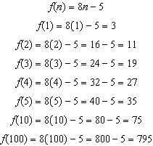 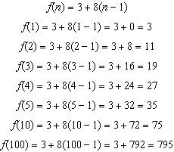

**Recursive formulas** requires you to know the value of another term, usually the preceding term, to find the value of a specific term.

**Example:** Using the same sequence 3, 11, 19, 27, ... as above, a **recursive formula** for the sequence 3, 11, 19, 27, ... can be written as:



This **recursive formula** tells us that the value of any term in the sequence is equal to the value of the term before it plus 8. A recursive formula must usually be anchored to a specific term in the sequence (usually the first term), so the recursive formula for the sequence 3, 11, 19, 27, ... could be anchored with the statement



Using this **recursive formula**, we can reconstruct the sequence as follows:

|  |  |
| --- | --- |
|  | Observe that the recursive formula  includes two different values of the dependent variable, which in this example are  and , and we can only reconstruct our original sequence using this **recursive formula** if we know the term immediately preceding the term we are seeking. |

**Two Kinds of Sequences**

**arithmetic sequence** *(A2T)* A set of numbers in which the common difference between each term and the preceding term is constant.

Example: In the **arithmetic sequence** 2, 5, 8, 11, 14, … the common difference between each term and the preceding term is 3. A table of values for this sequence is:

|  |  |  |  |  |  |
| --- | --- | --- | --- | --- | --- |
| Term # (*n*) | 1 | 2 | 3 | 4 | 5 |
|  | 2 | 5 | 8 | 11 | 14 |

An **explicit formula** for this sequence is 

A **recursive formula** for this sequence is: 

**geometric sequence** *(A2T)* A set of terms in which each term is formed by multiplying the preceding term by a common nonzero constant.

Example: In the geometric sequence ... the common ratio is 2. Each

term is 2 times the preceding term. A table of values for this sequence is:

|  |  |  |  |  |  |
| --- | --- | --- | --- | --- | --- |
| Term ( *n*) | 1 | 2 | 3 | 4 | 5 |
|  | 2 | 4 | 8 | 16 | 32 |

An **explicit formula** for this sequence is 

A **recursive formula** for this sequence is: 

**DEVELOPING ESSENTIAL SKILLS**

1) If  and , then 

|  |  |  |  |
| --- | --- | --- | --- |
| 1) | -15 | 3) | 45 |
| 2) | 20 | 4) | -135 |

2) If a sequence is defined recursively by  and  for all , then is equal to

|  |  |  |  |
| --- | --- | --- | --- |
| 1) | 22 | 3) | 46 |
| 2) | -27 | 4) | -14 |

3) In a sequence, the first term is 3 and the common difference is 4. The fifth term of this sequence is

|  |  |  |  |
| --- | --- | --- | --- |
| 1) |  | 3) | 16 |
| 2) |  | 4) | 19 |

4) Given the functiondefined by the following:



Which set could represent the range of the function?

|  |  |  |  |
| --- | --- | --- | --- |
| 1) |  | 3) |  |
| 2) |  | 4) |  |

**ANSWERS**

1. 4
2. 3
3. 4
4. 1

**REGENTS EXAM QUESTIONS (through June 2018)**

F.IF.A.3, F.LE.A.2: Sequences and Series

487) If  and , then 

|  |  |  |  |
| --- | --- | --- | --- |
| 1) |  | 3) | 21 |
| 2) | 11 | 4) | 43 |

488) If a sequence is defined recursively by  and  for , then  is equal to

|  |  |  |  |
| --- | --- | --- | --- |
| 1) | 1 | 3) | 5 |
| 2) |  | 4) | 17 |

489) In a sequence, the first term is 4 and the common difference is 3. The fifth term of this sequence is

|  |  |  |  |
| --- | --- | --- | --- |
| 1) |  | 3) | 16 |
| 2) |  | 4) | 19 |

490) Given the function  defined by the following:



Which set could represent the range of the function?

|  |  |  |  |
| --- | --- | --- | --- |
| 1) |  | 3) |  |
| 2) |  | 4) |  |

491) A sequence of blocks is shown in the diagram below.

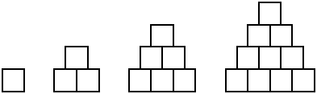

This sequence can be defined by the recursive function  and . Assuming the pattern continues, how many blocks will there be when ?

|  |  |  |  |
| --- | --- | --- | --- |
| 1) | 13 | 3) | 28 |
| 2) | 21 | 4) | 36 |

492) Determine and state whether the sequence  displays exponential behavior. Explain how you arrived at your decision.

493) A sunflower is 3 inches tall at week 0 and grows 2 inches each week. Which function(s) shown below can be used to determine the height, , of the sunflower in *n* weeks?

I. 

II. 

III. 

|  |  |  |  |
| --- | --- | --- | --- |
| 1) | I and II | 3) | III, only |
| 2) | II, only | 4) | I and III |

494) The diagrams below represent the first three terms of a sequence.

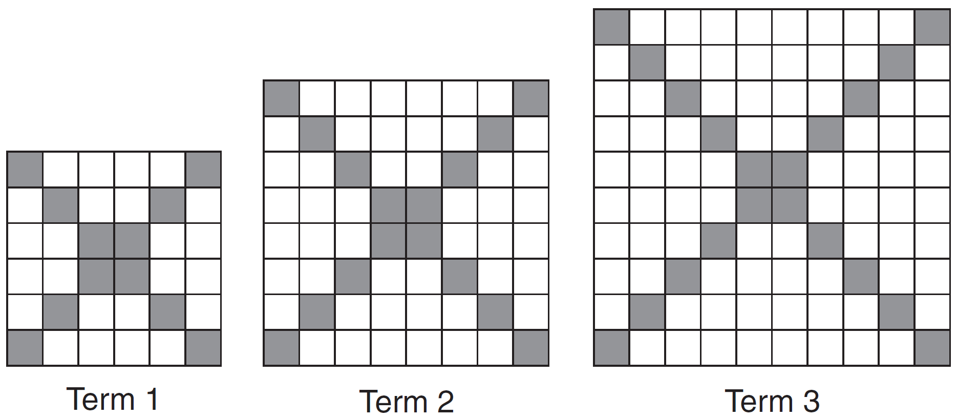

Assuming the pattern continues, which formula determines , the number of shaded squares in the *n*th term?

|  |  |  |  |
| --- | --- | --- | --- |
| 1) |  | 3) |  |
| 2) |  | 4) |  |

495) A pattern of blocks is shown below.

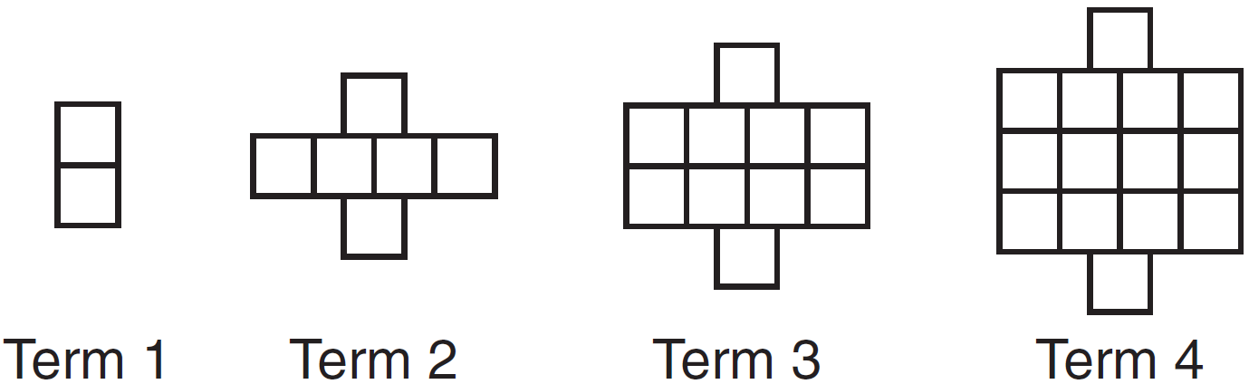

If the pattern of blocks continues, which formula(s) could be used to determine the number of blocks in the *n*th term?

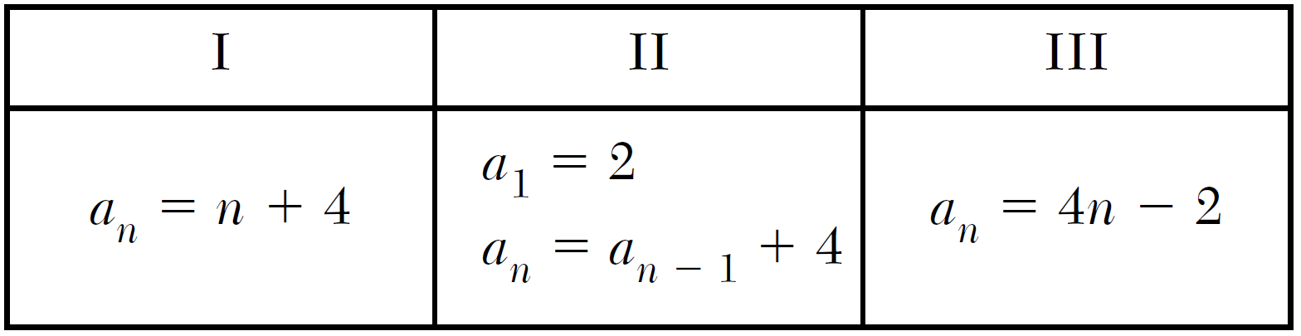

|  |  |  |  |
| --- | --- | --- | --- |
| 1) | I and II | 3) | II and III |
| 2) | I and III | 4) | III, only |

496) The third term in an arithmetic sequence is 10 and the fifth term is 26. If the first term is , which is an equation for the *n*th term of this sequence?

|  |  |  |  |
| --- | --- | --- | --- |
| 1) |  | 3) |  |
| 2) |  | 4) |  |

497) Which recursively defined function has a first term equal to 10 and a common difference of 4?

|  |  |  |  |
| --- | --- | --- | --- |
| 1) |  | 3) |  |
| 2) |  | 4) |  |

498) Which recursively defined function represents the sequence ?

|  |  |  |  |
| --- | --- | --- | --- |
| 1) |  | 3) |  |
| 2) |  | 4) |  |

499) Which function defines the sequence -6, -10, -14, -18, ..., where ?

|  |  |  |  |
| --- | --- | --- | --- |
| 1) |  | 3) |  |
| 2) |  | 4) |  |

500) In 2014, the cost to mail a letter was 49¢ for up to one ounce. Every additional ounce cost 21¢. Which recursive function could be used to determine the cost of a 3-ounce letter, in cents?

|  |  |  |  |
| --- | --- | --- | --- |
| 1) |  | 3) |  |
| 2) |  | 4) |  |

501) If the pattern below continues, which equation(s) is a recursive formula that represents the number of squares in this sequence?

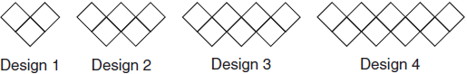

|  |  |  |  |
| --- | --- | --- | --- |
| 1) |  | 3) |  |
| 2) |  | 4) |  |

502) On the main floor of the Kodak Hall at the Eastman Theater, the number of seats per row increases at a constant rate. Steven counts 31 seats in row 3 and 37 seats in row 6. How many seats are there in row 20?

|  |  |  |  |
| --- | --- | --- | --- |
| 1) | 65 | 3) | 69 |
| 2) | 67 | 4) | 71 |

503) If  and , what is the value of ?

|  |  |  |  |
| --- | --- | --- | --- |
| 1) | 5 | 3) | 120 |
| 2) | 20 | 4) | 720 |

504) The expression  is equivalent to

|  |  |  |  |
| --- | --- | --- | --- |
| 1) |  | 3) |  |
| 2) |  | 4) |  |

**SOLUTIONS**

487) ANS: 4

Strategy: Use the recursive formula:  to find each term in the sequence.

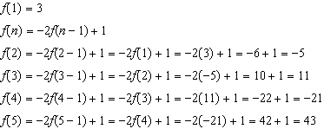

PTS: 2 NAT: F.IF.A.3 TOP: Sequences

488) ANS: 3

Strategy: Use the recursive formula:  to find each term in the sequence.

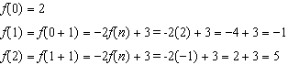

Answer choice *c* corresponds to .

PTS: 2 NAT: F.IF.A.3 TOP: Sequences

489) ANS: 3

Step 1. Understand that the problem wants to know the fifth term in a sequence when the first term is 4 and the common difference is 3.

Step 2. Strategy. Build a table.

|  |  |  |  |  |  |  |
| --- | --- | --- | --- | --- | --- | --- |
| Step 3. Execute the strategy. | Term # | 1 | 2 | 3 | 4 | 5 |
|  | Value | 4 | 7 | 10 | 13 | 16 |

Step 4. Does it make sense? Yes. You can check it by writing the following formula based on the table and using it to find any term in this arithmetic sequence.

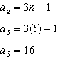

PTS: 2 NAT: F.IF.A.3 TOP: Sequences KEY: term

490) ANS: 2

The first value in the function must be 2. Therefore,  and  must be wrong choices.

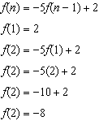

Since -8 is the second number, the correct answer choice is .

PTS: 2 NAT: F.IF.A.3 TOP: Sequences KEY: term

491) ANS: 3

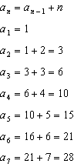

PTS: 2 NAT: F.IF.A.3 TOP: Sequences KEY: term

492) ANS:

Yes. Each number in the sequence is three times bigger than the previous number, so the sequence has a common ratio, which is 3.

PTS: 2 NAT: F.LE.A.1 TOP: Families of Functions

493) ANS: 4

Strategy: If sunflower’s height is modelled using a table, then the three formulas can be tested to see which one(s) produce results that agree with the table.

|  |  |  |  |  |
| --- | --- | --- | --- | --- |
| Weeks (*n*) | Height |  |  |  |
| 0 | 3 |  |  |  |
| 1 | 5 |  |  |  |
| 2 | 7 |  |  |  |
| 3 | 9 |  |  |  |

Formula I, , is an explicit formula that *agrees* with the table.

Formula II is an explicit formula that *does not agree* with the table.

Formula III, , is a recursive formula that agrees with the table.

PTS: 2 NAT: F.IF.A.3 TOP: Sequences

494) ANS: 2

Strategy: Examine the pattern, then test each formula and eliminate wrong choices.

Term 1 has 12 shaded squares.

Term 2 has 16 shaded squares.

Term 3 has 20 shaded squares.

|  |  |  |  |  |
| --- | --- | --- | --- | --- |
| Choice | Equation | Term 1 = 12 | Term 2 = 16 | Term 3 = 20 |
| a |  | = 16 (eliminate) |  |  |
| b |  | = 12 (correct) | = 16 (correct) | = 20 (correct) |
| c |  | = 8 (eliminate) |  |  |
| d |  | = 6 (eliminate) |  |  |

PTS: 2 NAT: F.LE.A.2 TOP: Sequences

495) ANS: 3

Strategy: Examine the pattern, then test each formula and eliminate wrong choices.

Term 1 has 2 squares.

Term 2 has 6 squares.

Term 3 has 10 squares.

Term 4 has 14 squares

|  |  |  |  |  |
| --- | --- | --- | --- | --- |
| *n* | 1 | 2 | 3 | 4 |
|  | 2 | 6 | 10 | 14 |

|  |  |  |  |  |  |
| --- | --- | --- | --- | --- | --- |
| Formula | Equation | Term 1 = 2 | Term 2 = 6 | Term 3 = 10 | Term 4 = 14 |
| I |  | This is wrong, so eliminate choices a and b.. |  |  |  |
| II |  | correct | correct | correct | correct |
| III |  | correct | correct | correct | correct |

Choose answer choice *c* because Formulas II and III are both correct.

PTS: 2 NAT: F.BF.A.1 TOP: Sequences

496) ANS: 2

Strategy: Build the sequence in a table, then test each equation choice and eliminate wrong answers.

|  |  |  |  |  |
| --- | --- | --- | --- | --- |
|  |  |  |  |  |
|  |  | 10 |  | 26 |

The  term must be half way between 10 and 26, so it must be 18.

The common difference is 8, so we can fill in the rest of the table as follows:

|  |  |  |  |  |
| --- | --- | --- | --- | --- |
|  |  |  |  |  |
| -6 | 2 | 10 | 18 | 26 |

The first term in the sequence is -6.

|  |  |  |  |  |
| --- | --- | --- | --- | --- |
| Choice | Equation | Term  = -6 | Term  = 10 | Term  = 26 |
| a |  | = 18 (eliminate) |  |  |
| b |  | = -6 (correct) | = 10 (correct) | = 26 (correct) |
| c |  | = 26 (eliminate) |  |  |
| d |  | = -12 (eliminate) |  |  |

PTS: 2 NAT: F.LE.A.2 TOP: Sequences

497) ANS: 1

Strategy: Eliminate wrong answers.

Choices *b* and *d* have first terms equal to 4, but the problem states that the first term is equal to 10. Therefore, eliminate choices *b* and *d*.

A common difference of 4 requires the addition or subtraction of 4 to find the next term in the sequence. Eliminate choice *c* because choice *c multiplies* the preceding term by 4.

Choice *a* is correct because the first term is 10 and 4 is added to each preceding term.

PTS: 2 NAT: F.IF.A.3 TOP: Sequences

498) ANS: 3

Each choice has a first term equal to 3.

Each additional term is twice its preceding term plus 1.

Strategy: Eliminate wrong answers and check.

All choices have show the the first term equals three: .

Eliminate  and  because they are exponential.

Eliminate  because each term is not three times its preceding term minus two.

Check  as follows:

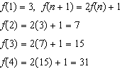

 produces the sequence 3, 7, 15, 31,.....

PTS: 2 NAT: F..IF.A.3 TOP: Sequences

499) ANS: 1

Strategy #1

Construct the following table from the problem:

|  |  |  |  |  |  |  |
| --- | --- | --- | --- | --- | --- | --- |
| *x* | 1 | 2 | 3 | 4 | 5 | 6 |
| *f(x)* | -6 | -10 | -14 | -18 |  |  |

Then, input the four answer choices in a graphing calculator and inspect the table view to determine which answer choice reproduces the table.

Strategy #2

Use a graphing calculator to find a regression equation for the data in the above table.

PTS: 2 NAT: F.IF.A.2

500) ANS: 1

Strategy: Eliminate wrong answers.

The first ounce costs 49 cents, so eliminate any answer choice where  does not equal 49.

PTS: 2 NAT: F.LE.A.2 TOP: Sequences

501) ANS: 3

STEP 1: Count the number of squares in Designs, 1, 2, 3, and 4.

Design 1 = 3

Design 2 = 5

Design 3 = 7

Design 4 = 9

STEP 2: Eliminate answer choices  and because they are not written as recursive formulas.

STEP 3: Eliminate because the first value in the sequence is three, so .

STEP 4: Choose 

PTS: 2 NAT: F.LE.A.2 TOP: Sequences

502) ANS: 1

Strategy: Find the constant rate of change, then write an equation to solve for the number of seats in row 20.

STEP 1. Find the constant rate of change.

|  |  |  |  |  |  |
| --- | --- | --- | --- | --- | --- |
|  | | x values increase by 1 | | | |
| row # (x) | 3 | | 4 | 5 | 6 |
| # seats (y) | 31 | | 33 | 35 | 37 |
|  | | y values increase by 2 | | | |



STEP 2. Write the slope-intercept form of the line having a constant rate of change of 2 and any pair of known x and y values.

|  |  |  |
| --- | --- | --- |
| Given | Solve for b | Write the Entire Equation |

STEP 3. Use the linear equation to solve for .

|  |  |  |  |
| --- | --- | --- | --- |
| Notes | Left Expression | Sign | Right Expression |
| Given | y | = |  |
| Let x equal 20 | y | = |  |
| Remove Parentheses | y | = | 40+25 |
| Simplify | y | = | 65 |

PTS: 2 NAT: F.IF.A.3 TOP: Sequences KEY: term

503) ANS: 3

Strategy: Build a table.

|  |  |  |
| --- | --- | --- |
| n | Calculations |  |
| 1 | , Given | 1 |
| 2 |  | 2 |
| 3 |  | 6 |
| 4 |  | 24 |
| 5 |  | 120 |

The correct answer is .

PTS: 2 NAT: F.IF.A.3 TOP: Sequences KEY: term

504) ANS: 2

Strategy: Use the distributive property to clear parentheses, then combine like terms.

|  |  |
| --- | --- |
| Notes | Expression |
| Given |  |
| Distributive Property |  |
| Reorder by Like Terms |  |
| Combine Like Terms |  |

PTS: 2 NAT: A.APR.A.1 TOP: Operations with Polynomials

KEY: subtraction