E – Linear Equations, Lesson 1, Modeling Linear Functions (r. 2018)

LINEAR EQUATIONS
Modeling Linear Equations
Common Core Standards  F-BF.A.1 Write a function that describes a relationship between two quantities.  F-LE.A.2 Construct linear and exponential functions, including arithmetic and geometric sequences, given a graph, a description of a relationship, or two input-output pairs (include reading these from a table).  PARCC: Tasks are limited to constructing linear and exponential functions in simple context (not multi-step).  F-LE.B.5 Interpret the parameters in a linear or exponential function in terms of a context.  PARCC: Tasks have a real-world context. Exponential functions are limited to those with domains in the integers.  S-ID.C.7 Interpret the slope (rate of change) and the intercept (constant term) of a linear model in the context of the data. | Next Generation Standards  F-BF.1 Write a function that describes a relationship between two quantities.  AI-F.LE.2 Construct a linear or exponential function symbolically given:  i) a graph;  ii) a description of the relationship;  iii) two input-output pairs (include reading these from a table).  (Shared standard with Algebra II)  Note: Tasks are limited to constructing linear and exponential functions in simple context (not multi-step).  AI-F.LE.5 Interpret the parameters in a linear or exponential function in terms of a context.  (Shared standard with Algebra II)  Note: Tasks have a real-world context. Exponential functions are limited to those with domains in the integers and are of the form  where a > 0 and b > 0 (b ≠ 1).  AI-S.ID.7 Interpret the slope (rate of change) and the intercept (constant term) of a linear model in the context of the data.

LEARNING OBJECTIVES
Students will be able to:
1)
Overview of Lesson
Teacher Centered Introduction  Overview of Lesson  - activate students’ prior knowledge  - vocabulary  - learning objective(s)  - big ideas: direct instruction  - modeling | Student Centered Activities  guided practice ⬅Teacher: anticipates, monitors, selects, sequences, and connects student work  - developing essential skills  - Regents exam questions  - formative assessment assignment (exit slip, explain the math, or journal entry)

VOCABULARY

BIG IDEAS

Linear functions are modelled using the same general approaches used in modelling linear equations (see Expressions and Equations, Lesson 4, Modelling Linear Equations). When modelling linear functions, however, any one of the four views of a function may describe the mathematical relationship between the variables and function notation may be required.

There are four views of a function: 1) the function rule; 2) the table of values; 3) the graph; and 4) the narrative or “context” view. All four views can be used to help understand a function, and the ability to move from one view to another is important.
NOTE: Graphing calculators will produce table and graph views of a function after inputting the function rule. The context view cannot be modelled with a graphing calculator. Regression can be used to find a function rule from a table or graph (see Graphs and Statistics, Lesson 5, Regression).

Function Notation

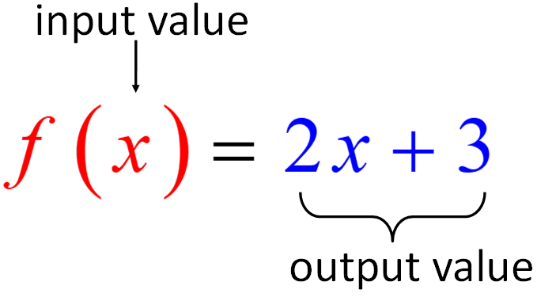

Function notation is a language for writing functions. It provides simple, but important information about the mathematical relationship between the variables in a function.
- Function notation identifies the mathematical relationship as a function.
  - A function has one and only one output (y-value) for each input (x-value).
  - Function notation should not be used with mathematical relationships that are not functions.
- Function notation identifies both the output (dependent variable) and the intput (independent variables) in a mathematical relationship
- The most common function notation is f(x), which is read as “f of x”.
  - f(x) is used to represent the dependent variable (y-value) of the function, and x is used to represent the independent variable (x-value) of the function.
    - In practice, any equation describing a function can be changed to function notation by substituting f(x) for y.
    - The y-axis of a graph is often labeled f(x) axis.
    - Ordered pairs may be written as
  - Other letters besides f and x may be used with function notation.
    - In practice, letters are often chosen to be descriptive of the variables involved.
    - Examples are the function rules for describing how to convert degrees Fahrenheit to degrees Celsius, and back.
Fahrenheit to Celsius | Celsius to Fahrenheit
This function rule can be interpreted as “degrees Celsius is a function of degrees Fahrenheit”. | This function rule can be interpreted as “degrees Fahrenheit is a function of degrees Celsius”.
- Function notation can be used to identify which value of the independent variable is to be used as an input.
  - For example, if, then
  - says that the output of the function should be evaluated when the input is x = 5.

Modeling a Sample Function
Context View: The inside of a freezer is kept at a constant temperature of 15 degrees Fahrenheit. When a quart of liquid water is placed in the freezer, its Fahrenheit temperature drops by one-half every 20 minutes until it turns into ice and reaches a constant temperature of 15 degrees.

Table View: The tables views below model what the temperatures of two different quarts of water with different initial temperatures would be after m minutes in the freezer.
Initial Temperature = 80 degrees
Minutes in Freezer (m) | 0 | 20 | 40 | 60 | 80
Temperature  f(m) | 80 | 40 | 20 | 15 | 15
Initial Temperature = 120 degrees
Minutes in Freezer (m) | 0 | 20 | 40 | 60 | 80
Temperature  f(m) | 120 | 60 | 30 | 15 | 15

Function Rule View
The narrative view and the table views suggest that the temperature drops exponentially at first, then stays at a constant temperature of 15 degrees.
Exponential growth or decay can be modeled by the function, where:
A represents the current amount,
P represents the starting amount,
represents the rate of growth or decay per cycle, and
t represents the number of cycles (usually measured as time)

The temperature of the water can be modeled using the formula for exponential decay, as follows:

A represents the temperature of the water after m minutes in the freezer.
P represents the initial temperature of the water.
represents the exponential rate of decay.
represents time.
The range of the function would be limited to

Check: Input the system of equations in a graphing calculator for a quart of water with an initial temperature of 80 degrees Fahrenheit. The second equation represents the lower limit of 15 degrees.
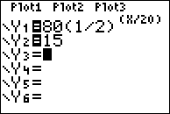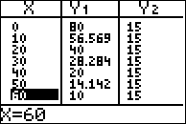

Graph View
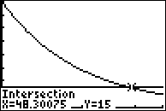

DIMS - Does It Make Sense? Yes, all four views of the function show that the water cools down quickly at first, then more slowly, then reaches a final temperature of 15 degrees. The graph view shows that it would take about 48 minutes for a quart of liquid water with an initial temperature of 80 degrees to reach a frozen temperature of 15 degrees.

DEVELOPING ESSENTIAL SKILLS
The table below represents the number of hours a student worked and the amount of money the student earned.

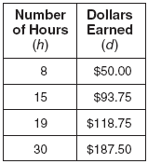

Write a function rule that represents the number of dollars, d, earned in terms of the number of hours, h, worked.

Bob sells appliances. He gets paid a fixed salary plus a fee for every appliance he sells. His total weekly compensation in dollars is modelled by the function . Explain what each of the three terms in this function means in the context of Bob’s compensation.
- c(a) Bob’s compensation is a function of the number of appliances he sells.
- 50a Bob gets $50 for every appliance he sells.
- 250 Bob gets $250 even if he doesn’t sell any appliances.

REGENTS EXAM QUESTIONS (through June 2018)

F.BE.A.1, F.LE.A.2, F.LE.B.5, S.ID.C.7:
Modeling Linear Functions

110) Caitlin has a movie rental card worth $175. After she rents the first movie, the card’s value is $172.25. After she rents the second movie, its value is $169.50. After she rents the third movie, the card is worth $166.75. Assuming the pattern continues, write an equation to define , the amount of money on the rental card after n rentals. Caitlin rents a movie every Friday night. How many weeks in a row can she afford to rent a movie, using her rental card only? Explain how you arrived at your answer.

111) In 2013, the United States Postal Service charged $0.46 to mail a letter weighing up to 1 oz. and $0.20 per ounce for each additional ounce. Which function would determine the cost, in dollars, , of mailing a letter weighing z ounces where z is an integer greater than 1?
1) |  | 3)
2) |  | 4)

112) Alex is selling tickets to a school play. An adult ticket costs $6.50 and a student ticket costs $4.00. Alex sells x adult tickets and 12 student tickets. Write a function, , to represent how much money Alex collected from selling tickets.

113) Jackson is starting an exercise program. The first day he will spend 30 minutes on a treadmill. He will increase his time on the treadmill by 2 minutes each day. Write an equation for , the time, in minutes, on the treadmill on day d. Find , the minutes he will spend on the treadmill on day 6.

114) Last weekend, Emma sold lemonade at a yard sale. The function represented the profit, , Emma earned selling c cups of lemonade. Sales were strong, so she raised the price for this weekend by 25 cents per cup. Which function represents her profit for this weekend?
1) |  | 3)
2) |  | 4)

115) Which chart could represent the function ?
1) | 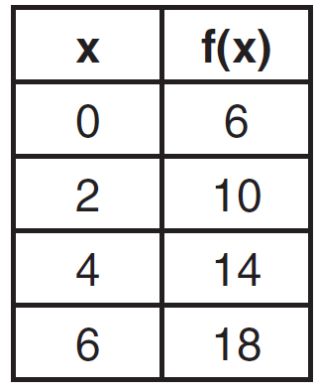 | 3) | 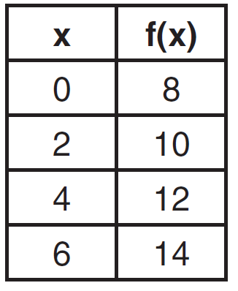
2) | 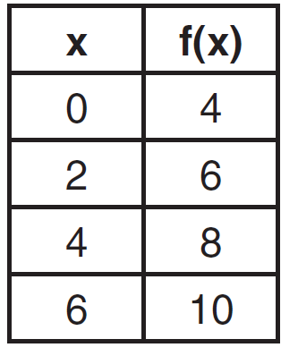 | 4) | 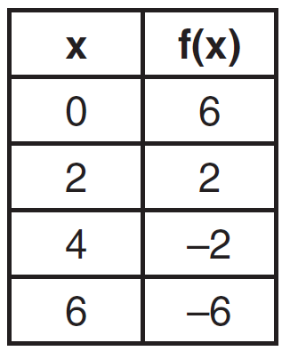

116) Jim is a furniture salesman. His weekly pay is $300 plus 3.5% of his total sales for the week. Jim sells x dollars' worth of furniture during the week. Write a function, , which can be used to determine his pay for the week. Use this function to determine Jim's pay to the nearest cent for a week when his sales total is $8250.

117) Each day Toni records the height of a plant for her science lab. Her data are shown in the table below.

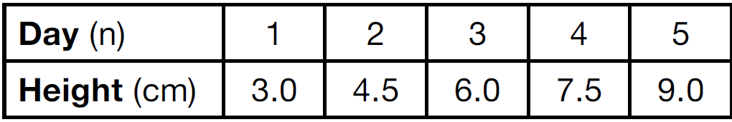

The plant continues to grow at a constant daily rate. Write an equation to represent , the height of the plant on the nth day.

118) Tanya is making homemade greeting cards. The data table below represents the amount she spends in dollars, , in terms of the number of cards she makes, x.

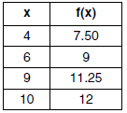

Write a linear function, , that represents the data. Explain what the slope and y-intercept of mean in the given context.

119) A company that manufactures radios first pays a start-up cost, and then spends a certain amount of money to manufacture each radio. If the cost of manufacturing r radios is given by the function , then the value 5.25 best represents
1) | the start-up cost | 3) | the amount spent to manufacture each radio
2) | the profit earned from the sale of one radio | 4) | the average number of radios manufactured

120) A satellite television company charges a one-time installation fee and a monthly service charge. The total cost is modeled by the function . Which statement represents the meaning of each part of the function?
1) | y is the total cost, x is the number of months of service, $90 is the installation fee, and $40 is the service charge per month. | 3) | x is the total cost, y is the number of months of service, $40 is the installation fee, and $90 is the service charge per month.
2) | y is the total cost, x is the number of months of service, $40 is the installation fee, and $90 is the service charge per month. | 4) | x is the total cost, y is the number of months of service, $90 is the installation fee, and $40 is the service charge per month.

121) The owner of a small computer repair business has one employee, who is paid an hourly rate of $22. The owner estimates his weekly profit using the function . In this function, x represents the number of
1) | computers repaired per week | 3) | customers served per week
2) | hours worked per week | 4) | days worked per week

122) The cost of airing a commercial on television is modeled by the function , where n is the number of times the commercial is aired. Based on this model, which statement is true?
1) | The commercial costs $0 to produce and $110 per airing up to $900. | 3) | The commercial costs $900 to produce and $110 each time it is aired.
2) | The commercial costs $110 to produce and $900 each time it is aired. | 4) | The commercial costs $1010 to produce and can air an unlimited number of times.

123) The cost of belonging to a gym can be modeled by , where is the total cost for m months of membership. State the meaning of the slope and y-intercept of this function with respect to the costs associated with the gym membership.

124) A car leaves Albany, NY, and travels west toward Buffalo, NY. The equation can be used to represent the distance, D, from Buffalo after t hours. In this equation, the 59 represents the
1) | car's distance from Albany | 3) | distance between Buffalo and Albany
2) | speed of the car | 4) | number of hours driving

125) A plumber has a set fee for a house call and charges by the hour for repairs. The total cost of her services can be modeled by . Which statements about this function are true?
I. A house call fee costs $95.
II. The plumber charges $125 per hour.
III. The number of hours the job takes is represented by t.
1) | I and II, only | 3) | II and III, only
2) | I and III, only | 4) | I, II, and III

126) A student plotted the data from a sleep study as shown in the graph below.

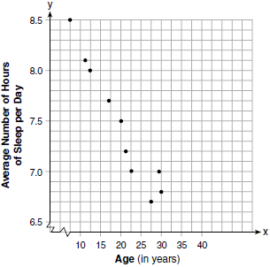

The student used the equation of the line to model the data. What does the rate of change represent in terms of these data?
1) | The average number of hours of sleep per day increases 0.09 hour per year of age. | 3) | The average number of hours of sleep per day increases 9.24 hours per year of age.
2) | The average number of hours of sleep per day decreases 0.09 hour per year of age. | 4) | The average number of hours of sleep per day decreases 9.24 hours per year of age.

127) During a recent snowstorm in Red Hook, NY, Jaime noted that there were 4 inches of snow on the ground at 3:00 p.m., and there were 6 inches of snow on the ground at 7:00 p.m. If she were to graph these data, what does the slope of the line connecting these two points represent in the context of this problem?

128) The amount Mike gets paid weekly can be represented by the expression , where a is the number of cell phone accessories he sells that week. What is the constant term in this expression and what does it represent?
1) | , the amount he is guaranteed to be paid each week | 3) | 290, the amount he is guaranteed to be paid each week
2) | , the amount he earns when he sells a accessories | 4) | 290, the amount he earns when he sells a accessories

SOLUTIONS

110) ANS:
63 weeks

Strategy: Model the problem with a linear function.

Each movie rental costs $2.75
Let n represent the number of rentals.
Let represent the amount of money on the rental card after n rentals.
Caitlin can rent a movie for 63 weeks in a row.

Explanation:
Caitlin has $175.
Each movie rental costs $2.75
$175 divided by $2.75 equals 63.6, so $2.75 times 63.6 equals $175.
Caitlin has enough money to rent 63 videos. After 63 weeks, Caitlin will not have enough money to rent another movie.
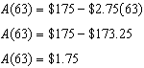
After 63 weeks, Caitlin will have $1.75 on her rental card, which is not enough to rent another movie.

Check using a table of values:
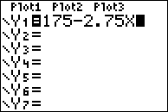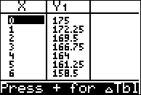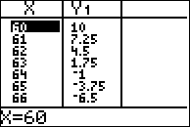

PTS: 4 NAT: F.BF.A.1 TOP: Modeling Linear Equations

111) ANS: 4
Strategy: Eliminate wrong answers.

The problem states that there is a flat charge of $0.46 to mail a letter. This flat charge applies regardless of what the letter weighs. Eliminate any answer that multiplies this flat charge by the weight of the letter. Eliminate answer choices a and c.

The difference between answer choices b and d is in the terms and , where z represents the weight of the letter in ounces. Choice b charges 20 cents for every ounce. Choice d charges 20 cents for every ounce in excess of the first ounce. Choice d is the correct answer.

DIMS? Does It Make Sense? Yes. Transform answer choice c for input into the graphing calculator.
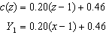
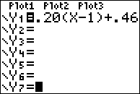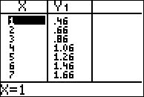
The table shows $0.46 to mail a letter weighing up to 1 oz. and $0.20 per ounce for each additional ounce.

PTS: 2 NAT: A.CED.A.2 TOP: Modeling Linear Equations

112) ANS:

Strategy: Translate the words into math.

$6.50 per adult ticket plus $4.00 per student ticket equals total money collected.
$6.50 times x plus $4.00 times 12 students equals total money collected

PTS: 2 NAT: F.BF.A.1 TOP: Modeling Linear Equations

113) ANS:
Jackson will spend 40 minutes on the treadmill on day 6.

Strategy: Start with a table of values, then write an equation that models both the table view and the narrative view of the function. Then, use the equation to determine the number of minutes Jackson will spend on the treadmill on day 6.

STEP 1: Model the narrative view with a table view.
 | 1 | 2 | 3 | 4 | 5 | 6 | 7 | 8 | 9
 | 30 | 32 | 34 | 36 | 38 | 40 | 42 | 44 | 46

STEP 2: Write an equation.
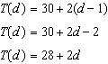

STEP 3: Use the equation to find the number of minutes Jackson will spend on the treadmill on day 6.
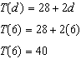

DIMS? Does It Make Sense? Yes. Both the equation and the table of values predict that Jackson will spend 40 minutes on the treadmill on day 6.

PTS: 2 NAT: A.CED.A.1 TOP: Modeling Linear Functions

114) ANS: 4
The problem asks us to change the function to reflect a 25 cents increase in the price for a cup of coffee. To do so, we must understand each part of the equation.
represents the total profits.
represents the price for each cup of coffee times the numbers of cups sold.
represents fixed costs, such as the price of the coffee beans used.

If Emma increases the price of coffee by 25 cents, the term .50c will change to .75c. Everything else will stay the same.

The new function will be .

PTS: 2 NAT: F.BF.A.1 TOP: Modeling Linear Functions

115) ANS: 4
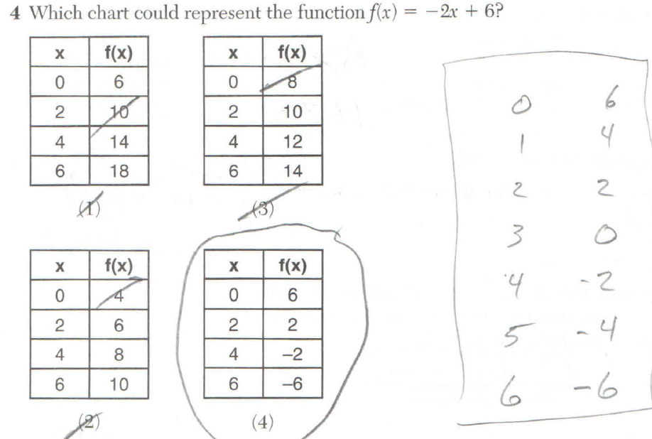

PTS: 2 NAT: F.LE.A.2

116) ANS:
STEP 1: Define variables and write a function rule.
Let represent Jim’s total pay for a week.
Let 300 represent Jim’s fixed pay in dollars.
Let .035 represent the additional pay that Jim receives for furniture sales.
Let x represent Jims dollars of furniture sales during the week.
Write the function rule:
STEP 2: Use the function rule to determine Jim’s pay if he has $8,250 in furniture sales.
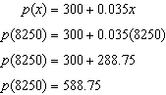
$588.75

PTS: 4 NAT: F.BF.A.1 TOP: Modeling Linear Functions

117) ANS:

Strategy 1: The problem states that the plant grows at a constant daily rate, so the rate of change is constant. Use the slope-intercept form of a line, , and data from the table to identify the slope and y-intercept.

STEP 1: Extend the table to show the y-intercept, as follows:
Day (n) | 0 | 1 | 2 | 3 | 4 | 5
Height (cm) | 1.5 | 3 | 4.5 | 6 | 7.5 | 9
The y-intercept is 1.5, so we can write .

STEP 2. Use the slope formula and any two pairs of data to find the slope. In the following calculation, the points (1,3) and (5,9) are used.
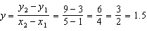
The slope is 1.5, so we can write

DIMS?: See below.

Strategy 2: Use linear regression.
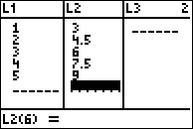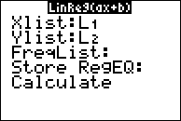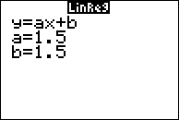
The equation is

DIMS? Does It Make Sense? Yes. The equation can be used to reproduce the table view, as follows:
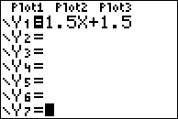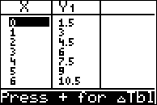

PTS: 2 NAT: F.BF.A.1 TOP: Modeling Linear Functions

118) ANS:
. Each card costs 75¢ and start-up costs were $4.50.

Strategy: Input the table of values in a graphing calculator and use linear regression to write the function rule.
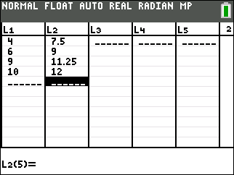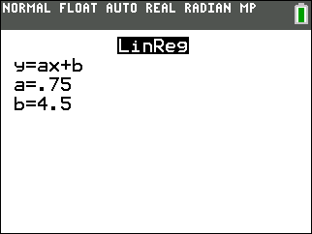

PTS: 4 NAT: F.BF.A.1 TOP: Modeling Linear Functions

119) ANS: 3
Strategy: Interpret the the function in narrative (word) form.

$5.25 for each radio represents the amount spent to manufacture each radio, which is answer choice c.

PTS: 2 NAT: F.LE.B.5 TOP: Modeling Linear Equations

120) ANS: 2
Strategy: Interpret the the function in narrative (word) form.

PTS: 2 NAT: F.LE.B.5 TOP: Modeling Linear Equations

121) ANS: 2
The problem states that the employee is paid an hourly rate of $22.
In the equation , the hourly rate of $22 appears next to the letter x, which is a variable representing the number of hours that the employee works.

DIMS (Does it Make Sense?)
Yes. The equation says that the owner’s profit (P) is a function of how much the employee gets paid. As the value of x increases, the employee gets paid more and the owner’s profits get smaller.

PTS: 2 NAT: A.SSE.A.1 TOP: Modeling Linear Equations

122) ANS: 3
Strategy: Interpret the the function in narrative (word) form, then eliminate wrong answers.

Answer choice a is wrong because the the production costs are not $0.
Answer choice b is wrong because the production costs and costs per airing are reversed.
Answer choice c is correct.
Answer choice d in wrong because it makes no sense.

PTS: 2 NAT: F.LE.B.5 TOP: Modeling Linear Equations

123) ANS:

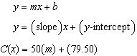
The slope is 50 and represents the amount paid each month for membewrship in the gym.
The y-intercept is 79.50 and represents the initial cost of membership.

PTS: 2 NAT: F.LE.B.5 TOP: Modeling Linear Functions

124) ANS: 2
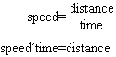
The equation models the distance from Buffalo for a car after t hours. 280 represents the distance in miles from Albany to Buffalo. The car is travelling at an average speed of 59 miles per hour.
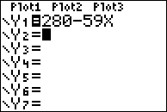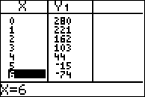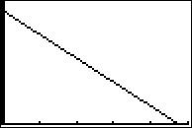
The car’s distance from Albany decreases by 59 miles every hour, so 59 represents the speed of the car.

PTS: 2 NAT: F.LE.B.5 TOP: Modeling Linear Functions

125) ANS: 4
The function can be interpreted as follows: Cost is a function of time and is equal to $125 times the number of hours plus a set fee of $95. All three statements are true.

PTS: 2 NAT: F.LE.B.5 TOP: Modeling Linear Functions

126) ANS: 2
The graph shows that the average number of hours of sleep per day decreases as age increases. The correlation is negative.
a) The average number of hours of sleep per day increases 0.09 hour per year of age.
b) The average number of hours of sleep per day decreases 0.09 hour per year of age.
c) The average number of hours of sleep per day increases 9.24 hours per year of age.
d) The average number of hours of sleep per day decreases 9.24 hours per year of age.

PTS: 2 NAT: S.ID.C.7 TOP: Modeling Linear Functions

127) ANS:

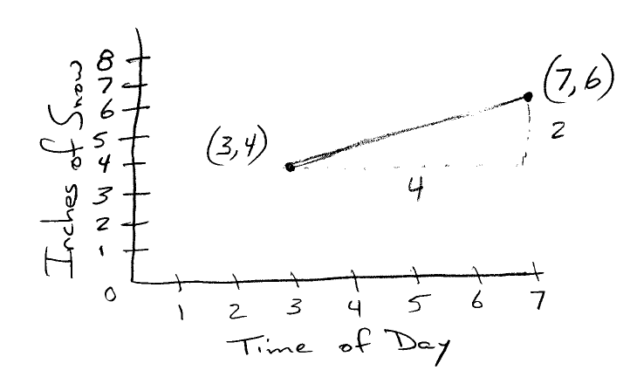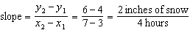
The slope represents the rate of snowfall, which is 2 inches of snow every 4 hours.

PTS: 2 NAT: F.IF.B.6 TOP: Modeling Linear Functions

128) ANS: 3
Strategy: Identify the constant term in the expression , what it means, and eliminate wrong answers..
STEP 1. 2.50a is a variable term and 290 is a constant term. Eliminate the two answer choices that start with 2.50a.
STEP 2. The term 290 can represent the amount Mike earns when he sells a accessories, since the term does not contain a. Eliminate this choice.
Does It Make Sense? Yes. Mike gets $2.50 for every cell phone accessory he sells plus a constant amount of $290 each week.

PTS: 2 NAT: F.LE.B.5 TOP: Modeling Linear Functions

