**I – Systems, Lesson 6, Quadratic-Linear Systems (r. 2018)**

SYSTEMS

Quadratic-Linear Systems

|  |  |
| --- | --- |
| **Common Core Standard**  **No Current Standard in New York**  **A-REI.D.11** Explain why the x-coordinates of the points where the graphs of the equations *y=f(x)* and *y=g(x)* intersect are the solutions of the equation *f(x)=g(x)*; find the solutions approximately, e.g., using technology to graph the functions, make tables of values, ~~or find successive approximations~~. Include cases where *f(x)* and/or *g(x)* are linear, polynomial, rational, absolute value, exponential~~, and logarithmic functions~~.  ~~PARCC: Tasks that assess conceptual understanding of the indicated concept may involve any of the function types mentioned in the standard except exponential and logarithmic functions. Finding the solutions approximately is limited to cases where f(x) and g(x) are polynomial functions.~~ | **Next Generation Standards**  **AI-A.REI.7a** Solve a system, with rational solutions, consisting of a linear equation and a quadratic equation (parabolas only) in two variables both algebraically and graphically.  (Shared standard with Algebra II)  **AI-A.REI.11** Given the equations *y = f(x)* and *y = g(x)*:  i) **recognize** that each x-coordinate of the intersection(s) is the solution to the equation *f(x) = g(x)*;  ii)find the solutions approximately using technology to graph the functions or make tables of values; and  iii) **interpret the solution in context**.  (Shared standard with Algebra II)  **Notes: Algebra I tasks are limited to cases where *f(x)* and *g(x)* are linear, polynomial, absolute value, and exponential functions of the form  where *a* > 0 and *b* > 0 (*b* ≠ 1).**  **Students should be taught to find the solutions approximately by using technology to graph the functions *and* by making tables of values. When solving any problem, students can choose either strategy.** |

**LEARNING OBJECTIVES**

Students will be able to:

1) solve quadratic-linear systems of equations algebraically or by graphing.

**Overview of Lesson**

|  |  |
| --- | --- |
| **Teacher Centered Introduction**  **Overview of Lesson**  **- activate students’ prior knowledge**  **- vocabulary**  **- learning objective(s)**  **- big ideas: direct instruction**  **- modeling** | **Student Centered Activities**  **guided practice ⬅Teacher: anticipates, monitors, selects, sequences, and connects student work**  **- developing essential skills**  **- Regents exam questions**  **- formative assessment assignment (exit slip, explain the math, or journal entry)** |

**VOCABULARY**

linear equation

quadratic equation

solution

**BIG IDEAS**

Quadratic-linear systems are solved in the same ways that systems of linear equations and/or systems of linear inequalities are solved, either algebraically or by graphing.

A **solution of a system** of equations makes each equation in the system true. Solutions can be found using three different views of a function. Quadratic linear systems will have:

* no solution (the graphs do not intersect),
* one solution (the graphs intersect at one point)
* two solutions (the graphs intersect at two points).

Example: If  and , then the solution may be found using a graphing calculator, as follows:

|  |  |  |
| --- | --- | --- |
|  |  |  |

The solutions to this quadratric-linear system are (-3,4) and (1,0).

NOTE: The calculate intersection function of some graphing calculators can be used to identify solutions.

How to Solve a Quadratic Linear System Algebraically

|  |  |  |  |  |
| --- | --- | --- | --- | --- |
| Step 1 | Step 2 | Step 3 | Step 4 | Step 4 |
| Isolate the same variable in both equations. | Set the opposite expressions equal to one another. | Solve for the first variable.  NOTE: Strategies other than factoring can be used. | Input the solutions from Step 3 into an equation and solve for the second variable. | Write the solutions as ordered pairs. |
|  |  |  |  | Two solutions:  (-4,-5)  and  (1,10) |

**DEVELOPING ESSENTIAL SKILLS**

Solve the following quadratic-linear systems of equations algebraically and by graphing.

|  |  |  |  |  |
| --- | --- | --- | --- | --- |
| 1. | 2. | 3. | 4. | 5. |

Answers

|  |  |
| --- | --- |
| 1. | 2. |

|  |  |
| --- | --- |
| 3. | 4. |

|  |  |
| --- | --- |
| 5. |  |

**REGENTS EXAM QUESTIONS (through June 2018)**

A.REI.C.7, A.REI.D.11: SOLVE QUADRATIC-LINEAR SYSTEMS

287) The graphs of  and  intersect at approximately

|  |  |  |  |
| --- | --- | --- | --- |
| 1) | , only | 3) | and |
| 2) | , only | 4) | and |

288) A company is considering building a manufacturing plant. They determine the weekly production cost at site *A* to be  while the production cost at site *B* is , where *x* represents the number of products, *in hundreds*, and  and  are the production costs, *in hundreds of dollars*. Graph the production cost functions on the set of axes below and label them site *A* and site *B*.

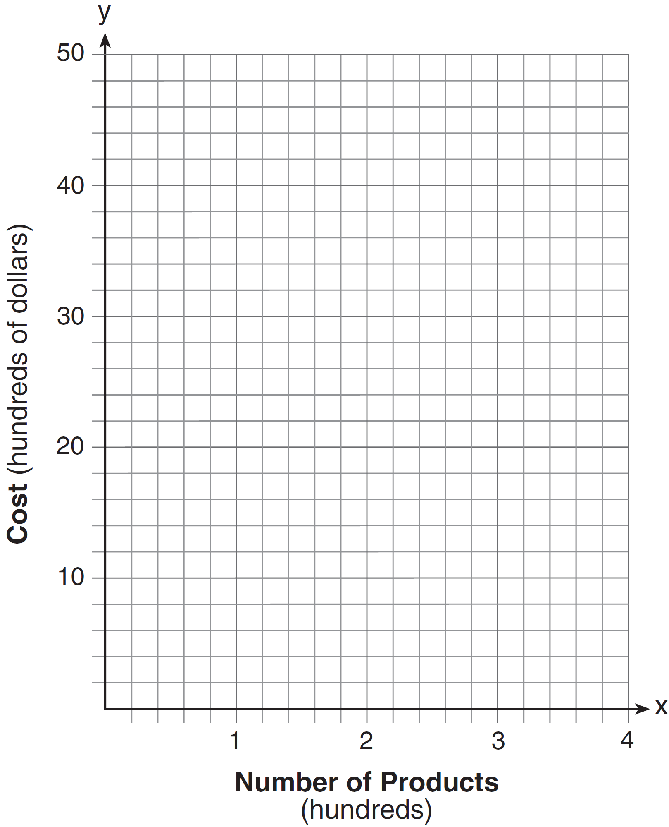

State the positive value(s) of *x* for which the production costs at the two sites are equal. Explain how you determined your answer. If the company plans on manufacturing 200 products per week, which site should they use? Justify your answer.

289) Let  and . On the set of axes below, draw the graphs of  and .



Using this graph, determine and state *all* values of *x* for which .

290) John and Sarah are each saving money for a car. The total amount of money John will save is given by the function . The total amount of money Sarah will save is given by the function . After how many weeks, *x*, will they have the same amount of money saved? Explain how you arrived at your answer.

291) If  and , for which value of *x* is ?

|  |  |  |  |
| --- | --- | --- | --- |
| 1) | and | 3) | and 0 |
| 2) | and 4 | 4) | 4 and 0 |

292) If  and , determine the value(s) of *x* that satisfy the equation .

293) Given: 

Solve the equation  algebraically for *x*, to the *nearest tenth*. Explain why you chose the method you used to solve this quadratic equation.

**SOLUTIONS**

287) ANS: 3

Strategy #1. Solve  and  as a system of equations.

 and 

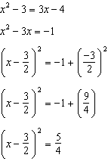 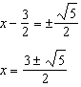

The values of x that satisfy the system are:

 and 

Strategy #2. Use a graphing calculator to determine the inttercepts of the graphs of the two equations.

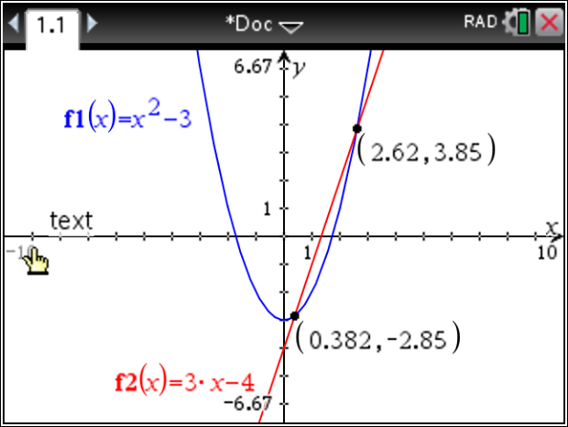

PTS: 2 NAT: A.REI.C.7 TOP: Quadratic-Linear Systems

KEY: algebraically

288) ANS:

a) 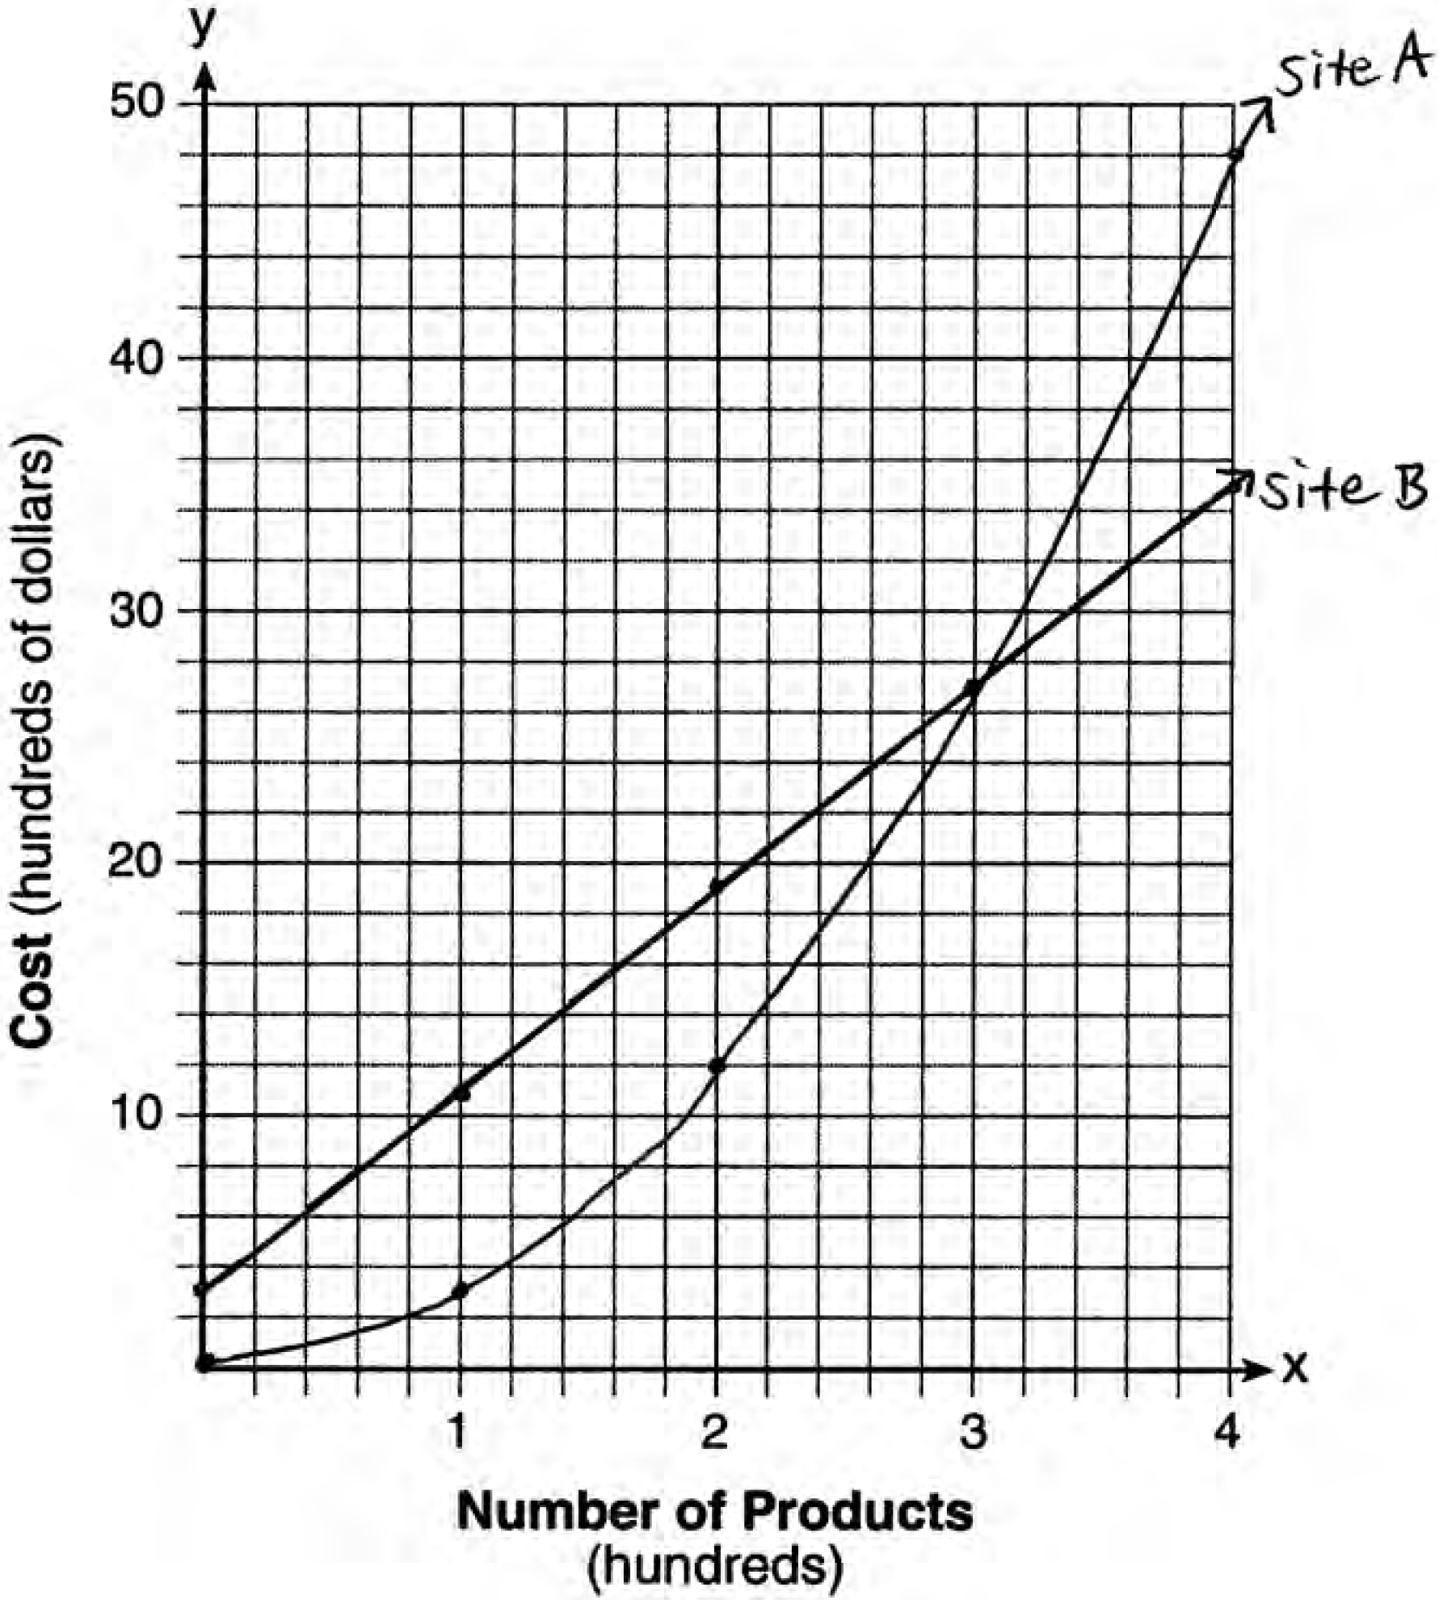

b) The graphs of the production costs are equal when .

c) The company should use Site *A*, because the costs of Site *A* are lower when .

Strategy: Input both functions into a graphing calculator and use the table and graph views to construct the graph on paper and to answer the question.

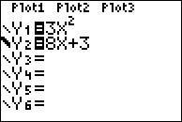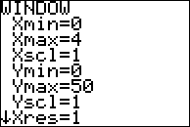

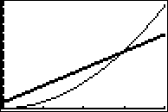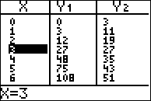

PTS: 6 NAT: A.REI.D.11 TOP: Quadratic-Linear Systems

289) ANS:

a) 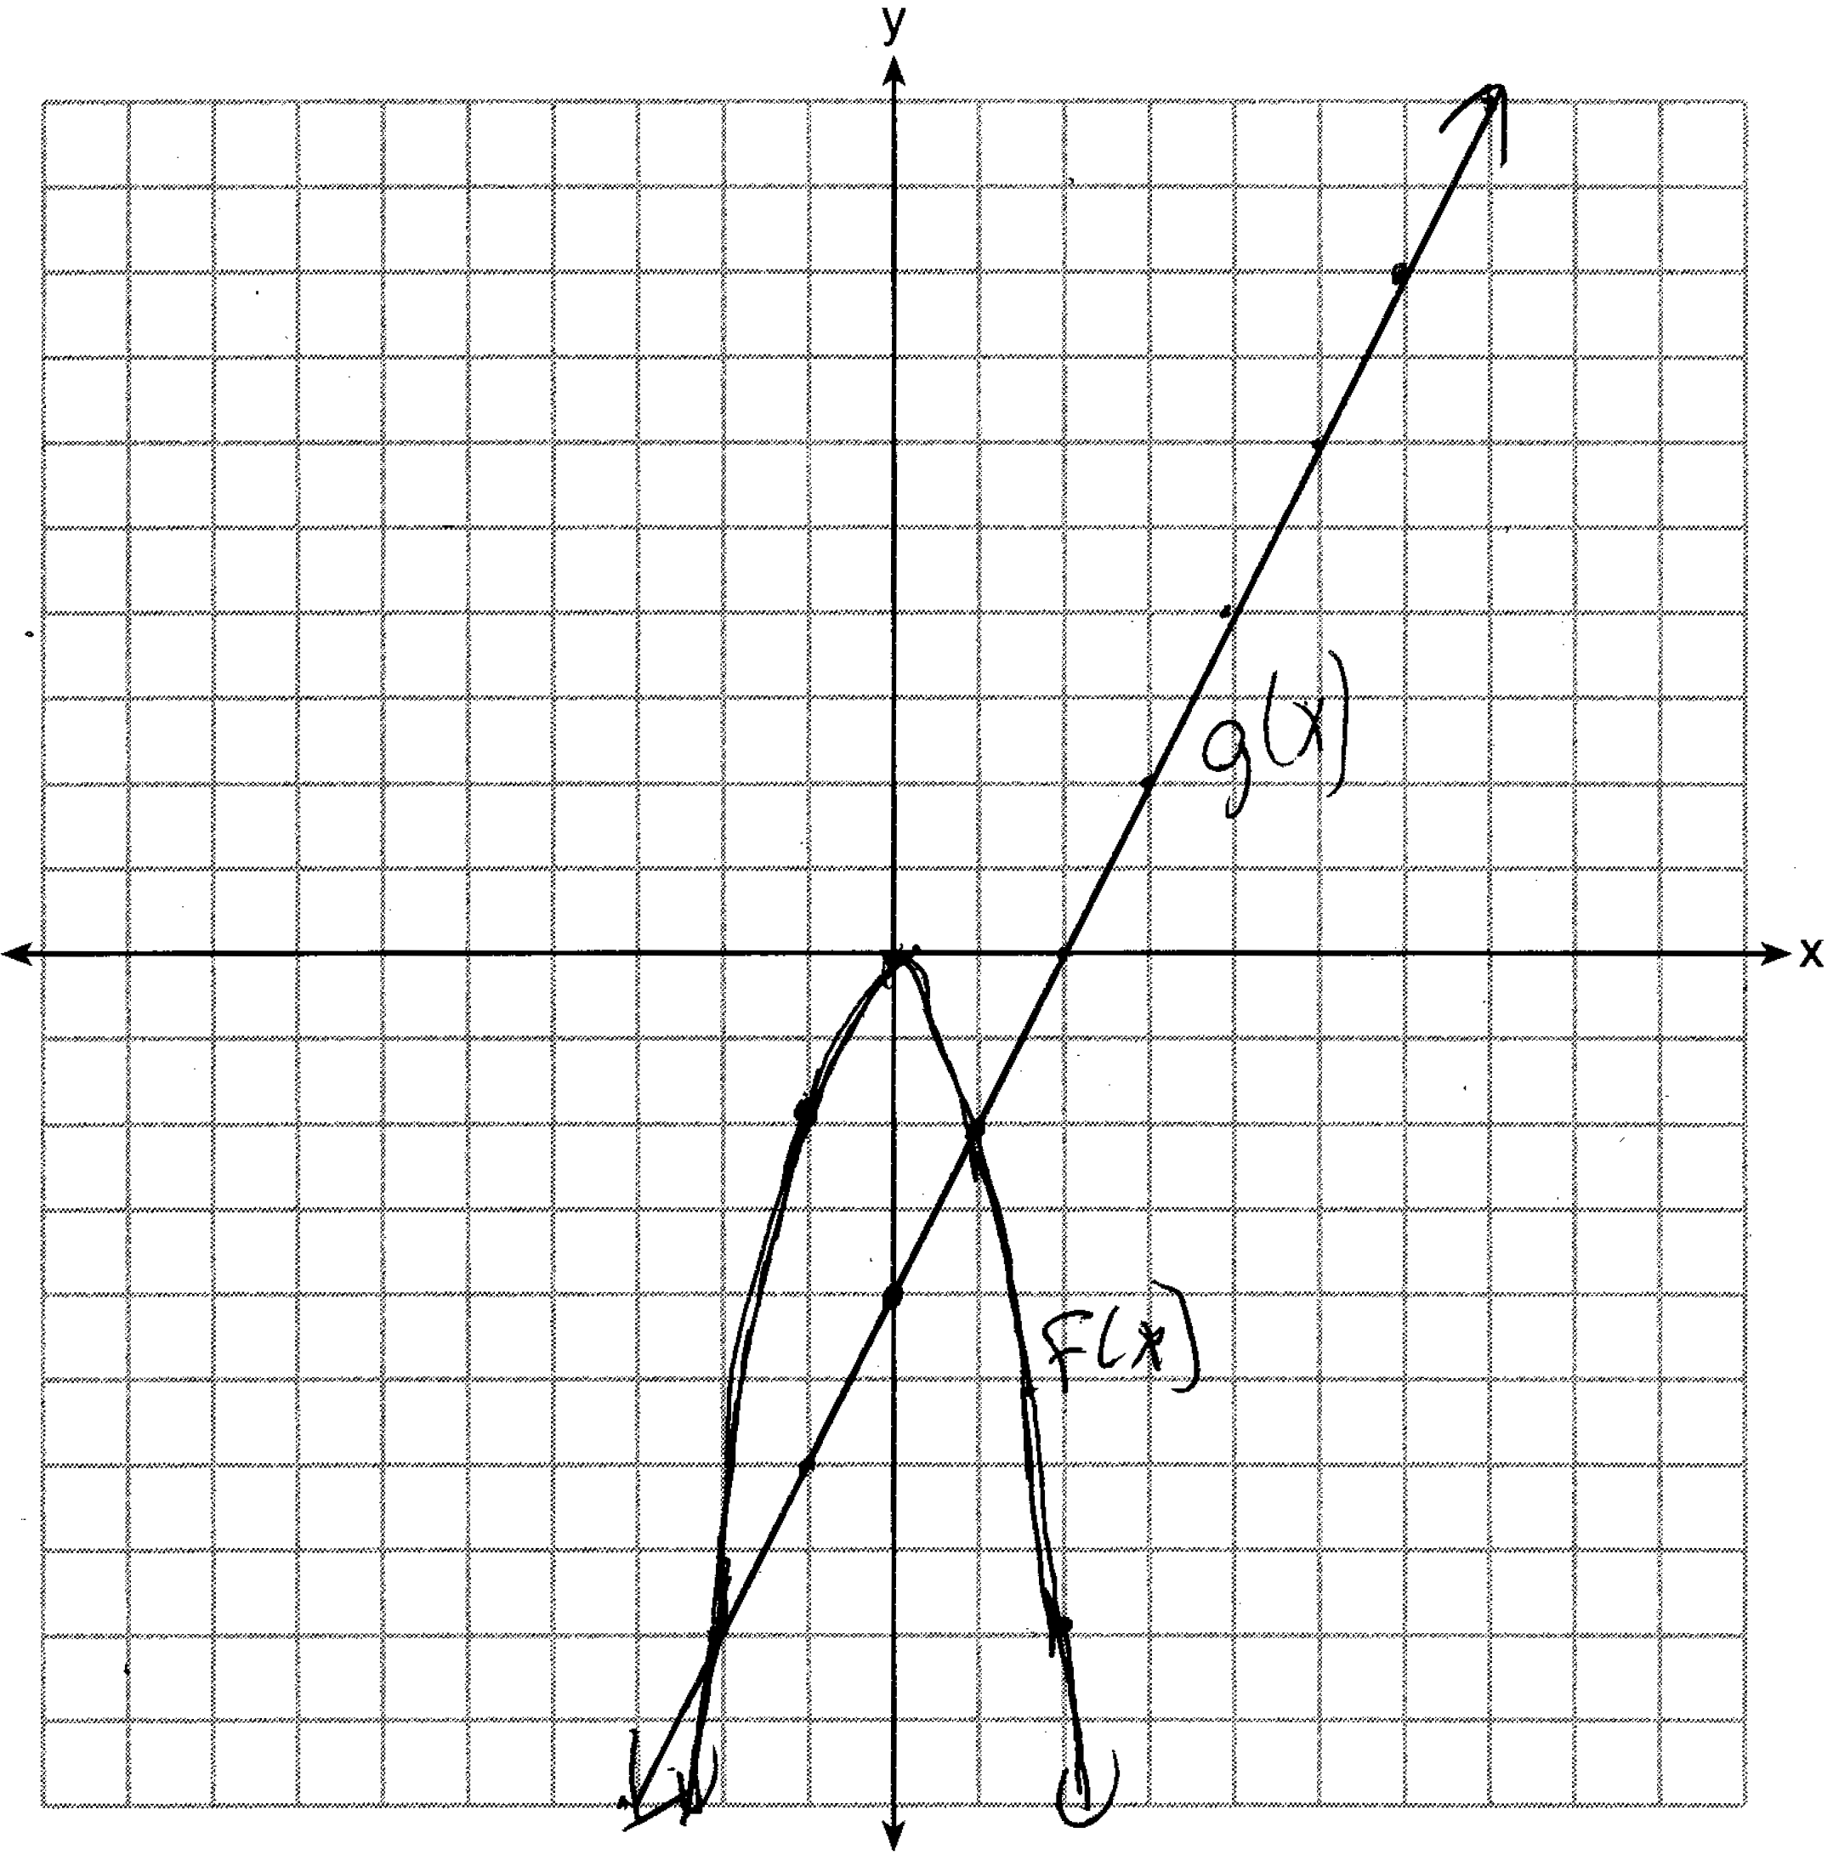

b)  when  and .

Strategy: Input both functions into a graphing calculator and use the table and graph views to construct the graph on paper and to answer the question.

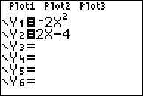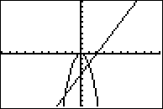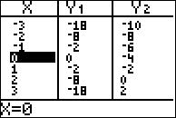

PTS: 4 NAT: A.REI.D.11 TOP: Quadratic-Linear Systems

290) ANS:

John and Sarah will have the same amount of money saved at 7 weeks. I set the expressions representing their savings equal to each other and solved for the positive value of *x* by factoring.

Strategy: Set the expressions representing their savings equal to one another and solve for *x*.

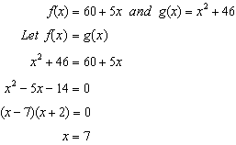

DIMS? Does It Make Sense? Yes. After 7 weeks, John and Sarah will each have $95.00.

|  |  |
| --- | --- |
| John’s Savings | Sarah’s Savings |

PTS: 2 NAT: A.REI.D.11 TOP: Quadratic-Linear Systems

291) ANS: 2

Strategy: Set both expressions equal to one another and solve for *x*.

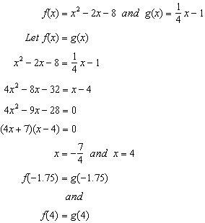

PTS: 2 NAT: A.REI.D.11 TOP: Quadratic-Linear Systems

292) ANS:



Given: and , find  as follows:

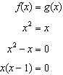

Therefore:  and 

PTS: 2 NAT: A.REI.D.11 TOP: Quadratic-Linear Systems

KEY: AI

293) ANS:



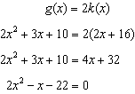

The quadratic formula can be used to solve this quadratic in standard form, where , , and .

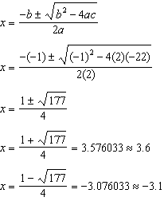

The quadratic formula was chosen because it works with any quadratic equation.

PTS: 4 NAT: A.REI.D.11 TOP: Quadratic-Linear Systems

KEY: AI