**E – Linear Equations, Lesson 2, Graphing Linear Functions (r. 2018)**

LINEAR EQUATIONS

Graphing Linear Functions

|  |  |
| --- | --- |
| **Common Core Standards**  **A-CED.A.2** Create equations in two or more variables to represent relationships between quantities; ~~graph equations on coordinate axes with labels and scales~~.    **F-IF.B.4** For a function that models a relationship between two quantities, interpret key features of graphs and tables in terms of the quantities, and sketch graphs showing key features given a verbal description of the relationship. *Key features include: intercepts; intervals where the function is increasing, decreasing, positive, or negative; relative maximums and minimums; symmetries; end behavior; and periodicity.*  PARCC: Tasks have a real-world context. Tasks are limited to linear functions, quadratic functions, square root functions, cube root functions, piece-wise defined functions (including step functions and absolute value functions) and exponential functions with domains in the integers. | **Next Generation Standards**  **AI-A.CED.2** Create equations and linear inequalities in two variables to represent a **real-world context**.  Notes:  • **This is strictly the development of the model (equation/inequality).**  • **Limit equations to linear, quadratic, and exponentials of the form where *a* > 0 and *b* > 0 (*b* ≠ 1).**  **AI-F.IF.4** For a function that models a relationship between two quantities:  i) interpret key features of graphs and tables in terms of the quantities; and  ii) sketch graphs showing key features given a verbal description of the relationship.  (Shared standard with Algebra II)  Notes:  • Algebra I key features include the following: intercepts, **zeros**; intervals where the function is increasing, decreasing, positive, or negative; maxima, minima; and symmetries.  • Tasks have a real-world context and are limited to the following functions: linear, quadratic, square root, piece-wise defined (including step and absolute value), and **exponential functions of the form  where *a* > 0 and *b* > 0 (*b*≠1)**. |

**LEARNING OBJECTIVES**

Students will be able to:

1. Write function rules that represent table and/or context views of a mathematical relationship between two variables.
2. Graph functions based on function rules, tables, or contexts.

**Overview of Lesson**

|  |  |
| --- | --- |
| **Teacher Centered Introduction**  **Overview of Lesson**  **- activate students’ prior knowledge**  **- vocabulary**  **- learning objective(s)**  **- big ideas: direct instruction**  **- modeling** | **Student Centered Activities**  **guided practice ⬅Teacher: anticipates, monitors, selects, sequences, and connects student work**  **- developing essential skills**  **- Regents exam questions**  **- formative assessment assignment (exit slip, explain the math, or journal entry)** |

**VOCABULARY**

context

coordinate pair

function rule

graph

plot point

rate of change

table of values

x-axis intercept

y-axis intercept

**BIG IDEAS**

**Three Facts About Graphs and Their Equations**

1. The graph of an equation represents the set of all points that satisfy the equation (make the equation balance).

2. Each and every point on the graph of an equation represents a coordinate pair that can be substituted into the equation to make the equation true.

3. If a point is on the graph of the equation, the point is a solution to the equation.

**How to Graph Any Equation**:

**Table of Values Method:** Given a table of values for a function, simply plot each coordinate pair on a coordinate plane, then sketch the line that connects the plotted points. If given a function rule or context view, first create a table of values either manually or using a graphing calculator, then plot enough coordinate pairs to sketch the graph.

**Minimum Number of Plot Points Required**: Equations can be classified as either *linear* or *non-linear*. All linear equations, *except* vertical lines, are functions.

* **To graph a *linear* equation**, you need to plot a minimum of *two* points using either of the following methods:
  + **Two Points Method**: If you know two points on the line, simply plot both of them and draw a straight line passing through the two points.
  + **One Point and the Slope Method**: If you know one point on the line and the slope of the line, plot the point and use the slope to draw a right triangle to find a second point. Then, draw a straight line passing through the two points.
* **To graph a *non-linear* equation**, you need a minimum of *three* plot points. More plot points are better.

**How to Find Intercepts of x and y-Axes**

The ***x*-axis intercept** is the x-value of the point at which the graph of a relation intercepts the *x-*axis. The ordered pair for any point of the x-axis will always have a value of *y* = 0.

**Example**: The equation y = 2x + 8 has an *x*-intercept of -4. This can be found algebraically by substituting a value of 0 for y.



The ***y*-axis intercept** is the y-value of the point at which a graph of a relation intercepts the *y-*axis. The ordered pair for this point has a value of *x* = 0.

**Example**: The equation y = 8 + 2x has a y-intercept of 8. This can be found algebraically by substituting a value of zero for x.



**Rate of Change/Slope**

|  |  |
| --- | --- |
| **Positive Slope**  Goes up from left to right. | **Negative Slope**. Goes down from left to right. |
| **Zero Slope**.  A horizontal line has a slope of zero. | **Undefined Slope**.  A vertical line has an undefined slope. |

**DEVELOPING ESSENTIAL SKILLS**

Super Painters charges $1.00 per square foot plus an additional fee of $25.00 to paint a living room. If *x* represents the area of the walls of Francesca's living room, in square feet, and *y* represents the cost, in dollars, which graph best represents the cost of painting her living room?

a) 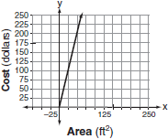 c) 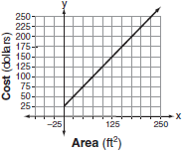

b) 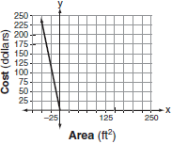 d) 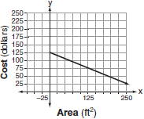

Answer: c: This graph has a *y*-intercept of 25 and a slope of 1.

The gas tank in a car holds a total of 16 gallons of gas. The car travels 75 miles on 4 gallons of gas. If the gas tank is full at the beginning of a trip, which graph represents the rate of change in the amount of gas in the tank?

a) 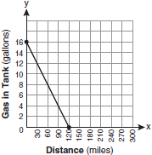 c) 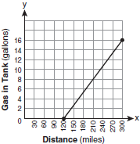

b) 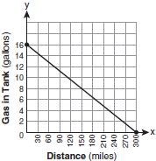 d) 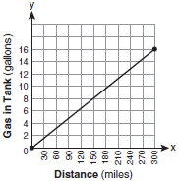

Answer: b: If the car can travel 75 miles on 4 gallons, it can travel 300 miles on 16 gallons.

 .

**REGENTS EXAM QUESTIONS (through June 2018)**

A.CED.A.2, F.IF.B.4: Graphing Linear Functions

129) Max purchased a box of green tea mints. The nutrition label on the box stated that a serving of three mints contains a total of 10 Calories. On the axes below, graph the function, *C*, where  represents the number of Calories in *x* mints.

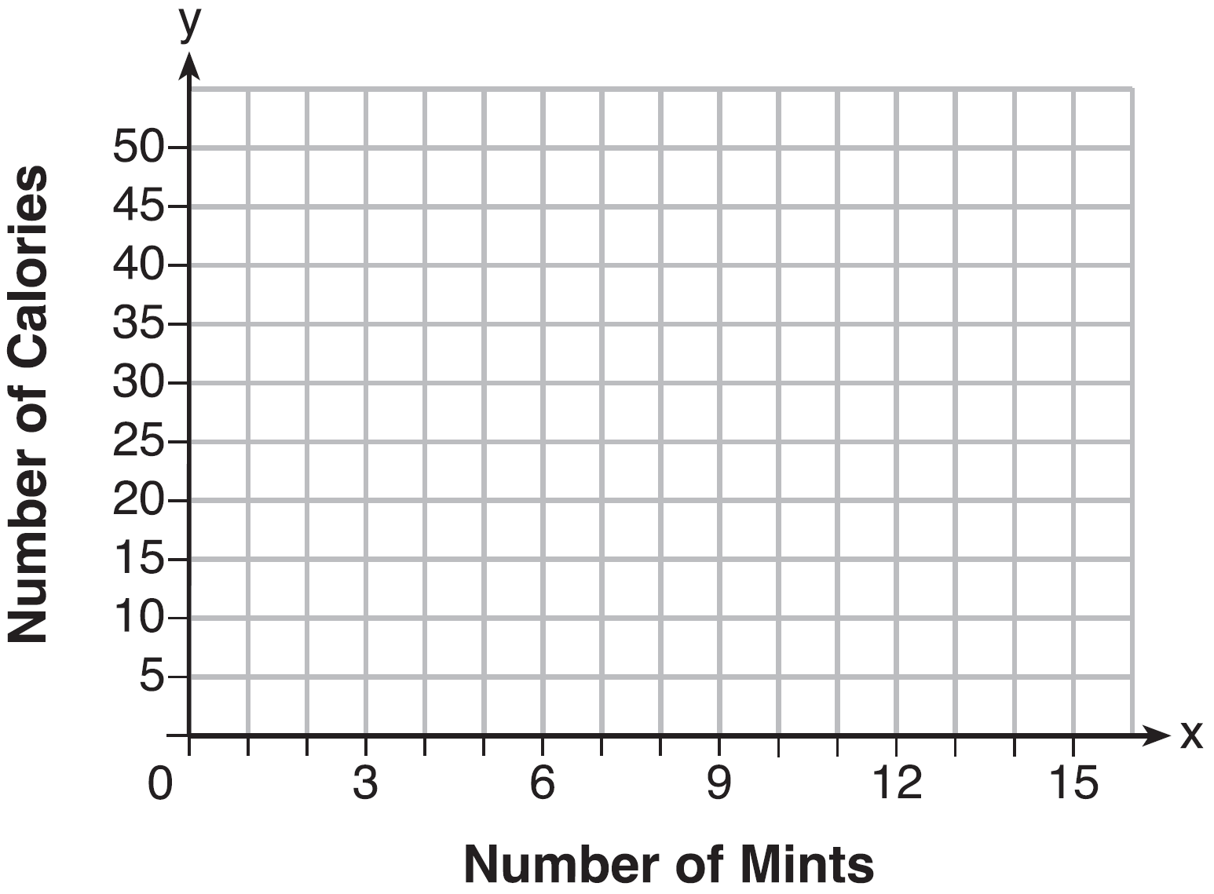

Write an equation that represents . A full box of mints contains 180 Calories. Use the equation to determine the total number of mints in the box.

130) Which graph shows a line where each value of *y* is three more than half of *x*?

|  |  |  |  |
| --- | --- | --- | --- |
| 1) |  | 3) |  |
| 2) |  | 4) |  |

131) The graph below was created by an employee at a gas station.

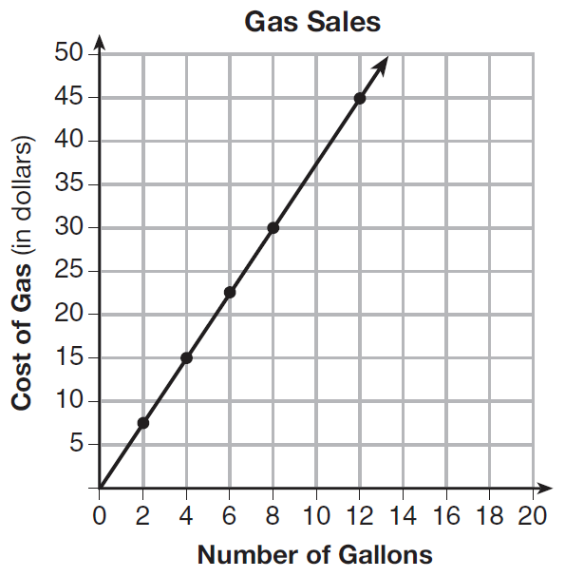

Which statement can be justified by using the graph?

|  |  |  |  |
| --- | --- | --- | --- |
| 1) | If 10 gallons of gas was purchased, $35 was paid. | 3) | For every 2 gallons of gas purchased, $5.00 was paid. |
| 2) | For every gallon of gas purchased, $3.75 was paid. | 4) | If zero gallons of gas were purchased, zero miles were driven. |

132) The value of the *x*-intercept for the graph of  is

|  |  |  |  |
| --- | --- | --- | --- |
| 1) | 10 | 3) |  |
| 2) |  | 4) |  |

133) Which function has the same *y*-intercept as the graph below?

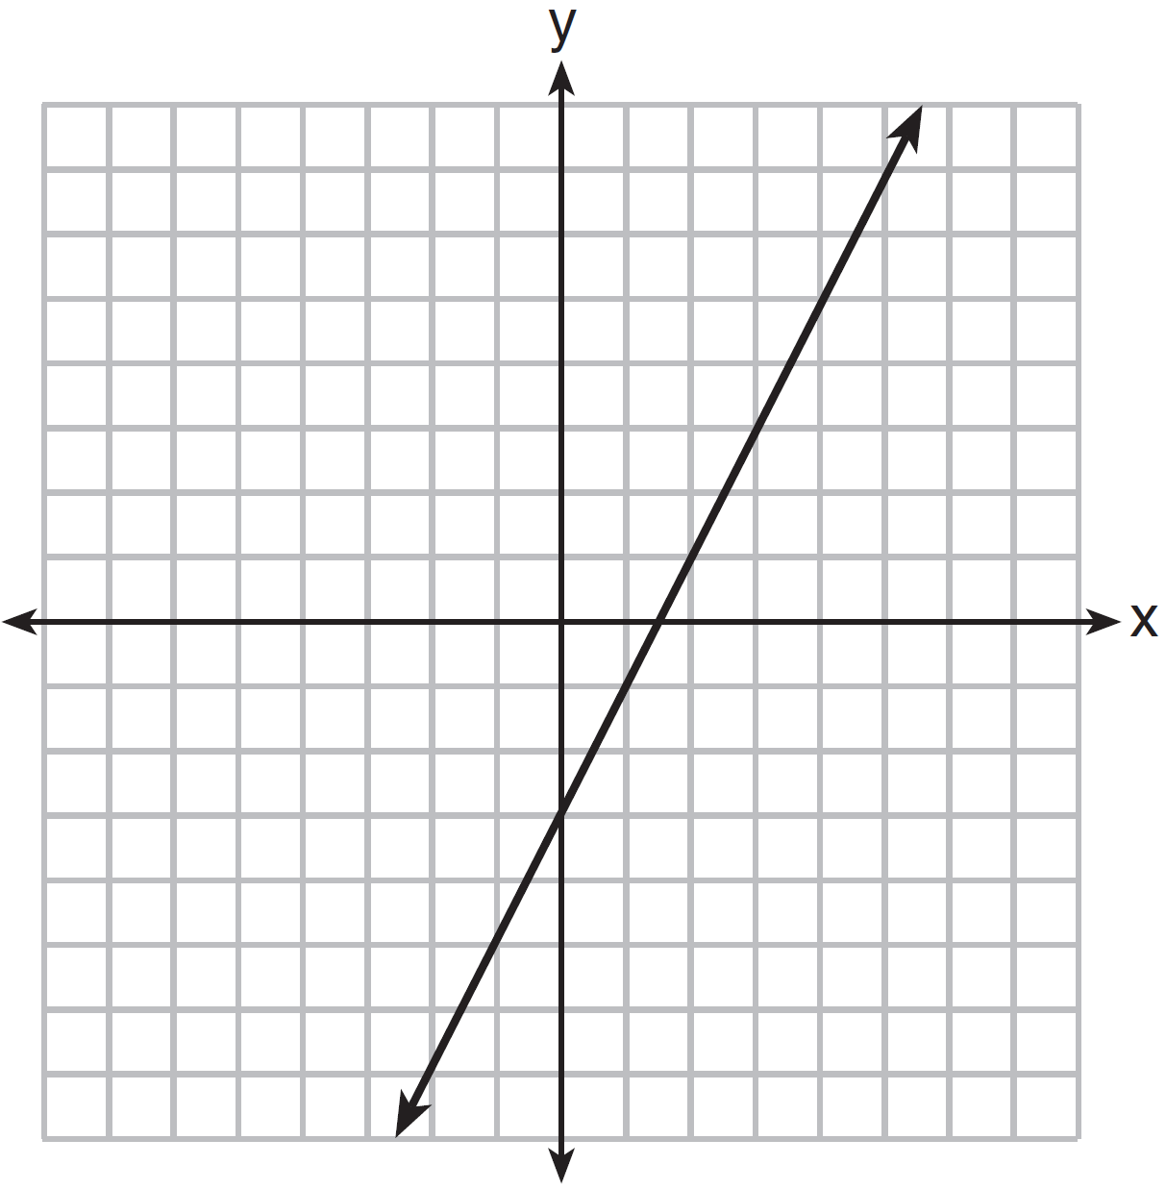

|  |  |  |  |
| --- | --- | --- | --- |
| 1) |  | 3) |  |
| 2) |  | 4) |  |

134) Samantha purchases a package of sugar cookies. The nutrition label states that each serving size of 3 cookies contains 160 Calories. Samantha creates the graph below showing the number of cookies eaten and the number of Calories consumed.

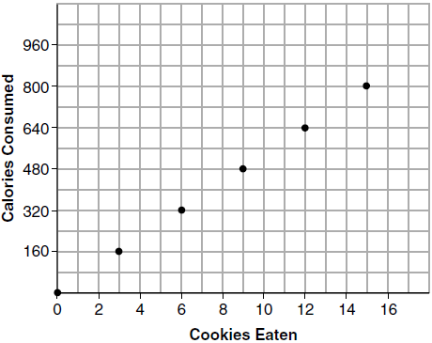

Explain why it is appropriate for Samantha to draw a line through the points on the graph.

**SOLUTIONS**

129) ANS:

a) 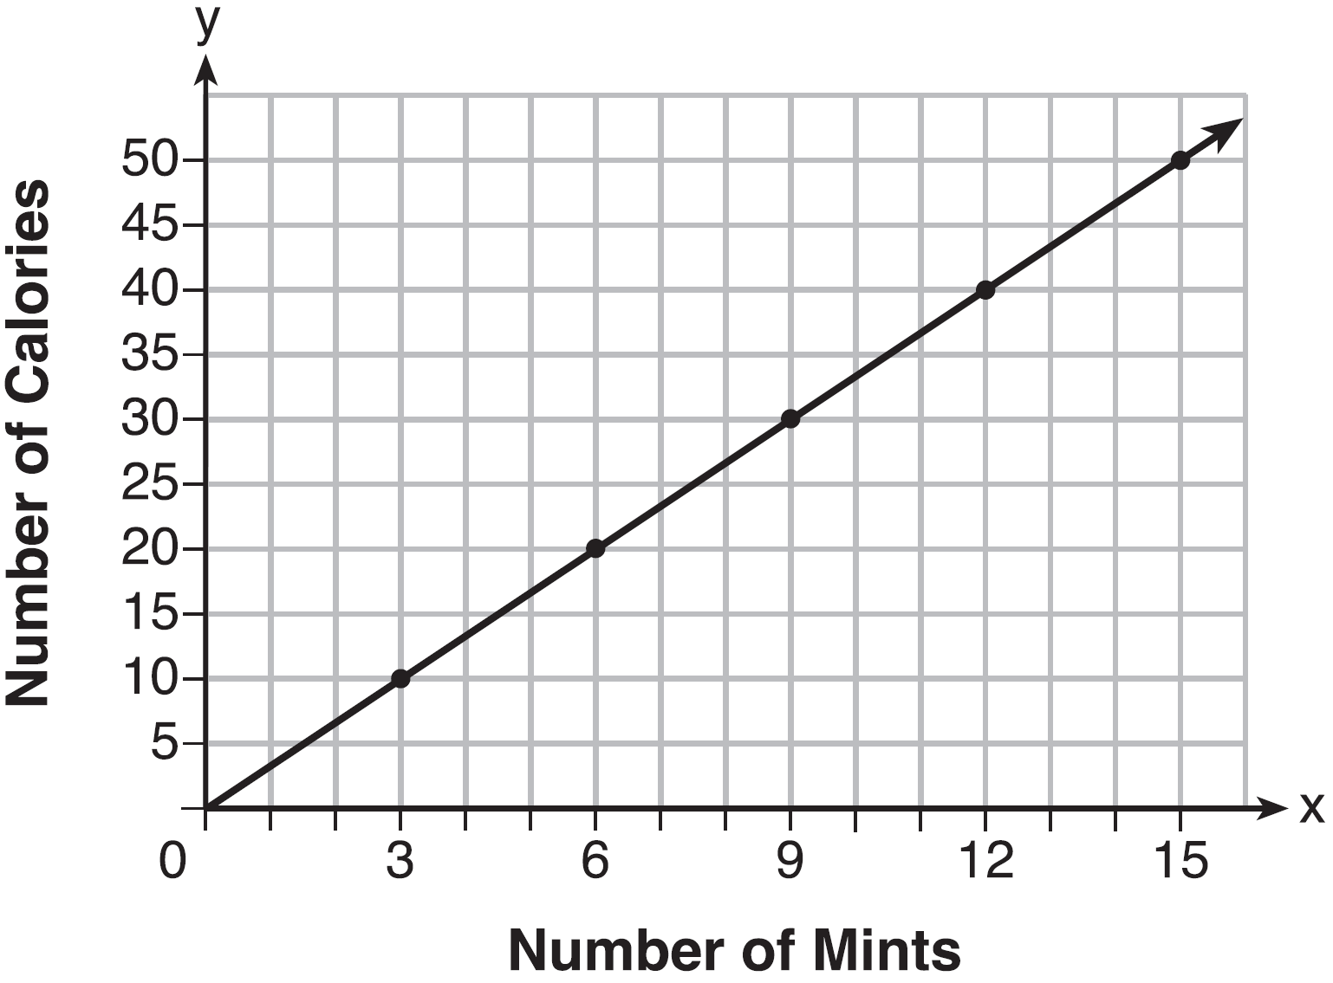

b) 

c) A full box contains 54 mints.

Strategy: Write the equation, then graph the equation, then use the equation and 180 calories to determine the number of mints in a full box.

STEP 1. Write the equation.

If 3 mints contain ten calories, then one mint contains  calories, and x number of mints contains  calories. Therefore: .

STEP 2: Transform the equation and input the equation into a graphing calculator.

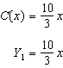

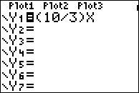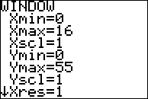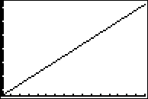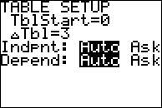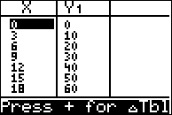

STEP 3. Transfer the graph from the calculators table of values to the paper graph and complete the graph.

STEP 4. Substitute 180 calories for  in the equation and solve for *x* (the number of mints)

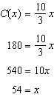

There are 54 mints in a full box.

DIMS: Does It Make Sense? Yes. The table view of the function also shows that 180 calories is paired with 54 mints.

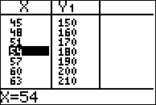

PTS: 4 NAT: A.CED.A.2 TOP: Graphing Linear Functions

130) ANS: 2

Strategy: Convert the narrative view to a function rule, then graph it.

STEP 1. Write the function rule.

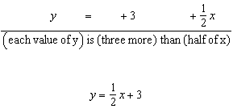

STEP 2. Input the function rule in a graphing calculator and compare the graph view of the function to the answer choices.

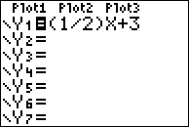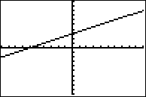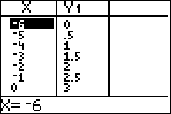

Answer choice *b* is correct.

DIMS? Does It Make Sense? Yes. The x and y intercepts are reflected in both the graph and the table of values.

PTS: 2 NAT: A.CED.A.2 TOP: Graphing Linear Functions

KEY: bimodalgraph

131) ANS: 2

Strategy #1: Use the slope of the line to determine the cost per gallon of gas. Select any two points that are on intersections of vertical and horizontal gridlines, then substitute them into the slope formula to determine the rate of change, which is the cost per gallon of gas.

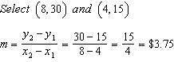

or

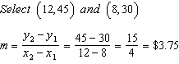

For every gallon of gas purchased. $3.75 was paid.

Strategy #2. Eliminate wrong answers.

Choice (a) is wrong because the chart shows that 10 gallongs of gas costs $37.50, not $35.00.

Choice (b) is correct.

Choice (c) is wrong because the chart shows that 2 gallons of gas cost $7.50, not $5.00.

Choice (d) is wrong because the chart says nothing about the number of miles driven.

PTS: 2 NAT: A.CED.A.2 TOP: Graphing Linear Functions

132) ANS: 1

Strategy: Find the value of x when y equals 0. NOTE: The x-intercept can also be defined as the x-value of the coordinate where the graph intercepts (passes through) the x-axis.

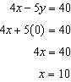

The value of the x-intercept is 10.

PTS: 2 NAT: F.IF.C.9 TOP: Graphing Linear Functions

133) ANS: 4

Strategy: Identify the y-intercept in the graph, then test each answer choice to see if it has the same y-intercept.

STEP 1. Identify the y-intercept in the graph.

The y-intercept is can be defined as the y-value of the coordinate where the graph intercepts (passes through) the y-axis. The graph shows that the function passes through the y-axis at the point , so the value of the y-intercept is -3.

STEP 2. Test the other equations to see if the point works.

|  |  |  |  |
| --- | --- | --- | --- |
| a | Does not work | c | Does not work |
| b | Does not work | d | works! |

PTS: 2 NAT: F.IF.C.9 TOP: Graphing Linear Functions

134) ANS:

A line is appropriate because the data is continuous. Samantha could eat any fraction of a cookie and fill in the line between the points for whole cookies.

PTS: 2 NAT: F.IF.B.4 TOP: Graphing Linear Functions