**C – Expressions and Equations, Lesson 4, Modeling Linear Equations (r. 2018)**

EXPRESSIONS AND EQUATIONS

Modeling Linear Equations

|  |  |
| --- | --- |
| **Common Core Standards**  **A-CED.A.1** Create equations and inequalities in one variable ~~and use them to solve problems~~. *Include equations arising from linear and quadratic functions, and ~~simple rational and~~ exponential functions.*  PARCC: Tasks are limited to linear, quadratic, or exponential equations with integer exponents.  **A-CED.A.2** Create equations in two or more variables to represent relationships between quantities; ~~graph equations on coordinate axes with labels and scales~~.  **A-CED.A.3** Represent constraints by equations or inequalities, and by systems of equations and/or inequalities, and interpret solutions as viable or non-viable options in a modeling context. *For example, represent inequalities describing nutritional and cost constraints on combinations of different foods.* | **Next Generation Standards**  **AI-A.CED.1** Create equations and inequalities in one variable to **represent a real-world context**.  (Shared standard with Algebra II)  Notes:  • **This is strictly the development of the model (equation/inequality).**  • **Limit equations to linear, quadratic, and exponentials of the form *f(x) = a(b)x* where *a* > 0 and *b* > 0 (*b* ≠ 1).**  • **Work with geometric sequences may involve an exponential equation/formula of the form an = arn-1, where a is the first term and r is the common ratio.**  • **Inequalities are limited to linear inequalities.**  • Algebra I tasks do not involve compound inequalities.  **AI-A.CED.2** Create equations and linear inequalities in two variables to represent a **real-world context**.  Notes:  • **This is strictly the development of the model (equation/inequality).**  • **Limit equations to linear, quadratic, and exponentials of the form  where *a* > 0 and**  ***b* > 0 (*b* ≠ 1).**  **AI-A.CED.3** Represent constraints by equations or inequalities, and by systems of equations and/or inequalities, and interpret solutions as viable or non-viable options in a modeling context.  e.g., Represent inequalities describing nutritional and cost constraints on combinations of different foods. |

**LEARNING OBJECTIVES**

Students will be able to:

1) Model real-world word problems as mathematical expressions and equations.

**Overview of Lesson**

|  |  |
| --- | --- |
| **Teacher Centered Introduction**  **Overview of Lesson**  **- activate students’ prior knowledge**  **- vocabulary**  **- learning objective(s)**  **- big ideas: direct instruction**  **- modeling** | **Student Centered Activities**  **guided practice ⬅Teacher: anticipates, monitors, selects, sequences, and connects student work**  **- developing essential skills**  **- Regents exam questions**  **- formative assessment assignment (exit slip, explain the math, or journal entry)** |

**VOCABULARY**

See key words and their mathematical translations under big ideas.

**BIG IDEAS**

Translating words into mathematical expressions and equations is an important skill.

**General Approach**

The general approach is as follows:

1. Read and understand the entire problem.
2. Underline key words, focusing on variables, operations, and equalities or inequalities.
3. Convert the key words to mathematical notation (consider meaningful variable names other than x and y).
4. Write the final expression or equation.
5. Check the final expression or equation for reasonableness.

**Key English Words and Their Mathematical Translations**

|  |  |  |
| --- | --- | --- |
| These English Words | Usually Mean | *Examples: English becomes math* |
| sum, plus, and | addition | *the sum of 5 and x becomes 5 + x* |
| minus, less, take away, difference of | subtraction | *5 minus x becomes 5 – x*  *the difference of x and 5 becomes x - 5* |
| *less than* | subtraction | *3 less than x becomes x - 3* |
| product, times, multiplied by | multiplication | *the product of five times two becomes 5 x 2*  *x multiplied by 4 becomes 4x* |
| fraction of, percent of | multiplication | *one half of x becomes*  *33 percent of y becomes .33y* |
| quotient, divided by,  ratio of | Division | *the quotient of x and y becomes*  *the ratio of two times y and 4 becomes* |
| is, are | equals | *the sum of 5 and x is 20 becomes 5 + x = 20* |

**Examples of Modeling Specific Types of Equations**

**Age Problems**

|  |  |  |
| --- | --- | --- |
| **Typical Problem in English** | **Mathematical Translation** | **Hints and Strategies** |
| Tamara has two sisters. One of the sisters is 7 years older than Tamara. The other sister is 3 years younger than Tamara. The *product of Tamara’s sisters' ages* is 24. How old is Tamara? | Let x represent Tamara’s age.  Let x+7 represent the older sister’s age.  Let x-3 represent the younger sister’s age.  Write:    Solve for x.  x = 5 | Define your variables.  Check your answers.  Remember than “is” means =. |

**Area, Volume and Perimeter Problems**

|  |  |  |
| --- | --- | --- |
| **Typical Problem in English** | **Mathematical Translation** | **Hints and Strategies** |
| If the length of a rectangular prism is doubled, its width is tripled, and its height remains the same, what is the volume of the new rectangular prism in relation to the volume of the original rectangular prism? | Use the formula *V = lwh*.  Let the volume of the original rectangular prism be represented by *lwh*.  Let the volume of the new rectangular prism be represented by , which simplifies to 6 times *lwh*.  The new rectangular prism has six times the volume of the original rectangular prism. | Use a geometric formula as a guide. |

**Coin Problems**

|  |  |  |
| --- | --- | --- |
| **Typical Problem in English** | **Mathematical Translation** | **Hints and Strategies** |
| Byron has 72 coins in his piggy bank. The piggy bank contains only dimes and quarters. If he has $14.70 in his piggy bank, write an equation that can be used to determine *q*, the number of quarters he has? | The total value of all coins is 1470 cents.  Let the number of quarters be represented by *q* and the value of quarters be represented by 25*q*.  Let the number of dimes be represented by 72 – *q* and the value of dimes be represented by 10(75 – *q*)  Write:    Solve for *q*. | Work with cents as units.  Remember that each coin has a specific value in cents |

**Consecutive Integer Problems**

|  |  |  |
| --- | --- | --- |
| **Typical Problem in English** | **Mathematical Translation** | **Hints and Strategies** |
| The sum of three consecutive odd integers is 18 less than five times the middle number. Find the three integers. [Only an algebraic solution can receive full credit.] | Let x represent the first integer.  Let x + 2 represent the middle integer.  Let x + 4 represent the 3rd integer.  Write:    Solve for x, x +2, and x + 4.  7, 9, 11 | For consecutive integer problems, define your variables as x, x + 1, and x + 2  For consecutive *even or odd* integer problems, define your variables as x, x +2, and x + 4. |

**Missing Number in the Average Problems**

|  |  |  |
| --- | --- | --- |
| **Typical Problem in English** | **Mathematical Translation** | **Hints and Strategies** |
| TOP Electronics is a small business with five employees. The mean (average) weekly salary for the five employees is $360. If the weekly salaries of four of the employees are $340, $340, $345, and $425, what is the salary of the fifth employee? | Let  represent the missing salary  Write:  Solve for . | Substitute given values into the following formula for finding the average.  , then solve for the missing value. |

**Number Problems**

|  |  |  |
| --- | --- | --- |
| **Typical Problem in English** | **Mathematical Translation** | **Hints and Strategies** |
| Twice the larger of two numbers is ten more than five times the smaller, and the sum of four times the larger and three times the smaller is 39. What are the numbers? | Let x represent the larger #.  Let y represent the smaller #.  Write two equations:    And    Solve as a system of equations.  x = 10 and y = 2 | Define your variables.  Check your answers.  Remember that “is” means =. |

**DEVELOPING ESSENTIAL SKILLS**

Write equations or expressions that model each of the following word problems.

|  |  |
| --- | --- |
| 1. The length of a rectangular window is 5 feet more than its width, *w*. The area of the window is 36 square feet. Write an equation that could be used to find the dimensions of the window? | or |
| 1. Rhonda has $1.35 in nickels and dimes in her pocket. If she has six more dimes than nickels, write an equation that can be used to determine *x*, the number of nickels she has? | or |
| 1. If *h* represents a number, write an equation that is a correct translation of "Sixty more than 9 times a number is 375"? |  |
| 1. The ages of three brothers are consecutive even integers. Three times the age of the youngest brother exceeds the oldest brother's age by 48 years. Write an equation that could be used to find the age of the youngest brother? | or |
| 1. The width of a rectangle is 3 less than twice the length, *x.* If the area of the rectangle is 43 square feet, write an equation that can be used to find the length, in feet? |  |
| 1. If *n* is an odd integer, write an equation that can be used to find three consecutive odd integers whose sum is ? |  |
| 1. The width of a rectangle is 4 less than half the length. If  represents the length, write an equation that could be used to find the width, *w*? |  |
| 1. Three times the sum of a number and four is equal to five times the number, decreased by two. If *x* represents the number, write an equation that is a correct translation of the statement? |  |
| 1. The product of a number and 3, increased by 5, is 7 less than twice the number. Write an equation that can be used to find this number, *n*? |  |

**REGENTS EXAM QUESTIONS**

A.CED.A.1: Modeling Linear Equations

61) Donna wants to make trail mix made up of almonds, walnuts and raisins. She wants to mix one part almonds, two parts walnuts, and three parts raisins. Almonds cost $12 per pound, walnuts cost $9 per pound, and raisins cost $5 per pound. Donna has $15 to spend on the trail mix. Determine how many pounds of trail mix she can make. [Only an algebraic solution can receive full credit.]

62) Kendal bought *x* boxes of cookies to bring to a party. Each box contains 12 cookies. She decides to keep two boxes for herself. She brings 60 cookies to the party. Which equation can be used to find the number of boxes, *x*, Kendal bought?

|  |  |  |  |
| --- | --- | --- | --- |
| 1) |  | 3) |  |
| 2) |  | 4) |  |

63) John has four more nickels than dimes in his pocket, for a total of $1.25. Which equation could be used to determine the number of dimes, *x*, in his pocket?

|  |  |  |  |
| --- | --- | --- | --- |
| 1) |  | 3) |  |
| 2) |  | 4) |  |

64) A gardener is planting two types of trees:

Type *A* is three feet tall and grows at a rate of 15 inches per year.

Type *B* is four feet tall and grows at a rate of 10 inches per year.

Algebraically determine exactly how many years it will take for these trees to be the same height.

65) A parking garage charges a base rate of $3.50 for up to two hours, and an hourly rate for each additional hour. The sign below gives the prices for up to 5 hours of parking.

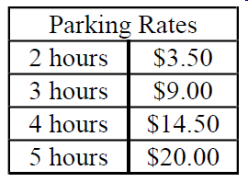

Which linear equation can be used to find x, the additional hourly parking rate?

|  |  |  |  |
| --- | --- | --- | --- |
| 1) |  | 3) |  |
| 2) |  | 4) |  |

66) Sandy programmed a website's checkout process with an equation to calculate the amount customers will be charged when they download songs. The website offers a discount. If one song is bought at the full price of $1.29, then each additional song is $.99. State an equation that represents the cost, *C*, when *s* songs are downloaded. Sandy figured she would be charged $52.77 for 52 songs. Is this the correct amount? Justify your answer.

67) A cell phone company charges $60.00 a month for up to 1 gigabyte of data. The cost of additional data is $0.05 per megabyte. If *d* represents the number of additional megabytes used and *c* represents the total charges at the end of the month, which linear equation can be used to determine a user's monthly bill?

|  |  |  |  |
| --- | --- | --- | --- |
| 1) |  | 3) |  |
| 2) |  | 4) |  |

68) A typical cell phone plan has a fixed base fee that includes a certain amount of data and an overage charge for data use beyond the plan. A cell phone plan charges a base fee of $62 and an overage charge of $30 per gigabyte of data that exceed 2 gigabytes. If *C* represents the cost and *g* represents the total number of gigabytes of data, which equation could represent this plan when more than 2 gigabytes are used?

|  |  |  |  |
| --- | --- | --- | --- |
| 1) |  | 3) |  |
| 2) |  | 4) |  |

**SOLUTIONS**

61) ANS:

Donna can make 2 pounds of trail mix.

Strategy 1: Determine the costs of six pounds of mix, then scale the amount down to $15 of mix.

STEP 1. The mix will have six parts. If each part is 1 pound, the costs of the mix can be determined as follows:

$12 for one part almonds @ $12 per pound,

$18 for two parts walnuts @ $9 per pound, and

$15 for three parts raisins @ $5 per pound.

$45 for six pounds of mix.

STEP 2: Scale the amount down to $15 of mix

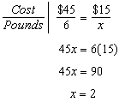

Donna can make 2 pounds of trail mix.

DIMS? Does It Make Sense? Yes. If 2 pounds of the mix cost $15, 3 times as much should cost $45.

Strategy 2. Write an expression that scales the costs of the mix to $15.

Let x represent the scale factor.

Write 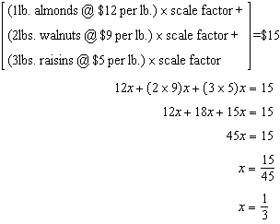

The scale factor is . If an entire batch of trail mix contains 6 pounds of ingredients, Donna needs to scale the recipe down and make only  of that amount. In other words, Donna needs to make  pounds of trail mix if she only has $15 to spend.

PTS: 2 NAT: A.CED.A.1 TOP: Modeling Linear Equations

62) ANS: 3

STEP 1. Underline key words.

Kendal bought *x* boxes of cookies to bring to a party. Each box contains 12 cookies. She decides to keep two boxes for herself. She brings 60 cookies to the party. Which equation can be used to find the number of boxes, *x*, Kendal bought?

STEP 2. Define key terms.

Let 12 x represent the total number of cookies Kendal Bought.

Let 24 represent the total number of cookies Kendal kept for herself.

Let 60 represent the total number of cookies Kendal took to school.

STEP 3. Write



PTS: 2 NAT: A.CED.A.1

63) ANS: 2

Strategy: This is a coin problem, and the value of each coin is important.

Let x represent the number of dimes, as required by the problem.

Let .10x represent the value of the dimes. (A dime is worth $0.10)

The problem says that John has 4 more nickels than dimes.

Let  represent the number of nickels that John has.

Let .05 represent the value of the nickles. (A nickel is worth $0.05)

The total amount of money that John has is $1.25.

The total amount of money that John has can also be represented by 

These two expressions are both equal, so write:



This is not an answer choice, but using the commutative property, we can rearrange the order of the terms in the left expression , which is the same as answer choice b.

DIMS? Does It Make Sense? Yes. Transform the equation for input into a graphing calculator as follows: 

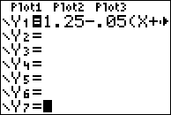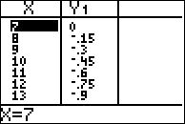

John has 7 dimes and 11 nickles. The dimes are worth 70 cents and the nickels are word 55 cents. In total, John has $1.25.

PTS: 2 NAT: A.CED.A.1 TOP: Modeling Linear Equations

64) ANS:

2.4 years

Strategy: Convert all measurements to inches per year, then write two equations, then write and solve a new equation by equating the right expressions of the two equations.

STEP 1: Convert all measurements to inches per year.

Type *A* is 36 inches tall and grows at a rate of 15 inches per year.

Type *B* is 48 inches tall and grows at a rate of 10 inches per year.

STEP 2: Write 2 equations



STEP 3: Write and solve a break-even equation from the right expressions.

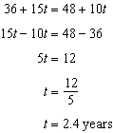

DIMS? Does It Make Sense? Yes. After 2.4 years, the type A trees and the type B trees will both be 72 inches tall.



PTS: 2 NAT: A.REI.C.6 TOP: Modeling Linear Equations

NOT: NYSED classifies this problem as A.CED.1: Create Inequations and Inequalities

65) ANS: 3

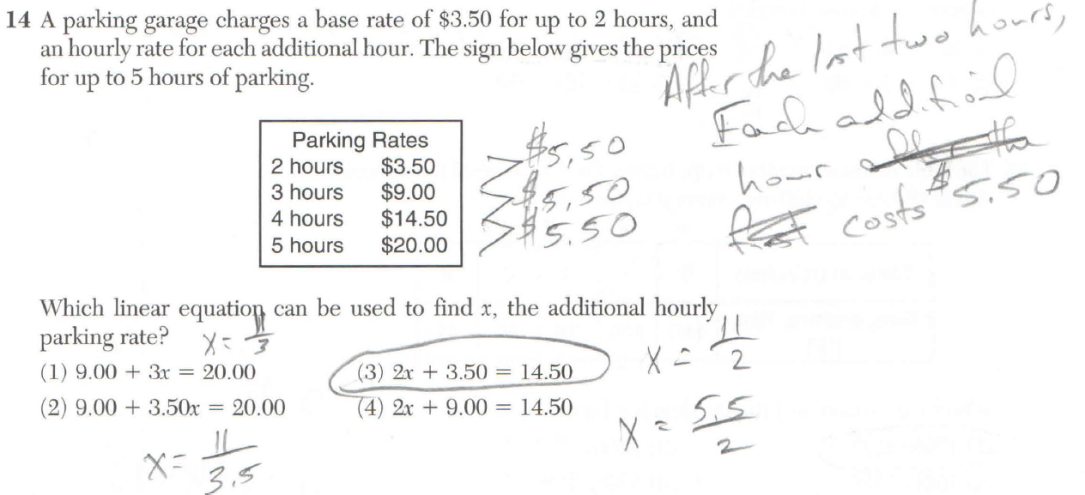

PTS: 2 NAT: A.CED.A.1

66) ANS:



Sandy is not correct. She used the wrong equation.

|  |  |  |
| --- | --- | --- |
| # Songs  (s) | Correct Costs | Sandy’s Costs |
| 1 | 1.29 | 2.28 |
| 2 | 2.28 | 3.27 |
| 3 | 3.27 | 4.26 |
| ---- | ---- | ---- |
| 52 | 51.76 | 52.77 |

PTS: 2 NAT: A.CED.A.2 TOP: Modeling Linear Equations

67) ANS: 4

Strategy: Translate the words into algebraic terms and expressions. Then eliminate wrong answers.

The problem tells us to:

Let *c* represent the total charges at the end of the month.

Let 60 represent the cost of 1 gigabyte of data.

Let d represent the cost of each megabyte of data after the first gigabyte.

The total charges equal 60 plus .05d.

Write . This is answer choice d.

DIMS? Does It Make Sense? Yes.  could be used to represent the user’s monthly bill. First, transpose the formula for input into the graphing calculator:

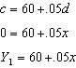

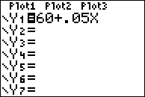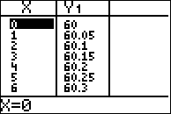

The table of values shows that the monthly charges increase 5 cents for every additional megabyte of data.

PTS: 2 NAT: A.CED.A.1 TOP: Modeling Linear Equations

68) ANS: 4

Strategy: Translate the words into algebraic terms and expressions. Then eliminate wrong answers.

The problem tells us to:

Let *C* represent the total cost.

Let *g* represent the number of gigabytes used.

The first sentence, “*A typical cell phone plan has a* ***fixed base fee*** *that includes a certain amount of data and an* ***overage charge*** *for data use beyond the plan*.” tells us that total cost equals a base fee plus an overage charge. From this, we know that the basic equation will look something like



The second sentence tells us that “A cell phone plan charges a base fee of $62 ....” so we can substitute this specific information into our general equation and we have



We can eliminate answer choices *a* and *b*. The correct answer is either *c* or d.

The second sentence also tells us that the overage charge is “...$30 per gigabyte of data that exceed 2 gigabytes.” We can use this information to choose between answer choices *c* and *d*.

Answer choice *c* is . This doesn’t make sense, because the value of the term  becomes negative if the number of gigabytes used is greater than 2, and the total cost becomes negative if the number of gigabytes used is 5 or more. Answer choice c can be eliminated. Answer choice d is the only choice left, and is the correct answer.

DIMS? Does It Make Sense? Yes.  could represent the plan *when more than 2 gigabytes are used*, as shown in the following table of values for this function..

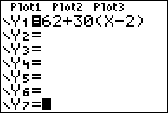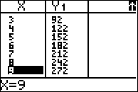

PTS: 2 NAT: A.CED.A.1 TOP: Modeling Linear Functions