1 Which expression is equivalent to ?
1) |  | 3)
2) |  | 4)

2 Which value, to the nearest tenth, is an approximate solution for the equation , if 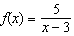 and ?
1) | 3.2 | 3) | 4.0
2) | 3.9 | 4) | 5.6

3 Which equation is graphed in the diagram below?
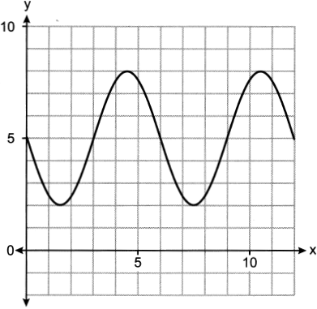

1) | 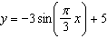 | 3) | 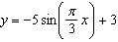
2) | 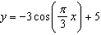 | 4) | 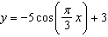

4 Which point is in Quadrant III and is a solution to the system below?
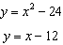
1) | (4, -8) | 3)
2) |  | 4) | (-3,-33)

5 For which equations will the value make the statement an identity?
I
II
1) | I, only | 3) | I and II
2) | II, only | 4) | neither I nor II

6 The number of bacteria in a sample, which can be modeled by an exponential regression, is shown in the table below.

Time Since Observation Began (hours) | 0 | 1 | 2 | 3.5 | 4
Number of Bacteria | 40 | 48 | 57 | 75 | 82

Assuming this trend continues, approximately how many bacteria would be present 8 hours after the observation began?
1) | 123 | 3) | 168
2) | 127 | 4) | 180

7 Factored completely, is equivalent to
1) |  | 3)
2) |  | 4)

8 The solution set for the equation is
1) |  | 3)
2) |  | 4)

9 If is represented by the graph below, which translation of would have imaginary roots?

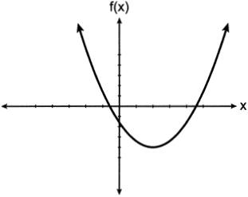
1) |  | 3)
2) |  | 4)

10 The solutions to the equation are
1) | 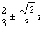 | 3) | 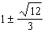
2) | 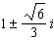 | 4)

11 A culture of 1000 bacteria triples every 10 hours. Which expression models the number of bacteria in the sample after t hours?
1) |  | 3)
2) |  | 4) | 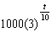

12 An initial investment of $5000 in an account earns 3.5% annual interest. Which function correctly represents a recursive model of the investment after n years?
1) |  | 3)
2) | 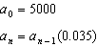 | 4) | 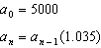

13 Which expression is equivalent to ?
1) | 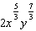 | 3) | 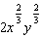
2) |  | 4)

14 Which statements must be true about the polynomial function ?
I. is a factor of
II.
III. 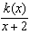 has a remainder of 5
1) | II, only | 3) | II and III
2) | I and II | 4) | I, II, and III

15 To prepare for lacrosse tryouts, Kole is increasing the amount of time he spends at the gym. This week he is spending 150 minutes there and he plans to increase this amount by 2% each week. The amount of time, in minutes, that he plans to spend at the gym t weeks from now is given by the function . In terms of a daily growth rate, the amount of time Kole is planning to spend at the gym can best be modeled by the function
1) | 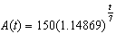 | 3) | 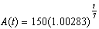
2) |  | 4)

16 Mr. Zachary posts review assignments on the Betamath website for his students. On his last test, 49% of his students used Betamath and passed. Overall, 68% of his students used Betamath. Approximately what percentage of Mr. Zachary's students passed, given that they used Betamath?
1) | 19% | 3) | 33%
2) | 32% | 4) | 72%

17 Given 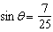 and terminates in quadrant II, what is the value of ?
1) |  | 3)
2) |  | 4)

18 A family owned grocery store in New Hartford, NY employs 49 people whose ages are approximately normally distributed with a mean of 36 years and a standard deviation of 6.2 years. Ryan has been hired to work at this store. He is 30 years old. How many people who work at this store would you expect to be younger than Ryan?
1) | 17 | 3) | 41
2) | 7 | 4) | 8

19 For the function , the inverse function, , equals
1) |  | 3)
2) |  | 4)

20 Given and , which values satisfy ?
1) | only | 3)
2) | only | 4)

21 The profit function, , is found by subtracting the cost function, , from the revenue function, . Which function below represents the cost function given and ?
1) |  | 3)
2) |  | 4)

22 What is the remainder when is divided by ?
1) |  | 3) | 13
2) |  | 4) | 29

23 The parabola with equation has
1) | a vertex at | 3) | a directrix
2) | a focus at | 4) | four units between the focus and vertex

24 Jay is training for a bike race over fifteen weeks. At the end of the first week, he has ridden ten miles, and he is planning to increase his weekly distance by nine percent each week. Approximately how many miles total will he have ridden from the beginning of his training to the end of the fifteenth week?
1) | 10.989 | 3) | 163.5
2) | 33.417 | 4) | 293.609

25 Given x is a real number, write the expression in simplest form:

26 Solve algebraically for t to the nearest hundredth.

27 In an attempt to get the student body's opinion of a new dress code, members of the statistics class surveyed the-students of the first period computer science class. Explain a statistical bias in the method of data collection.

28 Sketch a graph of polynomial , given the criteria below:
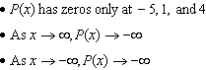

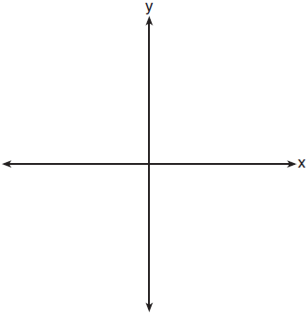

29 The height, above ground, of a Ferris wheel car can be modeled by the function 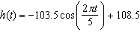 where h is measured in feet and t is measured in minutes. State the period of the function and describe what the period represents in this context.

30 Solve algebraically for all values of x: 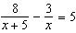

31 The transportation methods used by the upperclassmen at Calhoun High School are summarized in the table below.
Upperclassmen Transportation Methods
 | Drive | Take the Bus | Walk
Junior | 58 | 75 | 12
Senior | 81 | 39 | 12
Are the events "being a junior" and "driving to school" independent? Using statistical evidence, justify your answer.

32 Can be classified as an odd function? Justify your answer.

33 Solve the following system of equations algebraically for all values of x, y, and z:
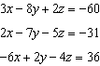

34 In the town of Skaneateles, New York, house prices since 2008 have changed based on the function , where t is the number of years since 2008 and is the median house price. Determine the average rate of change for the median house price in Skaneateles, from 2010 to 2018 to the nearest dollar per year. Explain what this rate of change means as it relates to median house prices.

35 A sporting goods manufacturer is trying to determine if they should continue to produce multiple types of hockey pucks. The company surveyed 50 randomly chosen customers and asked them if they purchased both game regulation pucks and lighter training pucks. Of those surveyed, 40 of them said that they purchase both types of pucks. A simulation that was run 100 times based on the survey results produced the approximately normal results below.

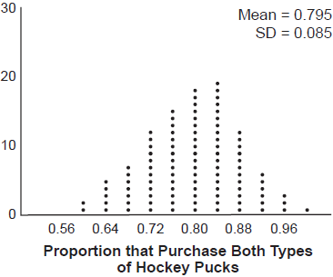

a) Determine an interval containing the middle 95% of plausible values that estimates the proportion of all customers who would purchase both types of pucks from the company.
b) The company will continue to manufacture both types of hockey pucks if it is reasonable to assume that the true proportion of customers who buy both types of hockey pucks is above 0.60. Using the interval from part a, explain whether or not the company should continue to produce both types of hockey pucks.

36 Graph , where on the set of axes below.

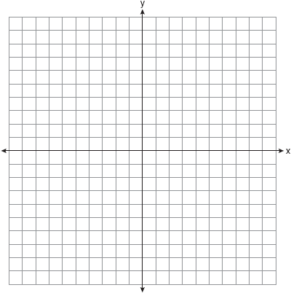

State the equation of the asymptote of . When is reflected over the line , a new function is formed: . State the equation of the asymptote of .

37 Megan is performing an experiment in a lab where the air temperature is a constant 73ºF and the liquid is 237ºF. One and a half hours later, the temperature of the liquid is 112ºF. Newton's law of cooling states where:
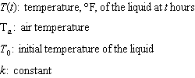
Determine the value of k, to the nearest thousandth, for this liquid. Determine the temperature of the liquid using your value for k, to the nearest degree, after two and a half hours. Megan needs the temperature of the liquid to be 80ºF to perform the next step in her experiment. Use your value for k to determine, to the nearest tenth of an hour, how much time she must wait since she first began the experiment.
1 ANS: 2
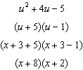

PTS: 2 REF: 062401aii NAT: A.SSE.A.2 TOP: Factoring Polynomials

2 ANS: 2
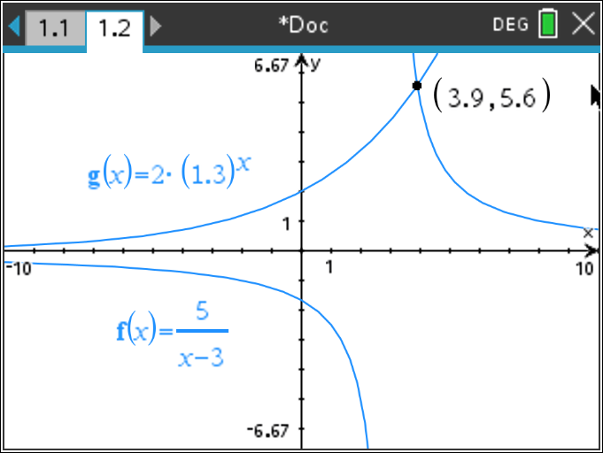

PTS: 2 REF: 062402aii NAT: A.REI.D.11 TOP: Other Systems

3 ANS: 1
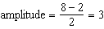, 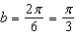, 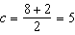

PTS: 2 REF: 062403aii NAT: F.TF.B.5 TOP: Modeling Trigonometric Functions

4 ANS: 2
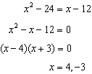

PTS: 2 REF: 062404aii NAT: A.REI.C.7 TOP: Quadratic-Linear Systems

5 ANS: 1
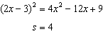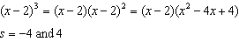

PTS: 2 REF: 062405aii NAT: A.APR.C.4 TOP: Polynomial Identities

6 ANS: 3

PTS: 2 REF: 062406aii NAT: S.ID.B.6 TOP: Regression

7 ANS: 2
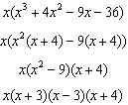

PTS: 2 REF: 062407aii NAT: A.SSE.A.2 TOP: Factoring Polynomials

8 ANS: 2
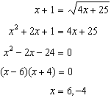

PTS: 2 REF: 062408aii NAT: A.REI.A.2 TOP: Solving Radicals

9 ANS: 3 PTS: 2 REF: 062409aii NAT: A.REI.B.4
TOP: Using the Discriminant KEY: determine nature of roots

10 ANS: 2
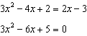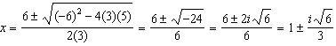

PTS: 2 REF: 062410aii NAT: A.REI.B.4 TOP: Solving Quadratics

11 ANS: 4 PTS: 2 REF: 062411aii NAT: F.BF.A.1
TOP: Modeling Exponential Functions

12 ANS: 4 PTS: 2 REF: 062412aii NAT: F.BF.A.2
TOP: Sequences KEY: recursive

13 ANS: 1
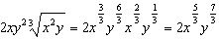

PTS: 2 REF: 062413aii NAT: N.RN.A.2 TOP: Radicals and Rational Exponents

14 ANS: 3
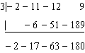 is not a factor since there is a remainder. 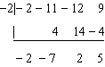

PTS: 2 REF: 062414aii NAT: A.APR.B.2 TOP: Remainder and Factor Theorems

15 ANS: 4
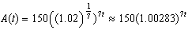

PTS: 2 REF: 062415aii NAT: A.SSE.B.3 TOP: Modeling Exponential Functions

16 ANS: 4
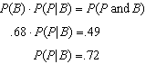

PTS: 2 REF: 062416aii NAT: S.CP.A.3 TOP: Conditional Probability

17 ANS: 1
If , 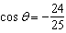 in QII, and 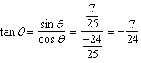

PTS: 2 REF: 062417aii NAT: F.TF.C.8 TOP: Determining Trigonometric Functions

18 ANS: 4

PTS: 2 REF: 062418aii NAT: S.ID.A.4 TOP: Normal Distributions
KEY: predict

19 ANS: 4
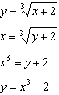

PTS: 2 REF: 062419aii NAT: F.BF.B.4 TOP: Inverse of Functions
KEY: cubic

20 ANS: 3
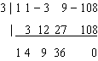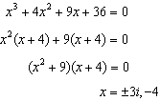

PTS: 2 REF: 062420aii NAT: A.APR.D.6 TOP: Solving Polynomial Equations

21 ANS: 3
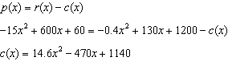

PTS: 2 REF: 062421aii NAT: F.BF.A.1 TOP: Operations with Functions

22 ANS: 4

PTS: 2 REF: 062422aii NAT: A.APR.B.2 TOP: Remainder and Factor Theorems

23 ANS: 3
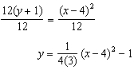The vertex is and , so the focus is .

PTS: 2 REF: 062423aii NAT: G.GPE.A.2 TOP: Graphing Quadratic Functions

24 ANS: 4
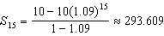

PTS: 2 REF: 062424aii NAT: A.SSE.B.4 TOP: Series
KEY: geometric

25 ANS:

PTS: 2 REF: 062425aii NAT: N.CN.A.2 TOP: Operations with Complex Numbers

26 ANS:
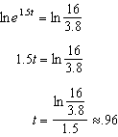

PTS: 2 REF: 062426aii NAT: F.LE.A.4 TOP: Exponential Equations
KEY: without common base

27 ANS:
The opinion sought is that of the entire student body, but the first period computer science class may not be representative of the entire student body.

PTS: 2 REF: 062427aii NAT: S.IC.B.6 TOP: Analysis of Data
KEY: bias

28 ANS:
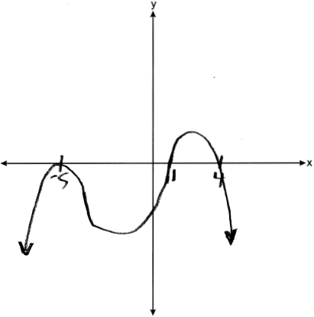

PTS: 2 REF: 062428aii NAT: F.IF.C.7 TOP: Graphing Polynomial Functions

29 ANS:
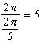 The wheel rotates every 5 minutes.

PTS: 2 REF: 062429aii NAT: F.IF.C.7 TOP: Graphing Trigonometric Functions
KEY: period

30 ANS:
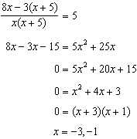

PTS: 2 REF: 062430aii NAT: A.REI.A.2 TOP: Solving Rationals

31 ANS:
Based on these data, the two events do not appear to be independent. 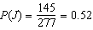, while 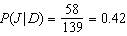. The probability of being a junior is not the same as the conditional probability of being a junior, given the junior drives to school.

PTS: 2 REF: 062431aii NAT: S.CP.A.4 TOP: Conditional Probability

32 ANS:
No, because a 180º rotation of f about the origin does not map f onto itself.

PTS: 2 REF: 062432aii NAT: F.BF.B.3 TOP: Even and Odd Functions

33 ANS:
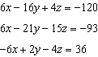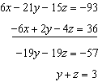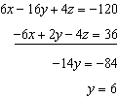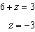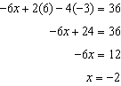

PTS: 4 REF: 062433aii NAT: A.REI.C.6 TOP: Solving Linear Systems
KEY: three variables

34 ANS:
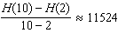 From 2014-2018, the median house price increased $11524 per year on average.

PTS: 4 REF: 062434aii NAT: F.IF.B.6 TOP: Rate of Change

35 ANS:
. Yes, as it is plausible at least .625 of the customers will purchase both.

PTS: 4 REF: 062435aii NAT: S.IC.A.2 TOP: Analysis of Data

36 ANS:
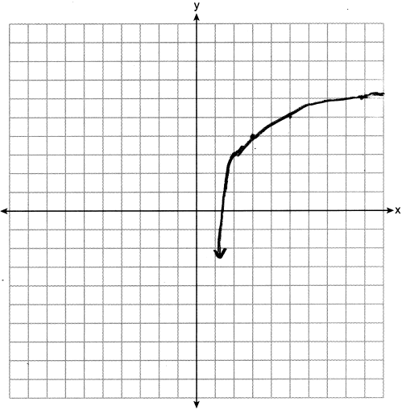

PTS: 4 REF: 062436aii NAT: F.IF.C.7 TOP: Graphing Logarithmic Functions

37 ANS:
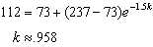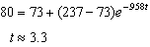

PTS: 6 REF: 062437aii NAT: A.CED.A.1 TOP: Exponential Decay

