1 The exact value of 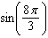 is
1) |  | 3) | 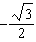
2) |  | 4)

2 A teacher randomly divides all of her students into two groups. She grades the homework for one group but does not grade the homework for the other group. All homework is returned to the students. She then compares test scores for each of the groups to see if grading homework has an effect on the tests cores. This method of data collection is best described as
1) | an experiment | 3) | a simulation
2) | an unbiased survey | 4) | an observational study

3 Which expression is equivalent to ?
1) |  | 3)
2) |  | 4)

4 Given the functions 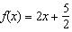 and 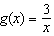, what are the solutions to ?
1) | or | 3) | or
2) | or | 4)

5 Given and , the quotient of is
1) |  | 3) | 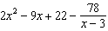
2) |  | 4)

6 Abby is told that each day there is a 50% chance it will rain. Which simulation can Abby perform to determine the likelihood of it raining for the next seven days?
1) | Flip a coin seven times, count how many heads, and repeat 50 times. | 3) | Roll a pair of dice, count totals of seven, and repeat 50 times.
2) | Roll a die seven times, count how many twos, and repeat 50 times. | 4) | Flip a coin 50 times and count how many heads.

7 What are the solutions to
1) | 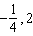 | 3) | 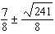
2) | 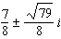 | 4) | 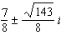

8 If is a factor of , then which statement must be true?
1) |  | 3)
2) |  | 4)

9 In a small city, there are 22 gas stations. The mean price for a gallon of regular gas was $2.12 with a standard deviation of $0.05. The distribution of the data was approximately normal. Given this information, the middle 95% of the gas stations in this small city likely charge
1) | $1.90 to $2.34 for a gallon of gas | 3) | $2.02 to $2.22 for a gallon of gas
2) | $1.97 to $2.27 for a gallon of gas | 4) | $2.07 to $2.17 for a gallon of gas

10 The expression 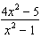 is equivalent to
1) | 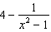 | 3) | 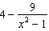
2) | 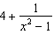 | 4) | 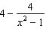

11 For all positive values of x, which expression is equivalent to ?
1) |  | 3)
2) |  | 4)

12 The expression is equivalent to
1) |  | 3)
2) |  | 4)

13 Functions f and g are given below.
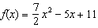
When is subtracted from , the result is
1) |  | 3)
2) |  | 4)

14 A manufacturer claims that the number of ounces of a beverage dispensed by one of its automatic dispensers is normally distributed with a mean of 8.0 ounces and a standard deviation of 0.04 ounces. To the nearest tenth of a percent, what percent of the cups filled by this company's dispenser will contain between 7.9 and 8.11 ounces?
1) | 99.5 | 3) | 99.1
2) | 99.4 | 4) | 97.6

15 What is the value of x in the solution of the system of equations below?
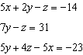
1) | -17 | 3)
2) | 2 | 4)

16 The graph below shows the amount of a radioactive substance left over time.
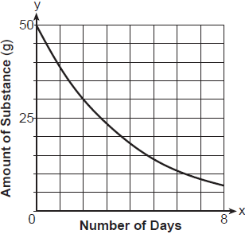
The daily rate of decay over an 8-day interval is approximately
1) | 23% | 3) | 5%
2) | 95% | 4) | 77%

17 If then x equals
1) |  | 3) | 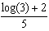
2) | 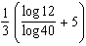 | 4) | 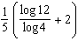

18 A random sample of 152 students was surveyed on a particular day about how they got to school. The survey results are summarized in the table below.
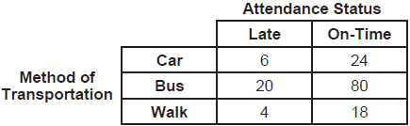
Which statement is best supported by the data?
1) | The probability of being late given that a student walked is greater than the probability that a student walked given that the student was late. | 3) | The probability of being late given that a student walked is equal to the probability that a student walked given that the student was late.
2) | The probability of being late given that a student walked is less than the probability that a student walked given that the student was late. | 4) | The probability of being late given that a student walked cannot be determined.

19 If , then equals
1) |  | 3) | 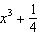
2) |  | 4)

20 Given the equation , where the period of is 12, what is the value of b?
1) |  | 3)
2) |  | 4)

21 Jin solved the equation by squaring both sides. What extraneous solution did he find?
1) |  | 3) | 3
2) |  | 4) | 4

22 The expression 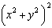 is not equivalent to
1) | 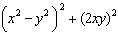 | 3)
2) |  | 4) | 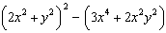

23 The height of a running trail is modeled by the quartic function shown below, where x is the distance in miles from the start of the trail and y is the height in feet relative to sea level.
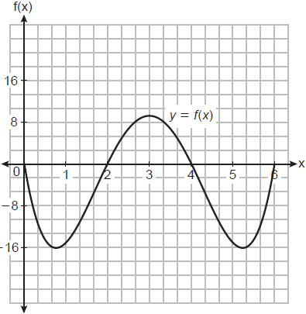
If this trail has a minimum height of 16 feet below sea level, which function(s) could represent a running trail whose minimum height is half of the minimum height of the original trail?
I. 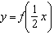 II. III. 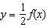
1) | I, only | 3) | I and III
2) | II, only | 4) | II and III

24 The crew aboard a small fishing boat caught 350 pounds of fish on Monday. From that Monday through the end of the week on Friday, the weight of the fish caught increased 15% per day. The total weight, in pounds, of fish caught is approximately
1) | 411 | 3) | 1748
2) | 612 | 4) | 2360

25 Describe the translations that map to .

26 Solve algebraically for x: 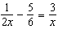

27 Given 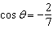 with in Quadrant II, find the exact value of .

28 Given , use the properties of rational exponents to determine the value of x for the equation below.
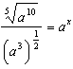

29 Graph at least one cycle of on the set of axes below.

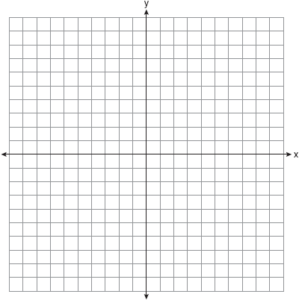

30 The cost of a brand-new electric-hybrid vehicle is listed at $33,400, and the average annual depreciation for the vehicle is 15%. The car's value can be modeled by the function , where x represents the years since purchase. Julia and Jacob have each written a function that is equivalent to the original.
Jacob's function: 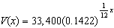
Julia's function:

Whose function is correctly rewritten to reveal the approximate monthly depreciation rate? Justify your answer.

31 Write a recursive formula for the sequence

32 A grocery store orders 50 bags of oranges from a company's distribution center. The bags have a mean weight of 3.85 pounds per bag. The company claims that their bags of oranges have a mean weight of4 pounds. The grocery store ran a simulation of 50 bags, 2500 times, assuming a mean of 4 pounds. The results are shown below.

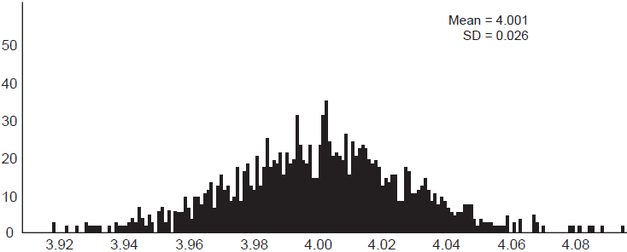

Is the mean weight of the grocery store's sample unusual? Explain using the results of the simulation.

33 At the Lakeside Resort, the probability that a guest room has a view of the lake is 0.24. The probability that a guest room has a queen-size bed is 0.74. Let A be the event that the guest room has a view of the lake, and let B be the event that the guest room has a queen-size bed. Events A and B are found to be independent of each other. Determine the exact probability that a randomly selected guest room has a view of the lake and a queen-size bed. Determine the exact probability that a randomly selected guest room has a view of the lake or a queen-size bed.

34 Which function has a greater average rate of change on the interval ? Justify your answer.
x | m(x)
 | 1
0 | 1
1 | 3
2 | 13
3 | 37
4 | 81
5 | 151

35 Determine an equation for the parabola with focus and directrix . (The use of the grid below is optional.)


36 Algebraically find the zero of . On the axes below, sketch .
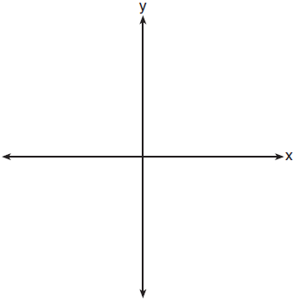

37 The populations of honeybees in two different colonies are studied for four months. During this time, the colony population can be approximated by , where is the colony population of bees at t months, is the initial population, and r is the growth rate. Colony A has an initial population of 10,000 bees and a continuous growth rate of 0.25. Colony B has an initial population of 6000 bees and a continuous growth rate of 0.45. Write functions for both and that model the honeybee populations of the colonies after t months. Graph and for .

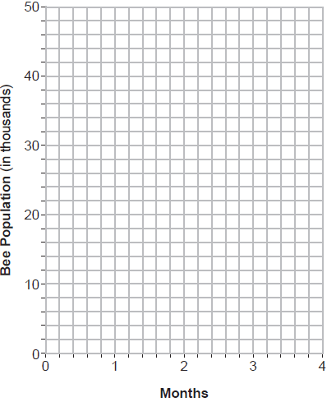

State, to the nearest tenth of a month, when the colonies will have the same population. Determine algebraically how long it will take, to the nearest tenth of a month, for the population in Colony A to triple.
1 ANS: 4 PTS: 2 REF: 012501aii NAT: F.TF.A.2
TOP: Determining Trigonometric Functions KEY: radians

2 ANS: 1 PTS: 2 REF: 012502aii NAT: S.IC.B.3
TOP: Analysis of Data

3 ANS: 2
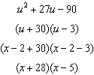

PTS: 2 REF: 012503aii NAT: A.SSE.A.2 TOP: Factoring Polynomials

4 ANS: 2
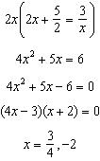

PTS: 2 REF: 012504aii NAT: A.REI.D.11 TOP: Other Systems
KEY: rational

5 ANS: 1
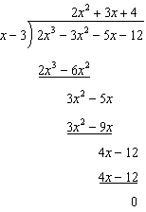

PTS: 2 REF: 012505aii NAT: A.APR.D.6 TOP: Rational Expressions
KEY: division

6 ANS: 1 PTS: 2 REF: 012506aii NAT: S.IC.B.3
TOP: Analysis of Data

7 ANS: 2
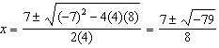

PTS: 2 REF: 012507aii NAT: A.REI.B.4 TOP: Solving Quadratics
KEY: complex solutions | quadratic formula

8 ANS: 3 PTS: 2 REF: 012508aii NAT: A.APR.B.2
TOP: Remainder and Factor Theorems

9 ANS: 3

PTS: 2 REF: 012509aii NAT: S.ID.A.4 TOP: Normal Distributions

10 ANS: 1
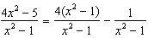

PTS: 2 REF: 012510aii NAT: A.APR.D.7 TOP: Addition and Subtraction of Rationals

11 ANS: 3
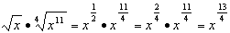

PTS: 2 REF: 012511aii NAT: N.RN.A.2 TOP: Radicals and Rational Exponents

12 ANS: 2

PTS: 2 REF: 012512aii NAT: N.CN.A.2 TOP: Operations with Complex Numbers

13 ANS: 2

PTS: 2 REF: 012513aii NAT: F.BF.A.1 TOP: Operations with Functions

14 ANS: 3
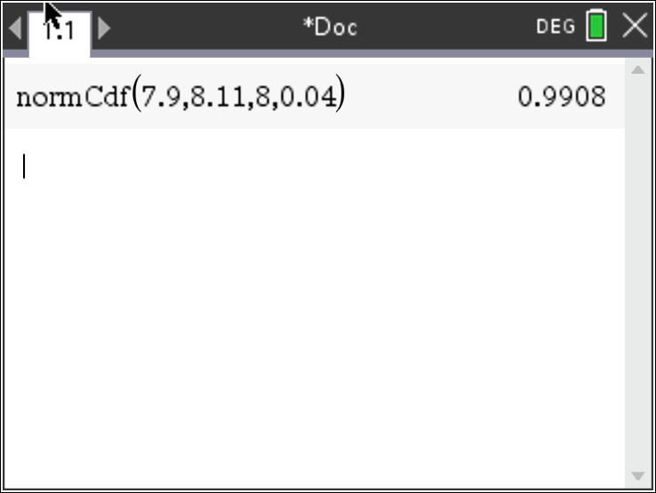 represents approximately 99.1% of the data.

PTS: 2 REF: 012514aii NAT: S.ID.A.4 TOP: Normal Distributions
KEY: percent

15 ANS: 4
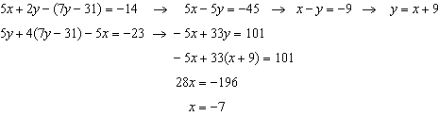

PTS: 2 REF: 012515aii NAT: A.REI.C.6 TOP: Solving Linear Systems
KEY: three variables

16 ANS: 1
Estimate and as points on the graph. 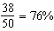 implies an estimated 24% rate of decay. Confirmed with graph of : 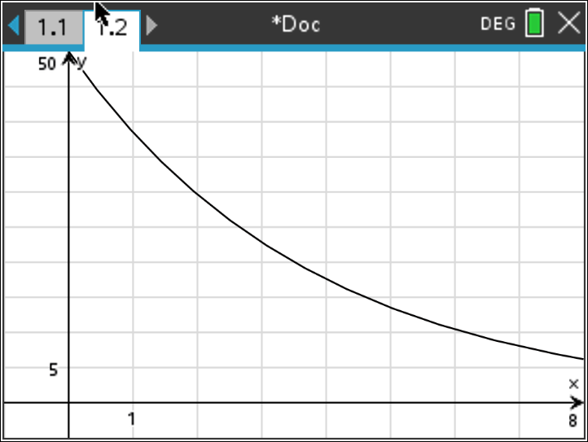

PTS: 2 REF: 012516aii NAT: F.LE.B.5 TOP: Modeling Exponential Functions

17 ANS: 3
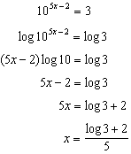

PTS: 2 REF: 012517aii NAT: F.LE.A.4 TOP: Exponential Equations
KEY: without common base

18 ANS: 1
The probability of being late given that a student walked is . The probability that student walked given that the student was late is .

PTS: 2 REF: 012518aii NAT: S.CP.A.4 TOP: Conditional Probability

19 ANS: 2
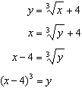

PTS: 2 REF: 012519aii NAT: F.BF.B.4 TOP: Inverse of Functions
KEY: cubic

20 ANS: 1
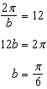

PTS: 2 REF: 012520aii NAT: F.IF.C.7 TOP: Graphing Trigonometric Functions
KEY: period

21 ANS: 2
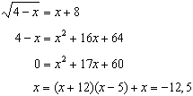

PTS: 2 REF: 012521aii NAT: A.REI.A.2 TOP: Solving Radicals

22 ANS: 2
1) ; 3) ; 4)

PTS: 2 REF: 012522aii NAT: A.APR.C.4 TOP: Polynomial Identities

23 ANS: 4
I. Minimum does not change, only period; II. ; III. 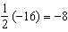

PTS: 2 REF: 012523aii NAT: F.BF.B.3 TOP: Transformations with Functions

24 ANS: 4
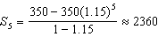

PTS: 2 REF: 012524aii NAT: F.BF.B.7 TOP: Series
KEY: geometric

25 ANS:
left 3, down 5

PTS: 2 REF: 012525aii NAT: F.IF.C.7 TOP: Graphing Logarithmic Functions

26 ANS:
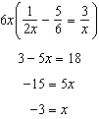

PTS: 2 REF: 012526aii NAT: A.REI.A.2 TOP: Solving Rationals

27 ANS:
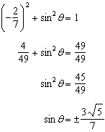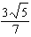 as sin is positive in Quadrant II.

PTS: 2 REF: 012527aii NAT: F.TF.C.8 TOP: Determining Trigonometric Functions

28 ANS:
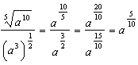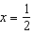

PTS: 2 REF: 012528aii NAT: N.RN.A.2 TOP: Radicals and Rational Exponents

29 ANS:
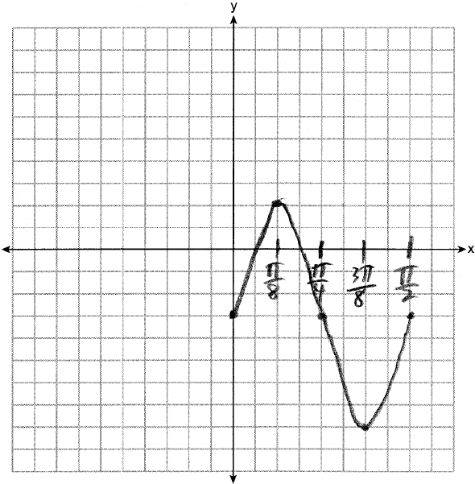

PTS: 2 REF: 012529aii NAT: F.IF.C.7 TOP: Graphing Trigonometric Functions
KEY: graph

30 ANS:
Julia: 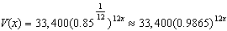

PTS: 2 REF: 012530aii NAT: A.SSE.B.3 TOP: Modeling Exponential Functions

31 ANS:
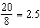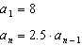

PTS: 2 REF: 012531aii NAT: F.BF.A.2 TOP: Sequences
KEY: recursive

32 ANS:
Yes. Using a 95% confidence interval, values outside the interval are unusual.

PTS: 2 REF: 012532aii NAT: S.IC.A.2 TOP: Analysis of Data

33 ANS:

PTS: 4 REF: 012533aii NAT: S.CP.B.7 TOP: Addition Rule

34 ANS:
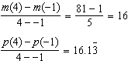 has a greater rate of change

PTS: 4 REF: 012534aii NAT: F.IF.B.6 TOP: Rate of Change
KEY: exponential

35 ANS:
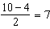, so the vertex is and . 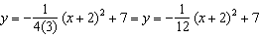 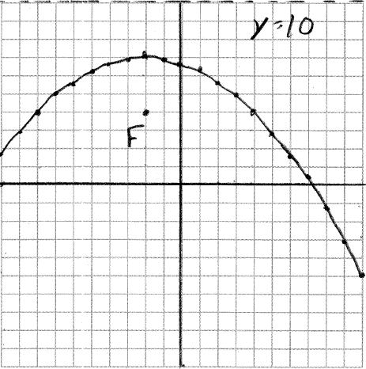

PTS: 4 REF: 012535aii NAT: G.GPE.A.2 TOP: Graphing Quadratic Functions

36 ANS:
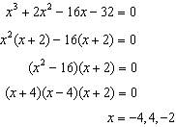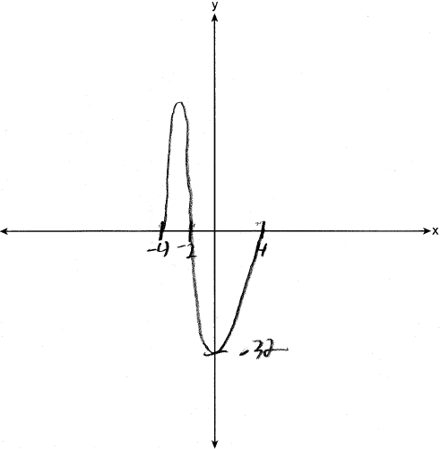

PTS: 4 REF: 012536aii NAT: F.IF.C.7 TOP: Graphing Polynomial Functions

37 ANS:
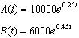 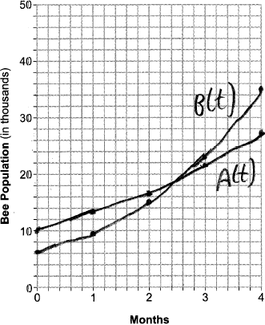 2.6 months for same. 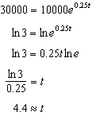

PTS: 6 REF: 012537aii NAT: A.REI.D.11 TOP: Other Systems
KEY: exponential

