1 In the diagram of and below, , , and .

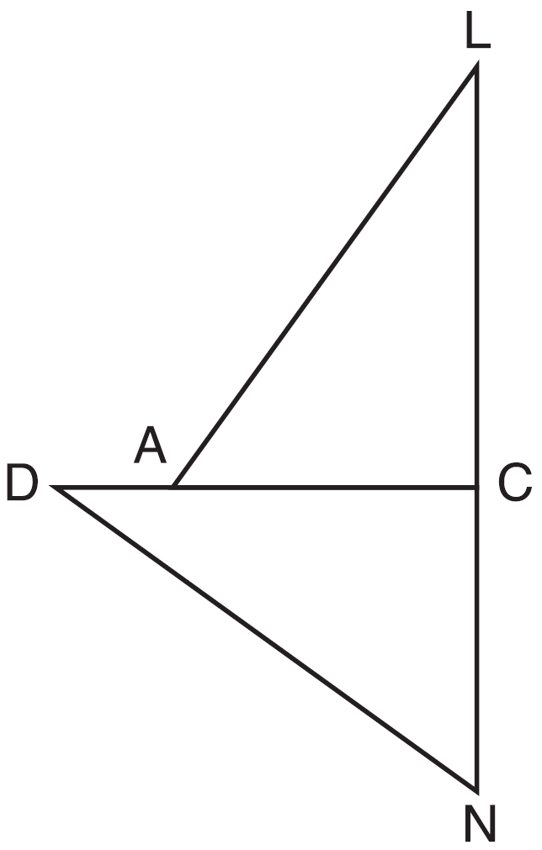

a) Prove that .
b) Describe a sequence of rigid motions that will map onto .
1 ANS:
, , and (Given). and are right angles (Definition of perpendicular lines). and are right triangles (Definition of a right triangle). (HL).
will map onto after rotating counterclockwise 90º about point C such that point L maps onto point D.

REF: spr1408geo

