1 If , where a, b, and c are positive, then t equals
1) | 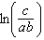
2) | 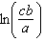
3) | 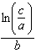
4) | 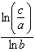

2 The solution to the equation is
1) | 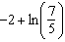
2) | 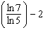
3)
4)

3 The solution to the equation is
1)
2) | 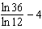
3)
4) | 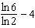

4 What is the solution to ?
1) | 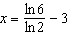
2)
3) | 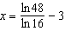
4)

5 Which expression is not a solution to the equation ?
1) | 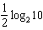
2)
3)
4)

6 The solution of , to the nearest thousandth, is
1) | 0.583
2) | 1.945
3) | 4.220
4) | 14.066

7 To the nearest tenth, the solution to the equation is
1) | 1.1
2) | 2.5
3) | 6.3
4) | 68.5

8 Using logarithms, find x, to the nearest hundredth:

9 Solve for x to the nearest hundredth.

10 Solve for x to the nearest hundredth: 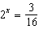

11 Using logarithms, solve the equation for x to the nearest tenth.

12 Solve algebraically for x, rounded to the nearest hundredth.

13 Solve algebraically for x to the nearest thousandth:

14 Solve algebraically for t to the nearest hundredth.
1 ANS: 3
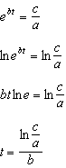

REF: 011813aii

2 ANS: 1
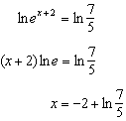

REF: 062207aii

3 ANS: 4
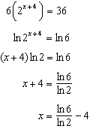

REF: 082408aii

4 ANS: 1
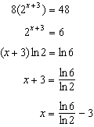

REF: 061702aii

5 ANS: 4
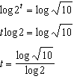 2) 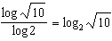, 1) 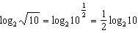, 3) 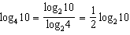

REF: 012009aii

6 ANS: 4
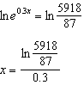

REF: 081801aii

7 ANS: 2
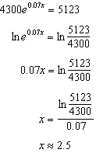

REF: 012302aii

8 ANS:
2.32

REF: 069542siii

9 ANS:
4.81

REF: 010141siii

10 ANS:

REF: 089839siii

11 ANS:
0.9

REF: 068636siii

12 ANS:
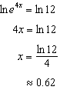

REF: 011530a2

13 ANS:
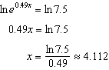

REF: 062330aii

14 ANS:
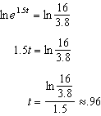

REF: 062426aii

