1 The graph below shows the function .
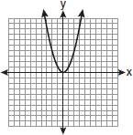
Which graph represents the function ?
1) | 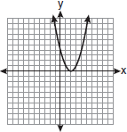
2) | 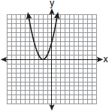
3) | 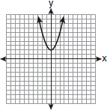
4) | 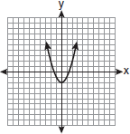

2 Which transformation of the graph of would result in the graph of ?
1)
2)
3)
4)

3 Which transformation of results in the function ?
1)
2)
3)
4)

4 The minimum point on the graph of the equation is . What is the minimum point on the graph of the equation ?
1)
2)
3)
4)

5 The maximum point on the graph of the equation is . What is the maximum point on the graph of the equation ?
1)
2)
3)
4)

6 Which transformation of moves the graph 7 units to the left and 3 units down?
1)
2)
3)
4)

7 The graph of the function is represented below. On the same set of axes, sketch the function .
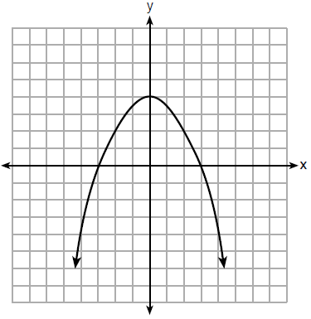

8 The function is graphed on the set of axes below. On the same set of axes, graph .

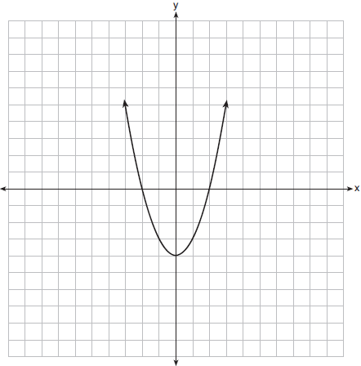

9 a On the accompanying grid, graph the equation in the interval and label it a.
b On the same grid, sketch the image of a under and label it b.

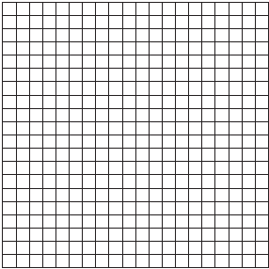

10 Graph and label the following equations, a and b, on the accompanying set of coordinate axes.
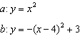
Describe the composition of transformations performed on a to get b.
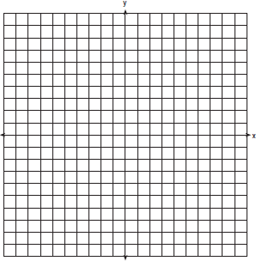

11 Two parabolic arches are to be built. The equation of the first arch can be expressed as , with a range of , and the second arch is created by the transformation . On the accompanying set of axes, graph the equations of the two arches. Graph the line of symmetry formed by the parabola and its transformation and label it with the proper equation.
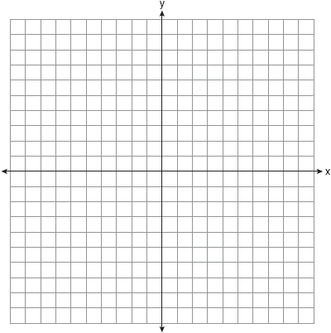

1 ANS: 2 REF: fall0926a2

2 ANS: 2 REF: 010605b

3 ANS: 2 REF: 080801b

4 ANS: 1 REF: 081022a2

5 ANS: 4 REF: 011714a2

6 ANS: 1 REF: 061516a2

7 ANS:
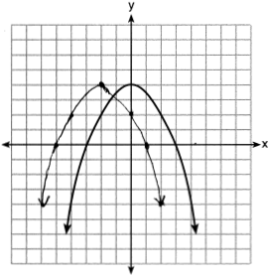

REF: 061828ai

8 ANS:
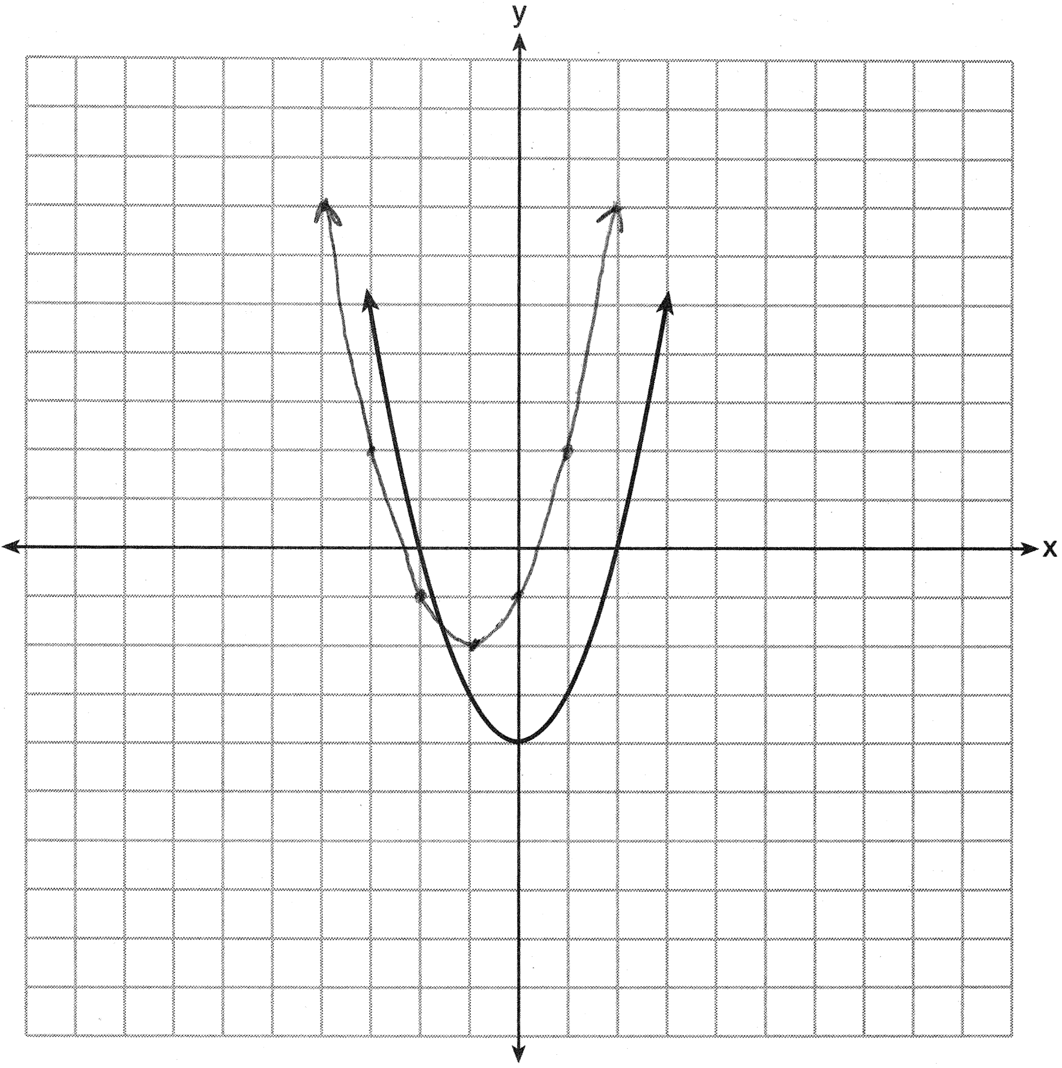

REF: 061435a2

9 ANS:
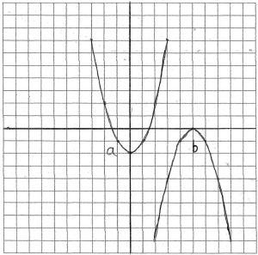

REF: 010232b

10 ANS:
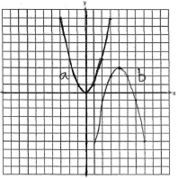 , or

REF: 080231b

11 ANS:
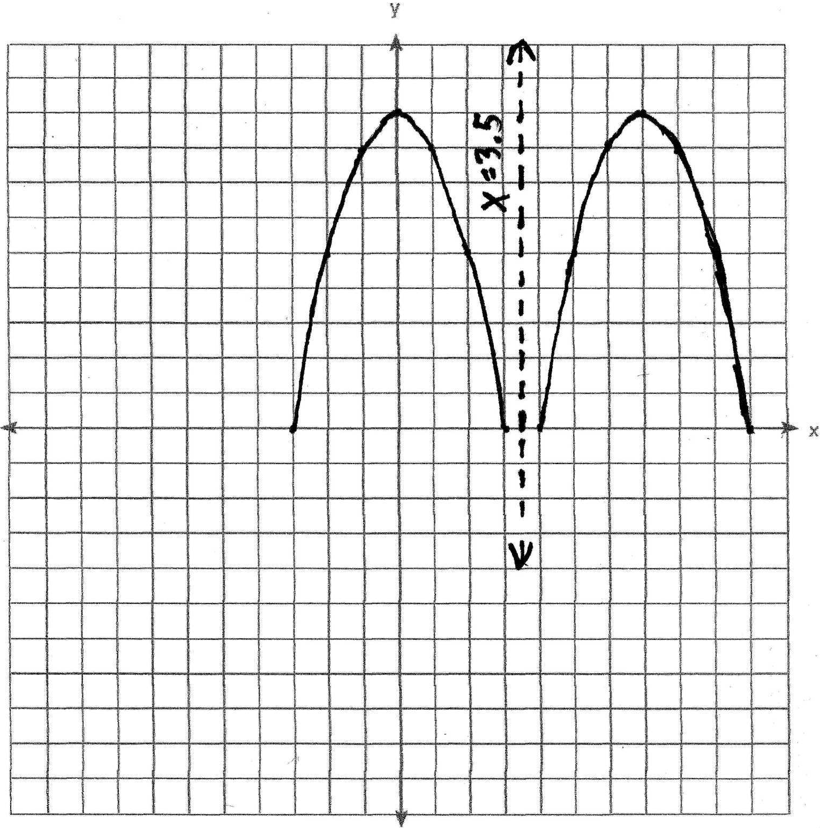

REF: 060129b

