1 Selected values for the functions f and g are shown in the tables below.

x | f(x) |  | x | g(x)
0 |  |  | 0 | 0.58
1.23 |  |  | 8.52 | 2.53
8.52 | 2.53 |  | 13.11 | 3.01
9.01 | 3.01 |  | 16.52 | 3.29

A solution to the equation is
1) | 0 | 3) | 3.01
2) | 2.53 | 4) | 8.52

2 Which value, to the nearest tenth, is not a solution of if and ?
1) |  | 3) | 2.1
2) |  | 4) | 4.7

3 If and , then how many real solutions are there to the equation ?
1) | 1 | 3) | 6
2) | 2 | 4) | 4

4 If and , an approximate solution for the equation is
1) | 1.96 | 3)
2) | 11.29 | 4)

5 To the nearest tenth, the value of x that satisfies is
1) | 2.5 | 3) | 5.8
2) | 2.6 | 4) | 5.9

6 The equations and approximately model the growth of two separate populations where . What is the best approximation of the time, t, at which the populations are the same?
1) |  | 3) | 5.1
2) | 0.3 | 4) | 21.3

7 Pedro and Bobby each own an ant farm. Pedro starts with 100 ants and says his farm is growing exponentially at a rate of 15% per month. Bobby starts with 350 ants and says his farm is steadily decreasing by 5 ants per month. Assuming both boys are accurate in describing the population of their ant farms, after how many months will they both have approximately the same number of ants?
1) | 7 | 3) | 13
2) | 8 | 4) | 36

8 The populations of two small towns at the beginning of 2018 and their annual population growth rate are shown in the table below.

Town | Population | Annual Population  Growth Rate
Jonesville | 1240 | 6% increase
Williamstown | 890 | 11% increase

Assuming the trend continues, approximately how many years after the beginning of 2018 will it take for the populations to be equal?
1) | 7 | 3) | 68
2) | 20 | 4) | 125

9 After examining the functions and over the interval , Lexi determined that the correct number of solutions to the equation is
1) | 1 | 3) | 3
2) | 2 | 4) | 0

10 How many solutions exist for 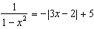?
1) | 1 | 3) | 3
2) | 2 | 4) | 4

11 When 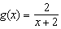 and are graphed on the same set of axes, which coordinates best approximate their point of intersection?
1) |  | 3)
2) |  | 4)

12 For which approximate value(s) of x will ?
1) |  | 3)
2) |  | 4) | , only

13 For which values of x, rounded to the nearest hundredth, will ?
1) | 2.29 and 3.63 | 3) | 2.84 and 3.17
2) | 2.37 and 3.54 | 4) | 2.92 and 3.06

14 If and , then what is the solution for ?
1) | 1.65 | 3) | 5.62
2) | 3.14 | 4) | no solution

15 What is the total number of points of intersection of the graphs of the equations and ?
1) | 1 | 3) | 3
2) | 2 | 4) | 0

16 Which value, to the nearest tenth, is the smallest solution of if 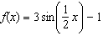 and ?
1) |  | 3)
2) |  | 4) | 1.4

17 Given: 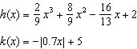
State the solutions to the equation , rounded to the nearest hundredth.

18 Researchers in a local area found that the population of rabbits with an initial population of 20 grew continuously at the rate of 5% per month. The fox population had an initial value of 30 and grew continuously at the rate of 3% per month. Find, to the nearest tenth of a month, how long it takes for these populations to be equal.

19 On a certain tropical island, there are currently 500 palm trees and 200 flamingos. Suppose the palm tree population is decreasing at an annual rate of 3% per year and the flamingo population is growing at a continuous rate of 2% per year. Write two functions, and , that represent the number of palm trees and flamingos on this island, respectively, x years from now. State the solution to the equation , rounded to the nearest year. Interpret the meaning of this value within the given context.

20 During the summer, Adam saved $4000 and Betty saved $3500. Adam deposited his money in Bank A at an annual rate of 2.4% compounded monthly. Betty deposited her money in Bank B at an annual rate of 4% compounded quarterly. Write two functions that represent the value of each account after t years if no other deposits or withdrawals are made, where Adam's account value is represented by , and Betty's by . Using technology, determine, to the nearest tenth of a year, how long it will take for the two accounts to have the same amount of money in them. Justify your answer.

21 On the set of axes below, graph and for the given functions.
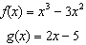

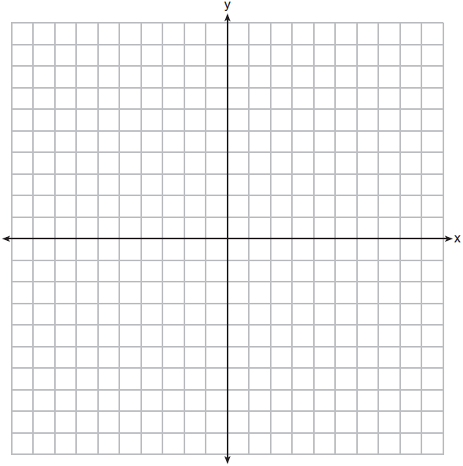

State the number of solutions to the equation .

22 Sketch the graphs of 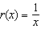 and on the set of axes below. Determine, to the nearest tenth, the positive solution of .

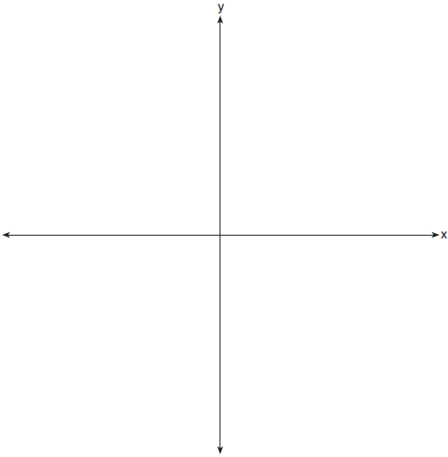

23 A technology company is comparing two plans for speeding up its technical support time. Plan A can be modeled by the function and plan B can be modeled by the function where x is the number of customer service representatives employed by the company and and represent the average wait time, in minutes, of each customer. Graph and in the interval on the set of axes below.

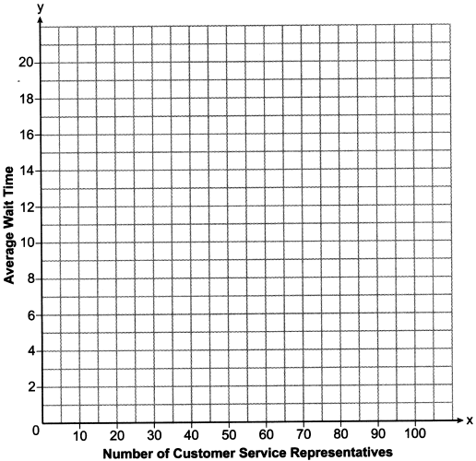

To the nearest integer, solve the equation . Determine, to the nearest minute, . Explain what this value represents in the given context.

24 The value of a certain small passenger car based on its use in years is modeled by , where is the value in dollars and t is the time in years. Zach had to take out a loan to purchase the small passenger car. The function , where is measured in dollars, and t is the time in years, models the unpaid amount of Zach's loan over time. Graph and over the interval , on the set of axes below.



State when , to the nearest hundredth, and interpret its meaning in the context of the problem. Zach takes out an insurance policy that requires him to pay a $3000 deductible in case of a collision. Zach will cancel the collision policy when the value of his car equals his deductible. To the nearest year, how long will it take Zach to cancel this policy? Justify your answer.

25 Drugs break down in the human body at different rates and therefore must be prescribed by doctors carefully to prevent complications, such as overdosing. The breakdown of a drug is represented by the function , where is the amount left in the body, is the initial dosage, r is the decay rate, and t is time in hours. Patient A, , is given 800 milligrams of a drug with a decay rate of 0.347. Patient B, , is given 400 milligrams of another drug with a decay rate of 0.231. Write two functions, and , to represent the breakdown of the respective drug given to each patient. Graph each function on the set of axes below.



To the nearest hour, t, when does the amount of the given drug remaining in patient B begin to exceed the amount of the given drug remaining in patient A? The doctor will allow patient A to take another 800 milligram dose of the drug once only 15% of the original dose is left in the body. Determine, to the nearest tenth of an hour, how long patient A will have to wait to take another 800 milligram dose of the drug.

26 Website popularity ratings are often determined using models that incorporate the number of visits per week a website receives. One model for ranking websites is , where x is the number of visits per week in thousands and is the website's popularity rating. According to this model, if a website is visited 16,000 times in one week, what is its popularity rating, rounded to the nearest tenth? Graph on the axes below.

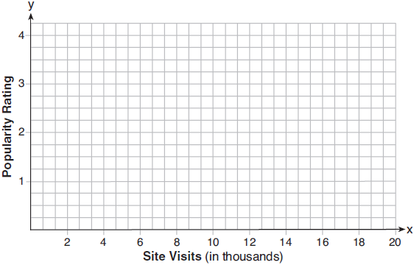

An alternative rating model is represented by 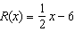, where x is the number of visits per week in thousands. Graph on the same set of axes. For what number of weekly visits will the two models provide the same rating?
1 ANS: 4 REF: 061914aii

2 ANS: 4
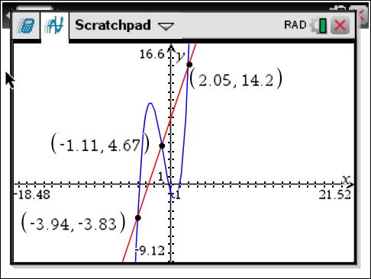

REF: 061622aii

3 ANS: 2
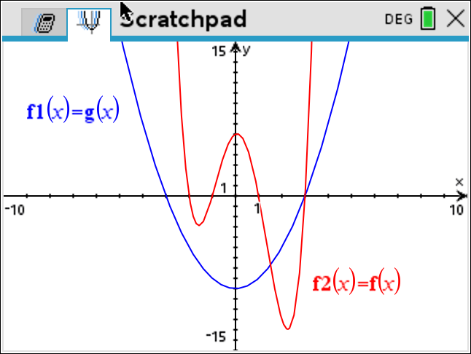

REF: 082319aii

4 ANS: 2
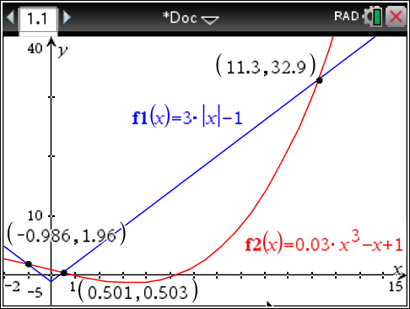

REF: 061705aii

5 ANS: 2
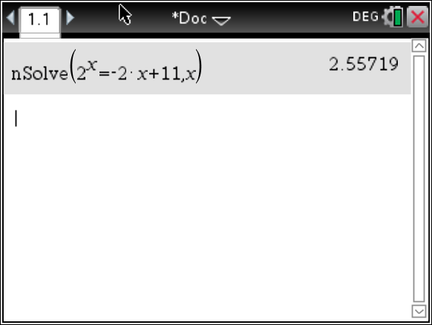

REF: 081603aii

6 ANS: 3
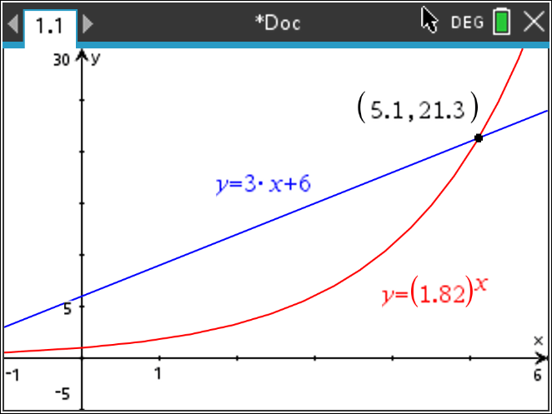

REF: 012406aii

7 ANS: 2
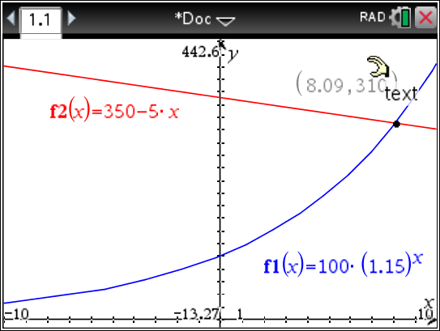

REF: 011716aii

8 ANS: 1
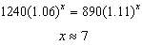

REF: 061814aii

9 ANS: 2
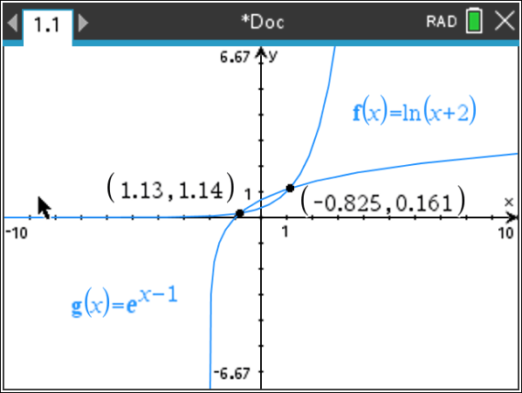

REF: 081920aii

10 ANS: 4
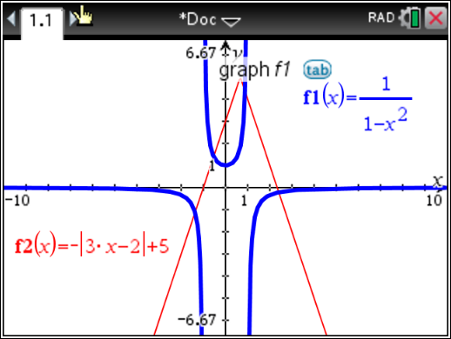

REF: 011924aii

11 ANS: 2
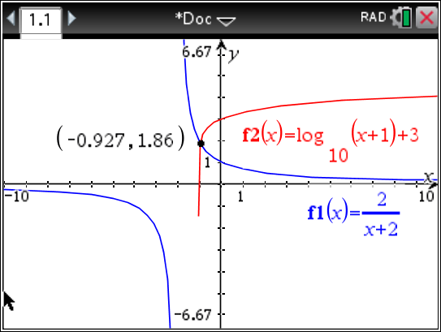

REF: 011712aii

12 ANS: 3
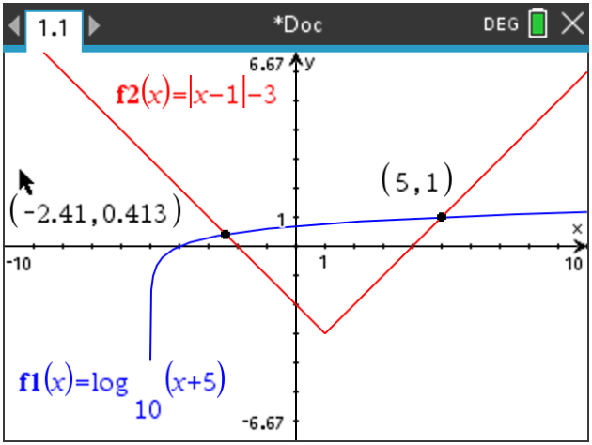

REF: 012317aii

13 ANS: 1 REF: 011814aii

14 ANS: 3 REF: 081819aii

15 ANS: 1
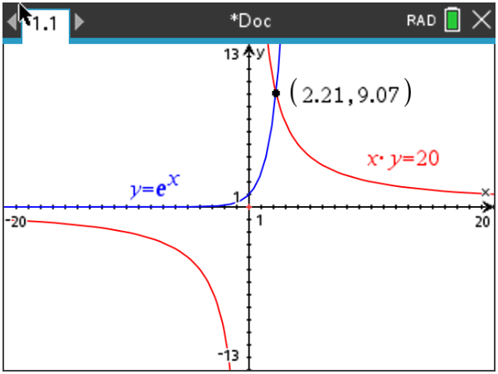

REF: 082210aii

16 ANS: 2
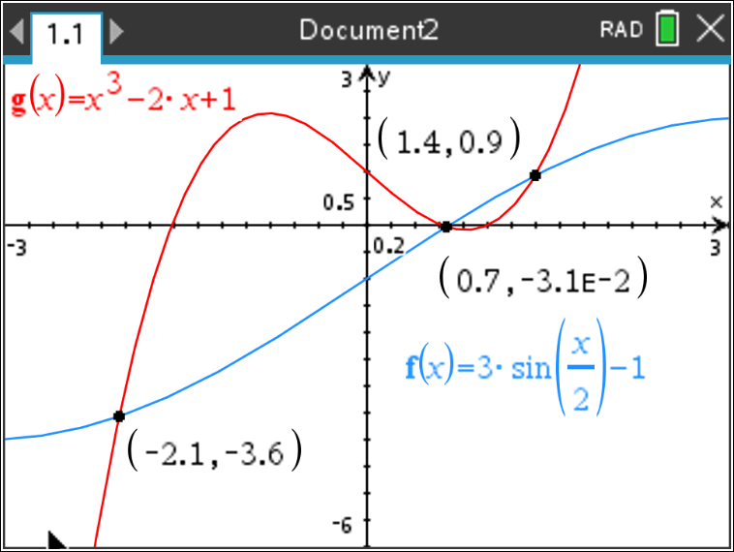

REF: 012021aii

17 ANS:
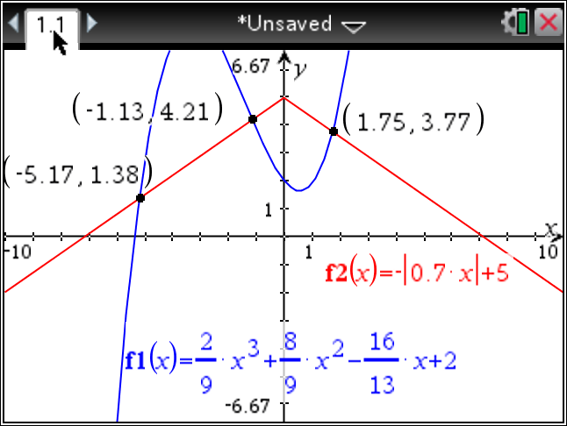

REF: fall1510aii

18 ANS:
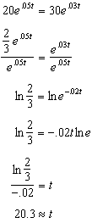

REF: 011829aii

19 ANS:
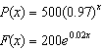; 18; The number of palm trees and flamingos will be equal in 18 years.

REF: 062336aii

20 ANS:
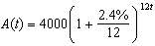 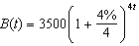 8.4, the value of t for which

REF: 012435aii

21 ANS:
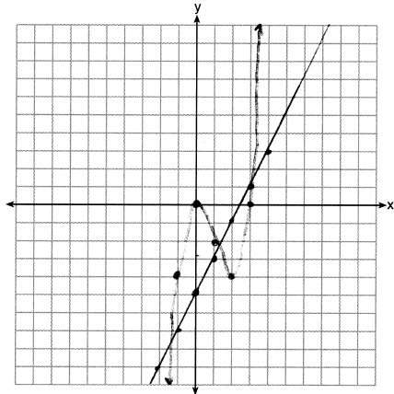 3

REF: 062233aii

22 ANS:
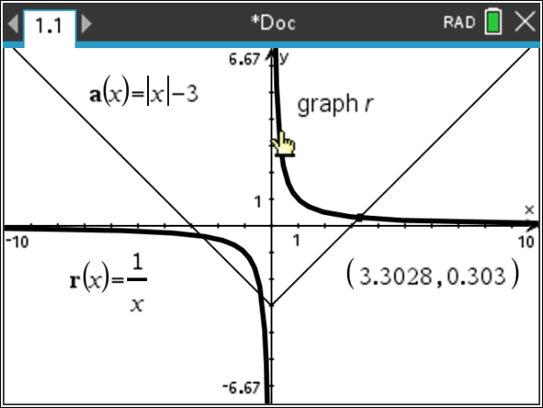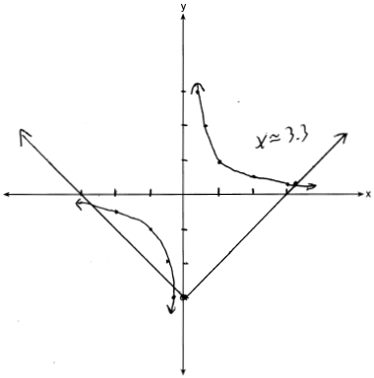

REF: 081932aii

23 ANS:
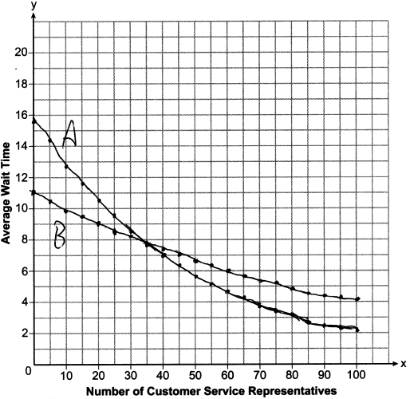35; , which represents the difference of the average wait time when there are 100 CSRs between the plans.

REF: 082237aii

24 ANS:
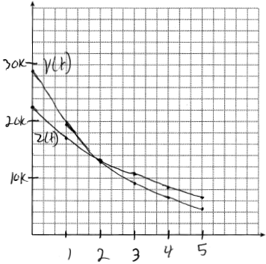 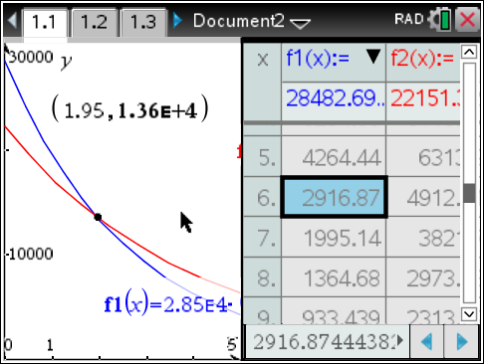 At 1.95 years, the value of the car equals the loan balance. Zach can cancel the policy after 6 years.

REF: 081737aii

25 ANS:
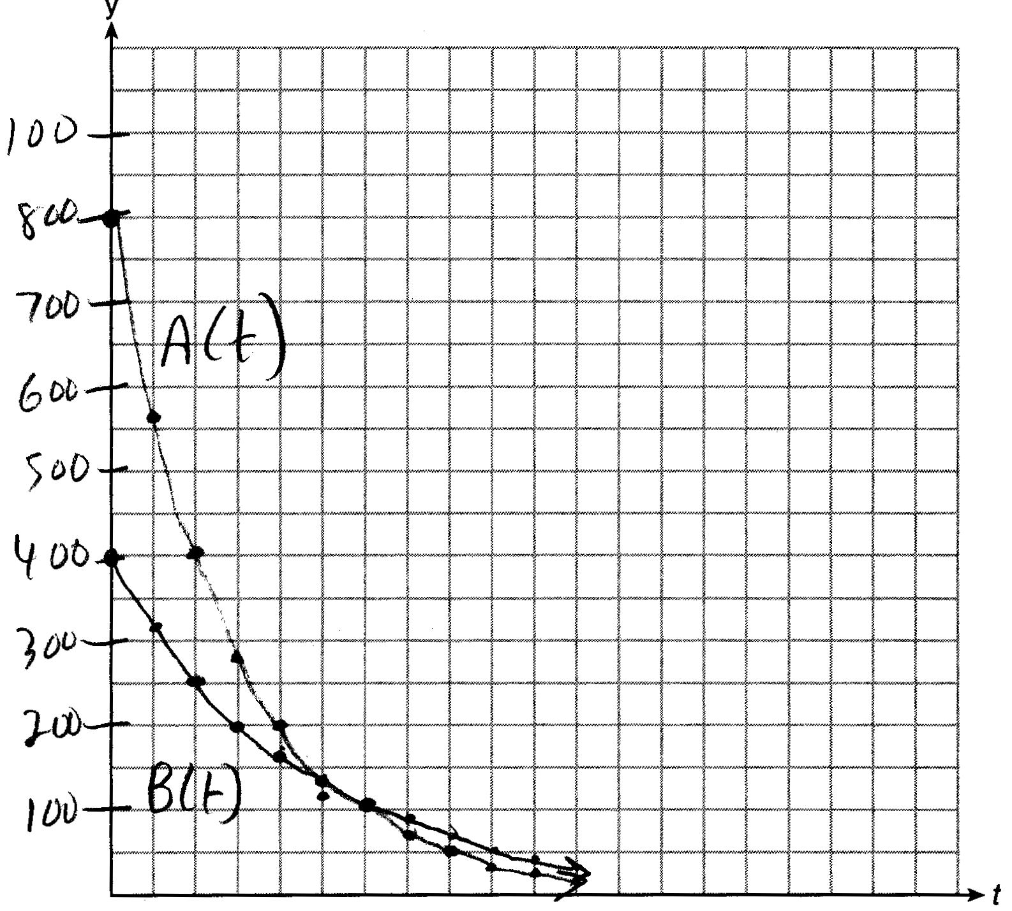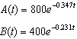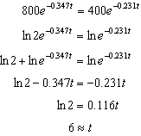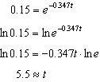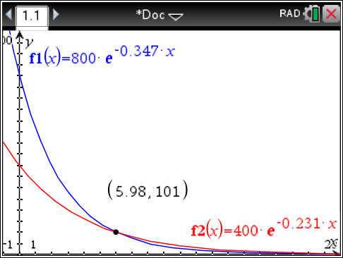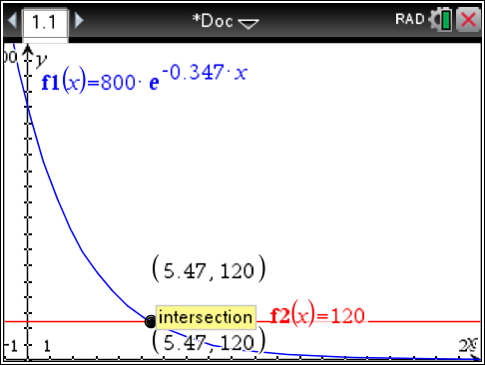

REF: 061637aii

26 ANS:
, 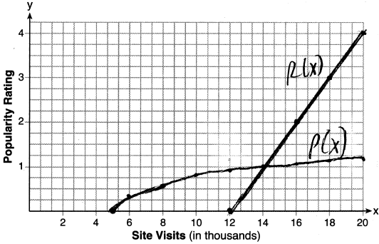, 14000

REF: 061837aii

