B – Graphs and Statistics, Lesson 4, Analysis of Data (r. 2018)

GRAPHS AND STATISTICS
Analysis of Data
Common Core Standard  S-ID.C.9 Distinguish between correlation and  causation. | Next Generation Standard  AI-S.ID.9 Distinguish between correlation and  causation.

LEARNING OBJECTIVES
Students will be able to:
1) Distinguish between correlation and causation in context.

Overview of Lesson
Teacher Centered Introduction  Overview of Lesson  - activate students’ prior knowledge  - vocabulary  - learning objective(s)  - big ideas: direct instruction  - modeling | Student Centered Activities  guided practice ⬅Teacher: anticipates, monitors, selects, sequences, and connects student work  - developing essential skills  - Regents exam questions  - formative assessment assignment (exit slip, explain the math, or journal entry)

VOCABULARY

correlation
causation
causal relationship

BIG IDEAS

Correlation: Event A is related to, but does not necessarily cause event B.

Causation: Event A causes event B.
Example: In the summer, ice cream sales are higher. This is an example of correlation, but not causation. Summer does not cause ice cream sales to be higher. What causes ice cream sales to be higher in the summer is hot weather.
Fallacy of Composition: A fallacy of composition is the erroneous conclusion that: because event B follows event A, event A caused event B. In Latin, a fallacy of composition is known at post hoc, ergo propter hoc, which means “after this, therefore because of this.” Fallacies of composition are usually correlations, not causations.
Example of a Fallacy of Composition: Deep in the rain forest, a tribe of indigenous people live. Every year, when the days start getting longer, the shaman of the tribe does a rain dance. Soon, the spring rains come. The people of the village believe the shaman’s dance caused the rain to come. Modern scientists would argue that the rains come every year because of the changing of the seasons, and the village peoples’ belief is a fallacy of composition - the rains were not caused by the shaman’s dance - they were only correlated with the timing of the dance. Such fallacies of composition can be difficult to identify, and it might be even more difficult to convince the village people that the rains are only correlated with, not caused by, the shaman’s rain dance.

DEVELOPING ESSENTIAL SKILLS
Decide whether the relationships between events A and B are correlation or causation.
Event A | Causes Event B | Which is it?
I get in the bathtub. | The phone rings. | Correlation
Attendance at the baseball game goes up. | Ice cream sales increase. | Correlation
I wear these socks. | We win the soccer game. | Correlation
I stream more videos on my cell phone. | My cell phone bill goes up. | Causation
I eat more food. | My weight increases. | Uncertain
Mankind’s influence on the environment. | Global warming. | Causation
I wash my car. | It rains. | Correlation
Smoking cigarettes. | Increased chances of getting lung cancer. | Causation
Junk food is sold in school to raise money. | Student obesity increases. | Uncertain
I get higher scores on exams. | My course grade increases. | Causation.
I do more homework. | My exam scores increase. | Correlation

REGENTS EXAM QUESTIONS
S.ID.C.9: Analysis of Data

23) Which situation does not describe a causal relationship?
1) | The higher the volume on a radio, the louder the sound will be.
2) | The faster a student types a research paper, the more pages the paper will have.
3) | The shorter the distance driven, the less gasoline that will be used.
4) | The slower the pace of a runner, the longer it will take the runner to finish the race.

24) What type of relationship exists between the number of pages printed on a printer and the amount of ink used by that printer?
1) | positive correlation, but not causal
2) | positive correlation, and causal
3) | negative correlation, but not causal
4) | negative correlation, and causal

25) Beverly did a study this past spring using data she collected from a cafeteria. She recorded data weekly for ice cream sales and soda sales. Beverly found the line of best fit and the correlation coefficient, as shown in the diagram below.

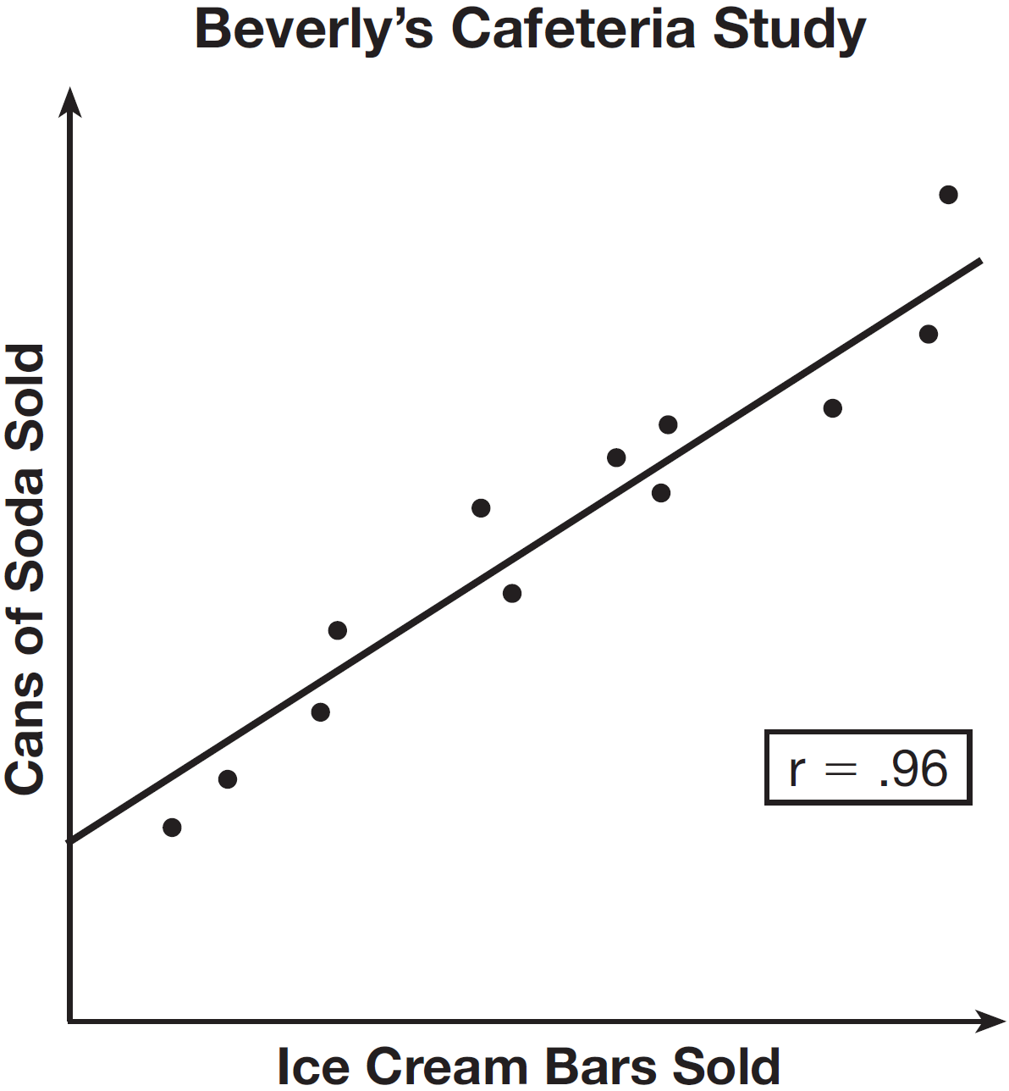

Given this information, which statement(s) can correctly be concluded?
I. Eating more ice cream causes a person to become thirsty.
II. Drinking more soda causes a person to become hungry.
III. There is a strong correlation between ice cream sales and soda sales.
1) | I, only | 3) | I and III
2) | III, only | 4) | II and III

SOLUTIONS

23) ANS: 2
The number of pages a paper will have does not depend on how fast the student types.

PTS: 2 NAT: S.ID.C.9 TOP: Analysis of Data

24) ANS: 2
Strategy: Eliminate wrong answers.
Observe: Both variables (numer of pages and amount of ink) increase together, so the correlation is positve. Eliminate answer choices with negative correlation.
Reason: Printing causes ink to be used, so the relationship is causal. Eliminate answer choices with non-causal.
a) positive correlation, but not causal
b) positive correlation, and causal
c) negative correlation, but not causal
d) negative correlation, and causal

PTS: 2 NAT: S.ID.C.9 TOP: Analysis of Data

25) ANS: 2
Strategy: Determine the truth value of each statement, then determine which of the four answer choices best matches the truth values of the three statements.

STEP 1. Determine the truth values of each statement:

Statement I is false. Eating more ice cream does not necessarily cause a person to become thirsty.

Statement II is false. Drinking more soda does not necessarily cause a person to become hungry.

Statement III is true. There is a strong correlation between ice cream sales and soda sales.

STEP 2. Use knowledge of correlation and causation to select the correct answer.

Statement III is the only statement than can be correctly concluded. The answer is choice b.

PTS: 2 NAT: S.ID.C.9 TOP: Analysis of Data

