D – Rate, Lesson 2, Using Rate (r. 2018)

RATE
Using Rate
Common Core Standard  N-Q.A.2 Define appropriate quantities for the purpose of descriptive modeling.  PARCC: In Algebra I, this standard will be assessed by ensuring that some modeling tasks (involving Algebra I content or securely held content from grades 6-8) require the student to create a quantity of interest in the situation being described. For example, a quantity of interest is not selected for the student by the task. For example, In a situation involving data, the student might autonomously decide that a measure of center is a key variable in a situation, and then choose to work with the mean. | Next Generation Standard  STANDARD REMOVED

LEARNING OBJECTIVES
Students will be able to:
- Use conversion rates to solve problems involving scale.
- Use unit conversion rates and the operations of multiplication and division to convert units.

Overview of Lesson
Teacher Centered Introduction  Overview of Lesson  - activate students’ prior knowledge  - vocabulary  - learning objective(s)  - big ideas: direct instruction  - modeling | Student Centered Activities  guided practice ⬅Teacher: anticipates, monitors, selects, sequences, and connects student work  - developing essential skills  - Regents exam questions  - formative assessment assignment (exit slip, explain the math, or journal entry)

VOCABULARY

conversion rate
proportion
scale
unit

BIG IDEAS

It is important to understand the units and scales used in mathematical representations. As a general rule, big units should be used to measure big things and small units are used to measure small things. Real world events are often modeled using scaled representations.

A scale is a ratio of the 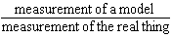.
Example. A toy car is 1 foot long. The real car it represents is 20 feet long. The scale of the model is:
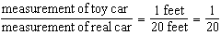 or 1:20

Scales may also be expressed in rates. For example, a map might have a scale expressed as , or a graph might use scaled intervals of various units on the x-axis and y-axis.

When using scales for representation, it is important to know whether you are going from smaller units to larger units, or from larger units to smaller units, as shown in the following graphic.

A unit conversion rate because it states the value of 1 unit in terms of another unit. Unit conversion rates are typically used in conversion tables. For example, 1 inch = 2.54 centimeters.
Proportions and cross multiplication can be used to convert a unit conversion rate for one unit into to a unit conversion rate for the other unit. For example:
This tells us that 1 centimeter = 0.39 inches.

DEVELOPING ESSENTIAL SKILLS
Use the conversion chart to state whether multiplication or division should be used when converting from one unit to the other unit. Specify the multiplicand or divisor for each operation.
Conversions Chart Used in Regents Algebra 1 (Common Core) Exams
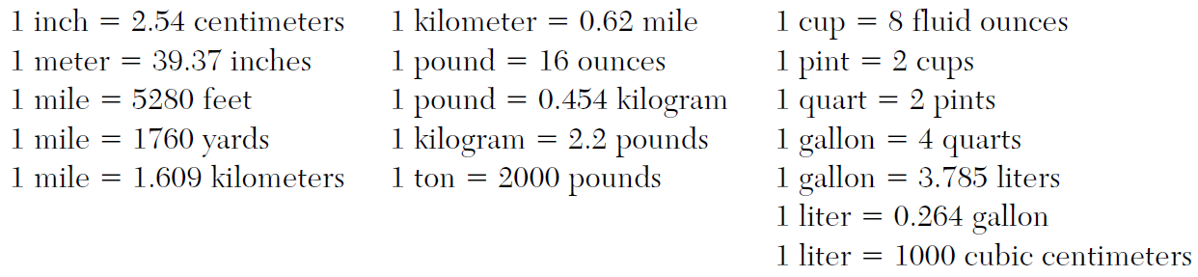

From | To | Operation Used
inches | centimeters | multiply by 2.54
centimeters | inches | divide by 2.54
meters | inches | multiply by 39.37
inches | meters | divide by 39.37
miles | feet | multiply by 5280
Feet | miles | divide by 5280
miles | kilometers | multiply by 0.62
kilometers | miles | divide by 0.62
pounds | ounces | multiply by 16
ounces | pounds | divide by 16
pounds | kilograms | divide by 2.2 or multiply by 0.454
kilograms | pounds | multiply by 2.2
ton | pound | multiply by 2.2
pound | ton | divide by 2000
cup | fluid ounces | multiply by 8
fluid ounces | cups | divide by 8
pint | cups | multiply by 2
cups | pints | divide by 2
quart | pints | multiply by 2
pints | quarts | divide by 2
gallons | quarts | multiply by 4
quarts | gallons | divide by 4
gallons | liters | multiply by 3.785
liters | gallons | divide by 3.785
liters | cubic centimeters | multiply by 1000
centimeters | liters | divide by 1000

REGENTS EXAM QUESTIONS (through June 2018)
N.Q.A.2: Using Rate

88) Patricia is trying to compare the average rainfall of New York to that of Arizona. A comparison between these two states for the months of July through September would be best measured in

1) | feet per hour | 3) | inches per month
2) | inches per hour | 4) | feet per month

89) A two-inch-long grasshopper can jump a horizontal distance of 40 inches. An athlete, who is five feet nine, wants to cover a distance of one mile by jumping. If this person could jump at the same ratio of body-length to jump-length as the grasshopper, determine, to the nearest jump, how many jumps it would take this athlete to jump one mile.

90) The distance traveled is equal to the rate of speed multiplied by the time traveled. If the distance is measured in feet and the time is measured in minutes, then the rate of speed is expressed in which units? Explain how you arrived at your answer.

SOLUTIONS

88) ANS: 3
Rainfall is not typically measured in feet, so eliminate choices a and b.
An hourly rate would not be meaningful.

PTS: 2 NAT: N.Q.A.1

89) ANS:
Strategy 1: Use proportional reasoning and work with inch units.
If a 2 inch long grasshopper can jump 40 inches, the grasshopper can jump 20 times its body length.
If a 5-feet nine-inch person could jump 20 times his body length, he could jump inches.
A mile is 5,280 feet long, or inches.
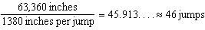

Strategy 2: Use proportional reasoning and work with feet units
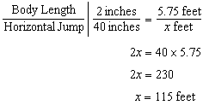
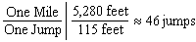

PTS: 2 NAT: N.Q.A.2 TOP: Using Rate

90) ANS:
Speed would be measured in feet per minute.
Explanation:
The problem tells us that distance (d) equals speed (s) multiplied by time (t).
Therefore:
and
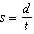
If distance units are measured in feet and time units are measured in minutes, then:
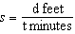

PTS: 2 NAT: N.Q.A.2 TOP: Using Rate

