**M – Functions, Lesson 9, Graphing Piecewise-Defined Functions (r. 2018)**

FUNCTIONS

Graphing Piecewise-Defined Functions

|  |  |
| --- | --- |
| **Common Core Standard**  **F-IF.C.7** Graph functions expressed symbolically and show key features of the graph, by hand in simple cases and using technology for more complicated cases. | **Next Generation Standard**  **AI-F.IF.7** Graph functions and show key features of the graph by hand and by using technology where appropriate.  (Shared standard with Algebra II) |

**LEARNING OBJECTIVES**

Students will be able to:

1. Graph and interpret piecewise functions.
2. Input piecewise functions in a graphing calculator.

**Overview of Lesson**

|  |  |
| --- | --- |
| **Teacher Centered Introduction**  **Overview of Lesson**  **- activate students’ prior knowledge**  **- vocabulary**  **- learning objective(s)**  **- big ideas: direct instruction**  **- modeling** | **Student Centered Activities**  **guided practice ⬅Teacher: anticipates, monitors, selects, sequences, and connects student work**  **- developing essential skills**  **- Regents exam questions**  **- formative assessment assignment (exit slip, explain the math, or journal entry)** |

**VOCABULARY**

closed dot

continuous

function

interval

open dot

piece

piecewise function

sub function

**BIG IDEAS**

**PIECEWISE FUNCTIONS**

A **piecewise function** is a function that is defined by two or more *sub* functions, with each sub function applying to a certain interval on the x-axis. Each *sub* function may also be referred to as a *piece* of the overall **piecewise function**, hence the name piecewise.

Example. The following is a piecewise function:



This example of a piecewise function has two “pieces,” or sub functions.

a. Over the interval , the sub function is .

b. Over the interval , the sub function is ..

|  |  |  |  |
| --- | --- | --- | --- |
| A table of values for this function. | | | A graph for this function. |
| *x* |  |  |  |
| -3 | -5 | na |
| -2 | -3 | na |
| -1 | -1 | na |
| 0 | 1 | na |
| 1 | na | 4 |
| 2 | na | 4 |
| 3 | na | 4 |
| 4 | na | 4 |
| 5 | na | 4 |
| 6 | na | 4 |
| 7 | na | 4 |

**Continuity**

**Piecewise functions** are often discontinuous, which means that the graph will not appear as a single line. In the above table, the piecewise function is discontinuous when . This is because  is not included in the sub function. Because piecewise functions are often discontinuous, care must be taken to use proper inequalities notation when graphing.

**Using Line Segments to Define Pieces**

If the circle at the beginning or end of a solution set (graph) is empty, that value *is not included* in the solution set. If the circle is filled in, that value *is included* in the solution set.

The number 1 is not included in the this solution set: 

The number 1 is included in this following solution set: 

**NOTE**: The TI83/84 family of graphing calculators can graph piecewise functions using the n-d function in the catalog and the test (second-math) function, as shown in the following screenshots.

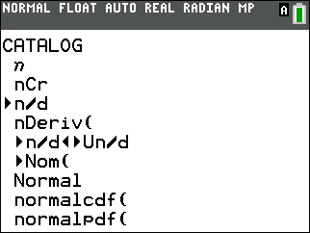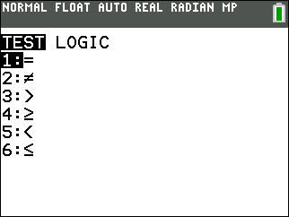

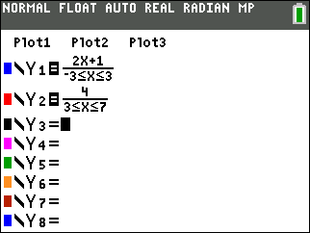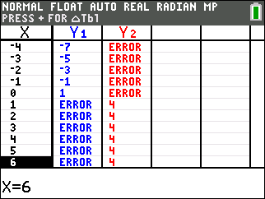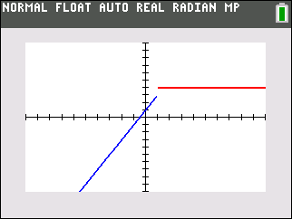

**DEVELOPING ESSENTIAL SKILLS**

Use technology to graph the following piecewise functions.







ANSWERS



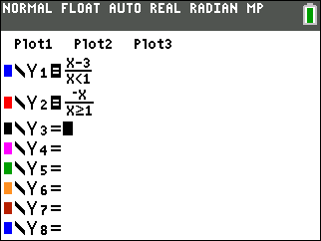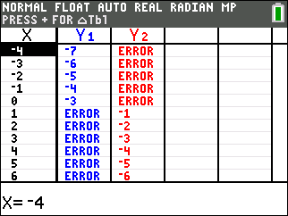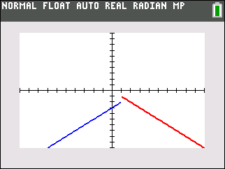



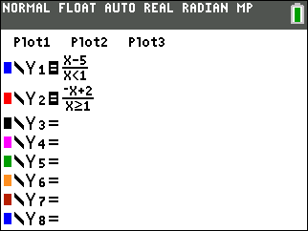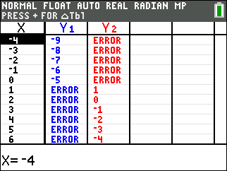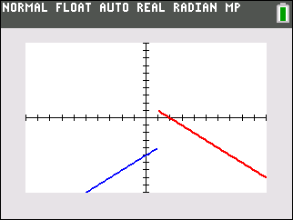



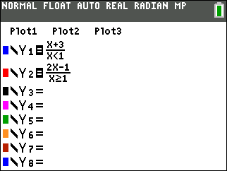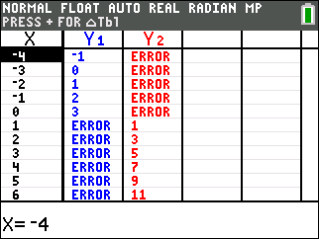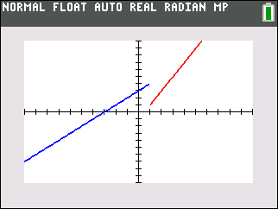

**REGENTS EXAM QUESTIONS (through June 2018)**

F.IF.C.7: Graphing Piecewise-Defined Functions

479) At an office supply store, if a customer purchases fewer than 10 pencils, the cost of each pencil is $1.75. If a customer purchases 10 or more pencils, the cost of each pencil is $1.25. Let *c* be a function for which  is the cost of purchasing *x* pencils, where *x* is a whole number.



Create a graph of *c* on the axes below.

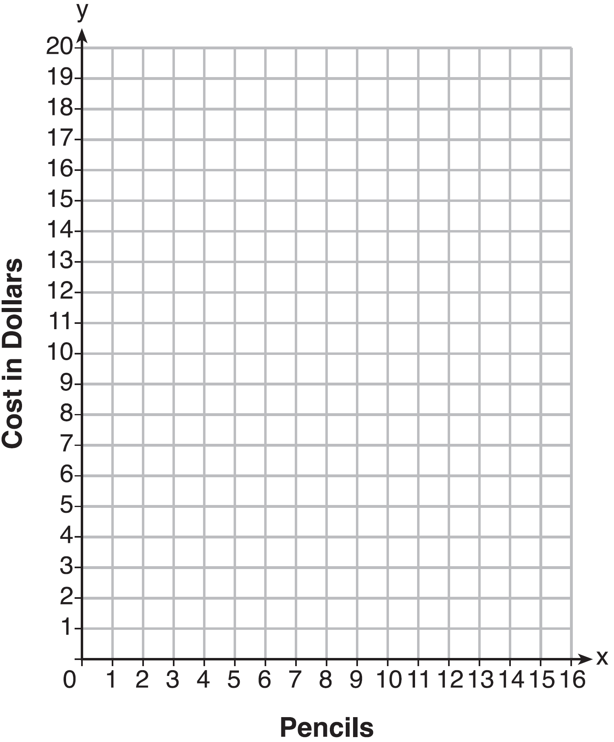

A customer brings 8 pencils to the cashier. The cashier suggests that the total cost to purchase 10 pencils would be less expensive. State whether the cashier is correct or incorrect. Justify your answer.

480) Which graph represents ?

|  |  |  |  |
| --- | --- | --- | --- |
| 1) |  | 3) |  |
| 2) |  | 4) |  |

481) A function is graphed on the set of axes below.

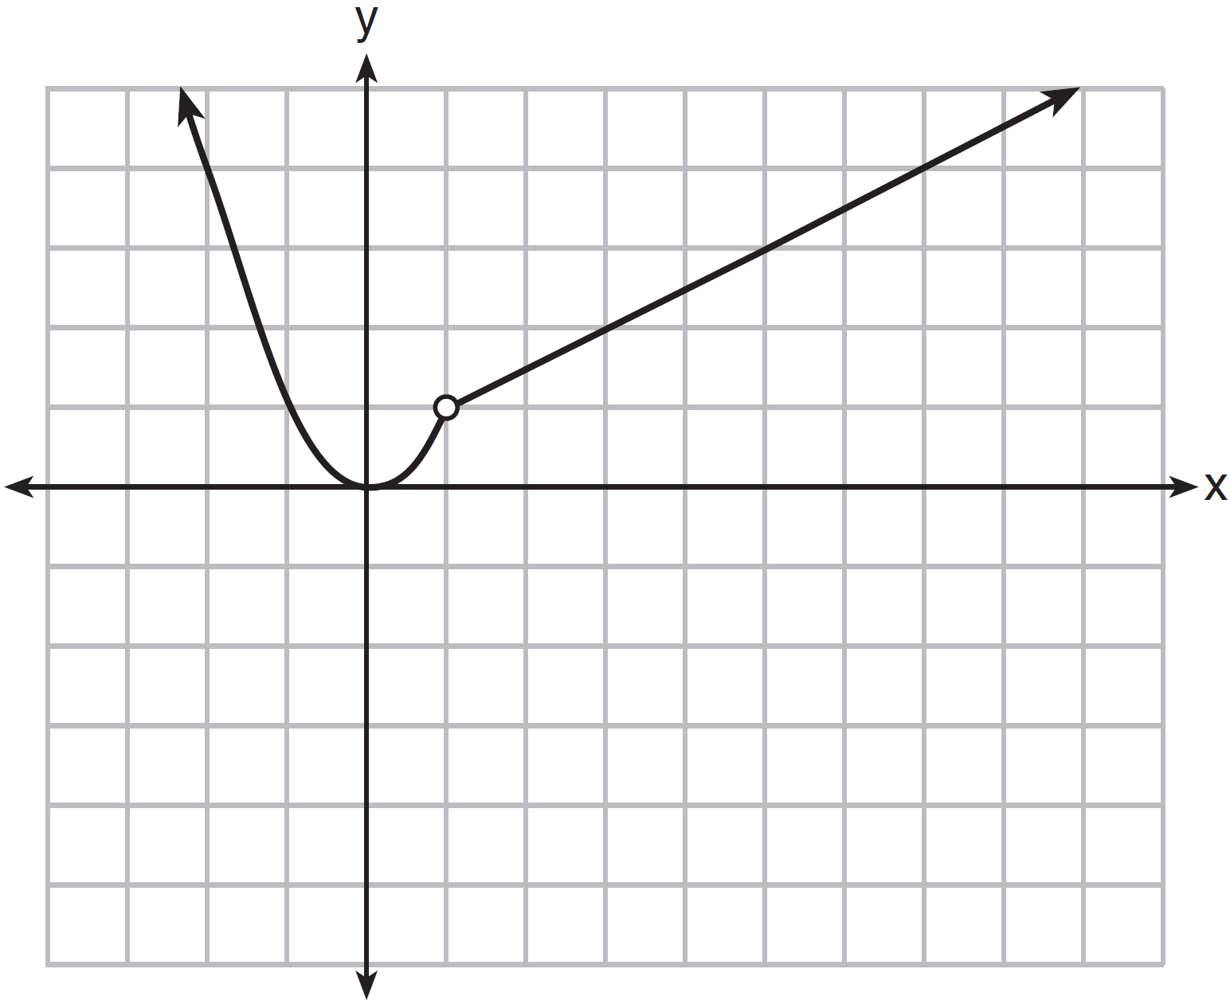

Which function is related to the graph?

|  |  |  |  |
| --- | --- | --- | --- |
| 1) |  | 3) |  |
| 2) |  | 4) |  |

482) Graph the following function on the set of axes below.



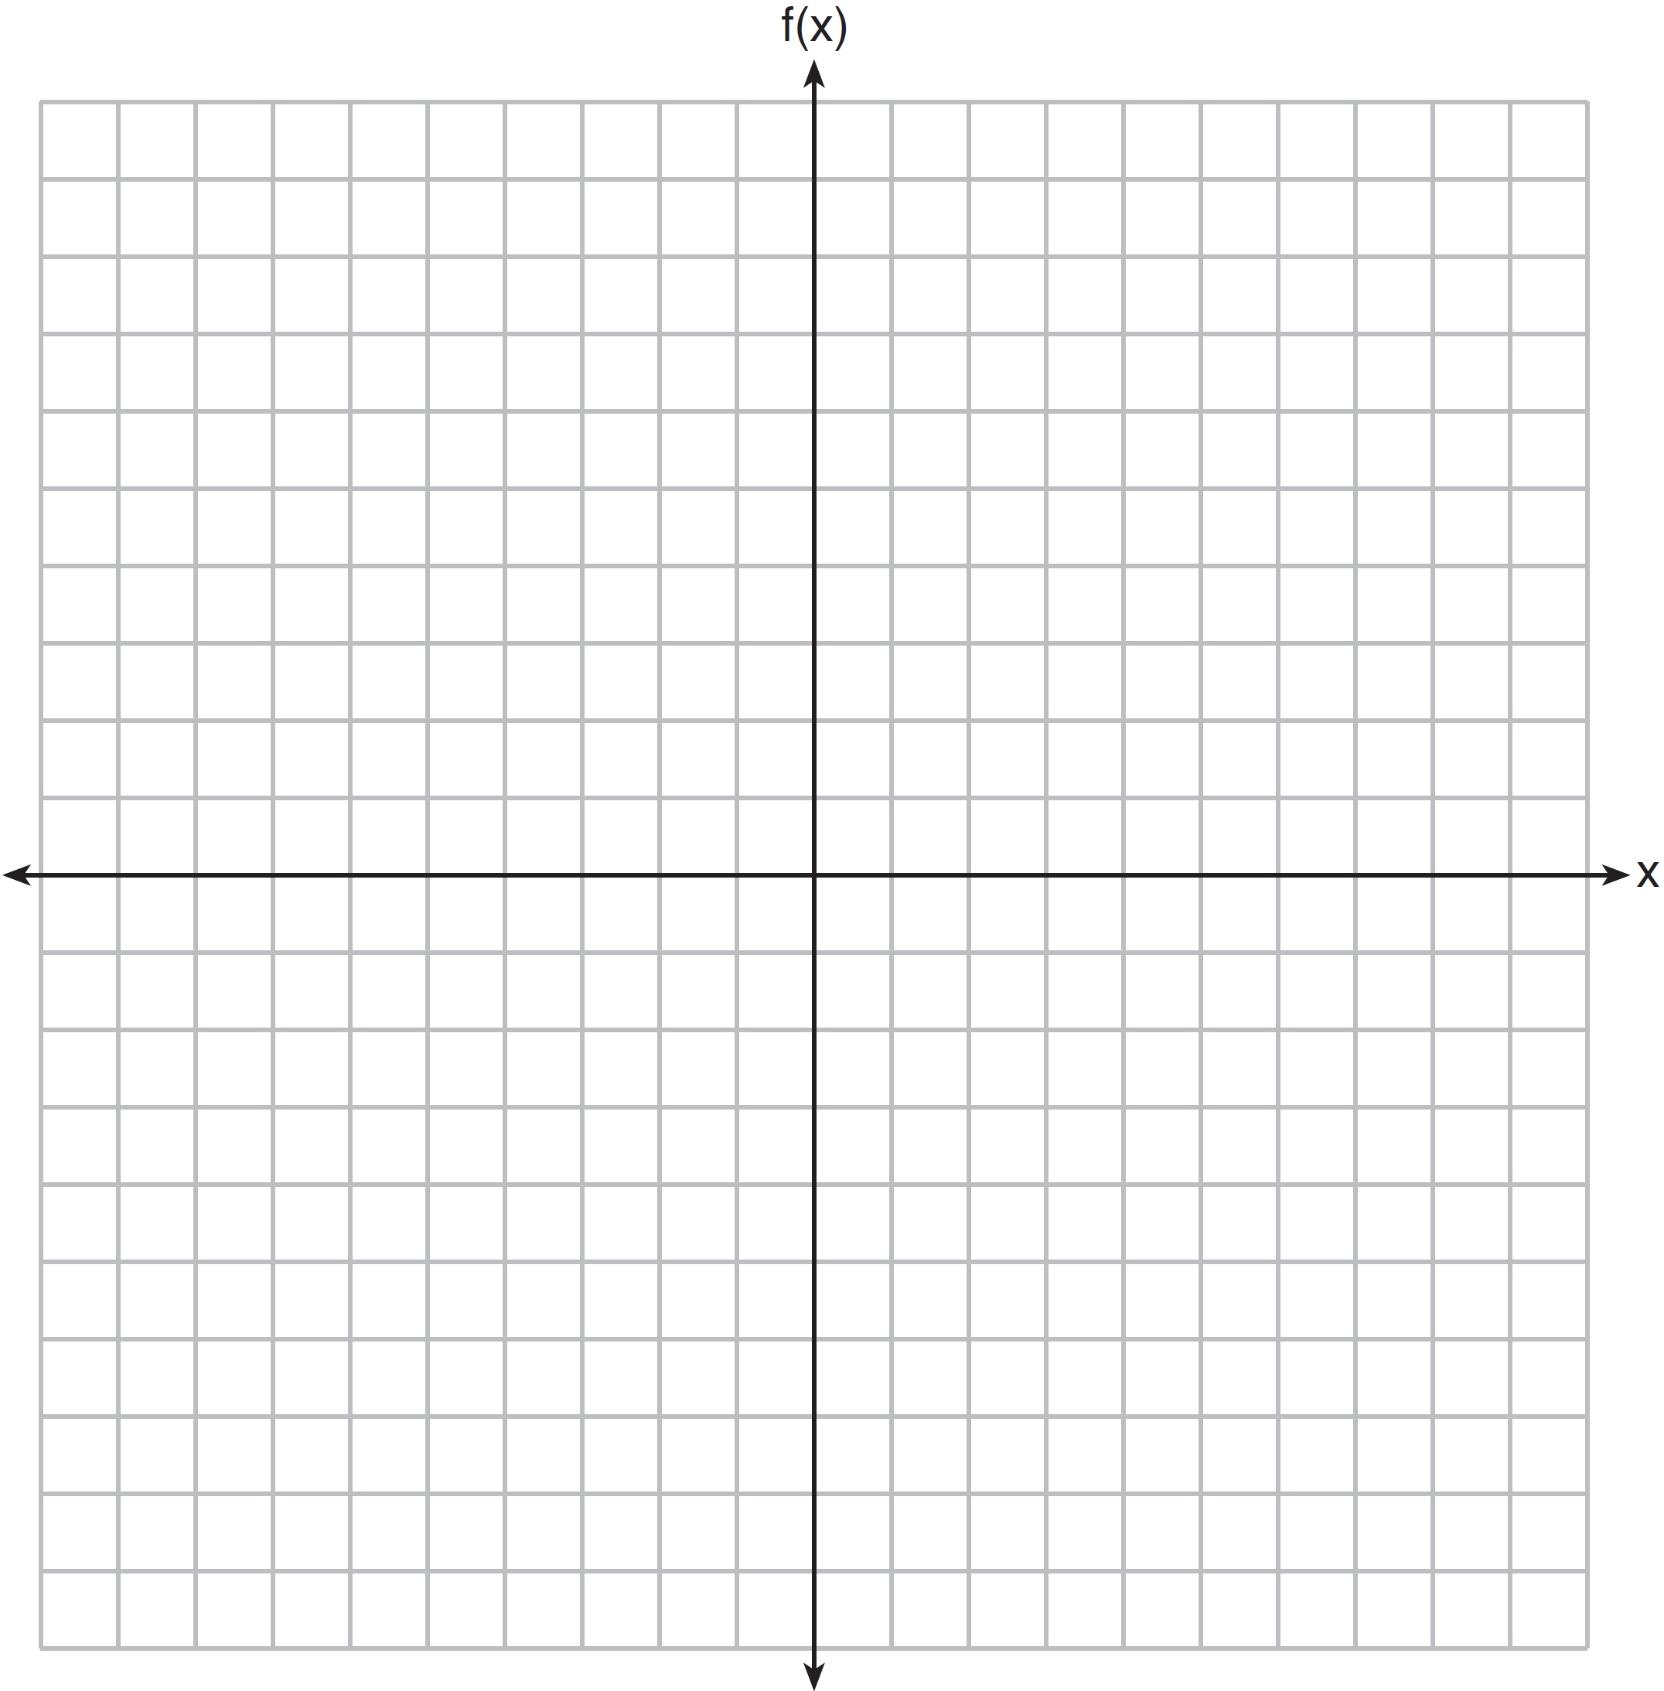

483) Which graph does *not* represent a function that is always increasing over the entire interval ?

|  |  |  |  |
| --- | --- | --- | --- |
| 1) |  | 3) |  |
| 2) |  | 4) |  |

484) On the set of axes below, graph the piecewise function:

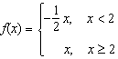

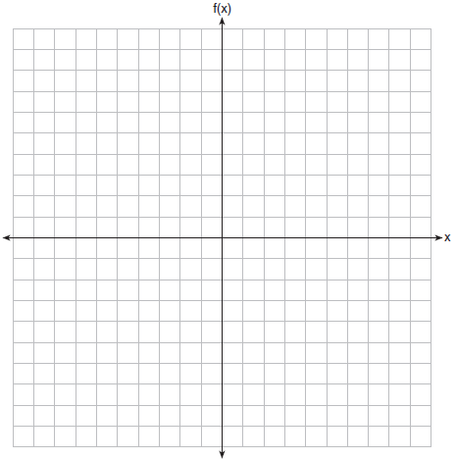

**SOLUTIONS**

479) ANS:

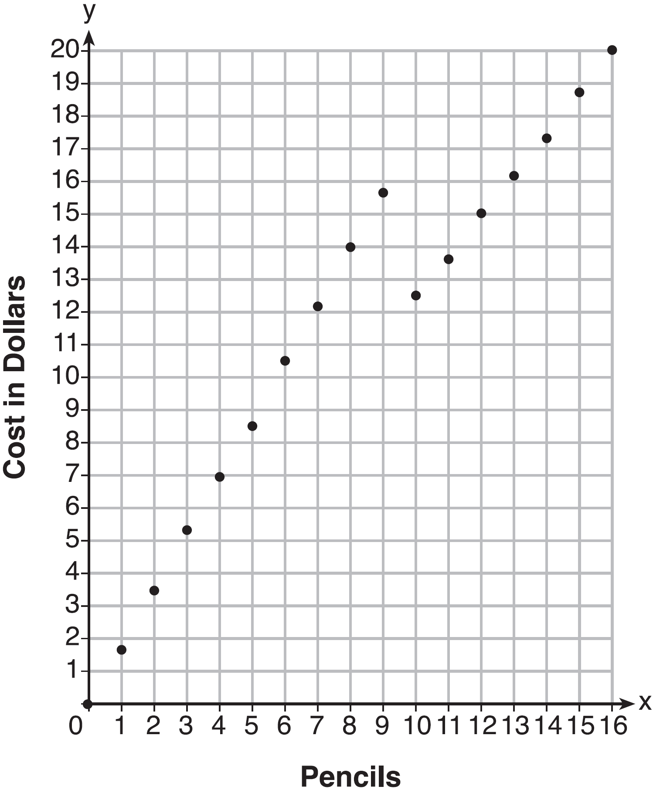

The cashier is correct. 8 pencils cost $14 and 10 pencils cost $12.50.

Strategy: Use a graphing calculator and graph the function in two sections. Note that the domain of the function is whole numbers. You cannot buy a part of a pencil. This means that the graph of the function will consist of points and not lines. After completing the graph, answer the questions presented in the problem.

STEP 1: Graph the section of the function represented by . Plot closed dots for each whole number in the domain .

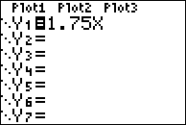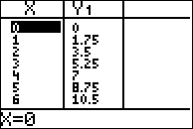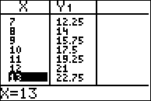

STEP 2: Graph the section of the function represented by . Plot closed dots for each whole number in the domain .

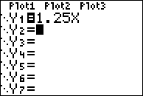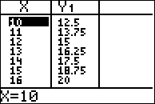

STEP 3: Answer the questions presented in the problem.

The data tables and the graph show that it would be cheaper to purchase 10 pencils that to purchase 8 pencils.

PTS: 4 NAT: F.IF.C.7 TOP: Graphing Piecewise-Defined Functions

480) ANS: 2

Strategy: Eliminate wrong answers.

The left half of each graph corresonds to  over the domain . The graph of should not curve because *x* is of the first degree. Answer choices *c* and *d* should be eliminated because they have curves over the domain . A quick look at the graph of

 in a graphing calculator shows why answer choices *c* and *d* should be eliminated.

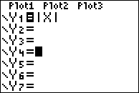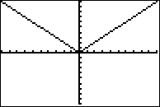

The graph of  over the domain  should be not be a straight line because the degree of x is not 1. A quick look at the graph of  in a graphing calculator shows that answer choice *b* is correct.

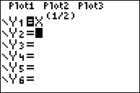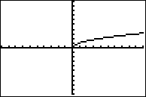

PTS: 2 NAT: F.IF.C.7 TOP: Graphing Piecewise-Defined Functions

KEY: bimodalgraph

481) ANS: 2

Strategy: Since  is included in every answer choice, concentrate on the linear functions for .

The linear equation has a slope of . The only linear function that has a slope of  is , which is answer choice b.

PTS: 2 NAT: F.IF.C.7 TOP: Graphing Piecewise-Defined Functions

482) ANS:

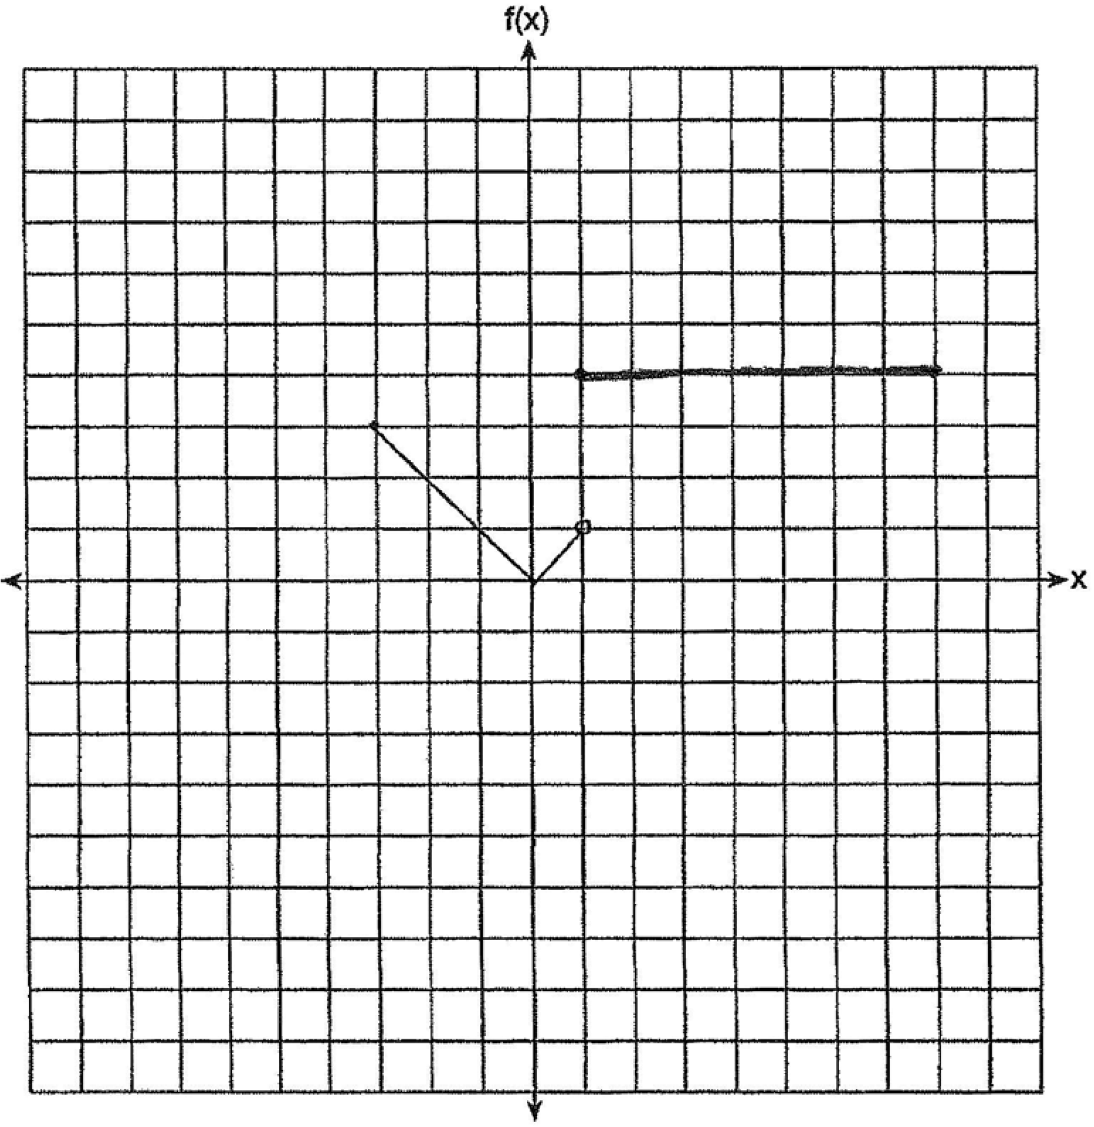

Strategy: Use a graphing calculator and graph the function in sections, paying careful attention to open and closed circles at the end of each function segment.

STEP 1. Graph  over the interval . Use a closed dot for  and an open dot for . Use data from the table of values to plot the interval .

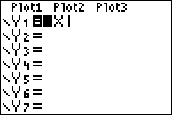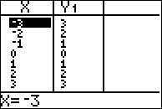

STEP 2: Graph  over the interval . Use a closed dot for  and a closed dot for . Use data from the table of values to plot the interval .

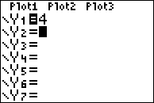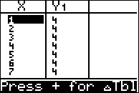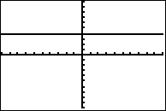

Do not connect the two graph segments.

PTS: 2 NAT: F.IF.C.7 TOP: Graphing Piecewise-Defined Functions

483) ANS: 3

Strategy: Looks at the slope of the graph over the interval . Select the answer choice where the slope of the graph is negative anywhere in this interval.

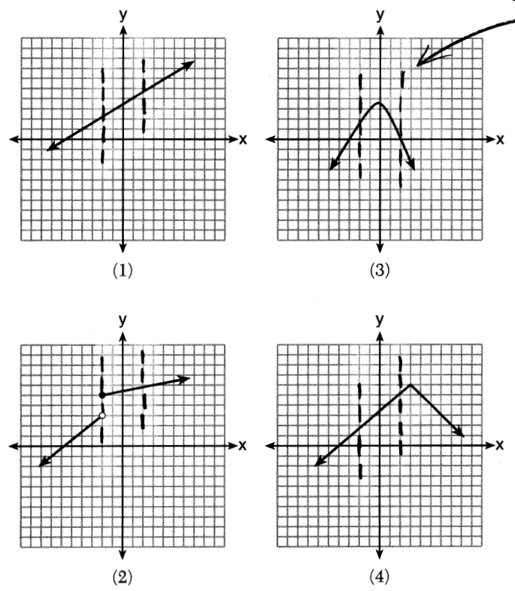

Answer choice (3) is the only graph that has a negative slope over the interval .

PTS: 2 NAT: F.IF.C.7 TOP: Graphing Piecewise-Defined Functions

484) ANS:

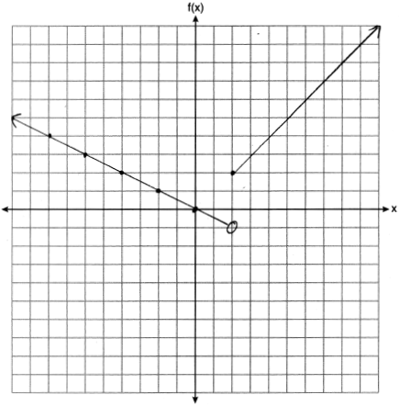

Strategy: Use a graphing calculator to help find and plot two points that define the lines for each part of this piecewise function.

STEP 1. Input the piecewise function as two separate equations in a graphing calculator and inspect the table of values for both functions.

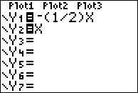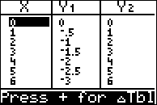

STEP 2. Plot the points for both functions when , which is the x-value where the function changes from the first piece to the second piece.

(2, -1) is plotted for the first part of the function  with an open circle, because the domain for this piece of the function is .

(2, 2) is plotted for the second part of the function  with a closed circle, because the domain for this piece of the function is .

STEP 3. Pick a second point in the domain  to plot for the first piece () of the function.

(0, 0) is an easy ordered pair to plot.

STEP 4. Draw a directed line that starts at (2,-1) and passes through (0,0).

STEP 5. Pick a second point in the domain  to plot for the second piece () of the function.

(6, 6) is an easy ordered pair to plot.

STEP 6. Draw a directed line that starts at (2,2) and passes through (6,6).

PTS: 2 NAT: F.IF.C.7 TOP: Graphing Piecewise-Defined Functions