**H – Quadratics, Lesson 6, Graphing Quadratic Functions (r. 2018)**

QUADRATICS

Graphing Quadratic Functions

|  |  |
| --- | --- |
| **Common Core Standard**  **F-IF.B.4** For a function that models a relationship between two quantities, interpret key features of graphs and tables in terms of the quantities, and sketch graphs showing key features given a verbal description of the relationship. *Key features include: intercepts; intervals where the function is increasing, decreasing, positive, or negative; relative maximums and minimums; symmetries; end behavior; and periodicity.*  PARCC: Tasks have a real-world context. Tasks are limited to linear functions, quadratic functions, square root functions, cube root functions, piece-wise defined functions (including step functions and absolute value functions) and exponential functions with domains in the integers.  **F-IF.C.7** Graph functions expressed symbolically and show key features of the graph, by hand in simple cases and using technology for more complicated cases. | **Next Generation Standard**  **AI-F.IF.4** For a function that models a relationship between two quantities:  i) interpret key features of graphs and tables in terms of the quantities; and  ii) sketch graphs showing key features given a verbal description of the relationship.  (Shared standard with Algebra II)  Notes:  • Algebra I key features include the following: intercepts, **zeros**; intervals where the function is increasing, decreasing, positive, or negative; maxima, minima; and symmetries.  • Tasks have a real-world context and are limited to the following functions: linear, quadratic, square root, piece-wise defined (including step and absolute value), and **exponential functions of the form  where *a* > 0 and *b* > 0 (*b*≠1)**.  **AI-F.IF.7** Graph functions and show key features of the graph by hand and by using technology where appropriate.  (Shared standard with Algebra II) |

**LEARNING OBJECTIVES**

Students will be able to:

1. Create a table of values from a function rule.
2. Sketch a graph from a table of values.
3. Identify and interpret in context key features of graphs, including: intercepts, zeros; intervals where the function is increasing, decreasing, positive, or negative; maxima, minima; and symmetries.

**Overview of Lesson**

|  |  |
| --- | --- |
| **Teacher Centered Introduction**  **Overview of Lesson**  **- activate students’ prior knowledge**  **- vocabulary**  **- learning objective(s)**  **- big ideas: direct instruction**  **- modeling** | **Student Centered Activities**  **guided practice ⬅Teacher: anticipates, monitors, selects, sequences, and connects student work**  **- developing essential skills**  **- Regents exam questions**  **- formative assessment assignment (exit slip, explain the math, or journal entry)** |

**VOCABULARY**

axis of symmetry

decreasing intervals

increasing intervals

intercepts

maxima

minima

negative slope

no slope

positive slope

symmetries

turning point

vertex

zeros

**BIG IDEAS**

Identify key features of graphs:

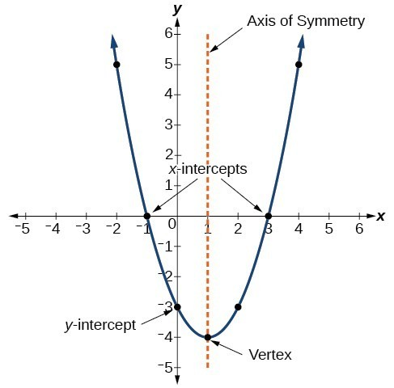

axis of symmetry: the axis of symmetry is the vertical line whose equation is 

decreasing intervals: the function is decreasing over the interval

increasing intervals: the function is increasing over the interval

intercepts: the x-axis intercepts are -1 and 3, the y-axis intercept is -3

maxima: there is no maxima

minima: the minima is -4

negative slope: the slope is negative on the left side of the axis of symmetry

no slope: the function has no slope at the vertex (1,-4)

positive slope: the slope is positive on the right side of the axis of symmetry

symmetries: the graph left of the axis of symmetry is symmetrical to the graph right of the axis of symmetry

turning point: the turning point is (1,-4)

vertex: the vertex is at (1,-4)

zeros: the zeros are , these are also the roots and solutions of the function.

**Sketching Graphs of Quadrilaterals**

STEP 1 Create a table of values.

* Use a graphing calculator whenever possible.
* Include the vertex in the table.

STEP 2 Select coordinate pairs that are easy to plot on a Cartesian plane.

* Start with the vertex.
* Select integer values when possible.
* Select an equal number of points on either side of the vertex
* 5 coordinate pairs are usually enough.

STEP 3 Connect the plotted points.

* Use the graph view of the function as a model for your sketch.
* Label the graph.
  + Include the function rule and at least three coordinates of plot points, and/or
  + Show the function rule and construct a table of values of plotted points on the page with the graph.

**Example**

Use technology to show three views of the following function: 

|  |  |  |
| --- | --- | --- |
|  |  |  |

**DEVELOPING ESSENTIAL SKILLS**

Sketch graphs of each of the following functions using technology and graph paper:

|  |
| --- |
|  |
|  |
|  |
|  |
|  |

Answers

Note: Students may submit answers on graph paper.

|  |  |  |  |
| --- | --- | --- | --- |
|  |  |  |  |
|  |  |  |  |
|  |  |  |  |
|  |  |  |  |
|  |  |  |  |

**REGENTS EXAM QUESTIONS (through June 2018)**

F.IF.B.4, F.IF.C.7: Graphing Quadratic Functions

224) Let  represent the height of an object above the ground after *t* seconds. Determine the number of seconds it takes to achieve its maximum height. Justify your answer.

State the time interval, in seconds, during which the height of the object *decreases*. Explain your reasoning.

225) A toy rocket is launched from the ground straight upward. The height of the rocket above the ground, in feet, is given by the equation , where *t* is the time in seconds. Determine the domain for this function in the given context. Explain your reasoning.

226) A ball is thrown into the air from the edge of a 48-foot-high cliff so that it eventually lands on the ground. The graph below shows the height, *y*, of the ball from the ground after *x* seconds.

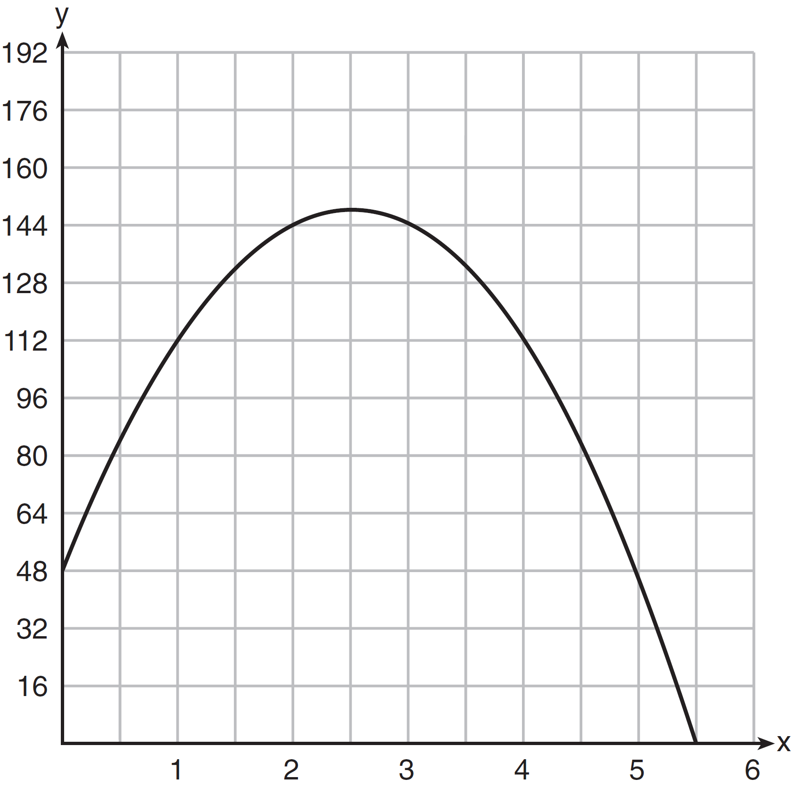

For which interval is the ball's height always *decreasing*?

|  |  |  |  |
| --- | --- | --- | --- |
| 1) |  | 3) |  |
| 2) |  | 4) |  |

227) Morgan throws a ball up into the air. The height of the ball above the ground, in feet, is modeled by the function , where *t* represents the time, in seconds, since the ball was thrown. What is the appropriate domain for this situation?

|  |  |  |  |
| --- | --- | --- | --- |
| 1) |  | 3) |  |
| 2) |  | 4) |  |

228) The height of a rocket, at selected times, is shown in the table below.

|  |  |  |  |  |  |  |  |  |
| --- | --- | --- | --- | --- | --- | --- | --- | --- |
| Time (sec) | 0 | 1 | 2 | 3 | 4 | 5 | 6 | 7 |
| Height (ft) | 180 | 260 | 308 | 324 | 308 | 260 | 180 | 68 |

Based on these data, which statement is *not* a valid conclusion?

|  |  |  |  |
| --- | --- | --- | --- |
| 1) | The rocket was launched from a height of 180 feet. | 3) | The rocket was in the air approximately 6 seconds before hitting the ground. |
| 2) | The maximum height of the rocket occurred 3 seconds after launch. | 4) | The rocket was above 300 feet for approximately 2 seconds. |

229) A football player attempts to kick a football over a goal post. The path of the football can be modeled by the function , where *x* is the horizontal distance from the kick, and  is the height of the football above the ground, when both are measured in feet. On the set of axes below, graph the function  over the interval .

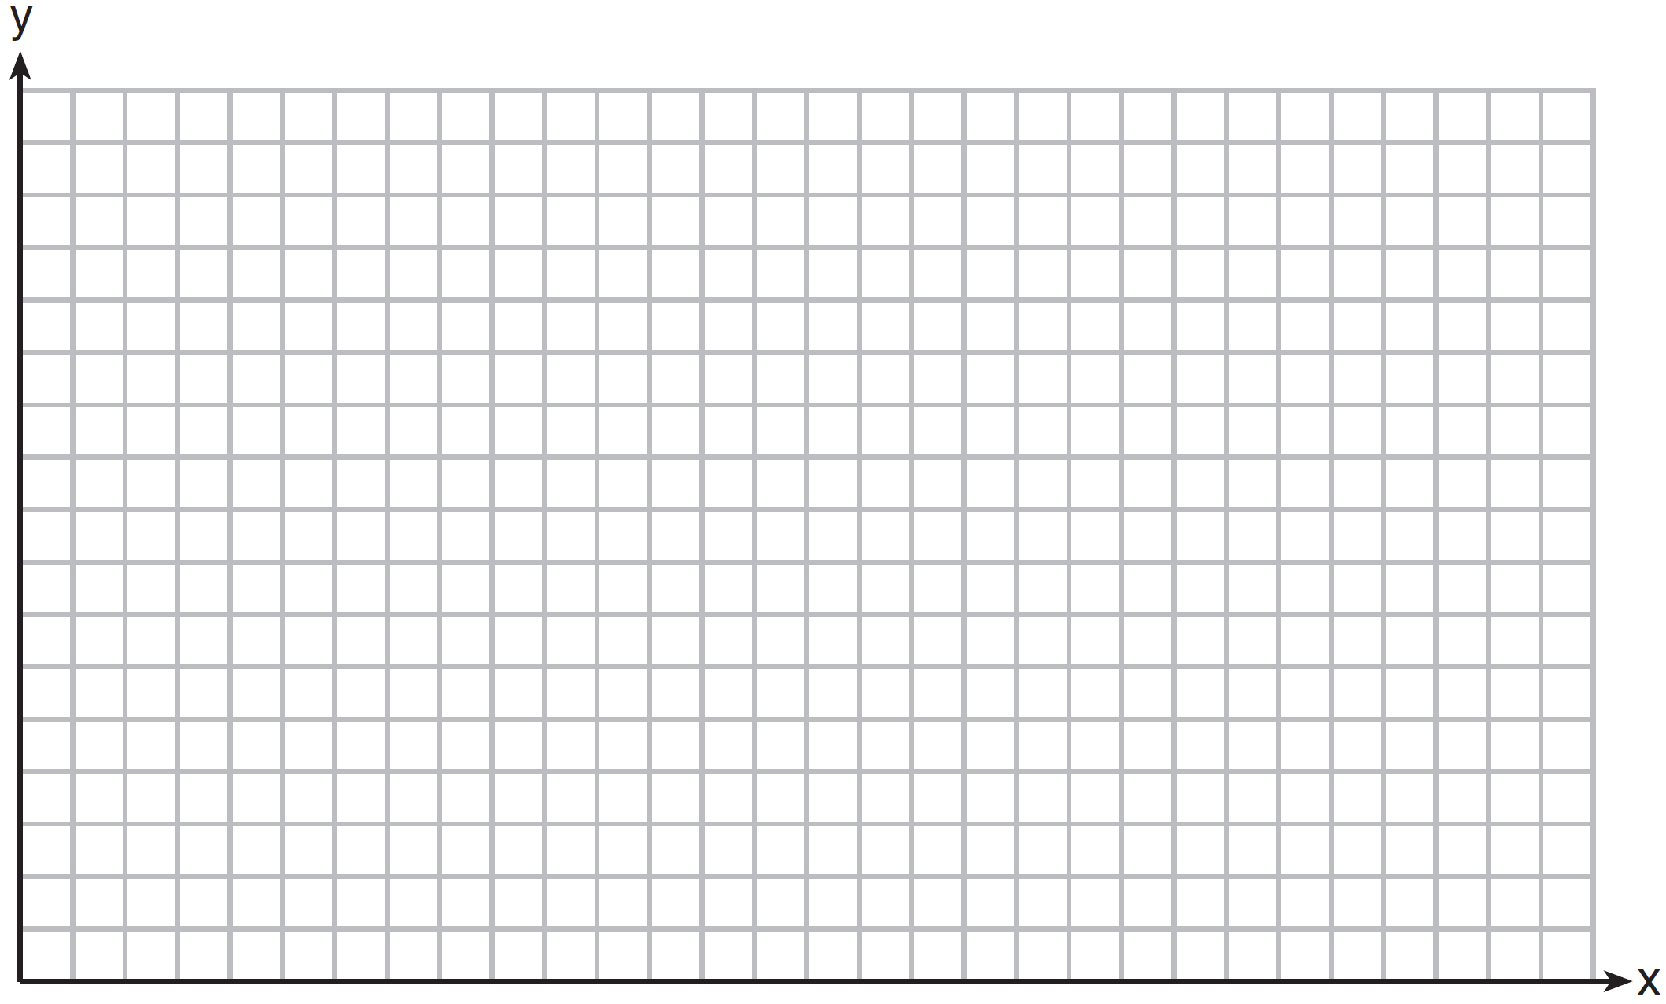

Determine the vertex of . Interpret the meaning of this vertex in the context of the problem. The goal post is 10 feet high and 45 yards away from the kick. Will the ball be high enough to pass over the goal post? Justify your answer.

230) On the set of axes below, draw the graph of .

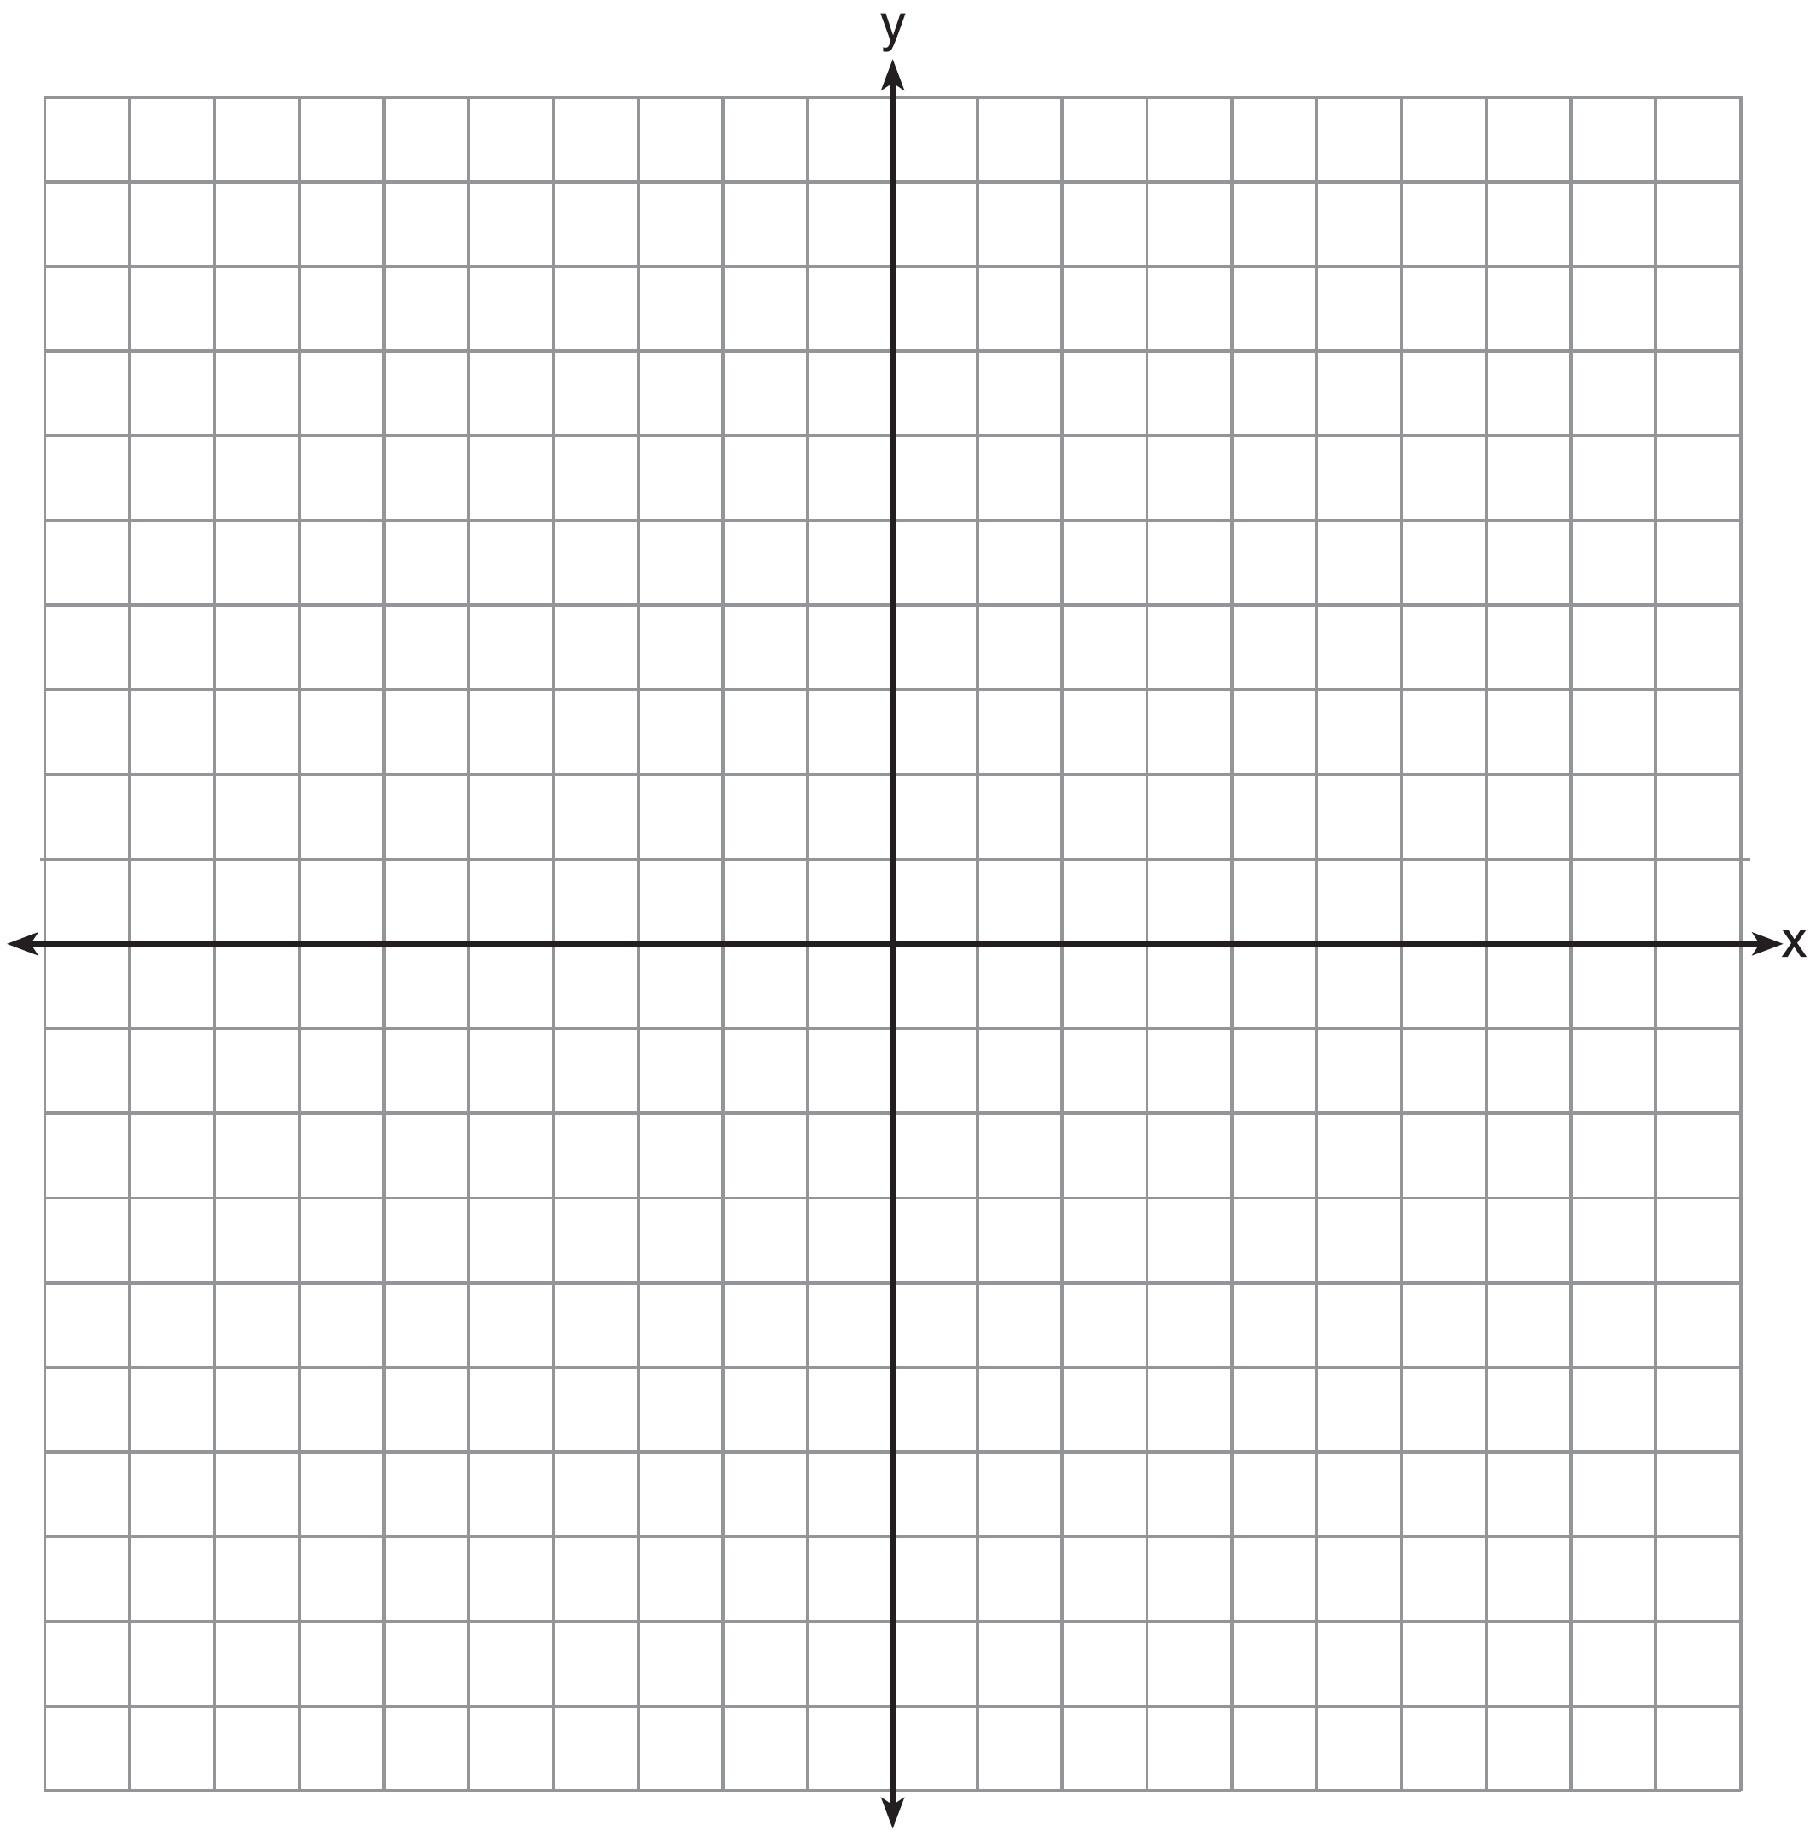

State the equation of the axis of symmetry.

231) If the zeros of a quadratic function, *F*, are  and 5, what is the equation of the axis of symmetry of *F*? Justify your answer.

232) Alex launched a ball into the air. The height of the ball can be represented by the equation , where *h* is the height, in units, and *t* is the time, in seconds, after the ball was launched. Graph the equation from  to  seconds.

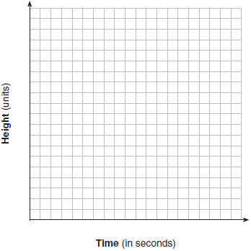

State the coordinates of the vertex and explain its meaning in the context of the problem.

233) An Air Force pilot is flying at a cruising altitude of 9000 feet and is forced to eject from her aircraft. The function  models the height, in feet, of the pilot above the ground, where *t* is the time, in seconds, after she is ejected from the aircraft. Determine and state the vertex of . Explain what the second coordinate of the vertex represents in the context of the problem. After the pilot was ejected, what is the maximum number of feet she was above the aircraft's cruising altitude? Justify your answer.

234) The expression  represents the height, in meters, of a toy rocket *t* seconds after launch. The initial height of the rocket, in meters, is

|  |  |  |  |
| --- | --- | --- | --- |
| 1) | 0 | 3) | 4.9 |
| 2) | 2 | 4) | 50 |

235) The graph of a quadratic function is shown below.

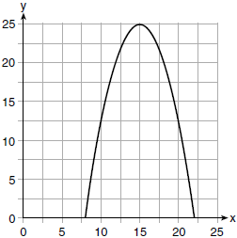

An equation that represents the function could be

|  |  |  |  |
| --- | --- | --- | --- |
| 1) |  | 3) |  |
| 2) |  | 4) |  |

236) Graph the function  on the set of axes below.

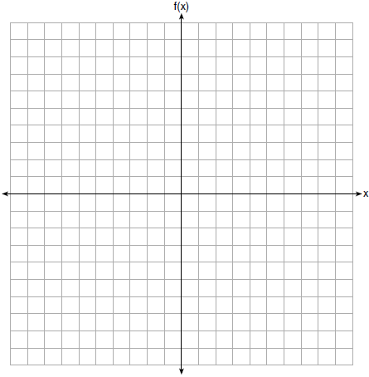

State the coordinates of the vertex of the graph.

237) The graph of the function  is given below.

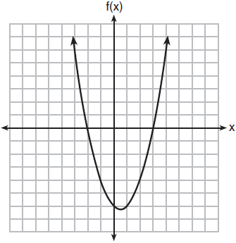

Could the factors of  be  and ? Based on the graph, explain why or why *not*.

238) When an apple is dropped from a tower 256 feet high, the function  models the height of the apple, in feet, after *t* seconds. Determine, algebraically, the number of seconds it takes the apple to hit the ground.

**SOLUTIONS**

224) ANS:

The object reaches its maximum height at 2 seconds.

The height of the object decreases between 2 seconds and 5 seconds.

Strategy: Inut the function in a graphing calculator and inspect the graph and table of values.

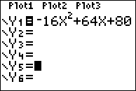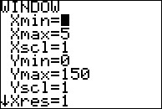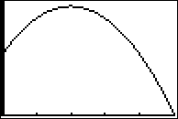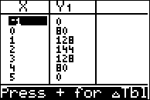

PTS: 4 NAT: F.IF.B.4 TOP: Graphing Quadratic Functions

225) ANS:

The rocket launches at  and lands at , so the domain of the function is .

Strategy: Input the function into a graphing calculator and determine the flight of the rocket using the graph and table views of the function.

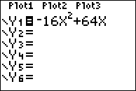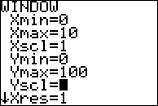

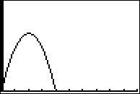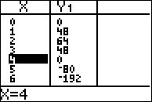

The toy rocket is in the air between 0 and 4 seconds, so the domain of the function is .

PTS: 2 NAT: F.IF.B.4 TOP: Graphing Quadratic Functions

226) ANS: 3

Strategy: Identify the domain of x that corresponds to a negative slope (decreasing height) in the function, then eliminate wrong answers.

STEP 1. The axis of symmetry for the parabola is  and the graph has a negative slope after  all the way to , meaning that the height of the ball is decreasing over this interval.

STEP 2. Eliminate wrong answers.

Answer choice a can be eliminated because the the slope of the graph increases over the interval .

Answer choice b can be eliminated because the the slope of the graph both increases and decreases over the interval .

Answer choice c is the correct choice, because it shows the domain of x where the graph has a negative slope.

Answer choice d can be eliminated because the the slope of the graph increases from  until .

PTS: 2 NAT: F.IF.B.4 TOP: Graphing Quadratic Functions

227) ANS: 1

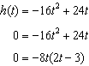

 and 

The appropriate domain for this function is .

PTS: 2 NAT: F.IF.B.4 TOP: Graphing Quadratic Functions

KEY: context

228) ANS: 3

Strategy: Eliminate wrong answers.

Eliminate “The rocket was launched from a height of 180 feet” because the ordered pair (0, 180) indicates this statement is true.

Eliminate “The maximum height of the rocket occurred 3 seconds after launch” because the ordered pair (3,324) is the vertex of the parabola modeled by the table.

**Select** “The rocket was in the air approximately 6 seconds before hitting the ground” because the ordered pair (7, 68) shows that the rocket had not yet hit the ground after 7 seconds.

Eliminate ‘The rocket was above 300 feet for approximately 2 seconds” because the rocket was above 300 feet during the 2 second interval between the ordered pairs (2, 308) and (4, 308).

PTS: 2 NAT: F.IF.B.4

229) ANS:

a) 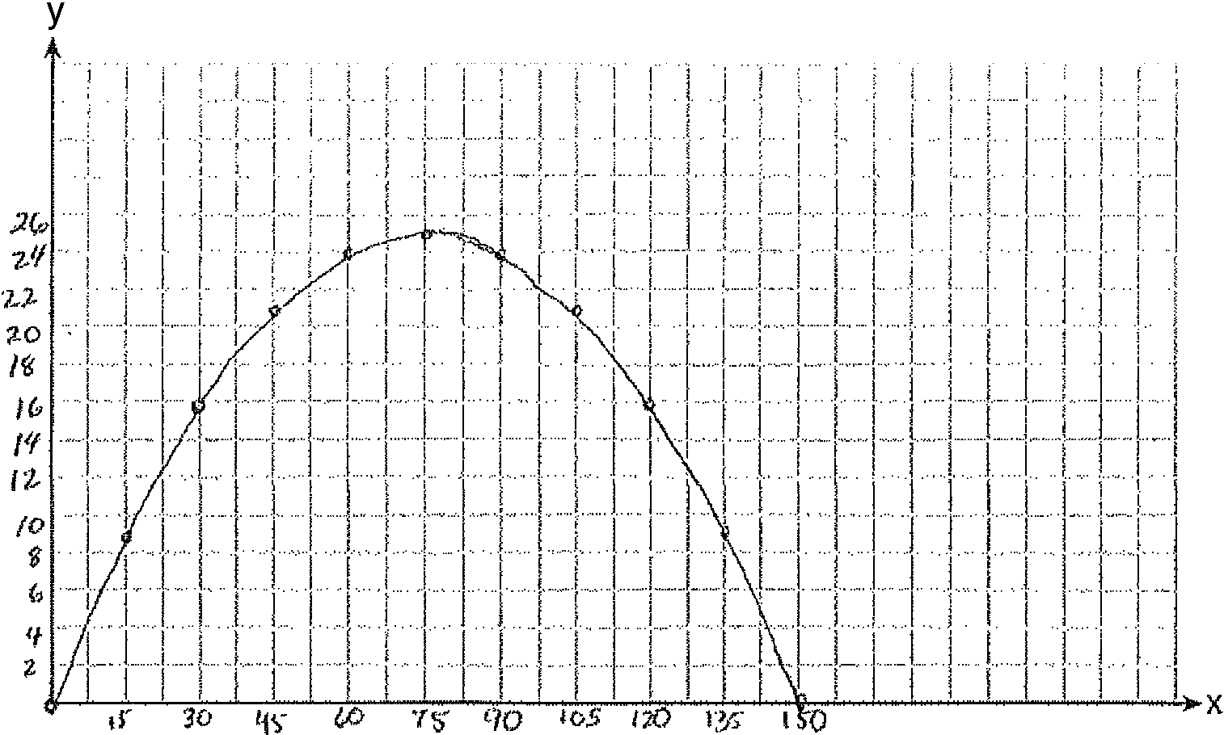

b) The vertex is at . This means that the ball will reach it highest (25 feet) when the horizontal distance is 75 feet.

c) No, the ball will not clear the goal post because it will be less than 10 feet high.

Strategy: Input the equation into a graphing calculator and use the table and graph views to complete the graph on paper, then find the vertex and determine if the ball will pass over the goal post.

STEP 1. Input  into a graphing calculator. Set the window to reflect the interval  and estimate the height to be approximately  the domain of *x*.

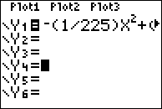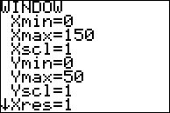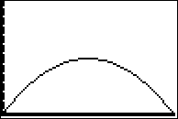

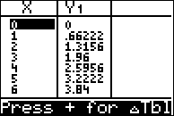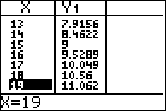

Observe that the table of values has integer solutions at 15 unit intervals, so change the Tbl to 15.

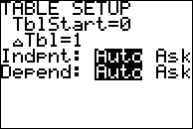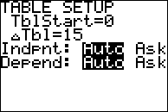

The change in Tbl results in a table of values that is easier to graph on paper.

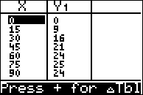

Use the graph view and the table of values to complete the graph on paper.

STEP 2. Use the table of values to find the vertex. The vertex is located at .

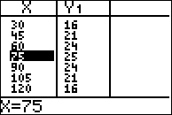

STEP 3. Convert 45 yards to 135 feet and determine if the the ball will be 10 feet or higher when .

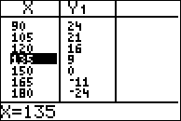 or 

The ball will be 9 feet above the ground and will not go over the 10 feet high goal post.

PTS: 6 NAT: F.IF.B.4 TOP: Graphing Quadratic Functions

230) ANS:

Input the equation in a graphing calculator, then use the table and graph views to draw the graph.

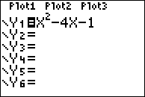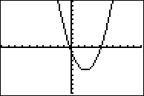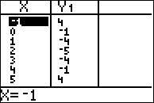

The axis of symmetry is 

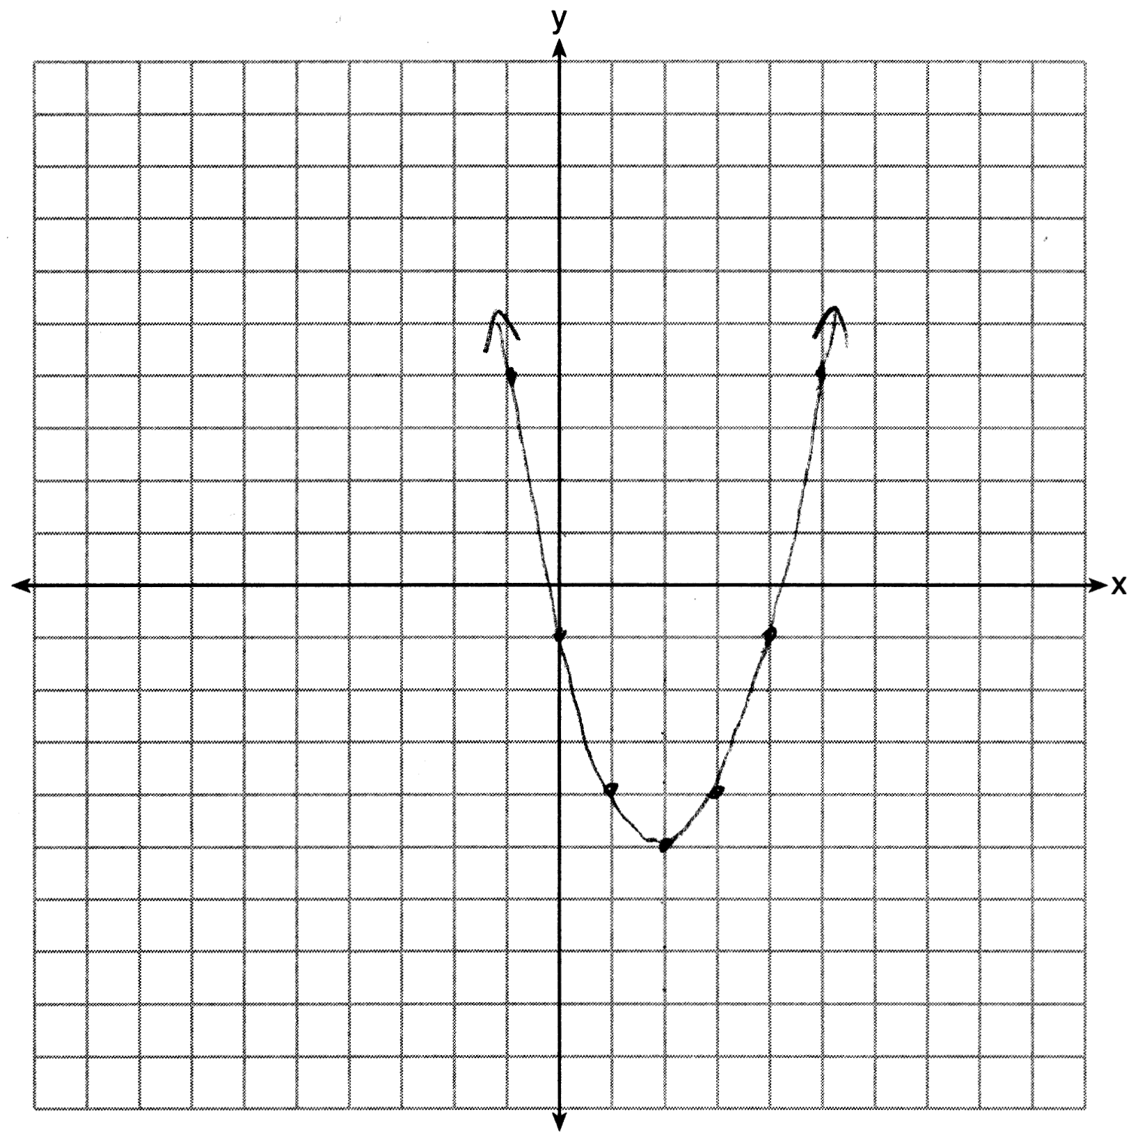

The equation for the axis of symmetry can also be found using the formula 

PTS: 2 NAT: F.IF.B.4 TOP: Graphing Quadratic Functions

NOT: NYSED classifies this as A.REI.D

231) ANS:

The equation of the axis of symmetry is .

The axis of symmetry is the vertical line that is midway between the zeros of a quadratic.



PTS: 2 NAT: F.IF.B.4 TOP: Graphing Quadratic Functions

KEY: no context

232) ANS:

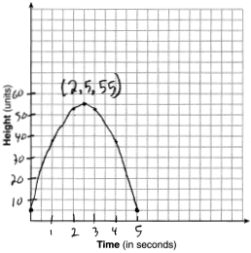

The ball reaches a maximum height of 55 units at 2.5 seconds.

Strategy: Input the equation in a graphing calculator, then use the table of values to plot the graph and answer the questions.

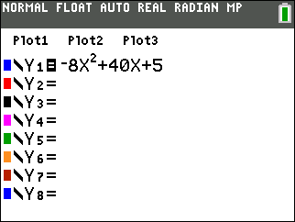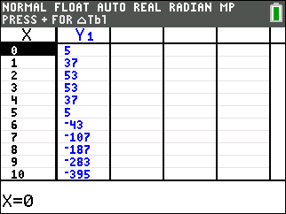

PTS: 4 NAT: F.IF.B.4 TOP: Graphing Quadratic Functions

233) ANS:

The vertex occurs at (4, 9256). This means that 4 seconds after the pilot ejects from the plane, she is 9,256 feet above the ground.

After being ejected at a crusing altitude of 9,000 feet, the maximum number of feet she was above cruising altitude was  feet.

|  |  |
| --- | --- |
|  |  |
|  |  |

PTS: 4 NAT: F.IF.B.4 TOP: Graphing Quadratic Functions

KEY: context

234) ANS: 2

The initial height of the rocket is when .

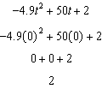

PTS: 2 NAT: F.IF.B.4 TOP: Graphing Quadratic Functions

KEY: context

235) ANS: 4

The graph shows the vertex to be at (15, 25).

Each of the answer choices is in vertex form: , where *h* is the x-coordinate of the vertex and *k* is the y-coorindate of the vertex. Stubstituting the x and y coordinatges of the vertex into  results in . Since the parabola opens downward, the value of *a* must be negative. The correct answer is .

PTS: 2 NAT: F.IF.B.4 TOP: Graphing Quadratic Functions

KEY: no context

236) ANS:

|  |  |  |
| --- | --- | --- |
|  | x | y |
| 0 | 0 |
| -1 | 5 |
| -2 | 8 |
| -3 | 9 |
| -4 | 8 |
| -5 | 5 |
| -6 | 0 |
| HINT: | Use graphing calculator! |

The coordinates of the vertex are (-3, 9)

PTS: 2 NAT: F.IF.B.4 TOP: Graphing Quadratic Functions

KEY: no context

237) ANS:

Yes, because the factors of a function and the zeros of a function are related through the multiplication property of zero. The multiplication property of zero states that the product of any number and zero is zero. This also means that if the product of two numbers is zero, then one or both of the factors must be zero.

If the factors of  are  and , then the function rule is  and the zeros of the function will occur when . By the multiplication property of zero, when , either , , or both  and , must equal zero.

If , then , which is shown as an x-intercept on the graph.

If , then , which is also shown as an x-intercept on the graph.

PTS: 2 NAT: F.IF.C.7 TOP: Graphing Quadratic Functions

238) ANS:

Answer: 4

Strategy: The apple will be on the ground when its height is zero, so evaluate the function  for .

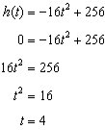

Check:

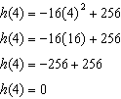

PTS: 2 NAT: F.IF.C.7 TOP: Graphing Quadratic Functions