**M – Functions, Lesson 6, Transformations with Functions (r. 2018)**

FUNCTIONS

Transformations with Functions

|  |  |
| --- | --- |
| **Common Core Standard**  **F-BF.3** Identify the effect on the graph of replacing *f(x)* by *f(x) + k, k f(x), ~~f(kx)~~,* and *f(x + k)* for specific values of *k* (both positive and negative); find the value of *k* given the graphs. Experiment with cases and illustrate an explanation of the effects on the graph using technology. Include recognizing ~~even and odd~~ functions from their graphs and algebraic expressions for them.  ~~PARCC: Identifying the effect on the graph of replacing~~ *~~f(x)~~* ~~by~~ *~~f(x) +k~~*~~,~~ *~~kf(x),~~* ~~and~~ *~~f(x+k)~~* ~~for specific values of~~ *~~k~~* ~~(both positive and negative) is limited to linear and quadratic functions. Experimenting with cases and illustrating an explanation of the effects on the graph using technology is limited to linear functions, quadratic functions, square root functions, cube root functions, piecewise-defined functions (including step functions and absolute value functions), and exponential functions with domains in the integers. Tasks do not involve recognizing even and odd functions.~~ | **Next Generation Standard**  **AI-F.BF.3a** Using *f(x) + k*, *k f(x)*, and *f(x + k):*  i) identify the effect on the graph when replacing *f(x)* by *f(x) + k*,  *k f(x)*, and *f(x + k)* for specific values of *k* (both positive and negative);  ii) find the value of *k* given the graphs;  **iii) write a new function using the value of *k*;** and  iv) use technology to experiment with cases and explore the effects on the graph.  (Shared standard with Algebra II)  **Note: Tasks are limited to linear, quadratic, square root, and absolute value functions; and exponential functions of the form where *a* > 0 and *b* > 0 (*b* ≠ 1).** |

NOTE: This lesson is related to Polynomials, Lesson 6, Graphing Polynomial Functions

**LEARNING OBJECTIVES**

Students will be able to:

1)

**Overview of Lesson**

|  |  |
| --- | --- |
| **Teacher Centered Introduction**  **Overview of Lesson**  **- activate students’ prior knowledge**  **- vocabulary**  **- learning objective(s)**  **- big ideas: direct instruction**  **- modeling** | **Student Centered Activities**  **guided practice ⬅Teacher: anticipates, monitors, selects, sequences, and connects student work**  **- developing essential skills**  **- Regents exam questions**  **- formative assessment assignment (exit slip, explain the math, or journal entry)** |

**VOCABULARY**

down

function

left

right

transform

up

**BIG IDEAS**

**Transforming Any Function**

The graph of any function is changed when either or *x* is multiplied by a scalar, or when a constant is added to or subtracted from either  or *x*. A graphing calculator can be used to explore the translations of graph views of functions.

**Up and Down**

The addition or subtraction of a constant **outside the parentheses** moves the graph up or down by the value of the constant.



Examples:

Replace *f*(*x*) by *f*(*x*) + *k*

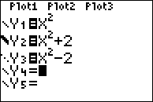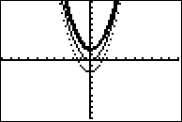

**Left and Right**

The addition or subtraction of a constant **inside the parentheses** moves the graph left or right by the value of the constant.



Replace *f*(*x*) by *f*(*x* + *k*)

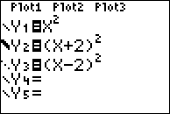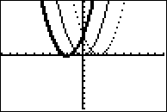

**Width and Direction of a Parabola**

Changing the value of *a* in a quadratic affects the width and direction of a parabola. The bigger the absolute value of *a*, the narrower the parabola.



Examples:

Replace *f*(*x*) by *f*(*kx*)

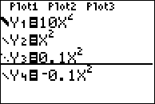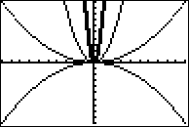

**DEVELOPING ESSENTIAL SKILLS**

1. The graph below shows the function .

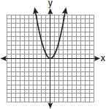

Which graph represents the function ?

|  |  |  |  |
| --- | --- | --- | --- |
| a. |  | c. |  |
| b. |  | d. |  |

2. The graph below represents .

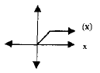

Which of the following is the graph of ?

|  |  |  |  |
| --- | --- | --- | --- |
| a. |  | c. |  |
| b. |  | d. |  |

3. The minimum point on the graph of the equation  is . What is the minimum point on the graph of the equation ?

|  |  |  |  |
| --- | --- | --- | --- |
| a. |  | c. |  |
| b. |  | d. |  |

4. The graph below represents .

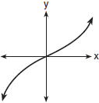

Which graph best represents ?

|  |  |  |  |
| --- | --- | --- | --- |
| a. |  | c. |  |
| b. |  | d. |  |

5. The graph of  is shown in the accompanying diagram

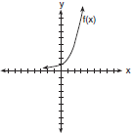

Which graph represents ?

|  |  |  |  |
| --- | --- | --- | --- |
| a. |  | c. |  |
| b. |  | d. |  |

**ANSWERS**

1. ANS: B

2. ANS: C

3. ANS: A

4. ANS: D

5. ANS: B

**REGENTS EXAM QUESTIONS (through June 2018)**

F.BF.B.3: Transformations with Functions

462) The graph of  is shown below.

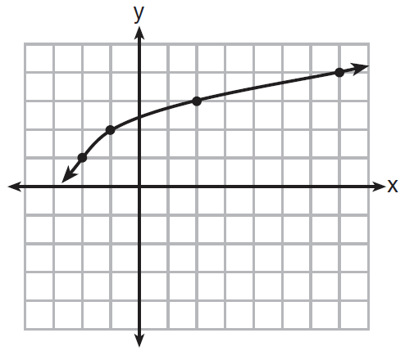

What is the graph of ?

|  |  |  |  |
| --- | --- | --- | --- |
| 1) |  | 3) |  |
| 2) |  | 4) |  |

463) Richard is asked to transform the graph of *b(x)* below.

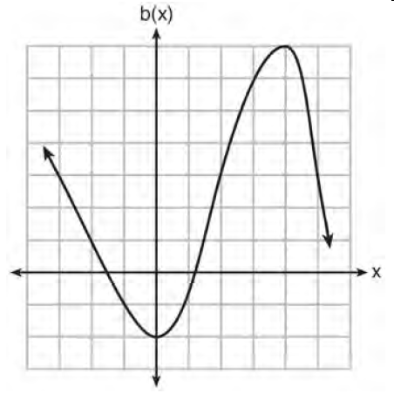

The graph of *b(x)* is transformed using the equation . Describe how the graph of *b(x)* changed to form the graph of *h(x)*.

**SOLUTIONS**

462) ANS: 1

Strategy: Identify the differences between the two function rules, then verify using the four points shown in the answer choices.

Function rules:

Difference #1: The term becomes . This means the graph will move to the left 1 unit. The mapping of each x value can be expressed as 

Difference #2: The term  is added to the function rule. This means the graph will move 2 units down. The mapping of each y value can be expressed as .

The 2 differences in the function rules mean that each point on the graph will move left 1 unit and down 2 units. Answer choice (a) shows this:

|  |  |  |  |  |
| --- | --- | --- | --- | --- |
|  | (-2, 1) | (-1, 2) | (2, 3) | (7, 7) |
|  | (-3, -1) | (-2, 0) | (1, 1) | (6, 2) |

PTS: 2 NAT: F.BF.B.3 TOP: Graphing Radical Functions

463) ANS:

Every point moves down 3 units.

Every point moves right 2 units.

PTS: 2 NAT: F.BF.B.3