M – Functions, Lesson 4, Operations with Functions (r. 2018)

FUNCTIONS
Operations with Functions
Common Core Standard  F-BF.1 Write a function that describes a relationship between two quantities. | Next Generation Standard  AI-F.BF.1 Write a function that describes a relationship between two quantities.

LEARNING OBJECTIVES
Students will be able to:
1) Compose new functions from existing functions using substitution and mathematical operations.

Overview of Lesson
Teacher Centered Introduction  Overview of Lesson  - activate students’ prior knowledge  - vocabulary  - learning objective(s)  - big ideas: direct instruction  - modeling | Student Centered Activities  guided practice ⬅Teacher: anticipates, monitors, selects, sequences, and connects student work  - developing essential skills  - Regents exam questions  - formative assessment assignment (exit slip, explain the math, or journal entry)

VOCABULARY

LEARNING OBJECTIVES
Students will be able to:
- Use the output of one function as the input for another function.
- Substitute expressions from one function into another.

BIG IDEAS
Polynomial expressions can be substituted into equations and functions.
Example:
Given that: and 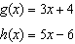, then

Functions can be multiplied or divided if each and every term in both expressions is multiplied or divided by the same value.
Example:

DEVELOPING ESSENTIAL SKILLS
1. If f and g are two functions defined by and , then is
a. |  | c.
b. |  | d.

2. If and , then is equal to
a. |  | c.
b. |  | d. | 7

3. The accompanying tables define functions f and g.

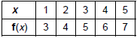

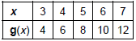

What is?
a. | 6 | c. | 8
b. | 2 | d. | 4

4. If and , what is the value of ?
a. |  | c. | 8
b. | 2 | d. | 13

5. If and , find .

ANSWERS

1. ANS: B
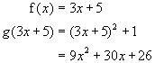

2. ANS: A
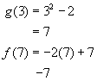

3. ANS: C
f(3) = 5, g(5) = 8

4. ANS: C
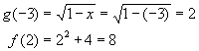
5. ANS:
5. . .

REGENTS EXAM QUESTION (through June 2018)

A.APR.A.1: Operations with Functions

434) A company produces x units of a product per month, where represents the total cost and represents the total revenue for the month. The functions are modeled by and . The profit is the difference between revenue and cost where . What is the total profit, , for the month?
1) |  | 3)
2) |  | 4)

SOLUTION

434) ANS: 2
Strategy: Substitute and into .

Given: 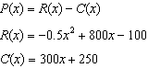
Therefore: 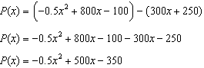

PTS: 2 NAT: A.APR.A.1 TOP: Addition and Subtraction of Polynomials
KEY: subtraction

