**I – Systems, Lesson 3, Graphing Linear Systems (r. 2018)**

SYSTEMS

Graphing Linear Systems

|  |  |
| --- | --- |
| **Common Core Standard**  **A-REI.6** Solve systems of linear equations exactly and approximately (e.g., with graphs), focusing on pairs of linear equations in two variables.  PARCC: Tasks have a real-world context. Tasks have hallmarks of modeling as a mathematical practice (less defined tasks, more of the modeling cycle, etc.). | **Next Generation Standard**  **AI-A.REI.6a** Solve systems of linear equations in two variables **both algebraically and graphically.**  **Note: Algebraic methods include both elimination and substitution**. |

**LEARNING OBJECTIVES**

Students will be able to:

1. Create function rules, tables of values, and graphs of systems of linear equations from real-world contexts.
2. Use graphs of systems of equations to solve problems involving real-world contexts.

**Overview of Lesson**

|  |  |
| --- | --- |
| **Teacher Centered Introduction**  **Overview of Lesson**  **- activate students’ prior knowledge**  **- vocabulary**  **- learning objective(s)**  **- big ideas: direct instruction**  **- modeling** | **Student Centered Activities**  **guided practice ⬅Teacher: anticipates, monitors, selects, sequences, and connects student work**  **- developing essential skills**  **- Regents exam questions**  **- formative assessment assignment (exit slip, explain the math, or journal entry)** |

**VOCABULARY**

context view

distinct equation

function rule view

graph view

infinite solutions

no-solution

same equation

simultaneous

solution

system of linear equations

table view

**BIG IDEAS**

**Graphing Method of Solving and System of Linear Equations**

Objective: Find the coordinates of the point where the graphs of the equations intersect.

|  |  |
| --- | --- |
| Manually | With Graphing Calculator |
| STEP #1.  Put the equations into slope-intercept form: . | STEP #1.  Put the equations into slope-intercept form: . |
| STEP #2.  Graph both equations on the same coordinate plane. | STEP #2.  Input both equations in a graphing calculator. |
| STEP #3.  Identify the coordinates of the point where the two lines intersect. This is the solution to the system of equations. | STEP #3.  Use the table and/or graph views to identify the coordinates of the point where the two lines intersect. This is the solution to the system of equations. NOTE: Some calculators also have a *calculate intersection* feature. |
| STEP #4.  Check your solution by substituting it into the original equations. If both equations balance, you have the correct solution. | STEP #4.  Check that you have input the equations properly and that both table and graph views show the same solution. |

**DEVELOPING ESSENTIAL SKILLS**

Solve each of the following systems by graphing.

1. 

1. 
2. 
3. 
4. 

**Answers**

1. 

Graphing



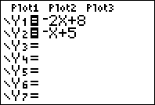 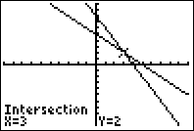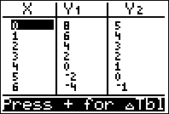

Screenshots from TI 84 Graphing Calculator

1. 

Graphing



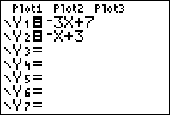 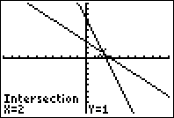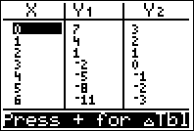

Screenshots from TI 84 Graphing Calculator

1. 

Graphing



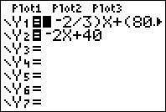 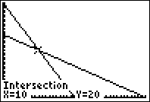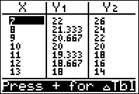

Screenshots from TI 84 Graphing Calculator

1. 

Graphing



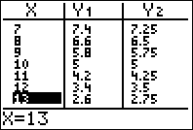 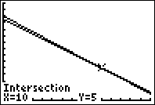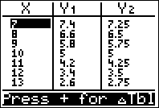

Screenshots from TI 84 Graphing Calculator

1. 

Graphing



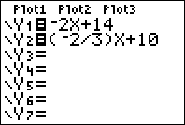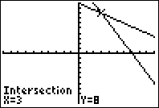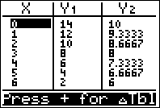

Screenshots from TI 84 Graphing Calculator

**REGENTS EXAM QUESTIONS**

A.REI.C.6: Graphing Linear Systems

263) Next weekend Marnie wants to attend either carnival *A* or carnival *B*. Carnival *A* charges $6 for admission and an additional $1.50 per ride. Carnival *B* charges $2.50 for admission and an additional $2 per ride.

a) In function notation, write  to represent the total cost of attending carnival *A* and going on *x* rides. In function notation, write  to represent the total cost of attending carnival *B* and going on *x* rides.

b) Determine the number of rides Marnie can go on such that the total cost of attending each carnival is the same. [Use of the set of axes below is optional.]

c) Marnie wants to go on five rides. Determine which carnival would have the lower total cost. Justify your answer.



264) A local business was looking to hire a landscaper to work on their property. They narrowed their choices to two companies. Flourish Landscaping Company charges a flat rate of $120 per hour. Green Thumb Landscapers charges $70 per hour plus a $1600 equipment fee. Write a system of equations representing how much each company charges. Determine and state the number of hours that must be worked for the cost of each company to be the same. [The use of the grid below is optional.] If it is estimated to take at least 35 hours to complete the job, which company will be less expensive? Justify your answer.



265) Franco and Caryl went to a bakery to buy desserts. Franco bought 3 packages of cupcakes and 2 packages of brownies for $19. Caryl bought 2 packages of cupcakes and 4 packages of brownies for $24. Let *x* equal the price of one package of cupcakes and *y* equal the price of one package of brownies. Write a system of equations that describes the given situation. On the set of axes below, graph the system of equations.

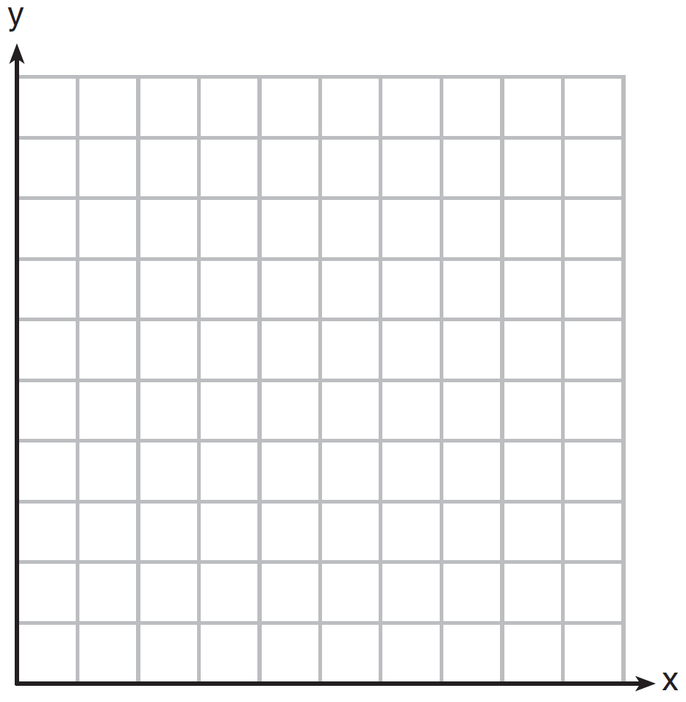

Determine the exact cost of one package of cupcakes and the exact cost of one package of brownies in dollars and cents. Justify your solution.

266) Central High School had five members on their swim team in 2010. Over the next several years, the team increased by an average of 10 members per year. The same school had 35 members in their chorus in 2010. The chorus saw an increase of 5 members per year. Write a system of equations to model this situation, where *x* represents the number of years since 2010. Graph this system of equations on the set of axes below.



Explain in detail what each coordinate of the point of intersection of these equations means in the context of this problem.

267) Zeke and six of his friends are going to a baseball game. Their combined money totals $28.50. At the game, hot dogs cost $1.25 each, hamburgers cost $2.50 each, and sodas cost $0.50 each. Each person buys one soda. They spend all $28.50 on food and soda. Write an equation that can determine the number of hot dogs, *x*, and hamburgers, *y*, Zeke and his friends can buy. Graph your equation on the grid below.



Determine how many different combinations, including those combinations containing zero, of hot dogs and hamburgers Zeke and his friends can buy, spending all $28.50. Explain your answer.

268) Rowan has $50 in a savings jar and is putting in $5 every week. Jonah has $10 in his own jar and is putting in $15 every week. Each of them plots his progress on a graph with time on the horizontal axis and amount in the jar on the vertical axis. Which statement about their graphs is true?

|  |  |  |  |
| --- | --- | --- | --- |
| 1) | Rowan’s graph has a steeper slope than Jonah’s. | 3) | Jonah’s graph has a steeper slope than Rowan’s. |
| 2) | Rowan’s graph always lies above Jonah’s. | 4) | Jonah’s graph always lies above Rowan’s. |

**SOLUTIONS**

263) ANS:

a) 

b) The total costs are the same if Marnie goes on 7 rides.

c) Carnival *B* has the lower cost for admission and 5 rides. Carnival B costs $12.50 for admission and 5 rides and Carnival A costs $13.50 for admission and 5 rides.

Strategy: Write a system of equations, then input it into a graphing calculator and use it to answer parts *b* and *c* of the problem.

STEP 1. Write a system of equations.



STEP 2. Input the system into a graphing calculator.

Let 

Let 

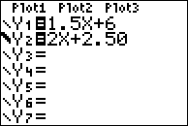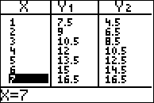

STEP 3. Use the different views of the function to answer parts b and c of the problem.

Part a) The total costs are the same at 7 rides.

Part b) Carnival B costs $12.50 for admission and 5 rides and Carnival A costs $13.50 for admission and 5 rides, so Carnival B has the lower total cost.

PTS: 6 NAT: A.REI.C.6 TOP: Modeling Linear Systems

264) ANS:

a) 

b) The costs will be the same when 32 hours are worked.

c) If the job takes at least 35 hours, Green Thumb Landscapers will be less expensive.

Strategy: Write a system of equations, then set both equations equal to one another and solve for *x*, then answer the questions

STEP 1. Write a system of equations.

Let x represent the number of hours worked.

Let  represent the total costs of Flourish Landscape Company.

Let  represent the total costs of Green Thumb Landscapers.

Write: 

STEP 2. Set both functions equal to one another to find the break even hours..

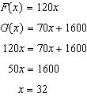

STEP 3. Input the equations into a graphing calculator to verify the break even amount and determine which company is cheaper for 35 hours or more of work.

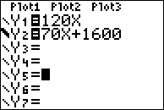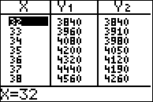

Green Thumb is less expensive.

PTS: 6 NAT: A.REI.C.6 TOP: Modeling Linear Systems

265) ANS:

Step 1. Write two equations.

|  |  |
| --- | --- |
| Franco’s Purchase: Franco bought 3 packages of cupcakes (3x) and 2 packages of brownies (2y) for $19. | Caryl’s Purchase: Caryl bought 2 packages of cupcakes (2x) and 4 packages of brownies (4y) for $24. |

Step 2. Input both equations in a graphing calculator, then complete the graph.

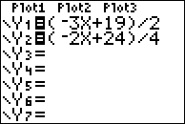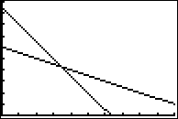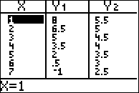

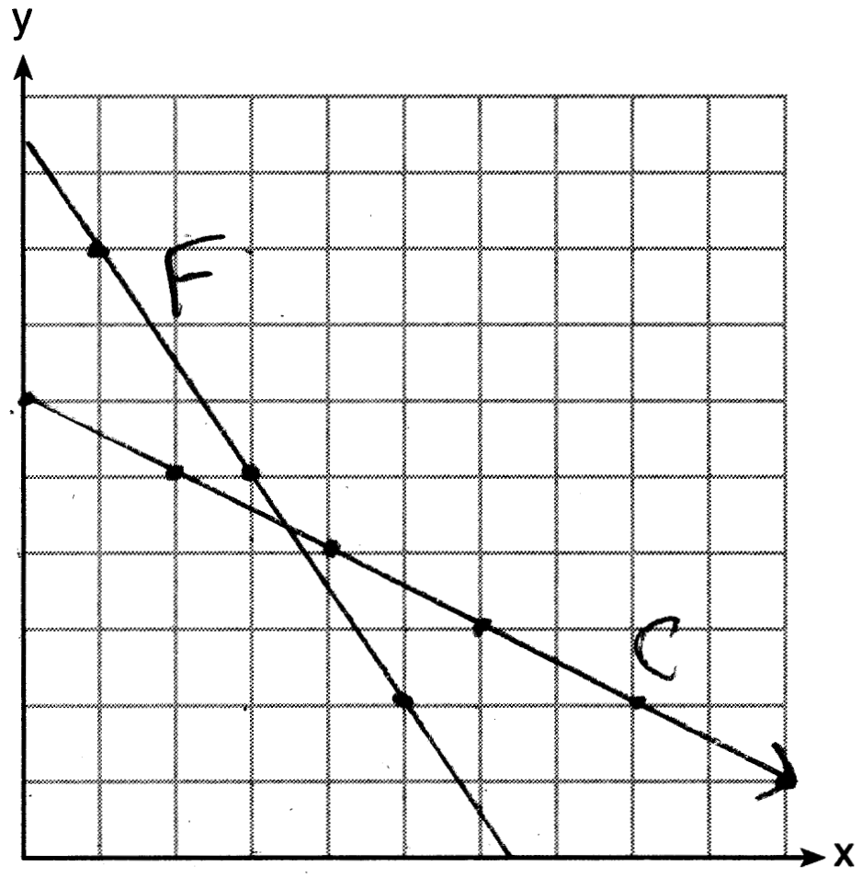

Determine the exact cost of one package of cupcakes and the exact cost of one package of brownies in dollars and cents. Justify your solution.

|  |  |
| --- | --- |
| Cupcakes      A package of cupcakes costs $3.50. | Brownies    A package of brownies costs $4.25 |

Check by inserting both values in both equations.

|  |  |
| --- | --- |
| Franco | Caryl |

PTS: 6 NAT: A.REI.C.6 TOP: Graphing Linear Systems

266) ANS:

Step 1. Create a table of values to model membership in the two clubs, as follows:

|  |  |  |  |  |  |  |
| --- | --- | --- | --- | --- | --- | --- |
|  | 2010 | 2011 | 2012 | 2013 | 2014 |  |
| x | 0 | 1 | 2 | 3 | 4 |  |
| Swim | 5 | 15 | 25 | 35 | 45 | rate of change is a constant: 10 members per year |
| Chorus | 35 | 40 | 45 | 50 | 55 | rate of change is a constant: 5 members per year |

Step 2. Use  to write two linear equations to model the data in the table.



Step 3. Graph the system of equations.

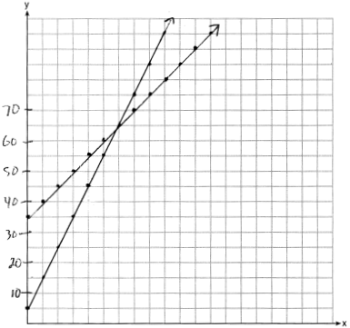

The intersection of these two equations means that in the sixth year, which is 2016, the swim team and chorus will each have 65 members.

PTS: 6 NAT: A.REI.C.6 TOP: Graphing Linear Systems

267) ANS:

Seven friends have $28.50. They spend  on sodas, leaving 25.00 for hot dogs and hamburgers. If hotdogs (*x*) cost $1.25 and hamburgers (*y*) cost $2.50, the following equation can be used to determine the number of hot dogs and hamburgers the 7 friends can buy.

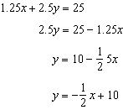

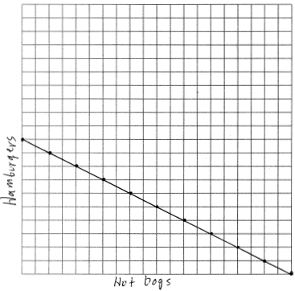

There are 11 combinations, as each dot represents a possible combination.

PTS: 6 NAT: A.REI.C.6 TOP: Graphing Linear Systems

268) ANS: 3

Strategy: Create equations that model Rowan’s and Jonah’s savings plans, then compare the slopes.

STEP 1. Create Equations

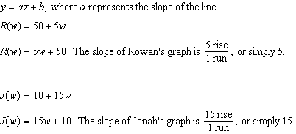

STEP 2. Compare the slopes.

Jonah’s slope is greater than Rowan’s slope because . Therefore, Jonah’s graph will have a steeper slope.

DIMS? Does It Make Sense? Yes. Input both equations in a graphing calculator, as follows:



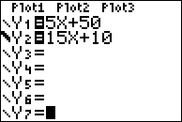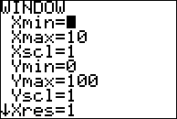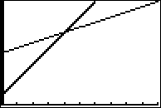

Jonah’s graph, which is bold, is steeper than Rowan’s graph.

PTS: 2 NAT: A.CED.A.2 TOP: Graphing Linear Systems