C – Expressions and Equations, Lesson 5, Transforming Formulas (r. 2018)

EXPRESSIONS AND EQUATIONS
Transforming Formulas
Common Core Standard  A-CED.A.4 Rearrange formulas to highlight a quantity of interest, using the same reasoning as in solving equations. For example, rearrange Ohm’s law V=IR to highlight resistance R. | Next Generation Standard  AI-A.CED.4 Rewrite formulas to highlight a quantity of interest, using the same reasoning as in solving equations.  e.g., Rearrange Ohm’s law V = IR to highlight resistance R.

LEARNING OBJECTIVES
Students will be able to:
- rewrite (transform) formulas to isolate specific variables.

Overview of Lesson
Teacher Centered Introduction  Overview of Lesson  - activate students’ prior knowledge  - vocabulary  - learning objective(s)  - big ideas: direct instruction  - modeling | Student Centered Activities  guided practice ⬅Teacher: anticipates, monitors, selects, sequences, and connects student work  - developing essential skills  - Regents exam questions  - formative assessment assignment (exit slip, explain the math, or journal entry)

VOCABULARY

formula
transform
transformation
isolate

BIG IDEAS

Properties and operations can be used to transform formulas to isolate different variables in the same ways that equations are manipulated to isolate a variable.

Example: The formula can be used to find the perimeter of a rectangle. In English, translates as “The perimeter equals two times the length plus two times the width.” In the formula , the P variable is already isolated. You can isolate the l variable or the w variables, as follows. (Note that the steps and operations are the same as with regular equations.)
To isolate the l variable:  Start with the formula:  Move the term 2w to the left expression.  Divide both sides of the equation by 2.  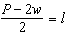  You now have a formula for l in terms of P and w. | To isolate the w variable:  Start with the formula:  Move the term 2l to the left expression.  Divide both sides of the equation by 2.  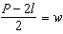  You now have a formula for l in terms of P and w.

DEVELOPING ESSENTIAL SKILLS
Isolate each variable in the Volume formula for a rectangular prism .
Isolate each variable in the slope intercept formula of a line .
REGENTS EXAM QUESTIONS
A.CED.A.4: Transforming Formulas

69) The formula for the volume of a cone is 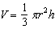. The radius, r, of the cone may be expressed as
1) | 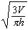 | 3) | 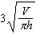
2) | 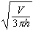 | 4) | 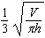

70) The formula for the area of a trapezoid is 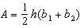. Express in terms of A, h, and . The area of a trapezoid is 60 square feet, its height is 6 ft, and one base is 12 ft. Find the number of feet in the other base.

71) The equation for the volume of a cylinder is . The positive value of r, in terms of h and V, is
1) | 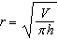 | 3)
2) |  | 4) | 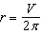

72) The distance a free falling object has traveled can be modeled by the equation 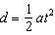, where a is acceleration due to gravity and t is the amount of time the object has fallen. What is t in terms of a and d?
1) | 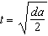 | 3) | 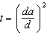
2) | 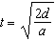 | 4) | 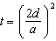

73) The volume of a large can of tuna fish can be calculated using the formula . Write an equation to find the radius, r, in terms of V and h. Determine the diameter, to the nearest inch, of a large can of tuna fish that has a volume of 66 cubic inches and a height of 3.3 inches.

74) Michael borrows money from his uncle, who is charging him simple interest using the formula . To figure out what the interest rate, r, is, Michael rearranges the formula to find r. His new formula is r equals
1) | 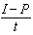 | 3)
2) | 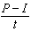 | 4)

75) The formula for the sum of the degree measures of the interior angles of a polygon is . Solve for n, the number of sides of the polygon, in terms of S.

76) Solve the equation below for x in terms of a.

77) Boyle's Law involves the pressure and volume of gas in a container. It can be represented by the formula . When the formula is solved for , the result is
1) |  | 3) | 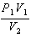
2) | 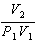 | 4) | 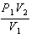

78) The formula for blood flow rate is given by 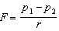, where F is the flow rate, the initial pressure, the final pressure, and r the resistance created by blood vessel size. Which formula can not be derived from the given formula?
1) |  | 3)
2) |  | 4) | 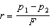

79) Using the formula for the volume of a cone, express r in terms of V, h, and .

80) The formula 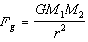 calculates the gravitational force between two objects where G is the gravitational constant, is the mass of one object, is the mass of the other object, and r is the distance between them. Solve for the positive value of r in terms of , G, , and .

81) Students were asked to write a formula for the length of a rectangle by using the formula for its perimeter, . Three of their responses are shown below.
I. 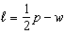
II. 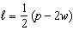
III. 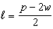
Which responses are correct?
1) | I and II, only | 3) | I and III, only
2) | II and III, only | 4) | I, II, and III

SOLUTIONS

69) ANS: 1
Strategy: Use the four column method.
Notes | Left Expression | Sign | Right Expression
Given |  | = | 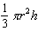
Multiply both expressions by 3 |  | =
Divide both expressions by |  | = | 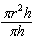
Simplify |  | =
Take square root of both sides. |  | =

PTS: 2 NAT: A.CED.A.4 TOP: Transforming Formulas

70) ANS:
a) 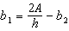
b) The other base is 8 feet.

Strategy: Use the four column method to isolate and create a new formula, then use it to find the length of the other base.
Notes | Left Expression | Sign | Right Expression
Given |  | = | 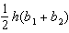
Multiply both expressions by 2 |  | =
Divide both expressions by h |  | = | 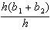
Simplify |  | =
Subtract from both expressions | 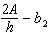 | =

Substitute the values stated in the problem in the formula.

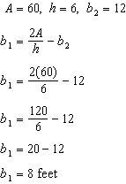

PTS: 4 NAT: A.CED.A.4 TOP: Transforming Formulas

71) ANS: 1
Strategy: Use the four column method to isolate r.
Notes | Left Expression | Sign | Right Expression
Given |  | =
Divide both expressions by |  | = | 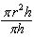
Simplify |  | =
Take square root of both expressions. | 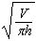 | =

PTS: 2 NAT: A.CED.A.4 TOP: Transforming Formulas

72) ANS: 2
Strategy: Use the four column method. Isolate t.
Notes | Left Expression | Sign | Right Expression
Given |  | = | 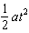
Multiply both expressions by 2 | 2d | =
Divide both expressions by a |  | =
Simplify |  | =
Take square root of both expressions | 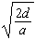 | = | t

PTS: 2 NAT: A.CED.A.4 TOP: Transforming Formulas

73) ANS:
a) 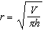
b) 5 inches

Strategy: Use the four column method to isolate r and create a new formula, then use the new formula to answer the problem.
Notes | Left Expression | Sign | Right Expression
Given |  | =
Divide both expressions by |  | =
Simplify |  | =
Take square root of both expressions. |  | =
Substitute the values from the problem into the new equation.
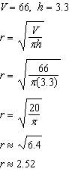
If the radius is approximately 2.5 inches, the diameter is approximately 5 inches.

PTS: 4 NAT: A.CED.A.4 TOP: Transforming Formulas

74) ANS: 3
Strategy: Isolate r, as follows:
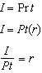

PTS: 2 NAT: A.CED.A.4 TOP: Transforming Formulas

75) ANS:

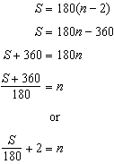

PTS: 2 NAT: A.CED.A.4 TOP: Transforming Formulas

76) ANS:
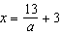
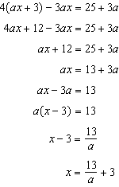

PTS: 2 NAT: A.CED.A.4

77) ANS: 3
Given |  | =
Divide by |  | = | 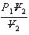
Simplify |  | =

PTS: 2 NAT: A.CED.A.4 TOP: Transforming Formulas

78) ANS: 3
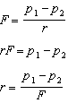
If , then cannot be true.

PTS: 2 NAT: A.CED.A.4 TOP: Transforming Formulas

79) ANS:

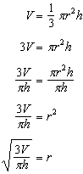.

PTS: 2 NAT: A.CED.A.4 TOP: Transforming Formulas

80) ANS:

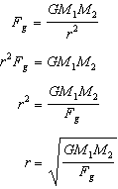

PTS: 2 NAT: A.CED.A.4 TOP: Transforming Formulas

81) ANS: 4
Strategy: Transform the formula to isolate the variable.
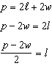
This is solution III.
NOTE that solution III can also be expressed as:
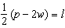
This is solution II.
NOTE also that the distributive property of multiplication can transform solution II into:
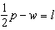
This is solution I.
The correct answer choice is I, II, and III.

PTS: 2 NAT: A.CED.A.4 TOP: Transforming Formulas

S

