**H – Quadratics, Lesson 4, Geometric Applications of Quadratics (r. 2018)**

QUADRATICS

Geometric Applications of Quadratics

|  |  |
| --- | --- |
| **Common Core Standard**  **A-CED.1** Create equations and inequalities in one variable ~~and use them to solve problems~~. *Include equations arising from linear and quadratic functions, and simple rational and exponential functions.*  PARCC: Tasks are limited to linear, quadratic, or exponential equations with integer exponents. | **Next Generation Standard**  **AI-A.CED.1** Create equations and inequalities in one variable to **represent a real-world context**.  (Shared standard with Algebra II)  Notes:  • **This is strictly the development of the model (equation/inequality).**  • **Limit equations to linear, quadratic, and exponentials of the form *f(x) = a(b)x* where *a* > 0 and *b* > 0 (*b* ≠ 1).**  • **Work with geometric sequences may involve an exponential equation/formula of the form an = arn-1, where a is the first term and r is the common ratio.**  • **Inequalities are limited to linear inequalities.**  • Algebra I tasks do not involve compound inequalities. |

**LEARNING OBJECTIVES**

Students will be able to:

1) model quadratic equations that reflect real-world contexts involving the area and dimensions of two-dimensional geometric figures.

**Overview of Lesson**

|  |  |
| --- | --- |
| **Teacher Centered Introduction**  **Overview of Lesson**  **- activate students’ prior knowledge**  **- vocabulary**  **- learning objective(s)**  **- big ideas: direct instruction**  **- modeling** | **Student Centered Activities**  **guided practice ⬅Teacher: anticipates, monitors, selects, sequences, and connects student work**  **- developing essential skills**  **- Regents exam questions**  **- formative assessment assignment (exit slip, explain the math, or journal entry)** |

**VOCABULARY**

area

area formulas

length

width

**BIG IDEAS**

**Geometric Area Problems**: Quadratics are frequently used to model problems involving geometric area. The keys to solving geometric area problems are to use a geometric area formula and draw a sketch to represent the problem.

|  |  |  |
| --- | --- | --- |
| **Typical Problem in Context** | **Mathematical Translation** | **Hints and Strategies** |
| The area of the rectangular playground enclosure at South School is 500 square meters. The length of the playground is 5 meters longer than the width. Find the dimensions of the playground, in meters. | width = 20 and length = 25  *A=lw*  Let *A*=500  Let width = *w*  Let length = *w*+5  Write: | Start with a formula.  Define variables.  Substitute known information into the formula. |

**Sketching a Diagram Can Help to Understand and Solve a Problem**

The general strategy for solving problems that involve geometric applications of quadratics is to substitute terms with a common variable for length and width in common area formulas. Drawing a picture can also help.

For example: A rectangular garden has length of x+2 and width of 2x-3, and the area of the garden is 72 square feet. What are the dimensions of the garden?

Start by drawing a picture to help understand the problem.



Then, use the formula for finding the area of a rectangle, which is:



Substitute information about the length and width of the garden into the area formula for a rectangle, then write:

 

The area of the garden is 72 square feet, so we can write:



Solve for x, then for x+2 and 2x-3. The length is 8 feet and the width is 9 feet.

**DEVELOPING ESSENTIAL SKILLS**

1) A contractor needs 54 square feet of brick to construct a rectangular walkway. The length of the walkway is 15 feet more than the width. Write an equation that could be used to determine the dimensions of the walkway. Solve this equation to find the length and width, in feet, of the walkway.

2) A rectangle has an area of 24 square units. The width is 5 units less than the length. What is the length, in units, of the rectangle?

3) Jack is building a rectangular dog pen that he wishes to enclose. The width of the pen is 2 yards less than the length. If the area of the dog pen is 15 square yards, how many yards of fencing would he need to completely enclose the pen?

4) A rectangular park is three blocks longer than it is wide. The area of the park is 40 square blocks. If *w* represents the width, write an equation in terms of *w* for the area of the park. Find the length and the width of the park.

5) What is the length of one side of the square whose perimeter has the same numerical value as its area?

**Answers**

1. The formula for the area of a rectangle is 

Let 54 represent A.

Let w represent the width of the rectangle.

Let w+15 represent the length of the rectangle.

Write:



Reject the negative solution.

The width of the sidewalk is 3 feet.

The length of the sidewalk is 18 feet.

1. The formula for the area of a rectangle is 

Let 24 represent A.

Let *l* represent the length of the rectangle.

Let *l*-5 represent the width of the rectangle.

Write:



Reject the negative solution.

The length of the rectangle is 8 units.

1. The formula for the area of a rectangle is 

Let 15 represent A.

Let l represent the length of the rectangle.

Let l-2 represent the width of the rectangle.

Write:



Reject the negative solution.

If the length is 5, the width is 3.

The formula for the perimeter of a rectangle is , so the length of fence needed is



16 yards of fencing are needed.

1. The formula for the area of a rectangle is 

The units in this problem are blocks.

Let 40 represent A.

Let w represent the width of the rectangle.

Let w+3 represent the length of the rectangle.

Write:



Reject the negative solution.

The park is 5 blocks wide and 8 blocks long.

5) The formula for the area of a square is 

The formula for the perimeter of a square is 

Write:



Reject the zero solution.

The length of one side of the square is 4 units.

**REGENTS EXAM QUESTIONS (through June 2018)**

A.CED.A.1: Geometric Applications of Quadratics

210) The length of the shortest side of a right triangle is 8 inches. The lengths of the other two sides are represented by consecutive odd integers. Which equation could be used to find the lengths of the other sides of the triangle?

|  |  |  |  |
| --- | --- | --- | --- |
| 1) |  | 3) |  |
| 2) |  | 4) |  |

211) New Clarendon Park is undergoing renovations to its gardens. One garden that was originally a square is being adjusted so that one side is doubled in length, while the other side is decreased by three meters. The new rectangular garden will have an area that is 25% more than the original square garden. Write an equation that could be used to determine the length of a side of the original square garden. Explain how your equation models the situation. Determine the area, in square meters, of the new rectangular garden.

212) A rectangular garden measuring 12 meters by 16 meters is to have a walkway installed around it with a width of *x* meters, as shown in the diagram below. Together, the walkway and the garden have an area of 396 square meters.

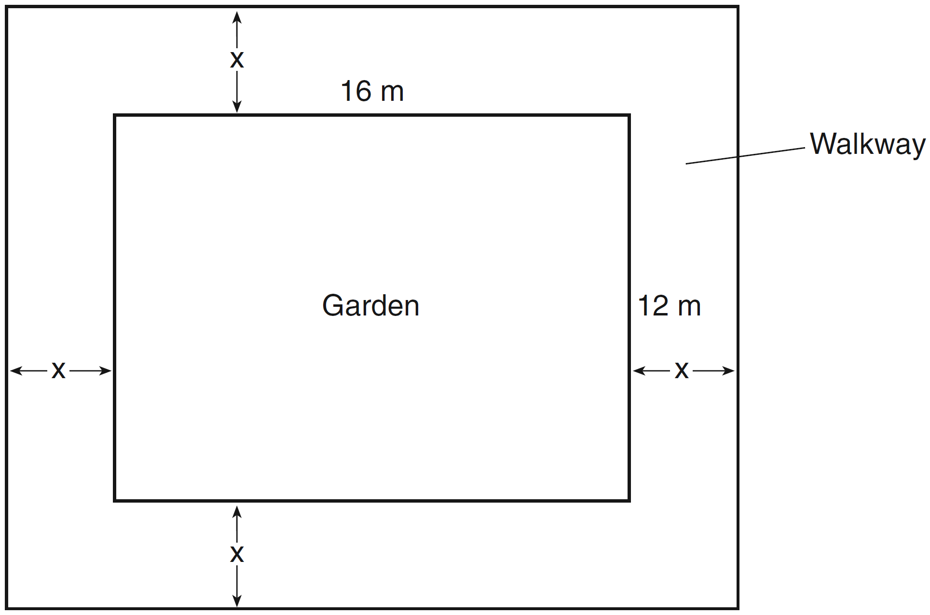

Write an equation that can be used to find *x*, the width of the walkway. Describe how your equation models the situation. Determine and state the width of the walkway, in meters.

213) A school is building a rectangular soccer field that has an area of 6000 square yards. The soccer field must be 40 yards longer than its width. Determine algebraically the dimensions of the soccer field, in yards.

214) A landscaper is creating a rectangular flower bed such that the width is half of the length. The area of the flower bed is 34 square feet. Write and solve an equation to determine the width of the flower bed, to the *nearest tenth of a foot*.

215) A rectangular picture measures 6 inches by 8 inches. Simon wants to build a wooden frame for the picture so that the framed picture takes up a maximum area of 100 square inches on his wall. The pieces of wood that he uses to build the frame all have the same width. Write an equation or inequality that could be used to determine the maximum width of the pieces of wood for the frame Simon could create. Explain how your equation or inequality models the situation. Solve the equation or inequality to determine the maximum width of the pieces of wood used for the frame to the *nearest tenth of an inch*.

216) Joe has a rectangular patio that measures 10 feet by 12 feet. He wants to increase the area by 50% and plans to increase each dimension by equal lengths, *x*. Which equation could be used to determine *x*?

|  |  |  |  |
| --- | --- | --- | --- |
| 1) |  | 3) |  |
| 2) |  | 4) |  |

217) A contractor has 48 meters of fencing that he is going to use as the perimeter of a rectangular garden. The length of one side of the garden is represented by *x*, and the area of the garden is 108 square meters. Determine, algebraically, the dimensions of the garden in meters.

**SOLUTIONS**

210) ANS: 4

Strategy: Use the Pythagorean Theorem, the sum of the squares of the lengths of the legs of a right triangle equals the square of the length of the hypotenuse.



The shortest side must be one of the legs, since the longest side is always the hypotenuse.

Substitute 8 for a in the equation.



The lengths of sides b and c are consecutive odd integers. Let x represent the smaller odd integer and let  represent the larger consecutive odd integer. Side c must be represented by  because side c represents the hypotenuse, which is always the longest side of a right triangle. Therefore, side b is represented by x and side c is represented by . Substitute these values into the equation.



By using the commutative property to rearrange the two terms in the right expression, we obtain the same equation as answer choice d.



DIMS? Does It Make Sense? Yes. Transorm the equation for input into a graphing calculator as follows:  and we find that the other two sides of the right triangle are 15 and 17.

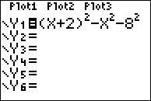 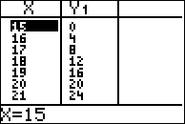

By the Pythagorean Theorem, 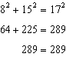

Everything checks!

PTS: 2 NAT: A.CED.A.1 TOP: Geometric Applications of Quadratics

211) ANS:

a) 

b) Because the original garden is a square,  represents the original area,  represents the side decreased by 3 meters,  represents the doubled side, and  represents the new garden with an area 25% larger.

c) The length of a side of the original square garden was 8 meters.

The area of the new rectangular garden is 80 square meters.

Strategy: Draw two pictures: one picture of the garden as it was in the past and one picture of the garden as it will be in the future. Then, write and solve an equation to determine the length of a side of the original garden.

STEP 1. Draw 2 pictures.



Area of original garden is . Area of new garden is .

STEP 2: Use the area formula, , to write an equation for the area of the new garden.



STEP 3: Transform the equation for input into a graphing calculator and solve.

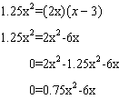

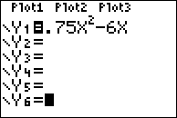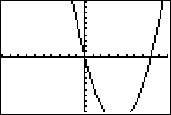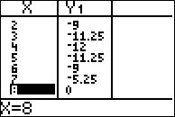

The length on a side of the original square garden was 8 meters.

The area of the new garden is  square meters.

DIMS? Does It Make Sense? Yes. The dimensions of the original square garden are 8 meters on each side and the area was 64 square meters. The dimensions of the new rectangular garden are 16 meters length and 5 meters width. The new garden will have area of 80 meters. The area of the new garden is 1.25 times the area of the original garden.

PTS: 6 NAT: A.CED.A.1 TOP: Geometric Applications of Quadratics

212) ANS:

a) .

b) The length, , and the width, , are multiplied and set equal to the area.

c) The width of the walkway is 3 meters.

Strategy: Use the picture, the area formula (), and information from the problem to write an equation, then solve the equation.

STEP 1. Use the area formula, the picture, and information from the problem to write an equation.



STEP 2. Solve the equation.

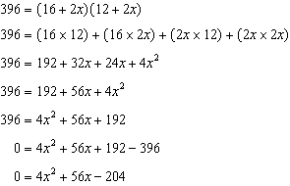

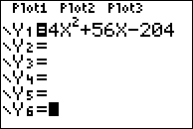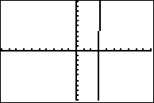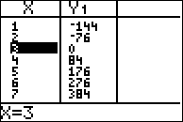

The width of the walkway is 3 meters.

DIMS? Does It Make Sense? Yes. The garden plus walkway is  meters long and  meters wide. , which fits the information in the problem.

PTS: 4 NAT: A.CED.A.1 TOP: Geometric Applications of Quadratics

213) ANS:

The soccer field is 60 yards wide and 100 yards long.

Strategy: Draw and label a picture, then use the picture to write and solve an equation based on the area formula: 

STEP 1: Draw and label a picture.



STEP 2: Write and solve an equation based on the area formula: 

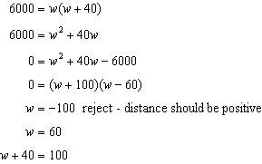

DIMS? Does It Make Sense? Yes. If the width of the soccer field is 60 yards and the length of the soccer field is 100 yards, then the area of the soccer field will be 6,000 square yards, as required by the problem.

PTS: 4 NAT: A.CED.A.1 TOP: Geometric Applications of Quadratics

214) ANS:

a) Equation

b) The width of the flower bed is approximately 4.1 feet.

Strategy: Draw a picture, then write and solve an equation based on the area formula, .

STEP 1. Draw a picture.



STEP 2: Write and solve an equation based on the area formula.

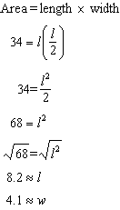.

PTS: 2 NAT: A.CED.A.1 TOP: Geometric Applications of Quadratics

215) ANS:

The maximum width of the frame should be 1.5 inches.

Strategy: Write an inequality, then solve it.

STEP 1: Write the inequality.

The picture is 6 inches by 8 inches. The area of the picture is .

The width of the frame is an unknown variable represented by x.

Two widths of the frame (2x) must be added to the length and width of the picture. Therefore, the area of the picture with frame is 

The area of the picture with frame, , must be less than or equal  to 100.

Write 

STEP 2: Solve the inequality.

|  |  |  |  |
| --- | --- | --- | --- |
| Notes | Left Expression | Sign | Right Expression |
| Given |  |  |  |
| Use Distributive Property to Clear Parentheses |  |  | 100 |
| Commutative Property |  |  | 100 |
| Combine Like Terms |  |  | 100 |
| Subtract 100 from both expressions |  |  | 0 |

Use the Quadratic Formula: a=4, b=28, c=-52

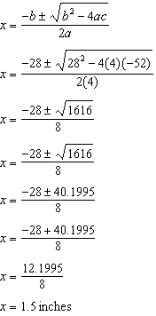

DIMS? Does It Make Sense? Yes. If the frame is 1.5 inches wide, then the total picture with frame will be

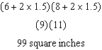

PTS: 6 NAT: A.CED.A.1 TOP: Geometric Applications of Quadratics

216) ANS: 2

Strategy: STEP 1. First, determine the area of the current rectangular patio and increase its size by 50%, which will be the size of the new patio. STEP 2. Then, increase each dimension of the current rectangular patio by x, as follows:

STEP 1.

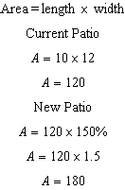

The new patio will have an area of 180 square feet. Eliminate choice (a).

STEP 2.



Choose answer b.

PTS: 2 NAT: A.CED.A.1 TOP: Geometric Applications of Quadratics

217) ANS:

The garden is a rectangle that measures 18 meters by 6 meters.

Strategy: . Solve as a system of two equations, because the question requires solving for two variables: length and width.

STEP 1. Draw a picture that illustrates the information in the problem.



STEP 2. Using the picture, write two equations using length and area formulas for rectangles. Let *l* represent the unknown *length* of the garden and let *w* represent the unknown *width* of the garden.

The first equation, , is based on the formula for the perimeter of a rectangle, which is .

The second equation, , is based on the area formula for rectangles, which is 



STEP 2. Isolate the length variable 



STEP 3. Solve  and as a system using substitution, as follows:

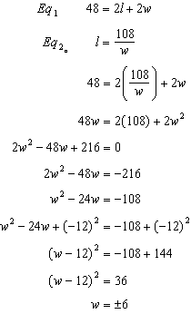

The garden is 6 meters wide. The length of the garden can be found using .

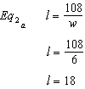

PTS: 4 NAT: A.CED.A.1 TOP: Geometric Applications of Quadratics